CCN Crib Sheet
** Please note: the CCN would only be uploaded / case note put on the OPEN child/children. This may not necessarily be all the children who live at the same address or all siblings. Children Triage will deal with any other children not Open to CS **
In the body of the email we receive from Children Triage, it will usually have the SW who the child is allocated to.
Go into the child on ICS and then in documents, create/attach document then see below
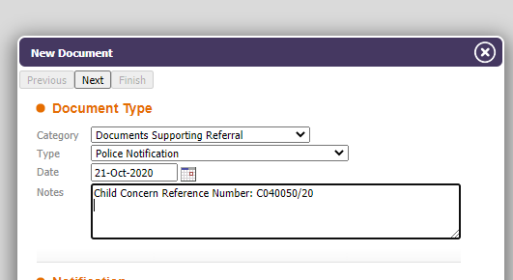
Category – Documents Supporting Referral
Type – Police Notification
Date – Use the email date we received the CCN
Notes – Copy the details from the top of the CCN document (if the CCN is further police checks info [would show at the very bottom ‘Details of Intelligence’ then you would copy details as above but also add ‘Further checks as requested’].
Next - Link to other children involved (only if the other children are OPEN cases)
Download the CCN and upload this as an attachment

Case Note
Add a case note…
Contact Date - Use the email date we received the CCN
Time – Time now
Type of Contact – contact on open case
Add any other children concerned (only if the other children are OPEN cases)
Reason for Contact – us the top section of the CCN including reference number, date/time
Detailed Notes – CCN received – please refer to attached documents re: (add reason for CNN DV, Grooming etc.)
Action – Open case DTM, TM & Duty Tray (*as applicable depending on below) emailed
Create and Close
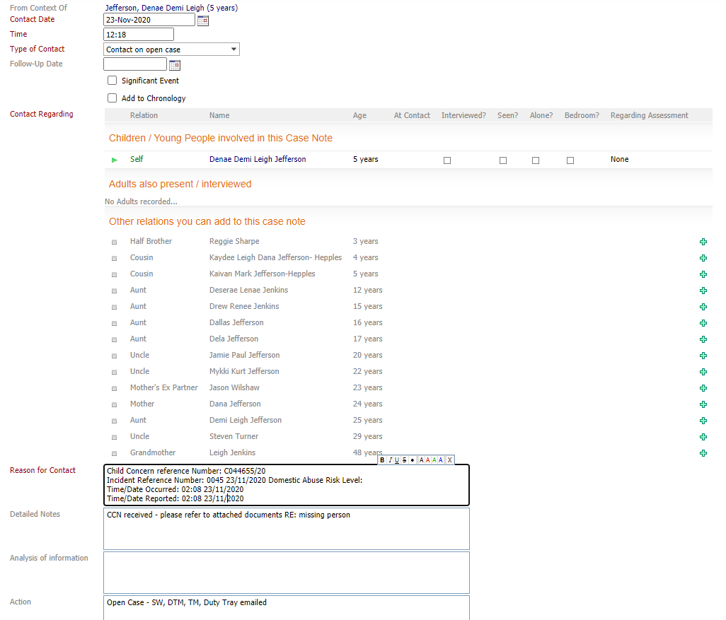
Email the SW, DTM. TM and Duty Tray (*as applicable depending on below) the CCN (add the ICS number to the body of the email if you wish).
NB * : SE & Central – notify SW, TM, DTM and Duty Tray
West & North – notify SW and Duty Tray
NAS / 14+ - notify SW and Duty Tray
ASYE Academy – notify SW, Sarah Stuart and Catherina Simpson

