Adults Safeguarding
Contents
1) Create a Contact, including safeguarding screening tool and Progress to Adults Safeguarding 2
2) Complete the SAM Enquiry Plan 4
3) Reassign the Safeguarding Episode to a Worker 6
4) How to view the Safeguarding episode 7
5) Safeguarding Case Notes 11
6) Risk Assessment and safeguarding Plan 13
7) Add and updating the safeguarding enquiry type detail 15
8) Updating the Adults at Risk’s Desired Outcomes 17
9) Stand Alone forms (I.E FACE Mental Capacity Assessment) 19
10) Attaching documents to the Safeguarding Enquiry 21
11) Progressing to a New Case 24
12) Closing the Safeguarding Enquiry Episode 26
13) Authorising the Safeguarding Enquiry Closure (Manager) 30
14) Completing the Safeguarding Enquiry (Safeguarding Enquiry Co-ordinator) 32

NOTE: If the Service User is not on the system, for further guidance in creating a new Service User record, please refer to the separate User Guide – Searching and Creating a Service User record

Create a Contact, including safeguarding screening tool and Progress to Adults Safeguarding
Navigate to the demographic screen. As shown below
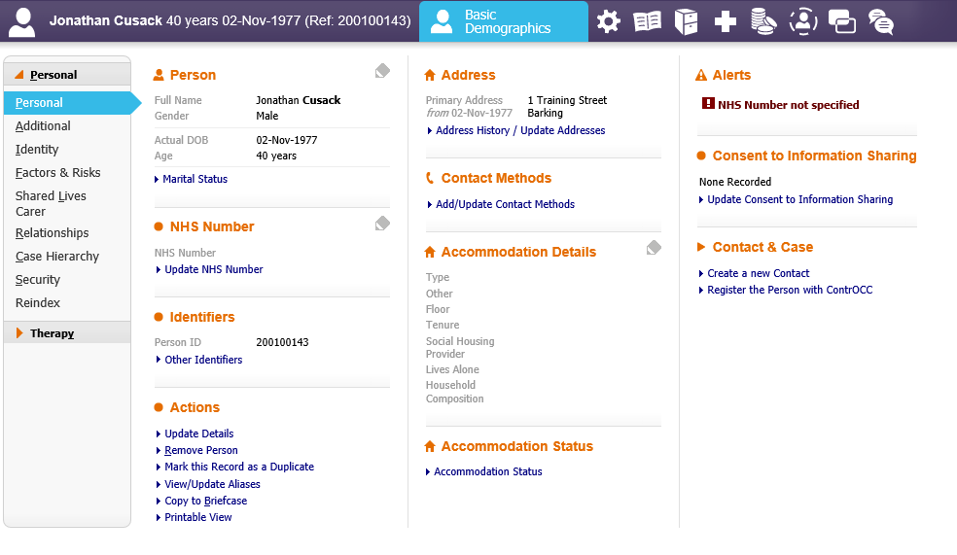
- Create a new contact. As highlighted above
The Contact record will now be available for the worker to complete as shown below:
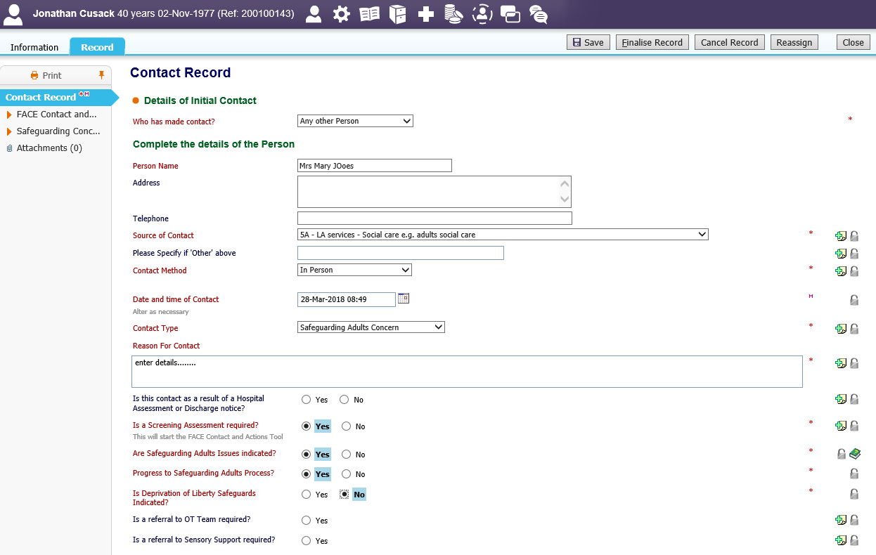
NOTE: The Safeguarding Screening/Concern tool will display on the form tabs, once the worker has answered the Safeguarding Adults questions on the first page of the form. As highlighted above,
The worker can now navigate through the Contact record and the Screening tool.
Once the worker has completed the screening Tool, Navigate to the Suggested outcomes section on the first page of the contact record. As shown below
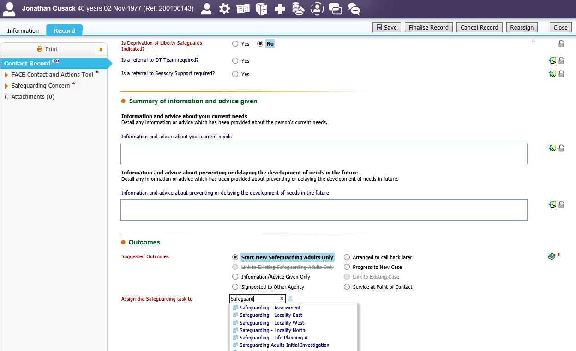
- Suggested outcomes-Start New Safeguarding Adults Only
- Assign the Safeguarding task to – Type to search safeguarding team tray – select the option
- Finalise Record
The worker will now see that there is yellow SA icon next to the persons name. This icon indicates that there is an Open Safeguarding Adults referral. As shown below.
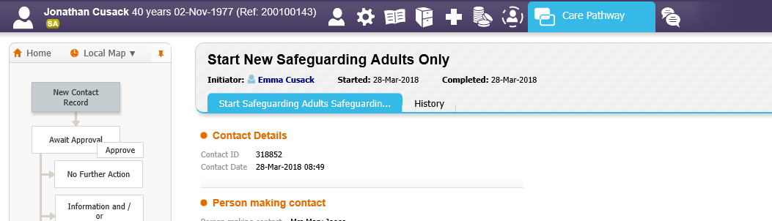

Complete the SAM Enquiry Plan
From the relevant Safeguarding Team Tray. Example below is safeguarding Assessment
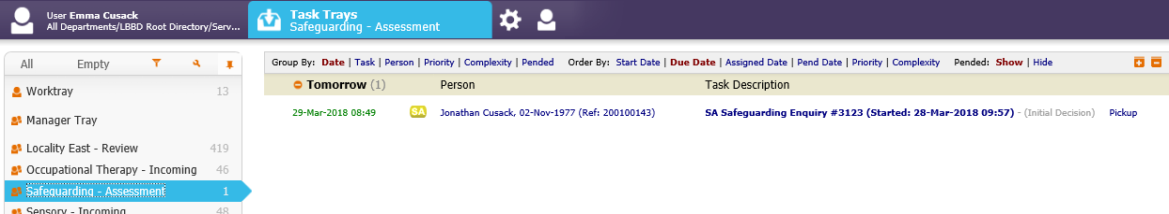
- SA Safeguarding Enquiry – initial decision ‘Pickup’
The worker will be directed to the Safeguarding Episode screen as shown below
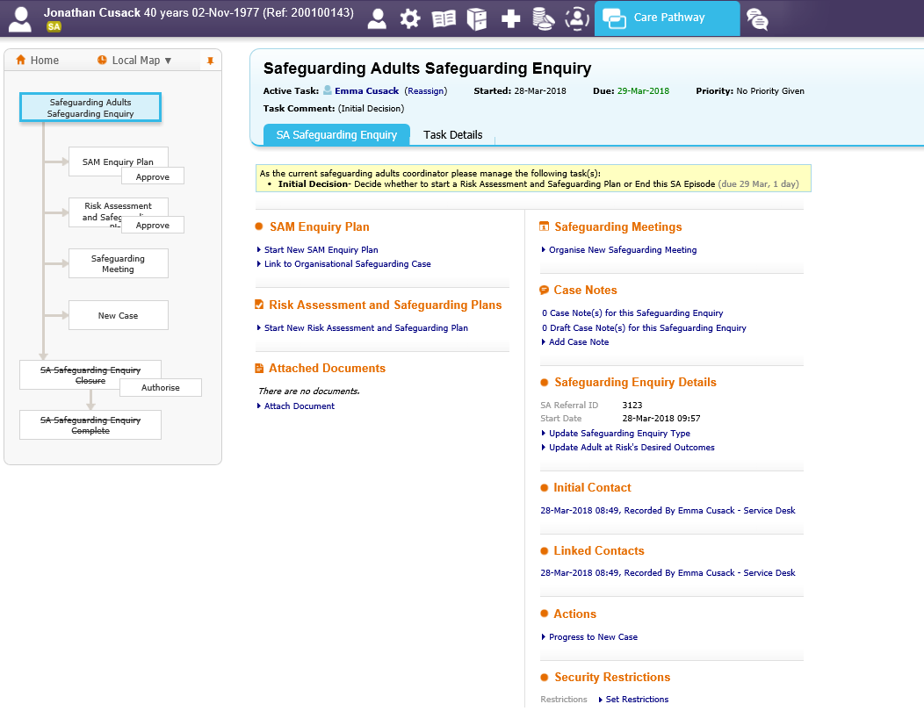
- Start New SAM Enquiry Plan
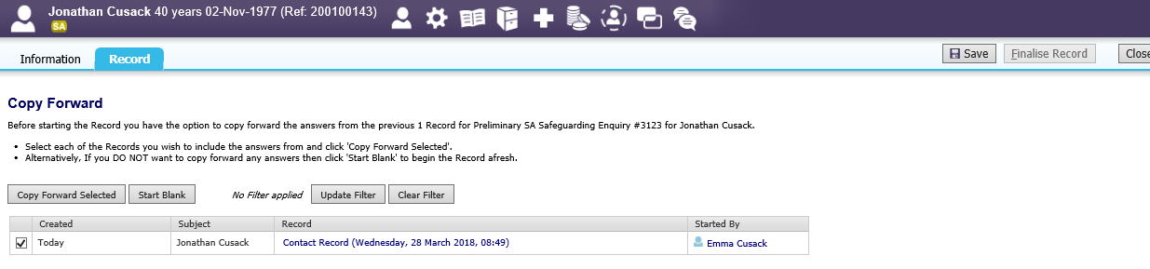
- Copy forward selected
The SAM worker can now navigate through and complete the form as required. As shown below.
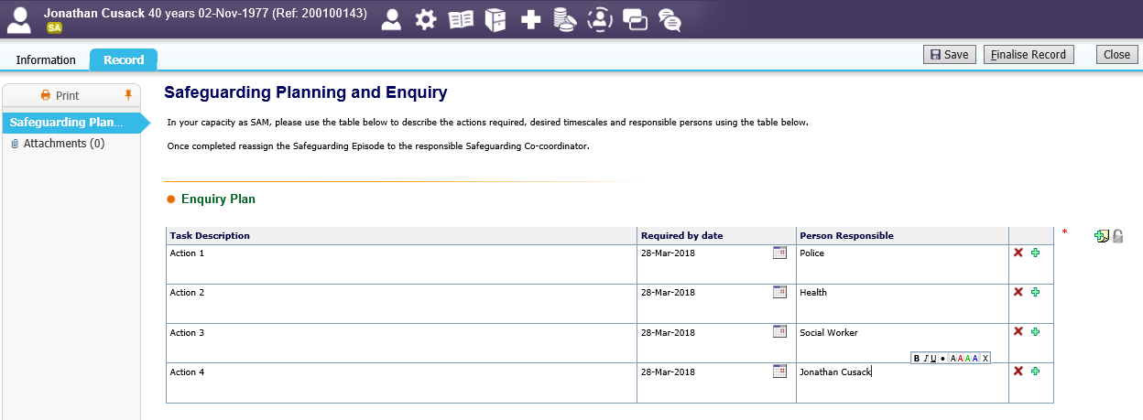
Once completed
- Finalise Record
The SAM enquiry record has now completed.

Reassign the Safeguarding Episode to a Worker
Once the SAM Worker has completed the SAM enquiry, the episode needs to be sent to the Worker for the Worker to undertake the relevant actions. From the Safeguarding Adults Enquiry screen – as shown below
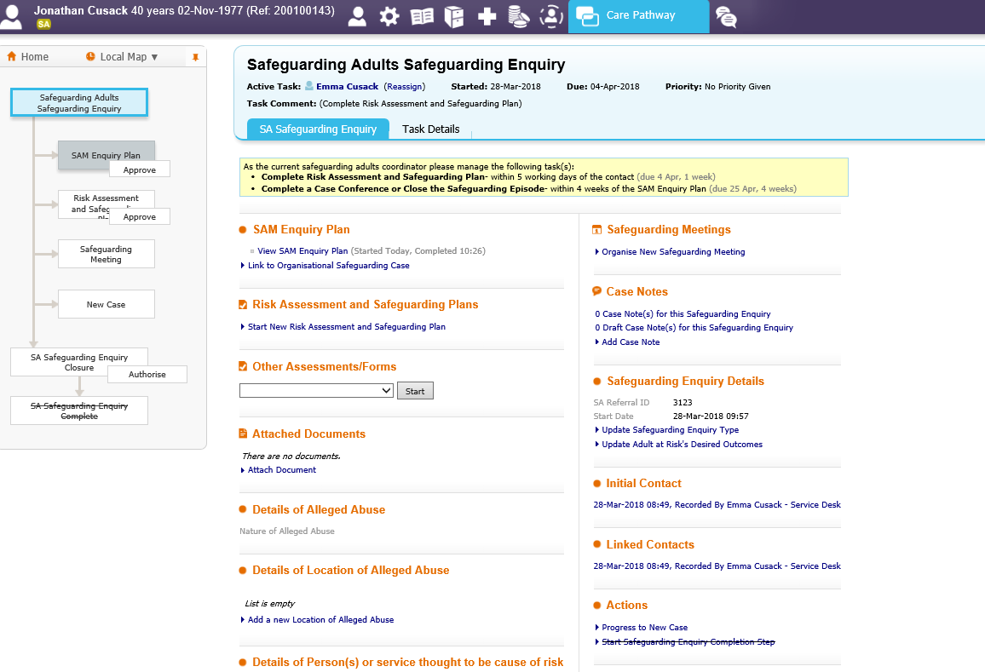
- Reassign. As highlighted above
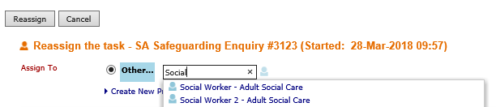
- Search for the name of the worker – select option
- Reassign
The safeguarding enquiry will now be displayed in the New Workers worktray.

How to view the Safeguarding episode
There are three ways in which the episode can be viewed/accessed.
- Via the Worktray (Safeguarding worker only)
From the Worktray. As shown below
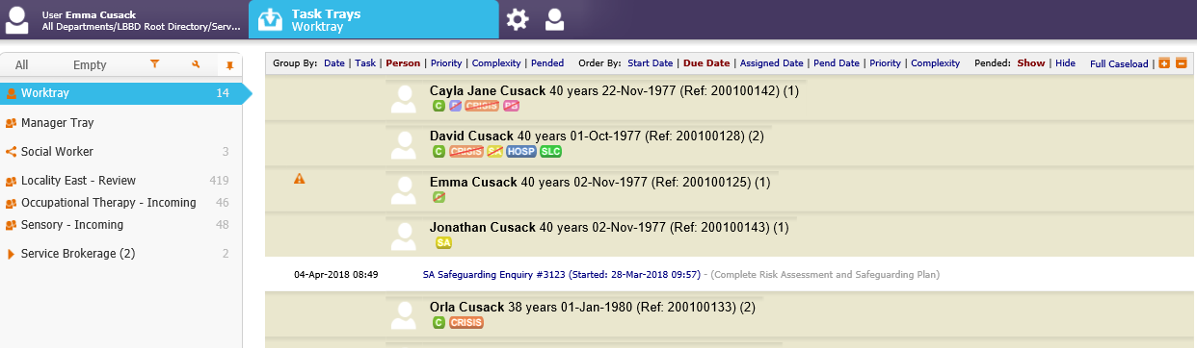
- SA Safeguarding Enquiry #...... As highlighted above
The safeguarding Episode will be displayed. As shown below.
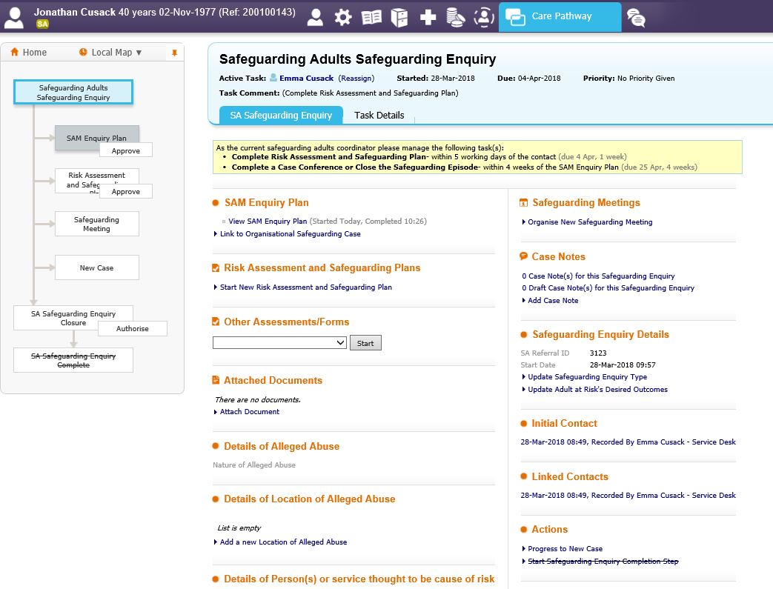

- Via the Case Files (everyone)
From the Persons Demographic record. As shown below
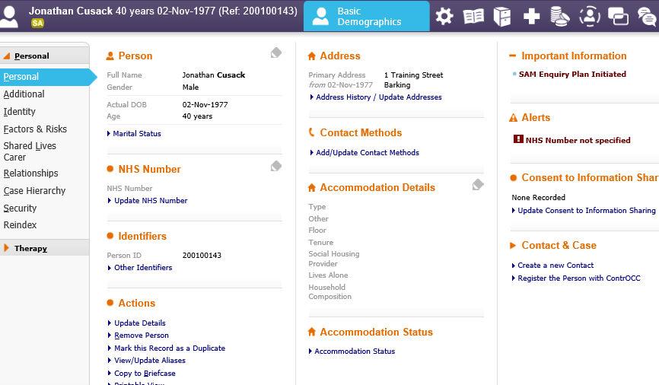
- Case files icon. As highlighted above
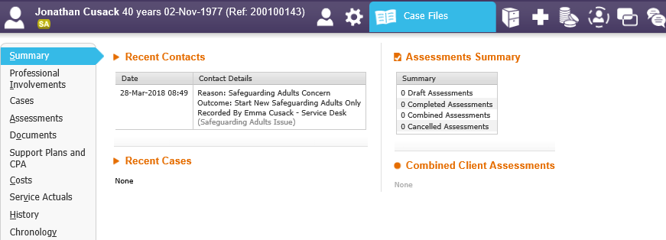
- Cases Tab. As highlighted above
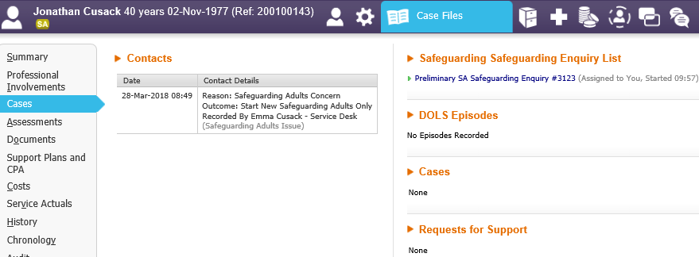
- Preliminary SA Safeguarding Enquiry #...... As highlighted above

The safeguarding Episode will be displayed. As shown below.

- Via the SA Icon (everyone)
From the persons demographic record. As shown below
- SA Icon. As highlighted above
- Preliminary SA Safeguarding enquiry. As highlighted above

The safeguarding Episode will be displayed. As shown below.

Safeguarding Case Notes
From within the Safeguarding Episode. As shown below
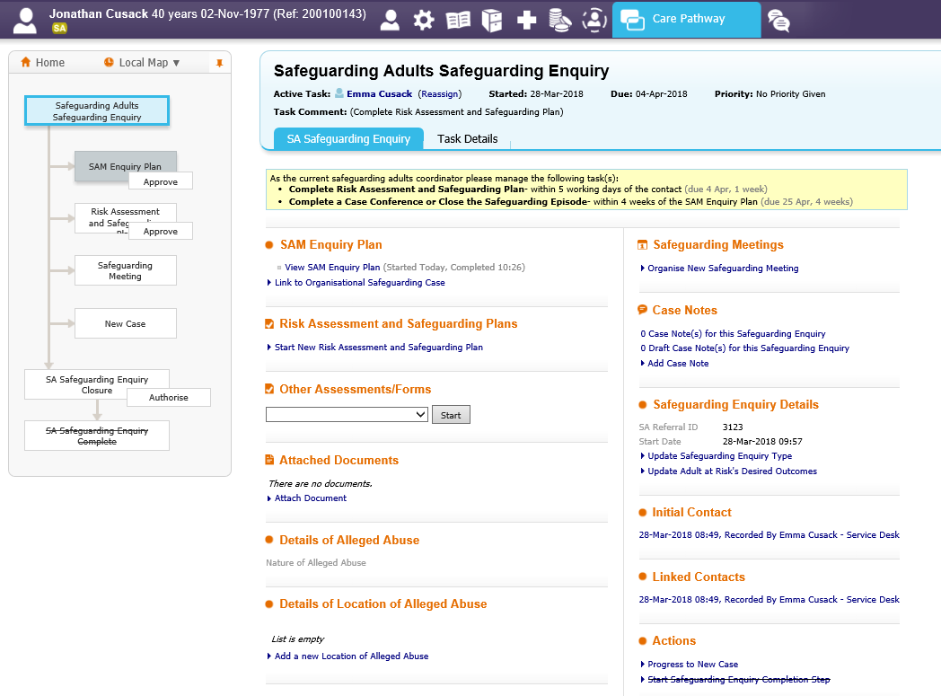
- Add Case Note. As highlighted above
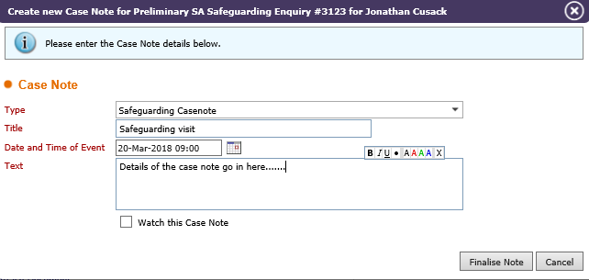
- Enter all details of the case note
- Finalise Note

The system will display that the case note has been record. As shown below
To view any recorded case notes
- # Case notes for this safeguarding Enquiry. As highlighted above
The case notes will be displayed. As shown below
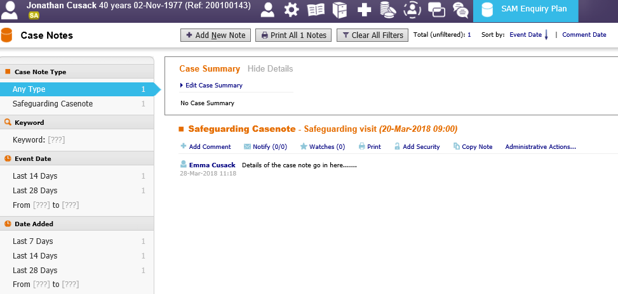
The case note will also be displayed on the Case Notes on the Persons demographic record.
*For further guidance on Case Note recording, please refer to the separate User Guide Recording Case notes.

Risk Assessment and safeguarding Plan
From the Safeguarding Episode. As shown below
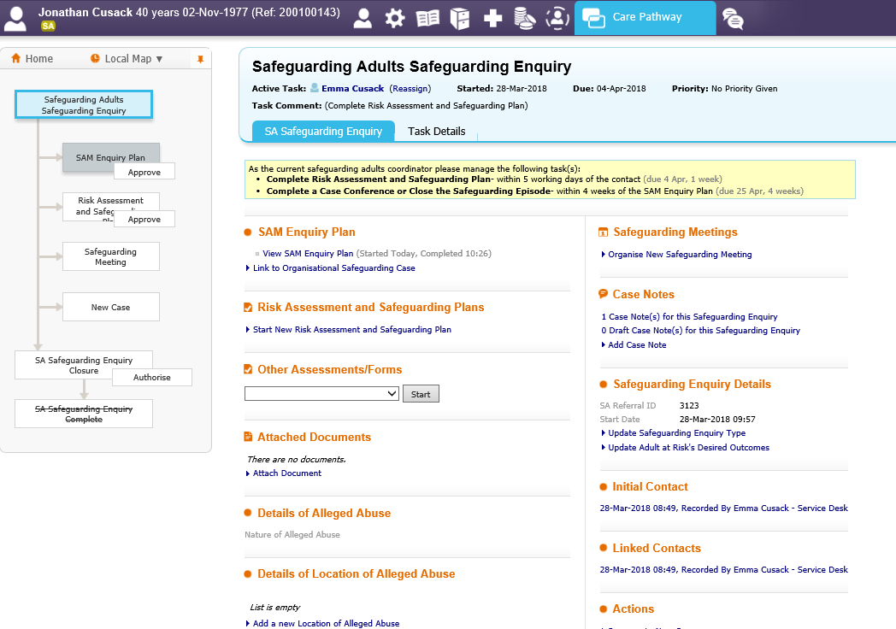
- Start New Risk Assessment and Safeguarding plan. As highlighted above
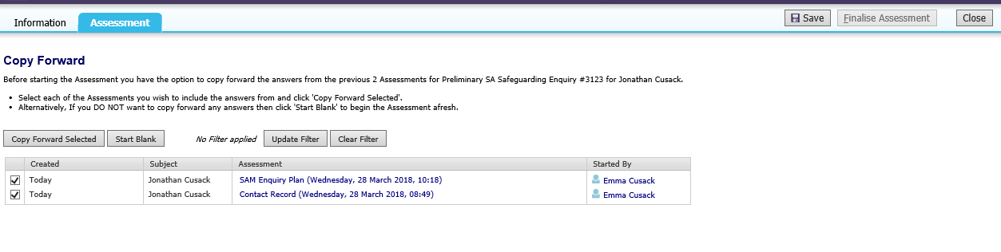
- Copy forward selected. As highlighted above
The worker can now complete the Risk Assessment and Safeguarding plan by navigating through the tabs. As shown below
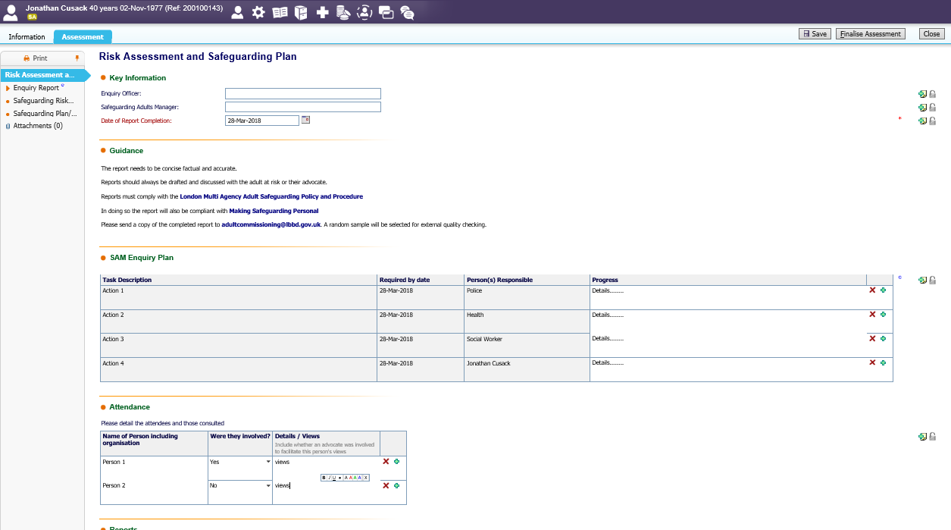
Once completed
- Finalise Assessment
The risk assessment will now show as complete – grey on the Pathway as shown below
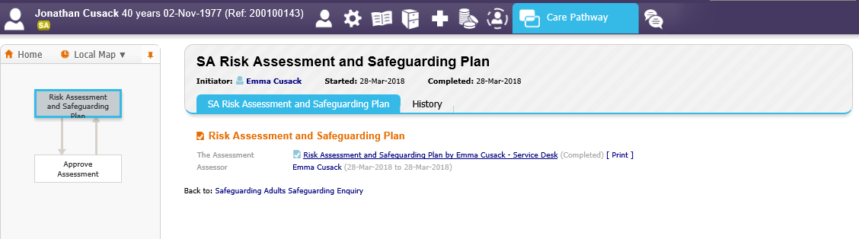

Add and updating the safeguarding enquiry type detail
From the Safeguarding Episode screen: as shown below
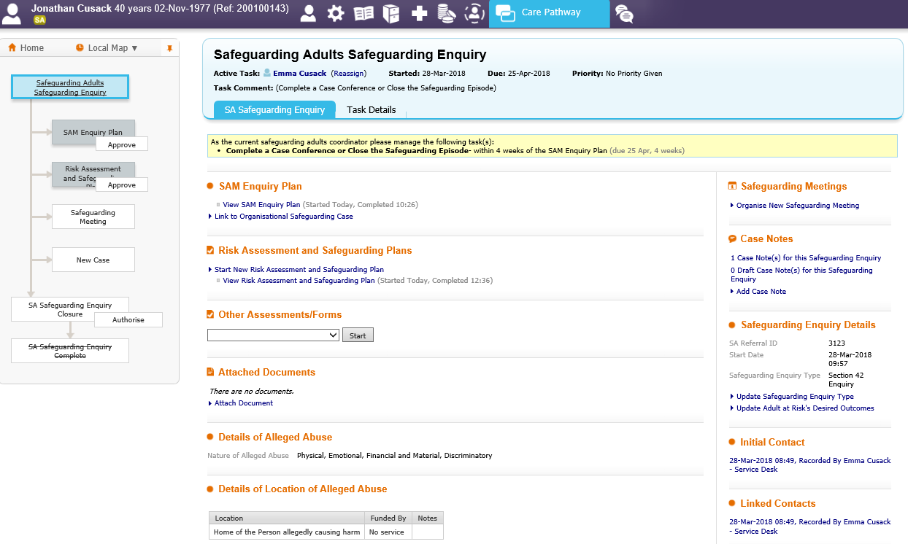
- Update Safeguarding Enquiry Type. As highlighted above
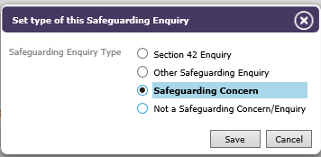
- Safeguarding Enquiry type – select option
- Save

The updated enquiry detail will be displayed on the screen. As shown below
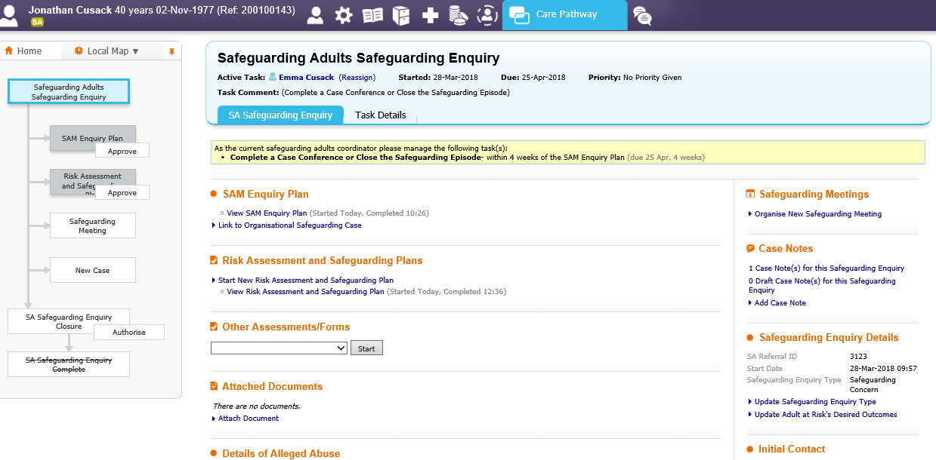

Updating the Adults at Risk’s Desired Outcomes
From the Safeguarding Episode screen: as shown below
- Update Adults at Risk’s Desired Outcomes. As highlighted above
- Select relevant option
- Save

The Adults at Risk’s details will now be displayed on the screen. As shown below
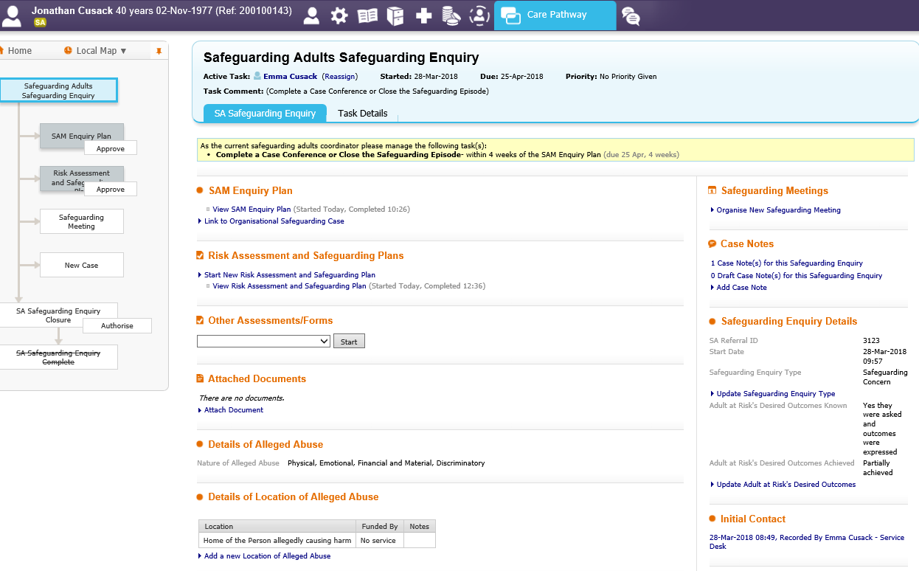

9) Stand Alone forms (I.E FACE Mental Capacity Assessment)
*This is not an exhaustive list of forms that may be in the LIVE system.
From the Safeguarding Episode screen: as shown below
- Other Assessments/Forms drop down. As highlighted above
- Select document
- Start
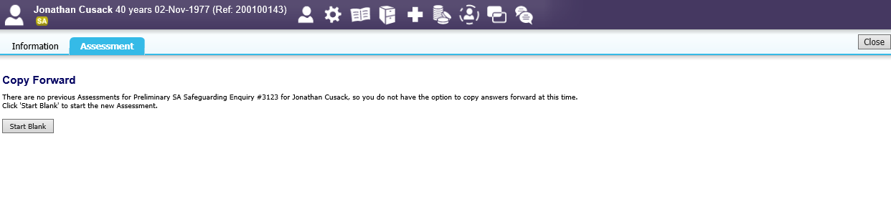
- Start blank (or copy forward if available-this is dependent on the form selected)

The form will now be displayed. The worker can navigate through the tabs to complete. As shown below
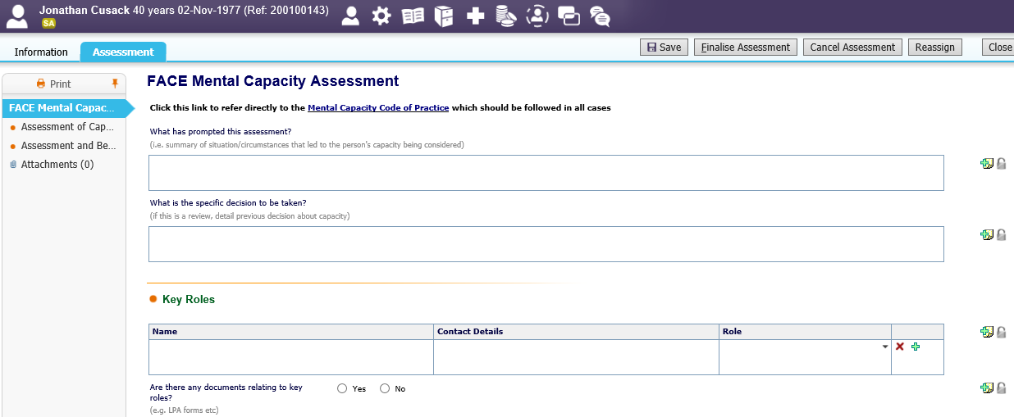
When complete
- Finalise Assessment. As highlighted above
The completed form will now display on the main screen. As shown below
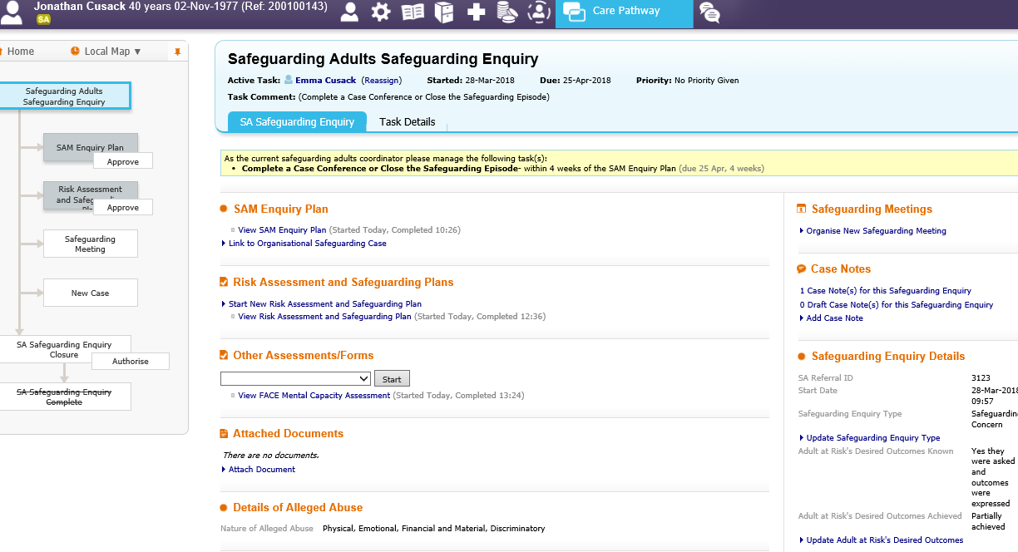
Workers can view completed Assessment and Forms by clicking on the link. As highlighted above.

Attaching documents to the Safeguarding Enquiry
From the Safeguarding Episode screen: as shown below
*Before attaching a document, please ensure you have saved it to the network
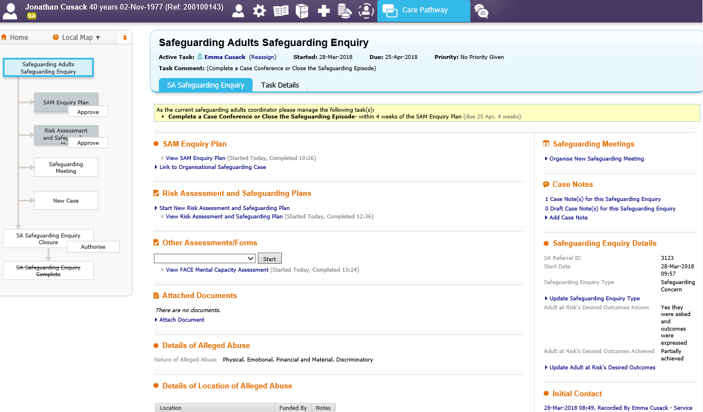
- Attach Document. As highlighted above
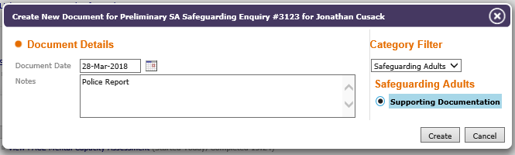
- Enter All relevant information
- Create
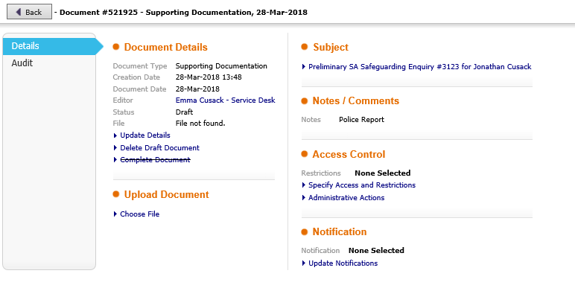
- Choose File. As highlighted above
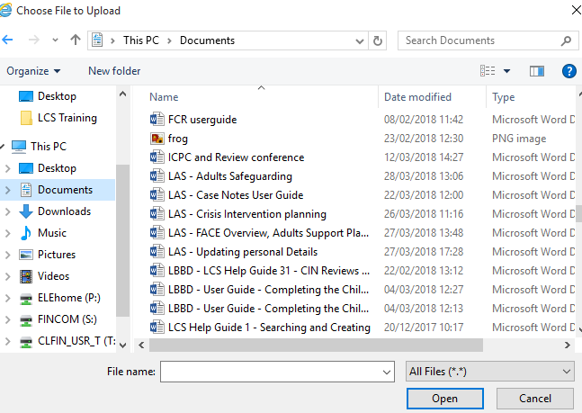
- Select required document
- Open
The file will then be displayed. As shown below
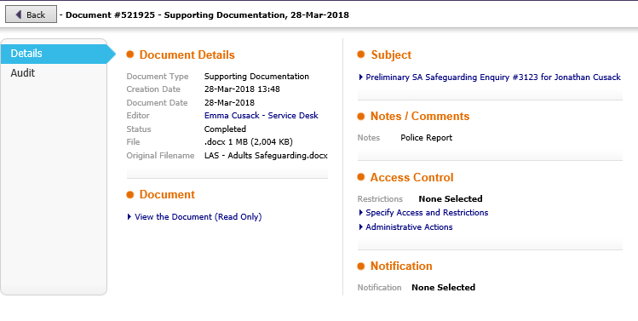
- Back. As highlighted above
The document also displays on the episode screen. To view the document, click on the blue link. As shown below
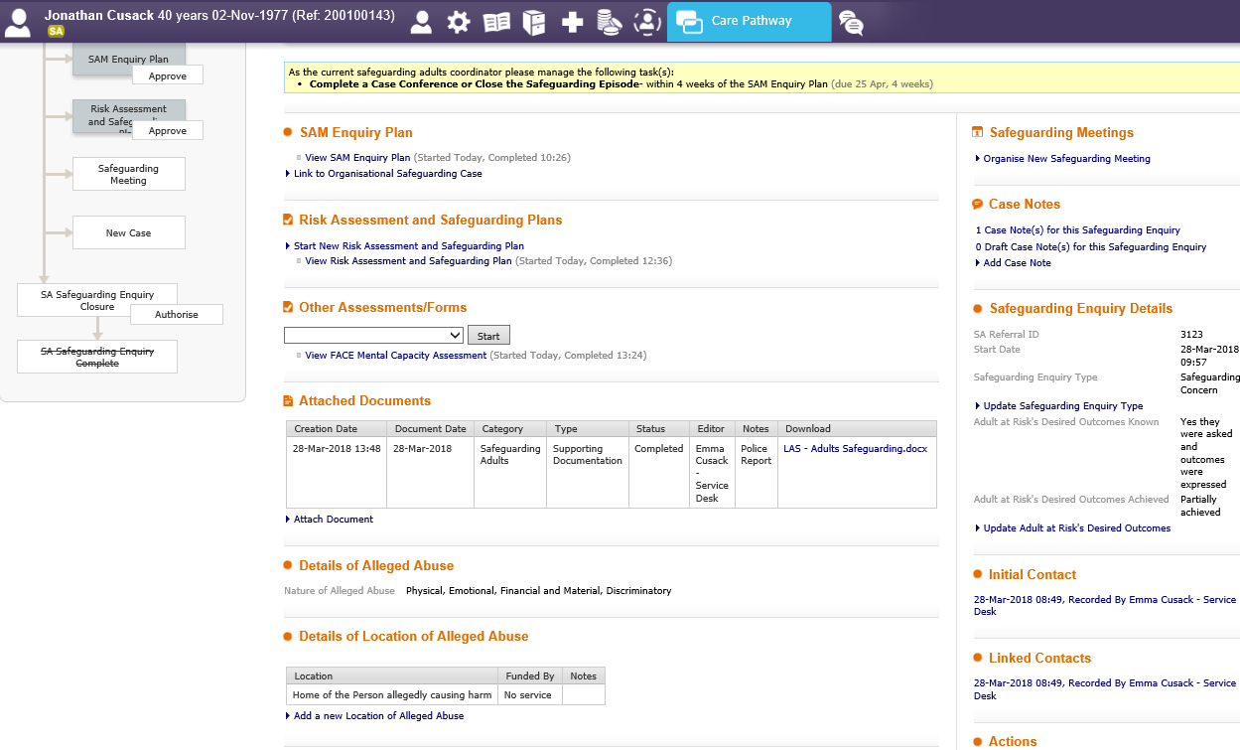

Progressing to a New Case
If the Adult at Risk is not currently a Service User but the case is required to progress, the worker can progress the case from within the episode. A new contact record is not necessary.
From the Safeguarding Episode screen: as shown below
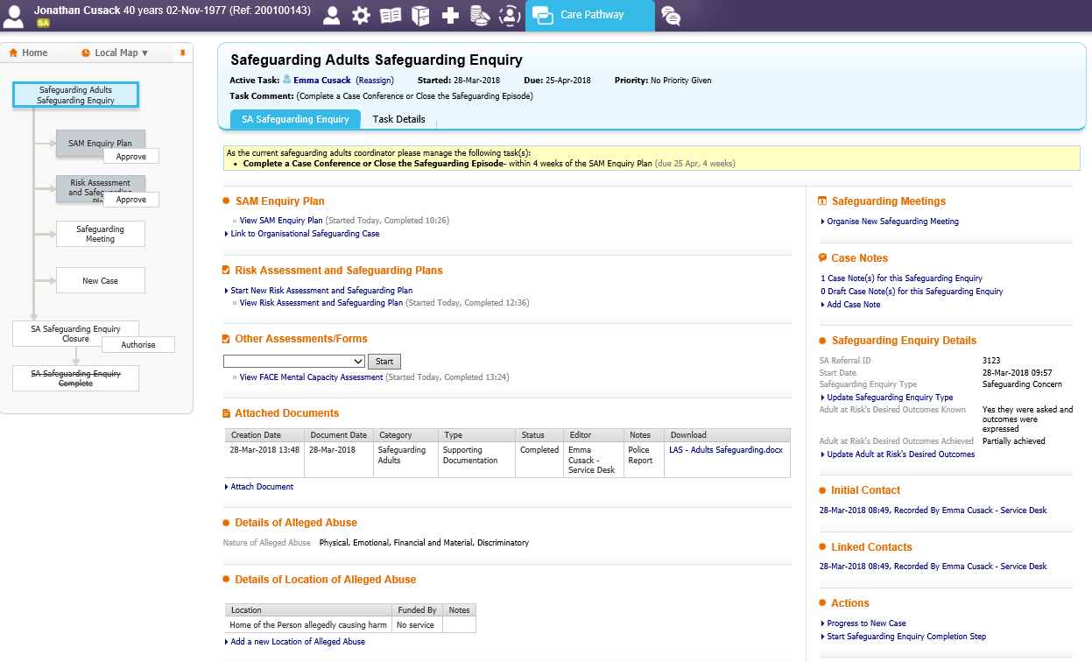
- Progress to new Case
The worker will now see that there is a green ‘c’ next to the persons name. This now indicates and open case. As highlighted below
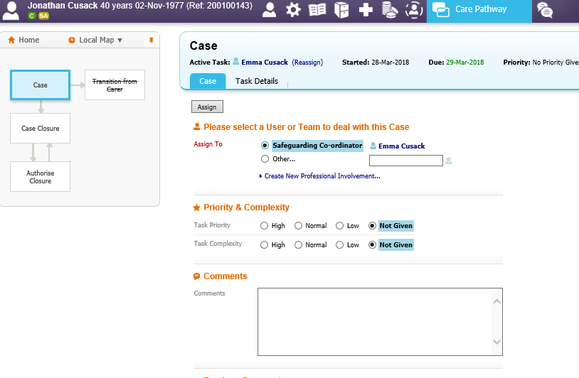
- The worker can select themselves to be the Case Worker or select another worker is necessary
- Assign
*NOTE: The selected worker will now be able to start the assessment and Care planning process. Please see separate User Guides for Further information regarding Assessment and Care Planning.

Closing the Safeguarding Enquiry Episode
From the Safeguarding Episode screen: as shown below
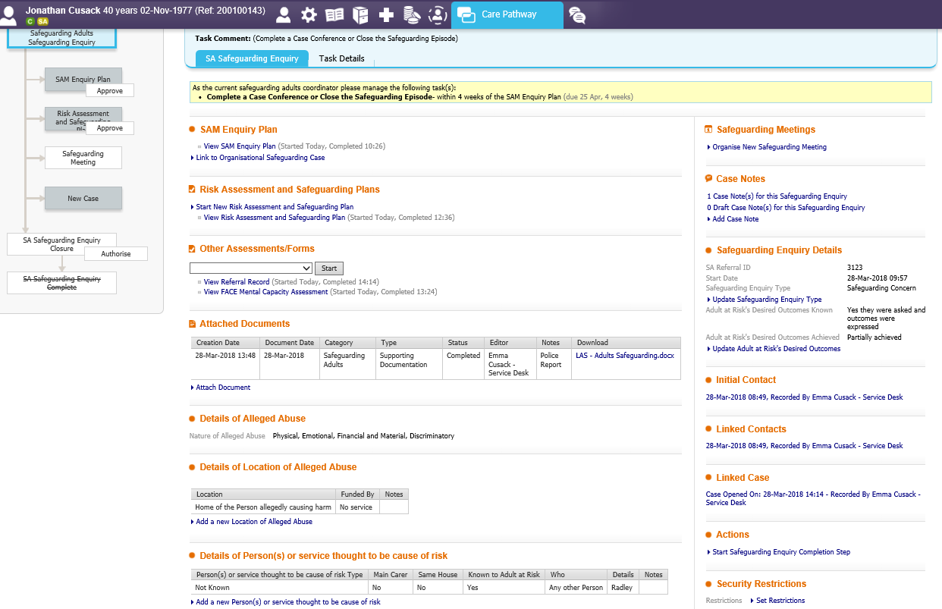
- Start Adults Safeguarding Enquiry
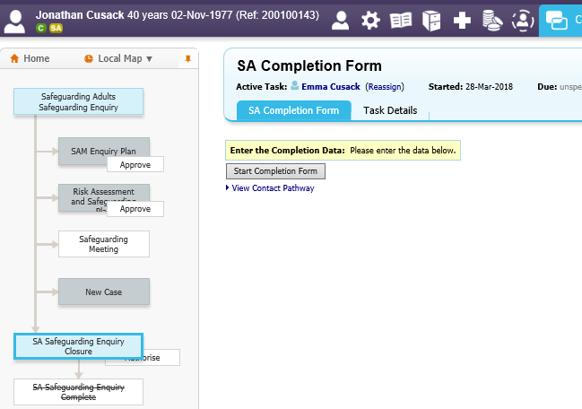
- Start Completion form. As highlighted above
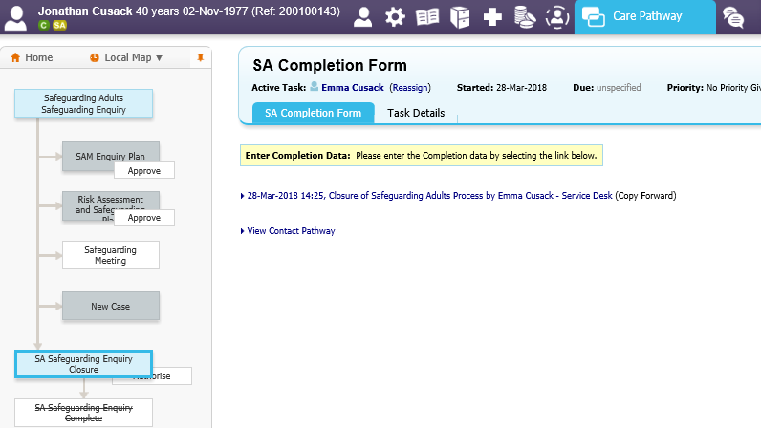
- Closure of Safeguarding Adults Process…. As highlighted above
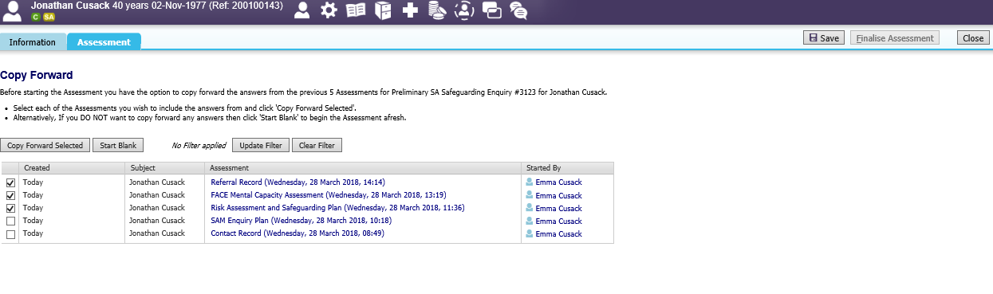
- Select Documents & Copy forward selected
OR
- Start Blank
The Closure of Adults Safeguarding will now be available for the worker to complete. As shown below
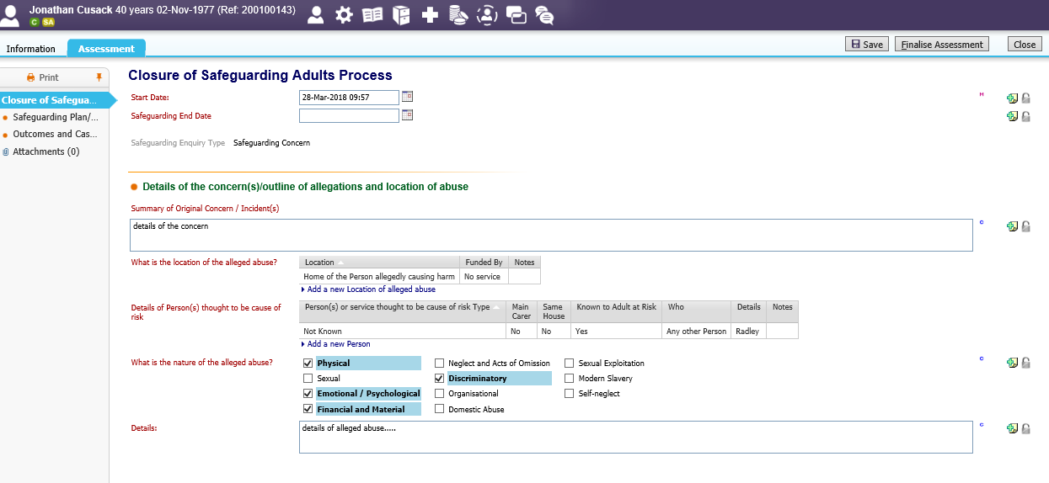
Complete the form
- Finalise Assessment
The worker will then be asked to select who will authorise the closure. As shown below
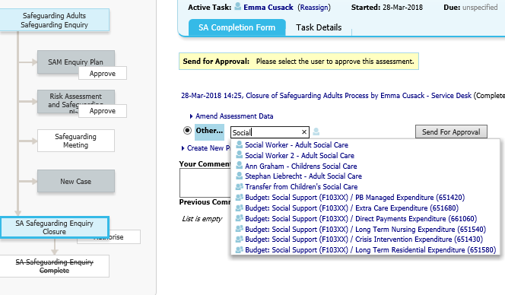
- Select the authoriser
- Send for approval
The Safeguarding closure form will now be with the Manager for Authorisation. As shown below
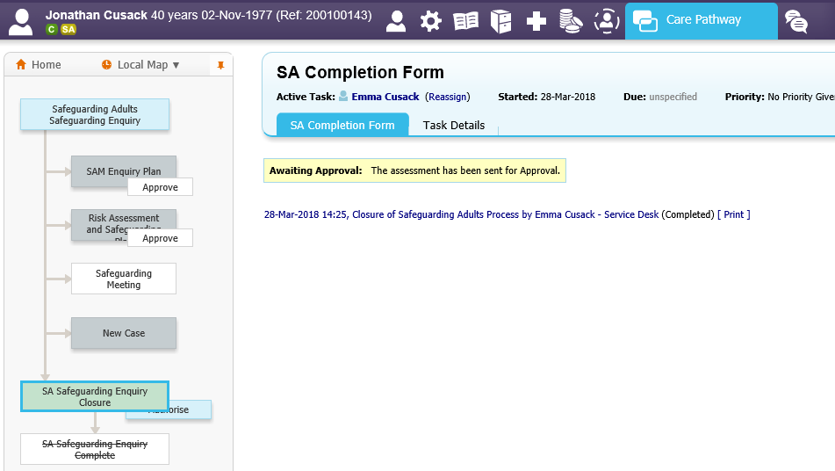

Authorising the Safeguarding Enquiry Closure (Manager)
Navigate to the Authorising Managers worktray. As shown below
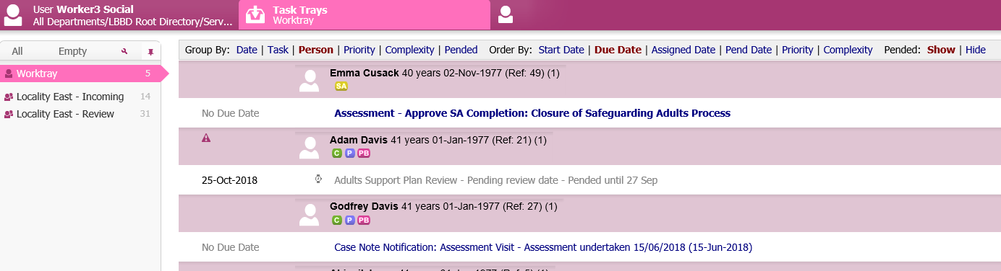
- Assessment – Approve SA Completion: Closure of safeguarding Adults process. As highlighted above.
The Safeguarding closure form will be displayed. As shown below.
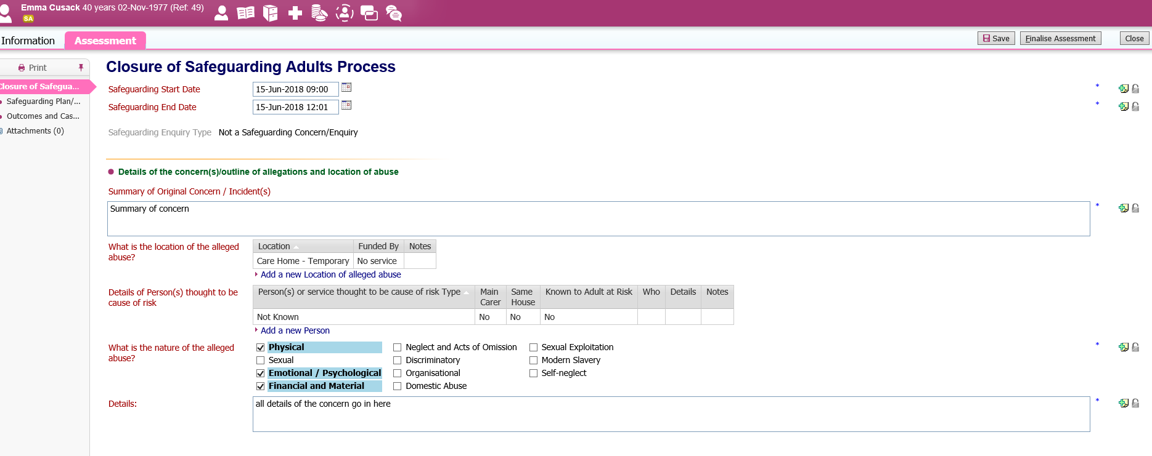
Navigate through and review form. (Managers can make changes if required)
- Finalise Assessment. As highlighted above
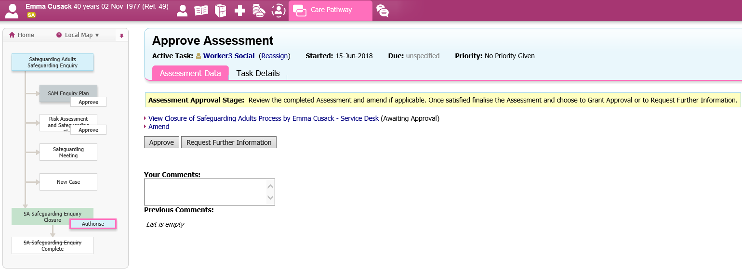
- Approve. As highlighted above

Once the Authorising Manager has authorised the Safeguarding Closure Assessment, a task will be sent to the Safeguarding Co-ordinator for the worker to complete the Enquiry.
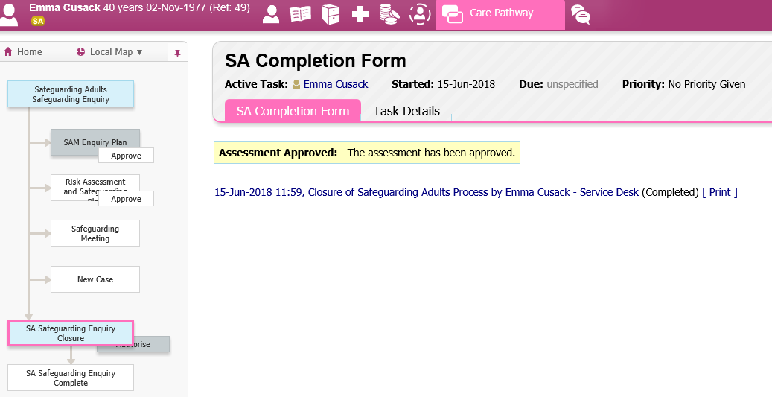

Completing the Safeguarding Enquiry (Safeguarding Enquiry Co-ordinator)
Navigate to the worktray. As shown below
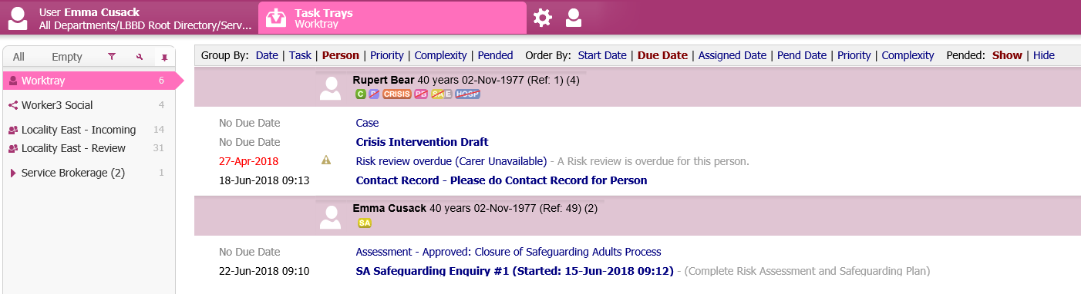
- Assessment Approved Closure of safeguarding Adults Process. As highlighted above
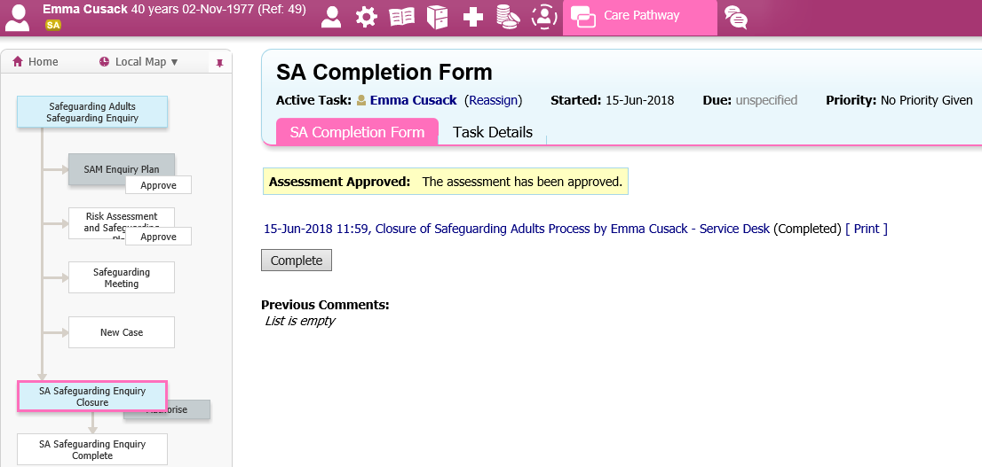
- Complete. As highlighted above

