“Consent to Information Sharing”

This process map must be read in conjunction with the “Confidentiality and Consent to Sharing Information” document.

Always ask for consent to share information unless there is a compelling reason for not doing so. Information can be shared without consent if it is justified in the public interest or required by law. Do not delay disclosing information to obtain consent if that might put a person at risk of significant harm.

Adult Social Care Process for Consent to Information Sharing

HSCD - The consent to information sharing is embedded within the Contact/Referral within Protocol as part of their screening process.

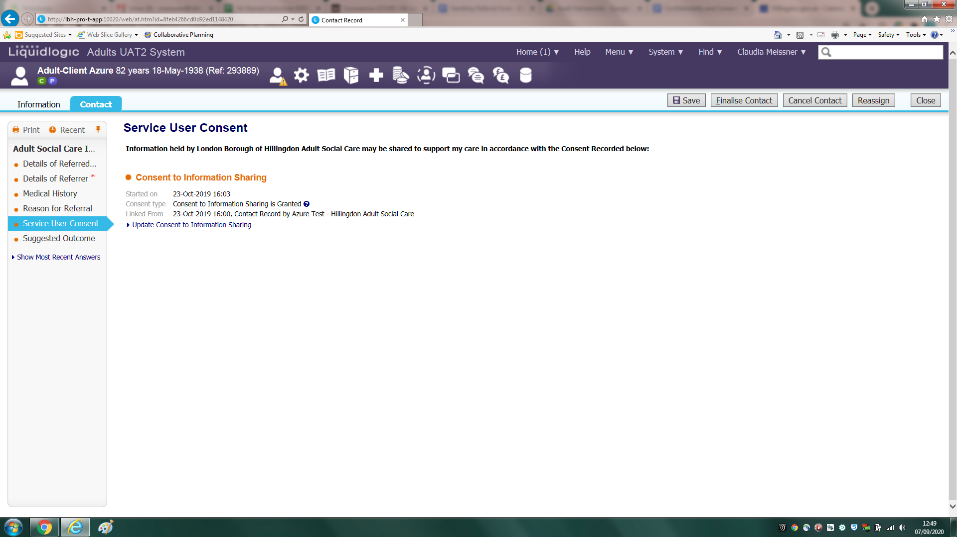
⇩
Contact/Referral passed on to relevant team
⇩
Print off the “GDPR Service User Consent Form” and take with you to visits (or when conversations/assessments are not taking place face to face ensure the form was sent electronically or via post. This needs to be recorded on case notes)
⇩
Explain why we need to gather and sometimes share information. Ask the adult to sign the form. It is important for written consent to be provided and this needs to be clearly recorded.

If the person lacks the mental capacity to make a decision about sharing information with key people, then the Mental Capacity Act should be followed to ensure each decision to share information is in the person’s best interests. Decisions and reasoning should always be recorded.
⇩
Update "Consent to Information Sharing" on main demographics (LAS Protocol) using below template
“I met with [name of service user/legal representative] at [place] on [date] and provided them with the service user consent form. I explained why we need to gather and sometimes share information.

[name of service user/legal representative] provided verbal consent for their information to be shared.

[name of service user/legal representative] signed the “GDPR Service User Consent form”, which has been uploaded onto Civica.”

or

“I met with [name of service user] at [place] on [date] to provide them with the service user consent form. I explained why we need to gather and sometimes share information.

[name of service user] lacks capacity to consent for their information to be shared and there is no legal representative. In line with the Mental Capacity Act guidance, I consulted with [name] who is [name of service user]’s [son, daughter, friend, advocate].

Following the Best Interests process, I established that it is in [name of service user]’s best interest for their information to be shared. The “GDPR Service User Consent form” has been completed and uploaded onto Civica.”

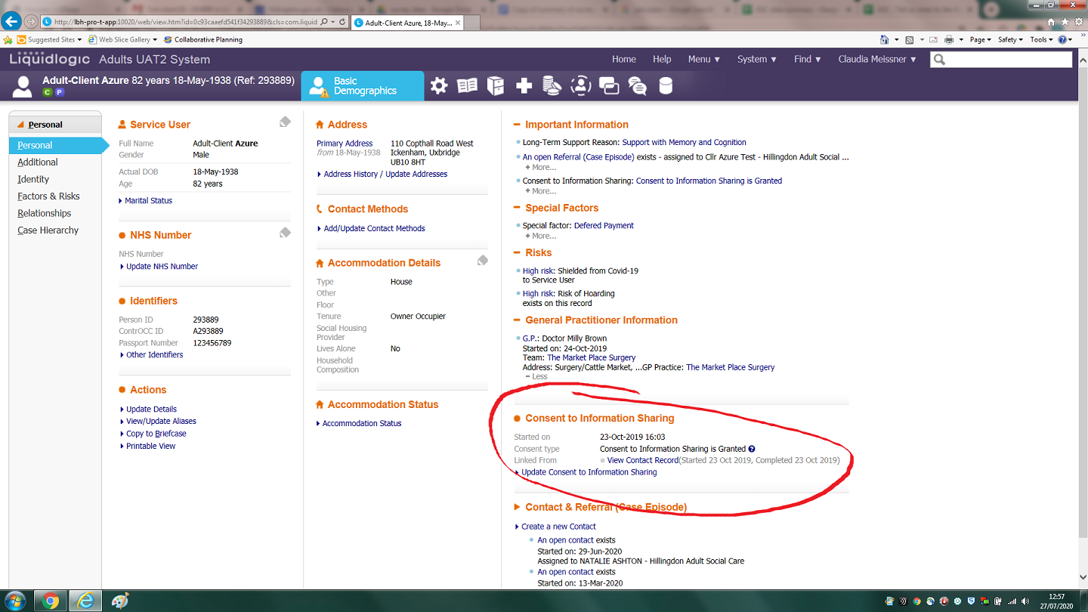
⇩
upload signed consent form to Civica under "ASC - Consent to Share"
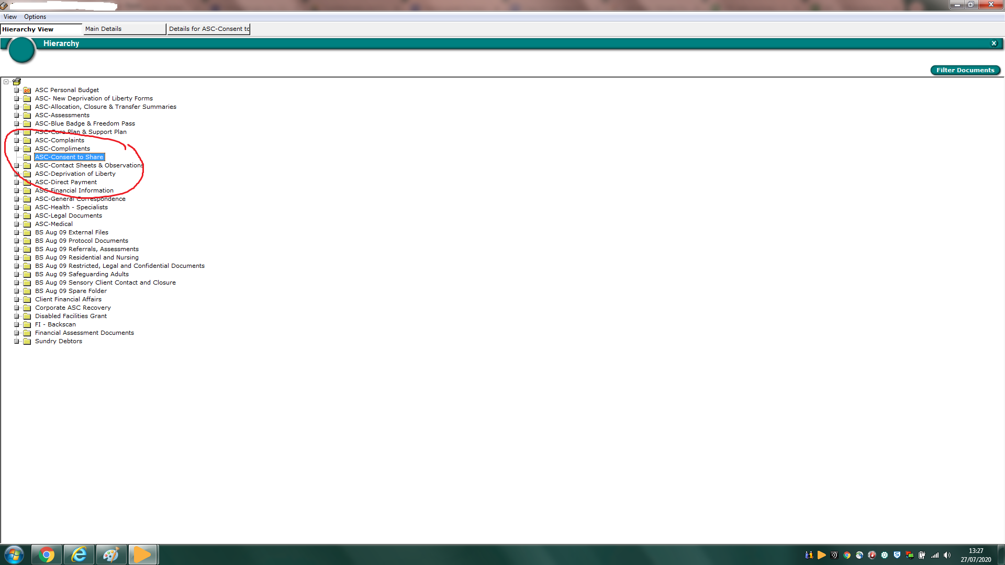
⇩
add case note “GDPR Service User Consent Form uploaded into Civica”

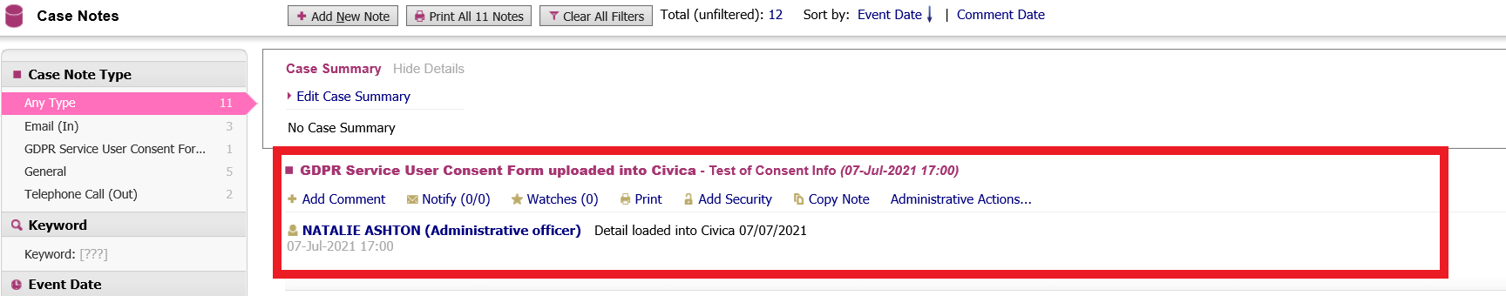

⇩
Only progress the assessment if consent to share information has been obtained, as care and support services will most likely not be possible to be provided without.
If consent couldn’t be obtained, please do not close the case but speak to your manager. Please see the “Confidentiality and Consent to Sharing Information” document for further information.
⇩
Following completion of the assessment:
Send out a copy of the assessment using the Civica “assessment letter” or “assessment letter – no capacity” template. Add case note on Protocol.
When reassigning the support plan to the Brokerage Team, add a note advising about Consent to Information Sharing has been granted.
Brokerage Team to only accept tasks where the above note has been added but also to check main demographics on Protocol “Consent to Information Sharing”. No support plan to be shared with providers unless Consent to Share Information has been obtained in writing and this is clearly recorded on Protocol.
If consent is not recorded, the Broker must go back to the worker.
⇩
Following completion of the support plan:
Send out copy of the support plan to the service user using the Civica “support plan letter” or “support plan letter – no capacity” template. Add case note on Protocol.
⇩
Following completion of the review:
Send out copy of the review to the service user using the Civica “review letter” or “review letter – no capacity” template. Add case note on Protocol.

⇩
Quality Assurance
The Business Performance Team will run a monthly “consent to information sharing v3 FOR ASC SERVICE” report. Team managers should use this report at their monthly team meetings to ensure compliance and to identify any learning needs or required changes to the process.

