Virtual Family Time Practice Guidance

Derbyshire’s children are receiving bespoke services in respect of their family time during COVID-19. This guidance is designed to support practitioners in delivering the service whilst adhering to government COVID19 guidance; to prevent transmission of the disease to children parents, foster carers and social care staff.
On all cases pre COVID-19: meaning the care plan does not take into account the current Government restrictions

- A discussion will take place with parents and children to involve them in decisions where contact is required to take place in a differing manner to that which has been detailed in their pre COVID-19 care plan. Consideration will be given to possible opportunities for face to face contact and where this is not deemed possible alternative virtual arrangements for family time will be facilitated.

- If the parent cannot be contacted, then a letter will need to be sent however direct conversation should be facilitated as soon as possible.

- Families could have a blended offer of virtual and face to face Family Time sessions. This will be set out in an agreement plan with all parties involved.

- The worker facilitating the virtual family time should encourage the parent to remain on the call at the end of family time in order to provide support and discuss how the session has gone. Conversation should include any difficulties and how this could be resolved for the next session.

- If parent does not remain on the call then the worker facilitating virtual family time, should make contact asap to have that conversation

- Foster carers will also be contacted at the end of each session to review the feedback from carers and the child. Any adjustments needed to accommodate the child’s welfare in virtual family time will be addressed.

- There will be reviews of the COVID-19 family time arrangements in order to consider any changes that may be required. The reviews will involve children, parents and carers. The Foster Care supervising social worker should also be updated on the arrangements, to ensure foster carers can effectively support family time arrangements. This will take place as a minimum within 20 working days.

- Parents may make the decision at any time to challenge the arrangements proposed and in such cases legal advice will be sought and it is likely that an application to court may be required. If this is the case the PAFT worker/CCW should alert the SW immediately and also escalate to the Social Care team manager.

- All discussions with parents, children and carers will be clearly recorded and the decision making evidenced on the child’s file. This will make reference to the reason for the changes (COVID 19), options discussed and responses. Parents/carers will be informed this will be kept under review. Consideration for other family members or pets, who have an established and meaningful relationship with the child; could be included in the virtual family time session, if appropriate. This will all be considered on a case by case basis.

- The IRO service will have oversight of the family time arrangements and are positioned to offer challenge should they feel the arrangements are not in the best interests of the child. They are also well placed to oversee the consistency and application of the family time guidance and decision making across the localities.

- The Virtual Family Time Agreement (see appendix 2) will be completed and signed by the parent/s, foster carer/s and the social care worker.

Any new cases going to court will address the COVID 19 restrictions in the child’s care plan.

Derbyshire ICT have provided guidance on the safe use of Skype conference calls to facilitate Virtual Family Time and guidance is available in Appendix 3.

Supporting families to engage effectively on Virtual Family Time sessions.

Tips to give parents when chatting with their children in virtual family time:

1. Prompt parents to look at the camera – it is tempting keep your eyes on your own picture, or the images on the screen – but you really make eye contact when you look at the camera and that is better for interactive communication.
2. Parents may keep very young children engaged by playing ‘peek a boo’ – covering their face and then removing hands – and then sometimes when their face reappears – they could surprise the child by showing a book, or toy, or something else that they want to talk about.
3. Prompt parents to use familiar greetings they would say in face to face family time sessions. Using familiar phrases and in the same tone of voice when chatting with infants and toddlers helps them to learn. It also helps them to recognize and feel comfortable with a real person on the screen when they hear that same sound each time they see the person. This is important because they often depend more on smell and touch when meeting a person – so they need more visual and sound cues to recognize family members on video chat.
4. Encourage parents to use gestures. Be close to the camera – but not so close that the child can’t see their hands. Not to be just be a talking head.
5. During a call the messaging button can be used to send prompts to parents and offer support if they are struggling with emotions during the Skype call.

Preparation pre the Virtual Family Time Session

- Some parents may want to practice with you prior to their first session starting, offer time to do this so parents are confident before the child is online with them.
- Ensure all parties are confident with the technology and are able to use Skype. The PAFT worker may need to have some trial runs with parents and carers. (see Skype guidance Appendix 3)
- Foster carers will be supported by the Foster Care team, to set up for Skype. (Foster Care skype technical advice is available from Claire.robinson2@derbyshire.gov.uk and Jayne.bacon@derbyshire.gov.uk )
- Advise all parties that sometimes the quality of the broadband may dip and the call quality can be impacted. It is important to manage everyone’s expectations to avoid unnecessary frustration.
- To maximise the broadband capacity for the call advise parents and foster carers to switch off other devices in the house e.g. online music streaming, Alexa devices or others browsing the internet etc. This will reduce broadband traffic and help to improve the Skype call.
- If the PAFT worker is frozen out of the Skype call, Foster carers and parents should end the Family Time session, until the worker is able to re-join or re-sets the meeting.
- Sometimes on virtual sessions children can get exuberant, perform to the camera and struggle to regulate their behaviours. Foster carers can mute the call whilst they deal with the child’s behaviour. Sometimes it might also be beneficial for a parent to observe how to manage appropriately their child’s behaviour, how parenting techniques can de-escalate conflict. The PAFT worker and foster carer may want to discuss how to manage these situations prior to the virtual session. This will also rely on understanding the level of anonymity needed in each case.

See Appendix 1 for additional tips.

Virtual Family Time Session Interactive Ideas

- Plan in advance with the parent and carer what activities can take place and ensure they are age appropriate.
- Pretend to share snacks. People on both sides of the screen have the same snack and the adults can pretend to hand it off - camera to camera. A tea party is a great idea.
- Play music and sing – People on both ends of the camera can hear songs and sing or dance together, and join in with instruments.
- Read a book together. The child may even follow along if they have a copy of the book at home.
- Draw pictures together, the child may choose a topic and you could both draw a picture and show it to each other.
- Drawing guessing games. The camera could focus towards a blank piece of paper and one person could begin to draw whilst the other guesses.
- Teach something or learn a new skill. Baking together, even something as simple as rice crispy cakes and eating one together at the end. The child could teach the parent a dance routine they know.
- Write a story together, each person takes it in turns to write a sentence, see how wacky and funny they can make it.
- Make hand puppets and put on a show together.
- Show and tell. The child could choose an item or object that they would like to tell you all about and why it’s special to them.

Review Family Time with parents

The Virtual Family Time session will end when the child is unable to remain engaged in the session. The child’s attention will vary depending on age, cognitive skills, previous relationship with parent and their emotional status.
It is important to end the sessions positively and avoid distress for the child. Once the child is off line, the practitioner should have a debrief conversation with the parent, reflecting on the session and ideas to plan for the next session.
- How do you feel the session went?
- Is there anything you would like to change in the Virtual Family time Session?
- Do you want to prepare or record a video for your child, so they can gain confidence seeing you in videos e.g. bedtime story, nursery rhyme etc.
- Have you ideas of activities for the next session?
- Can I help you to prepare for next time?

The virtual family time call can be complimented with additional story line photos or short video clips of the child’s day. Any recorded bedtime stories from the parent could be played to the child and this could be filmed for the parent to see.
For new born the sense of scent is also key and arrangements to exchange soft toys or cloths with mothers & babies scents could be arranged.

Appendix 1: Prompts for voice or video calls
Younger Children
Video & Voice calls
Sing nursery rhymes
Read to them- Show pictures
Colour together
Dancing to music and nursery rhymes
School Aged Children
Video & Voice calls
Create a scrapbook together, read from it and show during calls- work on it between calls
Setting tasks for the next call e.g. draw a rainbow
Read to children
Ask children to read to you
Give a scramble of letters- ask them to create words from the letters during the call or between calls
Children’s bingo – children write X amount of numbers from 1-50 etc. Parents say numbers – Parents could bring treat to next FT for winner if more than one child
Child friendly jokes e.g. Knock, Knock who’s there…
Show & tell – Some homework, arts & crafts
Create a child friendly quiz – Logos, Music, children’s programme characters
Spelling test if children are set spellings for homework
Play Hangman
Play Pictionary
Play Charades
Play name that tune- Humming
Write a story together- add different bits on each call
Creating memory boxes- add to each week
Dancing and singing to music together
Play Simon Says
Topics of conversation
Rainbows in windows
School work
If child has a hobby- ask about it

Appendix 2

DERBYSHIRE COUNTY COUNCIL
INFORMATION FOR FAMILY TIME DURING THE COVID-19 PANDEMIC

This document outlines important information to ensure that your family time is as enjoyable as possible during this period of social isolation due to Covid-19 pandemic.
During this period we are looking at using alternative methods of communication to support continued family time between parents/carers and their child/children.
This arrangement will be under constant review as governmental guidance is updated and also in line with the individual needs of your family.
All agreements that were in place prior to these alternative arrangements will remain in place, however will be adapted to fit the needs of non-contact family time.
As agreed please call ……. before …. to confirm your attendance at family time.
If it was agreed that you would attend a centre prior to family time taking place to make observations of your presentation, the allocated worker will make arrangements to call or video you prior to the call or video for the same purposes.
The lead worker will initiate the call or video for the family time, you must not do this yourselves. There are still the same expectations regarding punctuality. The worker shall attempt to call you only 2 times over a 5 minute period. Should there be no answer the session will be ended. This is to minimise any anxiety or distress for your child/children. If you are experiencing difficulties with the video, please call the lead worker so they are aware and support can be offered.
Due to this being an alternative arrangement to physical sessions we are aware that the structure of your family time will be different and therefore calls will be in place for approximately ……… minutes at a time, ……… times a week, at ………..(time) on ………….(days of the week).
If your Family time is being supervised you will have a worker/Family Support Worker/Social Worker present at all times during Family Time contact, whether this be on a voice or video call. This person will be observing Family Time to ensure the wellbeing of the child/children.
We will continue to write a record of Family Time which is shared with your social worker. We will ask you to read and sign the log and added any comments once the period of isolation is no longer in place.
As parents/ carers it is your responsibility to ensure that when taking part in a call you are in an appropriate environment to hold the call, with minimal disruptions and nothing or no one that would be classed as unsafe or inappropriate. If something is deemed inappropriate or unsafe by the supervising worker the call will be ended.
During video calls the video device should stay in one place. Parents/carers are not allowed to move the camera around their home or wherever the call is taking place. As in usual arrangements there should be no talk about home and pets should not feature during the call, as this can be emotional for children.

Workers can stop contact at any time at their discretion if –

- The child requests it (if old enough to say)
- If the child/children become distressed in any way.
- If the supervising worker is threatened or receives abuse of any form.
- If it is in the best interest of the child/children to do so.
- You are not permitted under any circumstances to record the video call, if you do so the call will be ended.

It is not permitted for any screen shots or recordings to take place during the calls. If this is found to be the case the call will be ended. No communication, photos or videos should be shared or streamed on social media.
Additional family members attending needs to be agreed in advance with your Social Worker. If during a call or video someone else is present and this has not already been agreed, they will be asked to leave and the call/video may be ended if this is not adhered to.
Our centres have a no smoking policy and it is still expected that this is to be adhered to during Family Time calls or video.
We have a mobile phone policy stating mobile phones should be switched off during Family Time/assessment. If you are waiting for an important call or need to use it in an emergency during your contact please inform the worker supervising you.

Signed………………………………… Date…………………………

Signed…………………………………. Date…………………………

Signed…………………………………. Date…………………………

‘Please note if it is difficult to get signatures during lockdown please log Full name, time, date & method of consent, you could arrange to video record the consent if necessary. Send a completed copy of the agreement to all appropriate parties.’

Appendix 3:

How to Set up a Skype meeting with External Participants
(Includes specific advice for Family Time Contacts or supervised contacts by video call using Skype)

There may be times when you want to hold a Skype video or audio call with external participants to Derbyshire County Council. For example when setting up Family Time Contact Meetings. It is certainly true that Skype Meetings work better where all those in the meeting are using Windows devices. However this is not always possible. This document will help identify ways to work a mixture of Windows, Android and Apple devices. It also highlights how to protect the identity and contact details of those involved where relevant. Pay special attention to the points marked .

How to set up a Skype meeting
- Launch Outlook

- Click on Calendar in the bottom left of Outlook

- Select New Skype Meeting located in the top ribbon

If you get a pop-up saying Skype for Business Not Running, answer OK
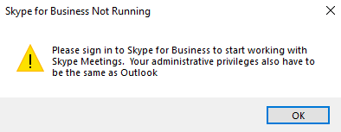
Skype has to be open for this to work. Return to page 1 to open Skype and check your personal settings.

Add participants to the meeting

You can invite anyone to a Skype meeting, including external participants as long as they have an email. Check you have a valid, up to date address for each recipient.

- Click on the Required or the To button (depending upon your view in Outlook) in the blank meeting, which will launch the global address list. Select any internal participants from the address book

- And/Or Manually enter the email address of external participants. Separate manually added participants with a semi colon:
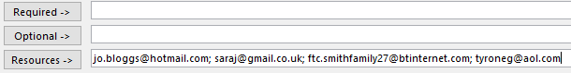

Use the Resources line to add all participants where you do not want the email address to be shared with other participants. This means that this detail will not show to other participants within the appointment and will not be shown in the meeting.

It works like the email ‘bcc’ option.

Required – These will show as invited in the email and will go to all participants
Optional – Add users that aren’t necessarily required to attend. Their detail will go to all participants

Note – When you use the Resource method, you will get a pop-up which asks Do you want to update the location to [email addresses entered in here].

- To ensure the participants information stays private Select No at the pop-up

Time Date and Text

- Add the Start date/time and End date/time

Just like setting up an Outlook meeting you can:

- Set a Reminder time at the top of the screen

- Add text about the meeting above the Join Skype Meeting text
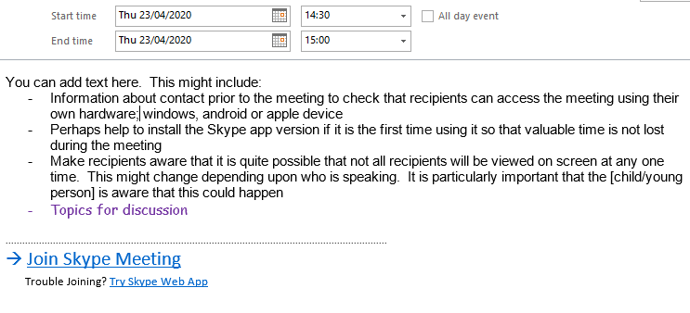

Remember text will be viewed by ALL participants

- If you wish to format your text, use the tools on the Format tab

- Finally click Send to send the invitation to the participants

Prior to the Meeting

It is suggested that as the meeting organiser you contact any or all of the participants separately: -

- Check that they have a device on which to access the meeting.
- Check that they have got the invitation, that it has not fallen into their spam/junk
- If it is the first time they have used Skype then help them get the app ahead of the meeting so that valuable meeting time is maximised. See section Participants – First Time Use of Skype (p6)
How to help participants get the App if they have never been through the process before
- Manage expectations of use e.g. it may be that the child/young person may not have video sight of a recipient all the time, though this can be kept to a minimum

Ask if other householders could refrain from using the internet during the meeting where practicable if the internet is slow in their household

Joining the Skype Meeting – Derbyshire County Council Meeting Organiser

As the organiser of a Skype meeting, the meeting will show in your Outlook calendar. Once you join the meeting it is your responsibility to admit the other participants to the meeting.

- Open the appointment and click on the Join Skype Meeting link.

- When you have clicked on the link, you will get a pop up – select Use Skype for Business followed by OK.
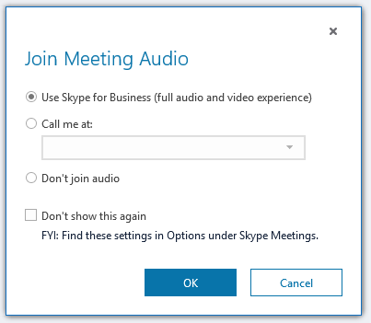

The meeting will then launch in Skype for Business.

When the organiser joins the meeting, their microphone will be enabled automatically

It is the role of the organiser to admit (or reject) participants into the meeting. Each time a participant attempts to join a Skype meeting they will be placed in a Lobby area. The organiser will receive a pop-up message asking if the organiser will admit the participant into the meeting. Alternatively, the organiser can view participants that are waiting to join the meeting in the lobby.

- If you chose to See Lobby you will see a list of participants waiting to be admitted into the meeting.

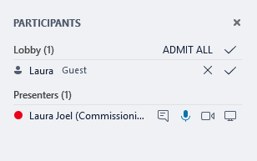

- In lobby view, the organiser also has the option to admit or decline all waiting participants

Use of the Mute button

This is for Meetings that include external participants who are using Android or Apple devices

For users of Android or Apple devices, Skype will only show two video feeds at any one time. This means that the external participant will see themselves plus the latest person to speak in the call.

In order that participants get the most out of the meeting, it is suggested that the organiser mutes their microphone when the meeting has started.
- To do this, click the microphone button on the Skype app to mute your microphone.

This advice is relevant for example when you want video feeds from foster carer and birth family devices to be displayed simultaneously during a Family Time Contact session. The supervising worker, who is the organiser and who will be using a Windows device, will still be able to hear the conversation and see all the participants.

Should the supervising worker unmute their Windows device Skype app to join in the conversation, the foster carer device will lose the video feed of the birth family device and the birth family device will lose the foster carer device video feed; the audio feed is not affected.

To restore the simultaneous video feed between the foster carer and the birth family all the worker has to do is to mute their microphone again and the video feed will be restored when the other participants begin speaking.

Organiser Participant Actions

- When the meeting has opened, as the organiser you can click on Participant Actions

You can decide what actions are allowed within the meeting you have arranged:

Mute audience Disable the microphones for all participants except the organiser
No Meeting IM Disable the instant messaging function
No Attendee Video Only the organiser video will be displayed
Hide Names Hides the names for participants
Everyone an Attendee There won’t be an organiser, everyone will have attendee privileges
Invite by Email You can add other participants via an email with a link.
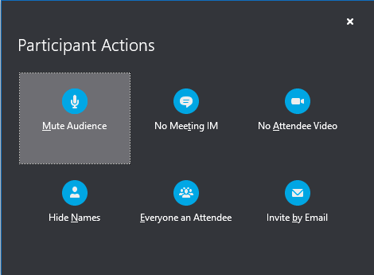

Chris Caley – August 2021
Next review due - 2024

