Together…Keeping Children Safe

Protocol between Children’s Social Care and Early Help for the transfer of children between services.

Responsible Manager: Head of Service, Early Help
Version Number: V4
Updated: August 2021
Next Review Date: August 2023

Contents
- Introduction…………………………………………..Page 3
- Key principles………………………………………..Page 3
- Responsibilities of Children’s Social Care………..Page 4
- Responsibilities of the Family Support Service….Page 4
- Step-up process……………………………………..Page 5
- Step-down process………………………………….Page 7
- Case transfer meeting Terms of Reference………Page 9
Appendices…………………………………………..Page 11

Introduction

  - This protocol details the transfer process between teams within children’s services which must adhere to the same principles and case transfer meeting (CTM) process to ensure all children are effectively supported by the most suitable service. It also sets out the process for the transition of children between Children’s Social Care (CSC) and the Family Support Service (FSS) to ensure that the support provided is family focused and at the appropriate level of need.

  - This protocol is designed to ensure the support a family receives is timely and seamless during a period of transfer between services.

  - This protocol is to be adhered to by all frontline staff and managers across CSC and FSS in respect of children transitioning across the service to best support children, young people and their families to achieve the best outcomes.

Key Principles

  - Children are safe with the process being simple, child-centred, transparent and future proofed.

  - The child's experience within the service is the central concern and on-going communication and consultation between the services in respect of individual children, young people and families must be a priority.

  - Decisions on transfers are driven by the needs of the child, young person and family, and not capacity within the team transferring the child or the destination team.

  - The threshold document is the primary tool for assessing the level of need of a child or young person and should underpin discussions and decisions at weekly transfer meetings.

  - Where there is a difference of threshold application, the child should be escalated to the relevant team managers for an overall decision as quickly as possible, whilst ensuring the needs of the children and family remain at the centre of the process. If there is still a difference of threshold application, the child should be escalated to the relevant Heads of Service. In cases of disagreement, the decision where to allocate should be made within 24 hours from the initial escalation to avoid delay.

  - Ongoing collaboration between CSC Managers and FSS Managers on consistent application of threshold levels is necessary to maintain an effective transfer mechanism and ensures the most appropriate support for children, young people and families.

  - Partner agencies should be kept informed of progress throughout the transfer process. This is critical for delivering a co-ordinated approach, and those providing support to the child, young person and family must be notified of any intention to step up or step down a child at the earliest opportunity.

  - All agencies have a responsibility to adhere to the Buckinghamshire Safeguarding Partnership Information Sharing Code of Practice.

  - Adherence to the process must not be used as a barrier to the timely movement of children and young people across services, and the need to provide effective and appropriate support is paramount. All actions required to ensure the transfer is effective must be completed within 72 hours of the CTM at which the transfer is confirmed.

Responsibilities of Children’s Social Care
  - Buckinghamshire Council’s Children’s Services is committed to providing services/interventions to prevent the most vulnerable children and families in the community from experiencing difficulties and suffering significant harm.

  - One standard form, the Multi Agency Referral Form (MARF) is used to refer children and families to either the FSS or CSC services (level 3 and 4 of the threshold document).
3.3 Multi-Agency Safeguarding Hub (MASH): receives the MARF for children in need of support at levels 3 and 4 of the threshold document. MARF’s which are triaged by Contact and Referral Officers (CARO)and meet level 3 criteria will be progressed to the Early Help Liaison Officer based in MASH within a maximum of 24 hours. Contacts and referrals assessed at level 1 or 2 of the threshold document will be signposted to a partner agency (e.g. Buckinghamshire Family Information Service https://www.bucksfamilyinfo.org or directed back to the referrer as appropriate. Where it is not possible for a referrer to complete a MARF (e.g. self-referral), all relevant information is passed to the Early Help Liaison Officers.
3.4 Children’s Social Care Teams: MARF’s meeting Level 4 criteria will be recorded as a contact on LCS Liquid Logic by the Contact and Referral Officer (CARO) in the MASH and progressed to the appropriate Children's Social Care Team. The most appropriate Social Care team will support the family until needs have been reduced to the level of no longer requiring statutory social care intervention. At this point, transition to FSS and universal services can be considered and planned.

Responsibilities of FSS

  - Family Support Service provides support as soon as problems emerge, at any point in the child’s life, focussing on supporting and enabling activity which will significantly improve the outcomes for the child and their family, and which prevents an escalation of risk. In addition, FSS supports children when they are stepped down from statutory support, where a specific plan is considered the best way to transition the child towards independence.

4.2 Early Help Liaison Officers: (located in the MASH): MARF’s triaged and meeting threshold level 3 criteria will be progressed to the Early Help Liaison Officers within 24 hours of receiving the contact in MASH. The Liaison Officer or a Business Support Officer will create a contact on the Early Help Module (EHM). The EHLO determines the appropriate lead agency for the child. Where this is believed to be an external partner agency the EHLO engages with that service to gain their agreement and will forward the referral to them, with relevant background information. FSS led cases are sent directly to the locality area work tray for allocation. Wherever possible, this will be completed within 72 hours from receipt of the contact in MASH.
4.3 Early Help Lead Agency: The lead agency, determined by the EHLO, will deliver and coordinate services to support the family and develop a support plan in line with their agency timescales. Best practice requires individual agency assessments to be completed within one month of allocation. The lead agency should review the plan at one month, three months and six months or closure.

4.4 Team Around the Family (TAF): Where families no longer require statutory intervention but will need ongoing targeted support and FSS are the lead service, they will be responsible for drawing together key agencies to best support the family, creating a Team Around the Family (TAF) to ensure the views of the family are heard and influence the development of their support plan. Early help partners are expected to ensure appropriate attendance at TAF meetings.

Step Up Process

5.1 Stepping up is the transition of a child(ren’s) support from non-statutory services including
FSS to statutory social care, to best meet the increased level of risk and need.
In any case where the FSS worker has concerns about safeguarding and risk, this must be discussed with their line manager. Following this discussion, where a child being supported by FSS may require escalation a discussion with First Response or the appropriate social care team manager (TM)/ assistant team manager (ATM) must be held to agree next steps, including consideration of escalation. All discussions including management oversight and direction must be appropriately recorded on EHM.

5.2 Where a child is open to FSS and risks are considered to have escalated to level 4 on the threshold document, a discussion with the family around the escalation should take place led by the current named worker

5.4 Where the child has been stepped-down to FSS within the previous 3 months, if following discussions between relevant professionals, L4 is agreed, they should transfer back to the last CSC team who held the case. This process can be agreed through discussion between ATM/TM’s of the teams involved but will not be confirmed until transition is finalised at the relevant Case Transfer Meeting (CTM).

5.5 Where a child/family has been supported by FSS without previous social care intervention, threshold discussions must be held between the FSS and social care TM/ATM. Where Level 4 is reached a provisional agreement to transfer can be made, however the child/family must be reviewed at the CTM where a timely transfer will be agreed. The clear rationale, transfer date and destination team will be recorded on EHM.

5.6 In the event of immediate safeguarding concerns, the FSS practitioner should speak to their line manager and MASH to discuss their concerns and follow their direction in respect of next steps, which may include submitting a MARF to MASH. The detailed process is set out below.

The step-up process is described in the flow-chart below.

Step-down Process

6.1 Stepping down is the progression of children from statutory social care to non-statutory
services, to support sustained improvements, build family resilience, and reduce future reliance on statutory services. For EH and universal services to work with the family, consent is required from the family. For more information about universal and voluntary and community sector (VCS) provided services available, please see Buckinghamshire Family Information Service at https://www.bucksfamilyinfo.org

6.2 Step downs from social care to the FSS should always be managed through the relevant locality Case Transfer Meeting.

6.3 Discussions between SC and FSS team managers/ATM’s should take place well in advance of the proposed transition date.

6.4 Where a step-down is considered to be the most appropriate progression for a child/family, this should be discussed between services and include consideration of the purpose of the FSS involvement, goals for the child/family to work towards and a timescale for the proposed support. (Typically, FSS work with families for a maximum of 6 months).

6.5 When a transition plan is agreed, a joint visit between the social worker and family support worker and the family should be arranged, to support smooth transition and continued engagement of the family.

6.6 When this meeting has taken place and the family have agreed to work with FSS, the child’s transition should be scheduled for finalisation at the relevant CTM.

6.7 At the CTM, the case should be discussed, the rationale for the transfer must be clear and together with an outline of the work to be completed by FSS, any outstanding actions identified and the agreed date for transfer to FSS will be recorded.

6.8 In advance of transition (and LCS closure) a case summary, outline objectives and purpose of FSS support will be completed and sent to FSS. EHM records will begin from the agreed transition date.

If there are any issues that cannot be resolved by talking to the appropriate manager, please escalate through your Head of Service or if unavailable, the Service Director within 24 hours for direction.

6.9 Following a joint visit or meeting to introduce the family to the potential destination service and obtain consent, the transfer meeting template must be completed and provided to the relevant Business Support Officer by the Friday prior to the transfer meeting. Those that do not meet this deadline will be delayed until the following transfer meeting and remain allocated to the sending team. If you are unable to meet the deadline, but a CIN review meeting is planned for the following week, notice should be given to the Business Support Officer to ensure the transfer is discussed at the upcoming transfer meeting.

The process for step-down is detailed fully in the following flow-chart.

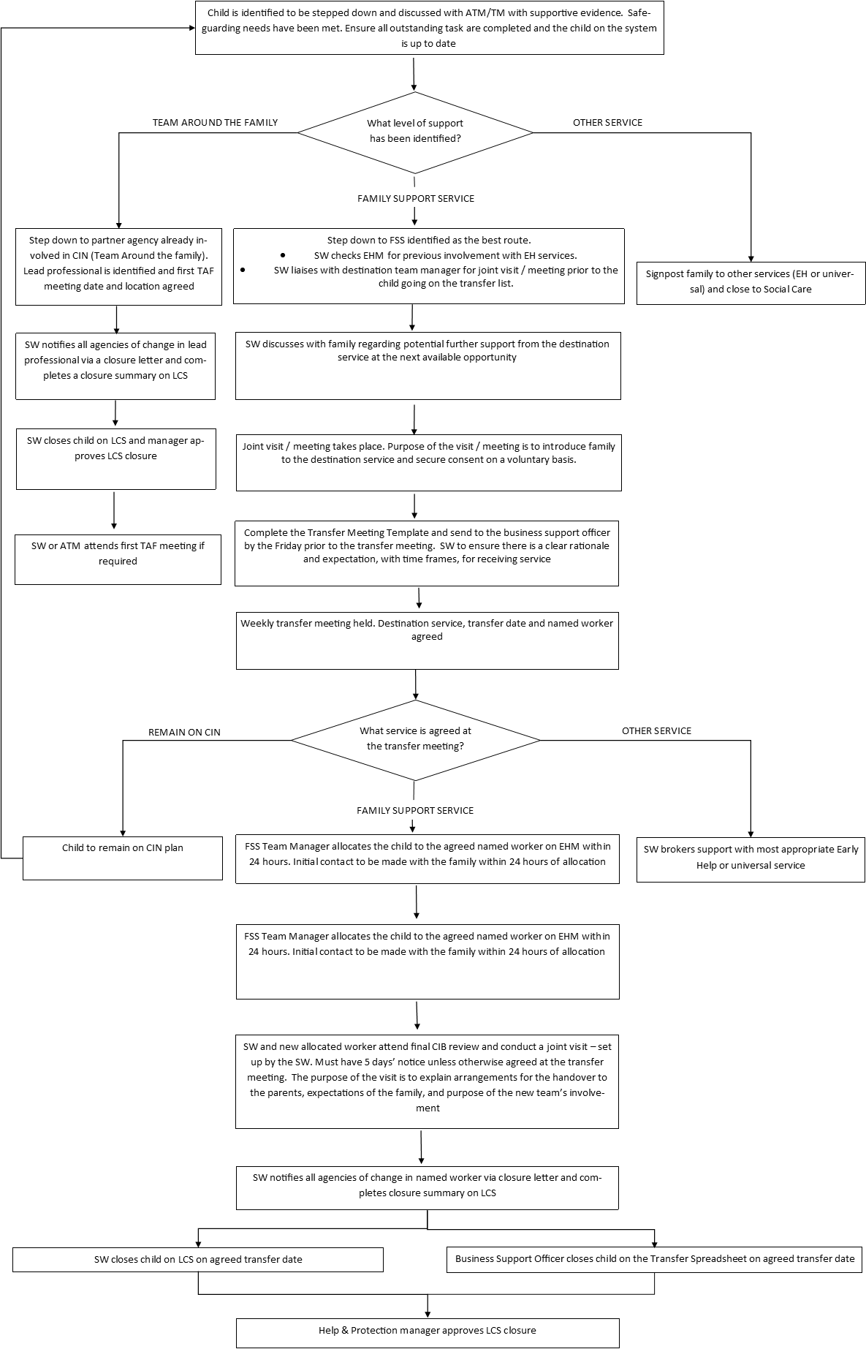

7. Case Transfer Meeting - Terms of Reference

7.1 The purpose of the Case Transfer Meeting (CTM) is to confirm the transfer of the child/children to an alternative team and to ensure there is an opportunity for receiving team to clarify any key issues.
It is deemed good practice to ensure that discussions take place prior to this meeting to ensure any communication to families about changes to team and professionals is clear and with both teams in agreement. This is the forum at which transfers are confirmed.
The expectation for cases being stepped down from social care to the FSS is that the following principals are followed following initial discussion.
A clear plan and intended outcomes are included within the LCS closure report together with the rationale for the transfer to FSS and contingency to manage non-engagement or where risks escalate.
The receiving FSS team will be invited to the final CIN meeting or handover home visit prior to the transfer being confirmed at CTM.
LCS will not be closed prior to case allocation to an FSS family worker.

7.2 Pretransfer meeting

- It is the transferring team’s responsibility to ensure the check list is completed for every child to be added to the transfer list. This checklist needs to be sent to BSS along with any children to be added to the transfer agenda.

- Cases to be transferred will need to be submitted to BSS by 1pm on a Friday – no further cases will be added to agenda after 1pm.

If there is any reason a case does need to be added on, this will only occur with agreement from HOS in consultation with Assistant Director for QA – BSS must escalate if they continue to receive cases post 1pm. They have the mandate to say no unless there is agreement from HOS and AD for QA.

- BSS will collate children to transfer into the one agenda

- This agenda (with the checklists embedded within the agenda) will be shared with all TM’s of receiving and sending teams along with Assistant Director for Quality, Standards and Performance. This will be done by COP Friday.

- A selection of these cases that are on the agenda deemed ready to be transferred by sending team will be QA’d using the checklist and reviewing LCS by a nominated person from the QA team.

- These LCS numbers that will be qa’d will be shared with the chair of the meeting so they can choose to review the remaining cases themselves and satisfy themselves that they are of a good standard. For those that are of a good standard can be transferred the following Tuesday, for those that require further work a week will be provided to the transferring team to improve the quality of what was received and the child will be expected to be transferred the week after.

- Children which go from FSS to Assessment following initial discussions between ATM’s, these can still be transferred on the 1st Tuesday.

- Once the checks are made the agenda will be sent back to BSS, Chair of meeting with a clear indication of what was requested by transferring team prior to the child moving teams. It will also note what can remain on the agenda for transfer on the Tuesday (This will be relevant for cases that are ready for transfer).

- The chair can then use the agenda with the requested actions in the meeting to ensure those actions have been taken and if not can escalate to QA

- There will be an expectation that where a childs file is not up to standard a week timescale is provided to allow for the quality to improve

- Cases that are deemed of poor quality will be addressed with TM and HOS of team that is transferring the child

- Once any actions to rectify this have taken place the transferring team can alert the chair, HOS and AD for QA that the childs file has been updated as requested

7.3 Day of CTM

- The CTM will be held every Tuesday between 1-4pm but will still be geographically split
- 1pm will be Wycombe, 2pm Amersham, 3pm Aylesbury

7.4 Chairing

- One manager will chair the meeting throughout – rota is attached
- It is the responsibility of the nominated manager to arrange cover for leave etc if they are unable to chair. If they are unable to find cover this needs to be escalated so a resolution can be sought

7.5 Transferring team will update LCS/EHM records with a case summary, rationale for transfer,
and agreed transfer date within 24 hours of the meeting taking place

Appendix 1 - Case Transfer Meetings – delegate expectations

- Attendees have a clear understanding and operational application of the Thresholds within the LA
- Discussions are child and family focussed to ensure they receive the right service and support, at the right time, with seamless transition between LA teams.
- Case Transfer meetings will be focussed with a consistent structure and approach to make swift and accurate decisions, which are outcome focussed for the child(ren)
- CTM’s will be chaired by the TM from the Assessment or Help & Protection service to ensure consistency of process, threshold application, standards and expectations
- The Chair is responsible for ensuring that the meeting is focussed on effective and efficient transfer of support for children, is focussed on positive outcomes for the child and ensuring that attendees from each team participate with a shared goal of ensuring that appropriate decisions are made in a timely manner.
- Clear information should be provided and discussed with the proposed receiving team in regards to assessed need and the work to be undertaken – so there is clarity for the child/family and the receiving team on how they will work with the child/family & what the desired outcomes are
- CTM’s will confirm the transfer date and allocated worker where appropriate, with conversations having taken place between the current and receiving team prior to the meeting, with arrangements in place for smooth transition
- Wherever practicable a planned transition including a joint visit with both workers and the family/ child should take place to hear their views, prior to any decision being sought at CTM
- It is the Team manager’s responsibility to ensure positive and effective engagement from their team in discussions of potential case transfers and at the Case Transfer Meeting.
- It is each individual team’s responsibility to prepare cases to support effective transfer and liaise with the receiving team proactively, highlighting any issues or where support/flexible approach may be required in exceptional circumstances
- An open, honest and professionally respectful relationship and communication between all workers is needed to foster collaborative practice, which ensures that children and families receive the support they need in a timely manner. This means being reflective, professionally challenging, flexible, solution focussed to resolve issues at the earliest stage, escalating promptly where needed
- Managers encourage and champion active engagement with receiving teams to promote smooth transition of support for families – where all workers are approachable and responsive
- Contingency plans with clear timescales agreed should be recorded on LCS/EHM, in the event that the family do not engage
- The BSO responsible for CTM administration will circulate the cases for discussion the Friday preceding the CTM and circulate the decision log within 24 hours of the meeting to participants
- Records of the meeting are clear and concise, recording transfer decisions, the agreed date of transfer and allocated worker
- Transfers are conducted in a planned way where there is clarity in regards to the risks and strengths and the support required for a child, with dialogue between teams prior to the CTM.
- Discussion and subsequently, the child’s record must highlight the rationale for the decision to transfer the case and the work required to support the family moving forward.
- This jointly agreed process should be followed aiming to ensure that the child and family receive the right support at the right time, telling their story only once. Practitioners must ensure this is at the core of their thinking and communication throughout case transfer and is appropriately recorded on LCS/EHM

Appendix 2 – Agenda and Minutes Template & Checklist

Appendix 3 - Attendees required (list) role and service

TM Help & Protection / Assessment on rota (Chair)
CSC BSO (Minute taker)
Nominated ATM from receiving teams
TM/ATM FSS
TM/ATM Court Team
TM/ATM CWD
TM/ATM CiC/Care Services

All attendees are responsible for identifying a deputy ATM/suitable representative to attend in their absence to ensure full representation at all meetings
In the case of planned absence the Chair, is responsible for identifying alternative TM to act as Chair, in advance of the meeting. In the unexpected absence of the chair the role should be taken by an attending TM or ATM, who will act as chair.

Appendix 4 - Information about Thresholds

https://www.buckssafeguarding.org.uk/childrenpartnership/reporting-a-concern/report-a-concern-professional/

Appendix 5 - Glossary
Case transfer meeting (CTM) | The weekly meeting held with Children’s Social Care and Family Support Service teams to discuss the best team to provide support for the child/family.
Children’s Social Care (CSC) | The teams delivering statutory support to children at Level 4.
Early Help (EH) | Early help is the identification of and response to emerging problems children, young people and their families face. It is a way of working that supports families to overcome these challenges and avoids things becoming worse and harder to resolve.
Early Help Liaison Officer (EHLO) | Located within the MASH, this role triages contacts at Level 2 or 3 and makes a decision about the support required.
Contact and Referral Officer (CARO | Located within the MASH, this role triages contacts at 3 or 4 and makes a decision about the support required.
Early Help Module (EHM) | The information management system used by the Family Support Service to record case information about families being worked with
Family Support Service (FSS) | The team delivering non-statutory early help support to children, young people and families at Levels 2 and 3.
Information sharing code of practice | The purpose of the Information Sharing Code of Practice is to outline the principles and practice which govern the sharing of information between agencies, for the purposes of safeguarding and promoting the welfare and protection of children and young people.
Liquid Logic Children’s System (LCS) | The information management system used by Children’s Social Care teams to record case information about the families being worked with.
Multi-Agency Referral Form (MARF) | The form used to report a concern about the safeguarding of a child.
Multi-Agency Safeguarding Hub (MASH) | A multi-agency team co-located to review and identify the risks posed to children, young people and vulnerable adults and to determine the appropriate level of support.
Request for Support | The form used to make a self-referral or request for support from the Family Support Service.
Threshold document | The Threshold Document assists professionals in identifying the scale of need and engagement required with children and young people.

