Supervision Policy
Children’s Social Care
Buckinghamshire Council
Date: November 2021
Review date: November 2022

Contents
1. Scope of this policy 3
2. Introduction 3
3. Working in partnership 4
4. Supervision agreement 5
5. Frequency of supervision for workers 5
6. Frequency of case supervisions 5
7. Features of effective supervision 6
8. Types of Supervision: 6
9. Coaching for Performance (C4P) 7
10. Preparation for supervision 7
11. Recording of supervision 7
12. Cancellation of supervision 8
13. Confidentiality of and access to supervision records 8
14. Management Decisions 9
15. Responsibilities 9
16. Resolution process 9
17. Quality assurance of supervision 10
18. Additional practice guidance for managers and staff 10
19. Further resources 11
Appendix 1 12
Appendix 2 15
Appendix 3 20
Appendix 4 22
Appendix 5 23

Scope of this policy
Supervision is a partnership between the supervisee, the supervisor and provides the setting to support accountable decision making and safer outcomes for children, young people and families. It can be defined as:
“A process in which one worker is given professional responsibility to work with another in order to meet certain organisational, professional and personal objectives. These objectives are competent, accountable performance, continuing professional development and personal support.” Morrison 1993, (adapted from, Harries 1987)
The purpose of this policy is to outline how supervision is to be carried out within Buckinghamshire Council’s Children’s Social Care Service and provide staff with guidance to support effective supervision and reflective practice.
This policy applies to all frontline and managerial staff, irrespective of whether staff are here temporarily or on a permanent basis. This policy also applies to social work students placed within Children's Social Care.

Introduction
At Buckinghamshire Council Children’s Services our most important asset is our staff and it is recognised that direct work with children and families can be highly rewarding as well as complex, stressful and emotionally demanding.
We have a duty of care to our workforce and good-quality supervision can support practitioners’ wellbeing and job satisfaction, will support workforce retention and will ensure children and young people are effectively supported. Supervision should:
- Ensure work with children, young people and families has impact and improves outcomes.
- Support proportionate decision-making.
- Support staff wellbeing and provide opportunities for professional development.

Supervision has a vital role to play in supporting staff and should be outcome focused, whereby the supervisor holds the supervisee to account for plans in place to support any given family, reflects and builds on good practice, and thoroughly explores and checks the supervisee’s rationale and thinking behind each plan, and the fundamental question of whether the plan is likely to achieve the desired outcome. If not, why not, and how does this affect the overall understanding of the case.
It is our aim to provide high quality supervision, which supports and motivates staff and encourages reflective practice. In addition to monitor the quality of our work and performance objectives to enhance the quality of services provided to our children and families.
This policy sets out the core expectations for supervision and provides managers and supervisors with the tools required to supervise staff effectively. Supervision is a key professional requirement enabling practitioners to achieve the best possible outcomes for the children and families they are working with. Managers, supervisors and supervisees are jointly responsible for ensuring that supervision meets the standards as outlined in this policy.
In order to ensure there is a consistent approach, the following principles should be applied for all Children's Social Care staff:
- The Supervision Policy is communicated regularly to all staff through induction, training and team meetings.
- Managers are responsible for ensuring that everyone they are responsible for has a designated Supervisor.
- All Children's Social Care staff are to receive regular personal supervision (sometimes referred as a 'one to one' supervision).
- All case holding children's social care staff are to receive, in addition to personal supervision, case supervision using the case supervision record on LCS.
- Reflective Practice Tools are to be incorporated within case supervision and within group supervision.
- Supervision will incorporate Continuing Professional Development (CPD) to ensure staff have the relevant skills, knowledge and understanding to succeed in their job role, this may include findings from audit activity and observations of practice (where applicable).
- All staff are responsible to ensure they meet the professional standards as defined within the Knowledge and Skills Statements (Department for Education).
- All staff are responsible to ensure they are familiar with and adhere to the Buckinghamshire Children’s Service Practice Standards.

Working in partnership
Effective supervision can only be fully achieved where there is a partnership between the supervisee and supervisor. This can take time to build and both parties have a shared responsibility to make the supervisory relationship work. Buckinghamshire Council’s values for the supervisory relationship can be found within the supervision agreement (See Appendix 1).
- Supervision agreement
Supervision agreements establish a set of “ground rules” that clarify the rights and the expectations on both sides in order to help create a safe, secure and effective supervisory setting. (Shulman, 2005, 2011)
All supervisors and supervisees will be expected to complete and sign a supervision agreement within the first 4 weeks of their employment. Supervision agreements should be reviewed when there is a change in supervisor or if there is a significant change in circumstances for the supervisee.
The supervisee should be emailed an electronic copy of the supervision agreement and the supervisor will be responsible for saving a record of the supervision agreement in the confidential supervision folder on the N Drive.

5. Frequency of supervision for workers
It is recognised that staff require different frequencies of supervision, depending on their role and experience.

Employee | Frequency | Additional notes
Students on placement | Weekly basis | To consider both case and academic work.
NQSW completing ASYE | First 6 weeks – 90 minutes each week  Week 7 onwards – fortnightly  Month 7 onwards – monthly | In the last 6 months of the ASYE, the supervisee and supervisor may still wish to meet more often, rather than having all their case supervisions in one session. This is at the discretion of both parties.
Social workers/alternatively qualified practitioners | At least once a calendar month | Staff may wish to meet more often, rather than having all their case supervisions in one session. This is at the discretion of both parties.
Team Managers | Once per calendar month by Head of Service
Heads of Service | Once per calendar month by Service Director

6. Frequency of case supervisions

It is important that there is regular supervision on individual children, but the frequency of these discussions should depend on the needs, risks and circumstances of the child.

The frequency of supervision, and rationale for this frequency, will be recorded clearly by the manager in each child’s file. A child should be reviewed as a minimum every 12 weeks or sooner if the child’s needs, risks and circumstances change significantly.

7. Features of effective supervision

It is important that staff to understand the key aims of a supervision. Good quality supervision should:

- Enable practitioners to ‘critically reflect on the understanding they are forming of the family, of considering their emotional response and whether this is adversely affecting their reasoning, and for making decisions about how best to help’ (Munro 2010. Paragraph 4.10).
- Ensure accountability for practice and a high-quality service for children and families.
- Promote and maintain professional standards.
- Build purposeful, professional relationships and encourage effective communication.
- Balance the need to manage risk and promote safeguarding alongside a duty to respect rights and address need.
- Understand and manage the emotional impact of social care practice.
- Share, debrief and provide additional support when dealing with distressing and stressful situations.
- Provide constructive challenge to move forward difficult and complex situations.
- Develop the knowledge, skills and values required to practice competently and work in partnership with other agencies.
- Use knowledge and experience to promote new practice approaches.
- Ensure peer and management review of professional decisions encouraging mutual learning and development.
- Allow for communication with line managers on organisational issues.
- Provide opportunity to manage workloads and caseloads and ensure tasks set are realistic.
- Review and discuss personal issues that might impact on professional roles and responsibilities.

8. Types of Supervision:

To support good quality practice and personal development, a range of supervision opportunities may be utilised. These include:

- Case supervision (group & one to one meetings): to promote discussion and decision making regarding the plans for individual children and families.
- Ad hoc/Informal case discussion: Ad Hoc/Informal discussions or decisions are likely to be needed between planned case supervision sessions on a case by case basis and may result from unexpected changes of circumstances or new incidents. Where as a result of this discussion, activity is planned or decisions made which diverts from the plan, these discussions and decisions should be recorded in LCS. It is the manager's responsibility to ensure accurate and timely recording of ad hoc/informal case discussions or decisions.
- Group supervision: to promote peer network interaction and reflective practice. Group supervision facilitates problem solving, peer support and the identification of specific tasks and actions.
- Peer group supervision: Peer Group Supervision is an effective form of leaderless peer group discussions. Team members confer with one another in relation to key topics/difficult cases etc. to facilitate the development of solutions. The participants learn better ways to manage professional challenges and offer new ideas and support.
- Personal supervision: ensures practitioners make the necessary links between their personal and professional roles and make effective decisions for children and their families. This type of supervision provides personal support and contributes to continuing professional development linking with the Council’s Coaching for Performance (C4P) programme.

Personal and case supervision is based on both the supervisee and supervisor having a clear understanding of the Knowledge and Skills Statement and its corresponding expectations.

9. Coaching for Performance (C4P)

Coaching for performance objectives should be set quarterly and discussed in personal supervision sessions to monitor performance and ensure objectives are on target to be met. Extra sessions to discuss C4P can be arranged where required.

10. Preparation for supervision
The key to successful supervision is effective preparation. Both the supervisor and supervisee should take responsibility for preparing in advance, with both parties clear about what will be discussed during the session.
Actions agreed at the last supervision should be followed up and reviewed in successive sessions.
For case supervisions, supervisees should be clear about key dates/information/tasks on their cases and consider the following:
- What is worrying me and/or others?
- This is what is working well
- This what I decided to do
- This is what I need help with today
Supervisors will be expected to prepare for case supervision by utilising LCS records and performance reports to check that workflow is being managed, and scheduled visits and other appointments are taking place. Any difficulties in completing tasks should be discussed and a plan with remedial actions developed with the supervisee.
Supervisions should be scheduled in advance and recorded in individual outlook calendars.

11. Recording of supervision
What is included in the supervision record should be detailed enough should it need to be revisited but should also be concise and clear. It is the responsibility of the supervisor to record the supervision.

Case supervisions are to be recorded on the supervision template on the individual child/young person’s LCS file within 5 working days.

Personal supervisions are to be recorded on the personal supervision template (see Appendix 2). The personal supervision notes will be emailed to the supervisee within 5 working days, and the supervisee will have 5 working days to respond to the contents. Otherwise it is assumed that it is accepted the notes are an accurate reflection of the discussion that took place and the actions agreed.

If there are disagreements content, amendments should only be made by the supervisor following a discussion with the supervisee.

12. Cancellation of supervision
In the event of cancellation by either party then it should be re-booked to take place within 5 working days of the cancellation or within 5 days of returning to work (if cancellation was due to sickness/leave).

If the supervisor is absent from work for more than 2 weeks unplanned leave/sickness, then it is the responsibility of the supervisee to report to their supervisor’s line manager for alternative supervision arrangements to be made.

13. Confidentiality of and access to supervision records
The case supervision record must be stored on the LCS supervision template for the relevant child/ young person.
The personal supervision must be stored in the relevant secure folder on the N Drive.
Whilst supervision offers a private area to discuss cases and personal circumstances the supervision records cannot be entirely confidential. Supervision records are the property of Buckinghamshire Council. There will be occasions where supervisors will need to discuss the content of supervisions [both case and personal] with others, such as their own line manager. This should always be with the knowledge of the supervisee.
Some examples of why records may need to be accessed include; quality assurance purposes, disciplinary purposes and for Ofsted inspectors.
In instances where there is an access to files request (Subject Access Request) personal supervisions would not be disclosed. However, case supervision records can be disclosed as part of a Subject Access Request. Elements of the case supervision record which relate to the social worker and the administration of their role would not need to be shared and therefore can be redacted. The information relating to the family would be shared although some information contained in the supervision record could be considered for redaction if:

- It would be likely to prejudice the carrying out of social work because of the risk of serious harm of the subject or someone else.
- In giving it could hinder the prevention or detection of a crime.
- It is legally privileged. (advice/correspondence between team and solicitors). Information in adoption records. (this would need to be dealt with by the relevant adoption team under their regulations).
- It is someone else’s information i.e. third-party information.

14. Management Decisions

Management decisions are often made outside the supervision process. These decisions should be recorded separately to the supervision record on LCS using the case note ‘management oversight’ on the child’s file. Discussions culminating in management decisions provide opportunities for learning and compliment but do not provide a substitute for more structured, one to one supervision sessions. You can find the practice standard for management oversight here.

The frequency of management decisions, and rationale for this frequency, will be recorded clearly by the manager in each child’s file.

15. Responsibilities
Managers are responsible for arranging appropriate professional supervision for all of their staff in accordance with this policy.

Employees are responsible for ensuring they have access to and use personal and professional supervision supplemented by regular discussions with their supervisor in between sessions.

16. Resolution process
If there is disagreement between Supervisor and Supervisee which cannot be resolved between the two parties, the issues should be referred to the Supervisor’s Line Manager and discussed as part of a three-way meeting.

17. Quality assurance of supervision
In order to be effective, the supervision process requires monitoring and quality assurance arrangements. The quality assurance process ensures that the expected standards of supervision, as outlined in this policy, are being followed:

- Staff are being supervised professionally and effectively
- Supervision sessions are recorded
- Supervision agreements are used and reviewed
- The supervision process promotes good practice.

The quality of case supervision will be monitored through sampling of personal and case supervisions. Observation of case management supervision may also be utilised and will be scheduled as part of planned quality assurance activity.

18. Additional practice guidance for managers and staff

These guidance notes may be used as a checklist to help you get the best out of the session as both the supervisor and supervisee.

To be a good supervisor you should:

- Plan a joint agenda (e.g. review previous supervision notes prior to the session and make a note of any items you wish to discuss).
- Clarify tasks and areas of work expected of the supervisee.
- Encourage open and honest communication.
- Hold regular sessions at agreed times and dates and be on time.
- Ensure the session is uninterrupted (unless unavoidable).
- Ensure the venue is appropriate.
- Praise work well done.
- Listen to and summarise the conversation.
- Be constructive and offer balanced feedback, focusing on positives as well as areas for improvement.
- Support staff to build on existing skills and knowledge.
- Set clear actions with clear timescales for review.
- Anticipate problems and issues and ensure the conditions are met for safe practice, creating clear safety plans where appropriate (i.e. in relation to violent service users).
- Do what you say you will do.
- Be specific in relation to the supervisee’s performance.
- Build on the supervisee’s strengths and encourage them to stretch their performance.
- Record any disagreements and the resolution.
- Use your own experience, knowledge and skills to support the supervisee. Consider who else might also be able to provide support.
- Set the supervisee’s work in the context of legislative and agency requirements signposting to relevant statute, regulations, practice standards, policies and procedures.
- Acknowledge conflict and tension openly.
- Give yourself time to seek further information or advice if you are not sure.
- Help staff reflect on their practice, e.g. what worked, what did not work, why and lessons for the future.
- Give space and permission for the supervisee to express their feelings.

To be a good supervisee you should:

- Plan a joint agenda (e.g. review previous supervision notes prior to the session and make a note of any items you wish to discuss).
- Openly discuss issues and be prepared to consider and share how you feel.
- Attend regular sessions at agreed dates and times.
- Raise problems and issues before they escalate and become serious.
- Do what you say you will do.
- Keep up to date with legislative changes, good practice, policies and procedures.
- Keep up to date with related reading around research and theory and reflect on how it applies to your practice.
- Use supervision to reflect on your understanding and application of knowledge, theory and skills and how this has an impact on the outcomes for the children, young people and families you are working with.
- Use supervision to reflect on how you promote good practice and meaningful engagement with children, young people and families.

Common barriers to the delivery of effective supervision:

- ‘Dumping’- saving up criticisms and discussing them all at once.
- Unplanned, rushed agenda and unfocused sessions.
- Inadequate preparation by either party.
- Telling rather than listening.
- Failure to offer constructive commentary.
- Misuse of power, e.g. bullying, harassment or victimisation.
- Allowing avoidable interruptions.
- Poor recording of supervision.
- Emotional issues left unaddressed.
- Case management to the exclusion of reflective discussion.

19. Further resources

https://www.ccinform.co.uk/knowledge-hubs/supervision-knowledge-and-practice-hub/

https://www.communitycare.co.uk/2016/11/22/tips-make-supervision-effective/

https://www.researchinpractice.org.uk/children/news-views/2021/january/new-open-access-resources-for-managers-of-practice-supervisors/

https://www.scie.org.uk/publications/guides/guide50/foundationsofeffectivesupervision/?gclid=EAIaIQobChMI5qz8vLDg8wIVZWHmCh2m3ABcEAMYASAAEgJhB_D_BwE

Appendix 1
Supervision Agreement
Buckinghamshire Council Supervision Agreement between:

Name of supervisee:
Name of supervisor:
Date of agreement:
Supervisee has read the supervision policy:
Supervisor has read the supervision policy:

Frequency
We agree to ensure that supervision takes place within the appropriate timescales, as set out in the supervision policy
Values
We support he values for partnership working in supervision:
The supervision partnership will: | The supervision partnership will not:
Be a confidential (subject to safety of service users and staff) | Break confidentiality
Be a continuous process of learning and development | Be a one-off event
Be a two-way process | Be one sided
Be mutually respectful | Undermine one another
Be focused | Be unprepared for, leading to verbal deluge
Be planned and in a private space | Be rushed or interrupted
Deal with situations clearly and provide clarity | Be confusing
Anticipate, acknowledge, discuss and manage the emotional impact of the work | Avoid discussing the emotional impact of the work
Recognise good performance and achievements | Avoid challenge when this is needed
Support professional development | Ignore the need for learning opportunities and career development

Preparation
We both agree to be prepared for supervision.
Supervisee:
I will come prepared for supervision, knowing key dates and will have given consideration to the cases for discussion prior to supervision using the preparation for case supervision form.
Supervisor:
I will consider LCS and performance reports and examine cases in more detail prior to supervision where it is felt it will support the supervision process.
The supervision sessions will be booked by the supervisor.

Anti-oppressive and anti-discriminatory practice
We will ensure that supervision is based on anti-oppressive and anti- discriminatory principles and should be sensitive to race, gender, disability, impairment, age, religion and sexuality.

Record keeping
We will ensure that supervisions are recorded in line with Buckinghamshire County Council’s supervision policy.

Disagreements
If we cannot agree on an item, then the disagreement will be formally recorded within supervision. We acknowledge that either party have the right to refer to the next tier of management if we have been unable to resolve the issue amongst ourselves.

Final statement
It is our responsibility to ensure that we are familiar with the policy and understand what we can expect from each other. We agree that supervision will be given and received in accordance with Buckinghamshire County Council’s Supervision Policy wherein more details regarding supervision can be located.

Signature of supervisee:

Date:

Signature of supervisor:

Date:

Appendix 2
Personal and professional supervision

Name of Supervisor:
Name of Supervisee:
Date of Supervision:
Agenda items |  | Discussion (to include actions where appropriate)
Personal discussion:

(to include anything brought to the supervisor’s attention that may impact on supervisees work)

Professional development:

(Including reading, research, training, learning and development, career progression, audit, feedback from service users and other professionals and how all these examples can influence future practice).

This section is only relevant to qualified social workers

Knowledge and skills statement for social workers

https://assets.publishing.service.gov.uk/government/uploads/system/uploads/attachment_data/file/338718/140730_Knowledge_and_skills_statement_final_version_AS_RH_Checked.pdf

Consider progress/ development against the following:

The role of child and family social work

Child development

Adult mental health, substance misuse, domestic abuse, disability and physical ill health

Abuse and neglect of children

Effective direct with children and families
Child and Family Assessment

Analysis, decision making, planning and review

The Law and the family justice system

Professional ethics

The role of supervision and research

DSP and Performance:

(Consider progress against DPS objectives, workflow, visit timeliness etc)

Annual Leave/TOIL/sickness

Team development/health and safety:

(lone working issues, resources to complete work, occupational health, etc)

Equality:

(Identifying possible discrimination in the workplace with regards to the protected characteristics. Concerns regarding lack of opportunities to progress)

Any other business

The personal and professional supervision notes will be emailed to the supervisee. When the notes are received by the supervisee there will be a period of 5 working days to respond to the contents. Otherwise it is assumed that it is accepted that this is a reflection of the supervision record.
Personal and professional supervision - Managers
Name of Supervisor:
Name of Supervisee:
Date of Supervision:
Agenda items |  | Discussion (to include actions where appropriate)
Personal discussion

(to include anything brought to the supervisor’s attention that may impact on supervisees work)

Professional development

(Including reading, research, training, learning and development, career progression, audit, feedback from service users and other professionals and how all these examples can influence future practice).

Knowledge and skills statement for leaders

https://assets.publishing.service.gov.uk/government/uploads/system/uploads/attachment_data/file/691540/Knowledge_and_skills_statement_for_practice_leaders.pdf

Consider progress/ development against the following:

Lead and govern excellent practice
Creating a context for excellent practice

Designing a system to support effective practice

Developing excellent practitioners
Support effective decision making

Quality assurance and improvement

DSP and Performance

(Consider progress against DSP objectives, individual team performance, managing staff absence)
Need to Know and Escalations

(high risk children/young people that need to be brought to the attention of senior managers)

Annual Leave/TOIL/sickness

Team development/health and safety
(lone working issues, resources to complete work, occupational health, etc)

Equality
(Identifying possible discrimination in the workplace with regards to the protected characteristics. Concerns regarding lack of opportunities to progress)

Any other business

The personal and professional supervision notes will be emailed to the supervisee. When the notes are received by the supervisee there will be a period of 5 working days to respond to the contents. Otherwise it is assumed that it is accepted that this is a reflection of the supervision record.

Appendix 3
Recording case supervision – tips for supervisors
Limit the social worker’s update
- Let the social worker know they will only have 10 minutes to update you about each case they want to discuss so need to structure their thinking to give you the most relevant information, new concerns or anything else they are a worried about.
- Resist the urge to type or ask questions – just listen. When the 10 minutes is up, you can then spend a few minutes asking clarifying questions, before moving on to discussing what is most concerning the social worker about this case or what they most need help with from you this session.
-This approach should help avoid getting trapped in lengthy discussions about where things are up to and allow more time for analysis, reflection, discussion of emotion and how theory or research may inform the work.
Ask the social worker to help create the written record of the session
-Wilkins’ research found many supervision records included considerable detail of all the activity a social worker has described. Much of this information will be elsewhere on the case management system so simply refer / signpost to this where possible.
- Then agree together what new information needs to be recorded, based not on what has already happened and been recorded (e.g. the home visit) but on the new thinking and reflection achieved together during the supervision discussion. (From tips for recording supervision – less typing, more talking)
Let the practitioner know that it is acceptable – and welcome – to talk about emotions
- Being able to talk about one’s emotions and those of others is widely considered essential for social workers. While managers will usually ask about a practitioners’ emotional wellbeing (“how are you this week?”) and social workers often use supervision to talk about feelings of frustration, it’s less common for these discussions to go much further. - - For example, if the social worker is frustrated by a parent, you might explore how this is playing a part in their assessment and decision-making. Are there times when they have been more or less frustrated with the parent? How might the parent be feeling? How might they experience the social worker’s frustration?
- If managers ‘give permission’ to talk about emotions by asking questions about how the social worker felt and/or saying how they might have felt in a similar situation, it allows for discussions that involve emotion as a more integral part of the work. (From Tips for talking about emotions in supervision)
Record the child’s views
-Children and family social workers are routinely interested in what children say and in their wishes and feelings but more often spoken about rather than their views being recorded directly.
-Try asking the social worker two simple questions in relation to each case: What does the child think about what is happening to them at the moment? What do they want to happen?
-By doing this, you can not only prompt the social worker to think about the things the child has said (or not said) and their behaviour and what this might mean, you can also ensure this is recorded and, where possible, acted upon. It would also be important to record the rationale behind any decision not to do what the child wants.
Make some records on paper, not a computer
Using paper allows you to be much more creative in terms of what and how you record. Large sheets of paper, to map out concerns within a genogram, to explore what risks are etc can be a helpful way to visualise concerns. The aim is not simply to replicate the same kind of recording in a different way but to enable supervision to lead to better thinking, feeling and reflecting, rather than creating a (duplicate) narrative record of activity.
Recording analysis
Supervision records often record what and when things should be done, with much less discussion of how and why. When recording actions, include ‘why’ as well as ‘what’. Having to record why particular actions are required may highlight the need for a more explicit consideration of why certain decisions have been made. Often, the reason for a particular action may be implicitly understood. Asking (and recording) ‘why’ should help to make your implicit reasoning more explicit.

Appendix 4
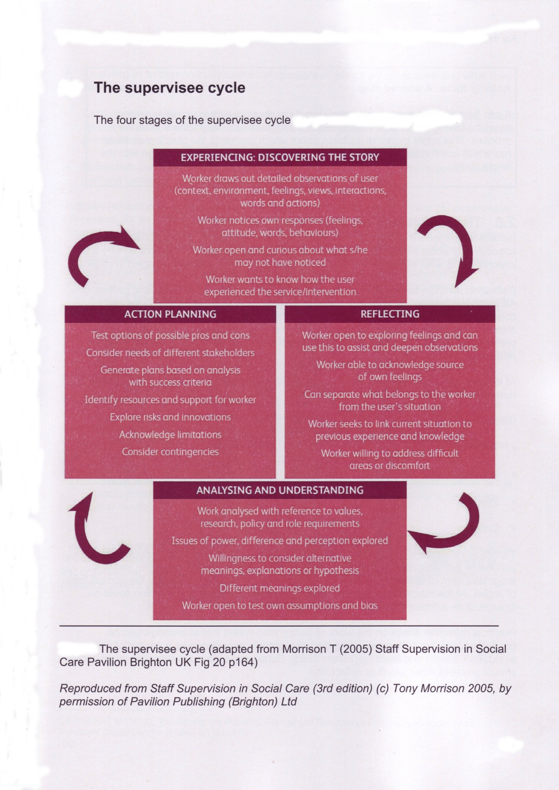

Appendix 5
Gibbs (1998) also provides a model for Reflective supervision which may be used within the service.
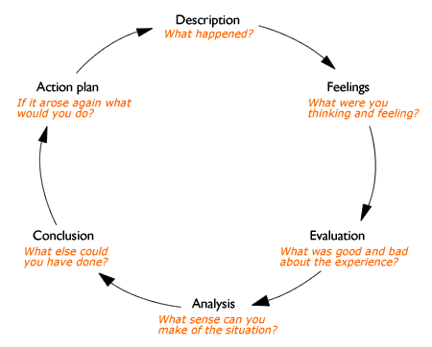
Gibbs G (1988) Learning by Doing: A guide to teaching and learning methods. Further Education Unit. Oxford Polytechnic: Oxford.

