Oversight of CIN cases via Improvement Cycle Meetings and Performance Meetings

Contents
Summary of Meetings 1
Improvement Cycle Meeting 2
Locality CIN Check-In 3
Operational Leadership Team CIN Check-In 5
Appendix 1. Minutes Template for Locality CIN Check-In 6
Appendix 2. Accessing the Improvement Cycle Meeting Document 7
Appendix 3. ICM Meeting Effectiveness Checklist 8

Summary of Meetings
Child In Need plan data is reviewed and acted upon in meetings summarised in the following diagram and detailed separately in the following pages.
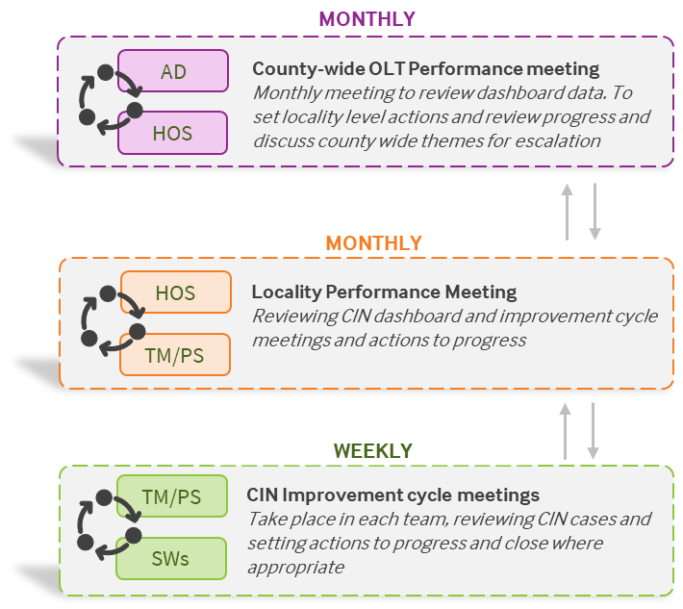

Meeting Name/Item | Improvement Cycle Meeting
Regularity | 30 mins, weekly
Purpose | - ensure good CIN visibility  - enable impactful actions that keep plans progressing well  - prevent plan drift  - share ideas, unblock barriers and learn from each other as a team  - to escalate where appropriate
Attendees | Practice supervisor, team manager, practitioners, (team coordinator optional)
Agenda | Go through CIN cases held by the team, prioritised according to those which have actions due, are approaching closure, are out of timescales or have particular challenges to discuss. For each case discuss with the SW the following:  - Agree “stage” of case (e.g. intervention underway, decided to close)  - Review previous action. Replace with new action.  - Set action owner and specific date for completion  - Problem solve any specific challenges preventing progression
Roles & responsibilities | PS: Chair meeting & fill in ICM tracker (or arrange who will). Add new CIN cases to tracker by checking PowerBI dashboard for new cases.  TM: Provide challenge/steer where appropriate, aid in problem solving, chair when PS not there.  Practitioners: Discuss own cases and share ideas on others.  Team coordinator: Ensure actions are circulated after meeting
Tools & templates | ICM document: stored on sharepoint, accessible to PS/TM/HoS via Teams. See Appendix 2 for access instructions.  PowerBI dashboard: accessible to PS/TM/HoS/AD, can view open cases, durations and sign offs in a visual way (for support ask performance officer)  SSRS report: accessible to all, can view durations and sign offs tabulated
What good looks like  (Effectiveness Review Checklist in Appendix 3) | - Leadership: PS & TM both present, engaged and clear on aims  - Attendance: All expected SWs there  - Actions: All actions have specific dates (within weeks not months timescale) & will lead to closure (eventually if not immediately)  - Closure identification: Several cases identified for potential closure/decided to close. Threshold challenged/barriers unblocked where applicable  - Progression: Some cases have closed as a result of specific actions set and many have advanced  - Technical: ICM document used confidently during meeting and actions shared with whole team after  - Meeting dynamic: Discussions are targeted and meeting has pace, the dynamic is supportive and not critical, the team helps each other

Meeting Name/Item | Locality CIN Check-In
Regularity | 20-30 mins, monthly (within performance meeting, unless HoS has chosen to also add to more regular meeting)
Purpose | - ensure good CIN visibility & prevent drift  - utilise data to spot challenges/successes/patterns and set actions to address  - share good practice, solve problems, escalate if needed
Attendees | Performance officer, head of service, team managers, practice supervisors, business services
Agenda | - View PowerBI dashboard & review previous actions  - While looking at dashboard data for that team, update from each team on how many cases are identified for potential closure or decided to close, and brief discussion of what it’s expected the caseload graph will look like over the next couple of weeks (with aim that drifting cases close & open case numbers decrease). Comment on ICMs – how they’re going/any support needed  - Any barriers or opportunities  - Set actions to help achieve desired/expected outcomes. Expectation that actions & data will be reviewed in the same way next time to see progress
Roles & responsibilities | HoS: Chair discussion  Performance officer: Shares screen with data, helps prioritise key information, steers conversation towards actions/what we want to see the data do  TM/PS: Contribute with information about their team including planned or previous actions, ideas, challenges and insights from ICMs.  BS: Record and distribute minutes with visible actions that can be reviewed. Minutes template in Appendix 1.
Tools & templates | PowerBI dashboard: accessible to PS/TM/HoS/AD, can view open cases, durations and sign offs in a visual way (For support ask performance officer).  ICM document (summary tab): stored on SharePoint, accessible to PS/TM/HoS via Teams. See Appendix 2 for access instructions.  Minutes template: In appendix
What good looks like | - Leadership: HoS engaged and clear on aims  - Attendance: Representatives from all teams (ideally TM & PS)  - Actions: Data from dashboard and ICMs are used to set actions which are specific, visible and reviewed (using data to determine impact). Actions have a clear connection to overall aim of preventing drift and progressing cases appropriately.  - Progress: There is continual improvement: challenges are raised and solved collaboratively or escalated, and successful measures are shared  - Technical: PowerBI dashboard viewed during meeting, with key data for each team viewed (at least: CIN starts, finishes, case numbers)  - Meeting dynamic: Discussions are focused towards how to improve CIN plans, the dynamic is supportive and collaborative and not critical.
Meeting Name/Item | Operational Leadership Team CIN Check-In
Regularity | 20-30 mins, monthly
Purpose | - ensure good CIN visibility & prevent drift  - utilise data to spot challenges/successes/patterns and set actions to address  - share good practice, solve problems, escalate if needed
Attendees | AD of EH and Safeguarding, heads of service, performance officers, business services
Agenda | - View PowerBI dashboard & review previous actions  - While looking at dashboard data for that locality, update from heads of service on expected closures, trends, and brief discussion of what it’s expected/desired the case numbers/other figures will look like over the next month (with aim that any drifting cases close).  - Any barriers or opportunities  - Set actions to help achieve desired/expected outcomes. Expectation that actions & data will be reviewed in the same way next time to see progress
Roles & responsibilities | AD: Chair discussion, prioritise what to focus on/what will have most impact  Performance officers: Support data interpretation and prioritisation  HoS: Contribute with information about their locality including planned or previous actions, ideas, challenges and insights.  BS: Record and distribute minutes with visible actions that can be reviewed.
Tools & templates | PowerBI dashboard: accessible to PS/TM/HoS/AD, can view open cases, durations and sign offs in a visual way.
What good looks like | - Leadership: AD present, clear on aims, and has prioritised data insights in advance  - Attendance: All expected heads of service (or rep) present  - Actions: Specific actions are visibly set and reviewed. Data is used to determine their impact. Actions have a clear connection to overall aim of preventing drift and progressing cases appropriately.  - Progress: There is continual improvement: Successful strategies are shared and adopted, challenges are raised and solved collaboratively or escalated  - Technical: PowerBI dashboard viewed during meeting and data used to prioritise discussion points/drive change.  - Meeting dynamic: Discussions are focused and occasionally more reflective, the dynamic is supportive and collaborative and not critical. Rather than retrospective explanations and emphasis on where we have come from, the tendency is towards proactive decisions and where we want to get to.

Appendix 1. Minutes Template for Locality CIN Check-In

Meeting: [Locality] CIN Check-In
Date: dd/mm/yy
Attendees:
CIN Check-Ins are a regular item on the locality managers’ meeting/performance meeting agenda to ensure good CIN visibility is maintained and leads to impactful actions that keep plans progressing well. Points covered:
- View PowerBI dashboard & review previous actions
- Hear from each team how the improvement cycle meetings (ICMs) are going – things going well/less well, any further support needed
- Hear from each team how many cases are identified for potential closure or decided to close, and brief discussion of what it’s expected the caseload graph will look like over the next couple of weeks (with aim that drifting cases close & open case numbers decrease)
- Any barriers or opportunities
- Set actions to help achieve desired/expected outcomes. Expectation that actions & data will be reviewed in the same way next time to see progress

Team | # plans closing this fortnight | Actions to achieve desired impact | By When | Other notes

Appendix 2. Accessing the Improvement Cycle Meeting Document

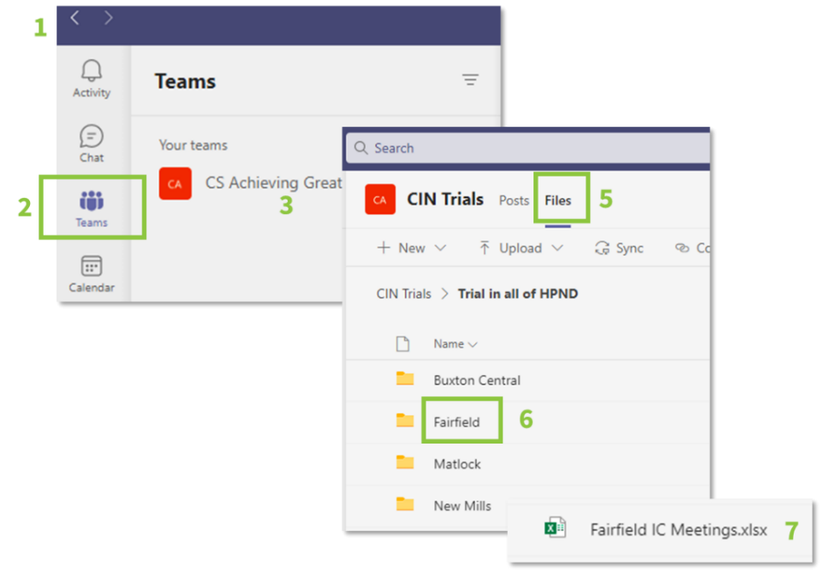
The ICM document is stored on Derbyshire’s SharePoint. It’s a live document that autosaves and multiple people can edit at once. You will find it on Teams, in a channel set up specifically for your locality’s ICM documents. Users who should have access: practice supervisors (and any nominated stand-in), team coordinators, team managers, heads of service, performance officers. For any queries, contact your performance officer, who is responsible for giving access and having oversight of the documents. More in depth guidance is in a separate document.
To find it:
- Open Teams.
- Click the “Teams” button on the left-hand panel
- Click the CS Achieving Great Futures team
- Choose the channel “CIN [locality]”
- Click “Files” at the top of the screen
- You will see folders for each team. Navigate to yours
- Click the document called “[Team Name] IC Meetings”

What it contains:
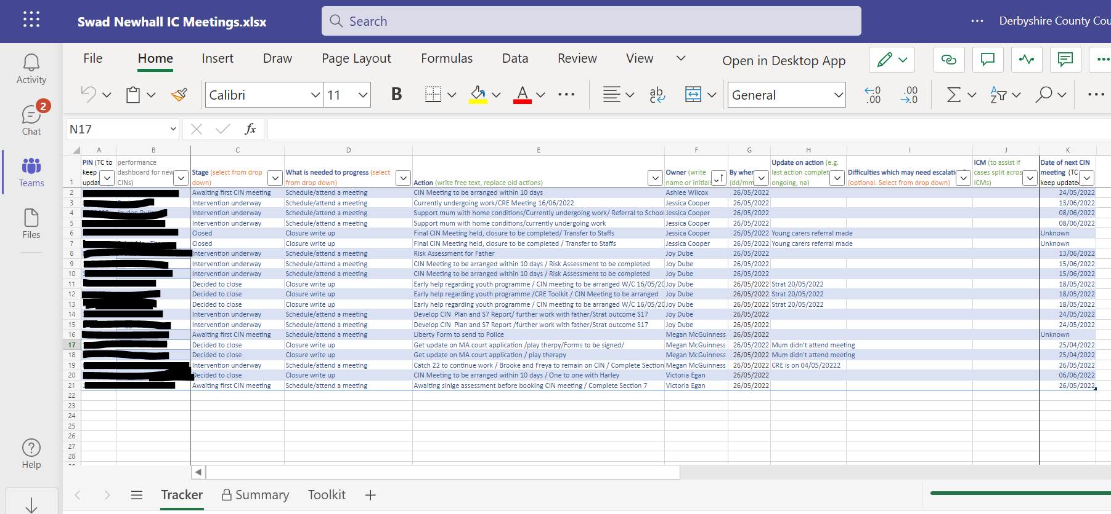
- A tracker table with a row for each child on a CIN plan
  - includes dated actions to progress each case
- A summary tab showing
  - how many cases are at each stage: awaiting first CIN meeting;
intervention underway; identified for potential closure; decided to close
  - what the main barriers to progression are

Appendix 3. ICM Meeting Effectiveness Checklist
The following checklists should be used by managers, performance officers, and any independent reviewers as a tool to identify areas for greater support and improvement. They can be completed by observing an improvement cycle meeting and speaking to a team’s PS, TM, and TC.
Locality: Date: Completed by (name):
Name of team | Example team
Meeting Effectiveness Criteria (Fill in by observing ICM) | Score from 1 to 5 where 5 = always; 4 = often; 3 = sometimes; 2 = rarely; 1 = never
Observation date | 23/05/22
1. Leadership: PS & TM both present, engaged and clear on aims | 5
2. Attendance: All expected SWs there | 5
3. Actions: Actions are reviewed, have specific dates (within weeks not months timescale) & will lead to closure (eventually if not immediately) | 4
4. Closure identification: Several cases identified for potential closure/decided to close. Threshold challenged/barriers unblocked where applicable | 5
5. Progression: Some cases have closed as a result of specific actions set and many have advanced | 3
6. Technical: ICM doc used confidently during meeting, has all CIN cases (from dashboard), and actions shared with whole team after | 2
7. Meeting dynamic: Discussions are targeted, meeting has pace, the dynamic is supportive and not critical, the team helps each other | 4
Enabling Activities Criteria (Fill in by discussing with PS, TM, TC) | Score from 1 to 5 where 5 = always; 4 = often; 3 = sometimes; 2 = rarely; 1 = never
8. Plan write up: Plan is written up in hour after CIN meeting. Where not possible, it is written up within 1-2 days of meeting. (Ask PS) | 2
9. Plan send out: Plan is sent out as soon as it’s signed off (Ask TC) | 1
10. Minutes: Plan does not include verbatim minutes. Concise, relevant updates are included in ‘any new information’ and inform the actions (Ask PS/TM) | 3
11. Dashboard use: PS and TM view PowerBI dashboard (at least) weekly, before ICM & act on duration/sign off data (Ask PS/TM) | 2
Improvements:
Have effectiveness scores changed since the previous review?
e.g. criteria 1, 2, 3, 4 all increased from 1/2 to 4/5

What are we doing/could be doing to improve?
e.g. TM to email TC as soon as a plan is signed off. PS and TM to hold 15 minutes in calendars for dashboard review before ICM

How is this expected to change the scores?
e.g. criteria 9 and 11 expected to go up to 4 or 5.

Date planned for next review: |  | Person planned to do next review:

