PPOC guide for team coordinators
March 2022

Contents

Material Required to Prepare for Identification Meetings………. Pg 2-3

During & After Identification Meeting…………………………………….Pg 4

Mobilisation Meeting…………………………………………………………….Pg 5

Permanence Panel…………………………………………………………………Pg 6

Before the week’s meetings…………………………………………………...Pg 7

After the week’s meetings…………………………………………………..….Pg 7

Tips & Advice………………………………………………………………………...Pg 8

Material Required to Prepare for Identification Meetings

The below instructions and screenshots relate to the Child Services Report Icon on your desktop.
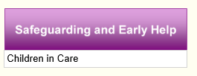
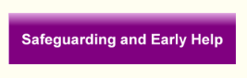
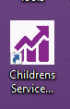

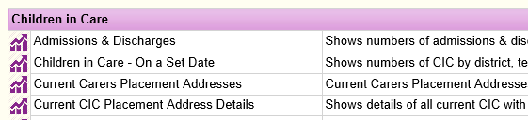

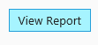

Run the report for your area by clicking on the number in cohort
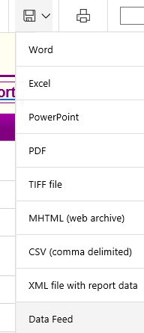
Export the data to Excel:

Exported data:
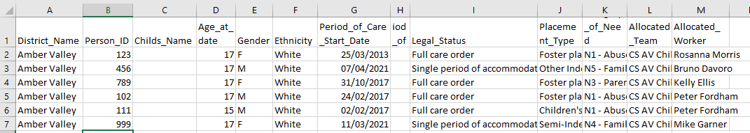

The tracker is a spreadsheet on Excel – this can be found in your PPOC locality CiC Teams Channels. Please open this and edit in teams, do not save directly in your files/on your desktop.
Complete the tracker with information from the report above, other columns will need to be inputted using the LAC episodes, YP’s Front Screen and discussion with PS/SW.
Information to fill in before meeting – columns A J in the tracker on the ‘All Data’ tab

After this has been completed the first time, we will only need to add new children who join our locality’s cohort i.e. any new cases that enter the team.

During & After Identification Meeting

During the meeting, fill in each column highlighted in the image below as it is discussed/agreed.

- After the meeting, move any relevant YP that has been identified as having potential for permanence outside of care onto the Mobilisation or Reunification Tab accordingly.

- Send a follow up email to HoS, Manager, PS and Team after the meeting, this should include all the cases you currently have on the SGO & reunification tabs with a reminder of actions due and any new cases added with ‘NEW CASE’ instead of an action in the action column. Please see example below:

- Keep updating columns A J in the “All Data” tab in the tracker with any new transfers into the team until the next Identification Meeting. Please e-mail your PS each Friday to check if any new children need to be added to the tracker.

Mobilisation Meeting

- Input relevant information into tracker on SGO and Reunification tab as children are being discussed. (All peach coloured cells must be filled in, these are target assessment start dates, when assessments have started and a workflow has been opened in Mosaic, the ‘actual start date’ column should be updated to reflect this.)

- All information for a YP should be on the same row as their name. Please complete information from left to right, before scrolling to the far right to type up the next actions that have been agreed.

- Not all columns will be completed as it will depend on the stage we are at with that child’s case as to what is relevant at that time.

- Ensure an action for next week is agreed upon in the meeting for each YP’s case and that the owner of this action is clear. If the action is for in a few weeks time please state the ‘action by’ date.

- After the meeting, hide columns D AF in both the Reunification & SGO tabs, leaving you with Name column and Next Steps Columns – Copy and paste into a Targeted Work email.

- At the end of the meeting send this updated Targeted Work email out to HoS, Manager, PS and Team, please see example below:

Permanence Panel

- Team Coordinator to select all cases discussed within the tracker during the mobilisation meeting prior to the permanence panel and share via email with all attendees ready for discussion at the meeting, input into agenda.

- Cases will be discussed between Head of Service, IRO, Manager and PS, make clear notes/bullet points (template attached)

- A case note is to be added named Case discussed at Permanence Panel on [date], detailing that the case has been presented and the following actions have been agreed.

- Notes of full meeting to be saved in appropriate folder for your manager under e.g. 20210716_PermanencePanel_NotesofMeeting

- Notes of full meeting to be distributed to the panel members

Before the week’s meetings
Please send the below e-mail (edited to include the details of your TM) out to your team each Monday morning to ensure everyone is aware and able to attend the meetings this week:

After the week’s meetings
On a Friday, after any PPOC meetings for the week have taken place, please could all TC’s complete this form: Microsoft Forms (office.com)
This has already been completed by us and is accurate up to 3rd March 2022. After this date, please complete weekly. You will need to fill in your locality name, which meetings have gone ahead and taken place this week and add any new/changed estimated assessment start dates (peach cells). There are three pages you will need to fill in to complete the form:
Page 1:
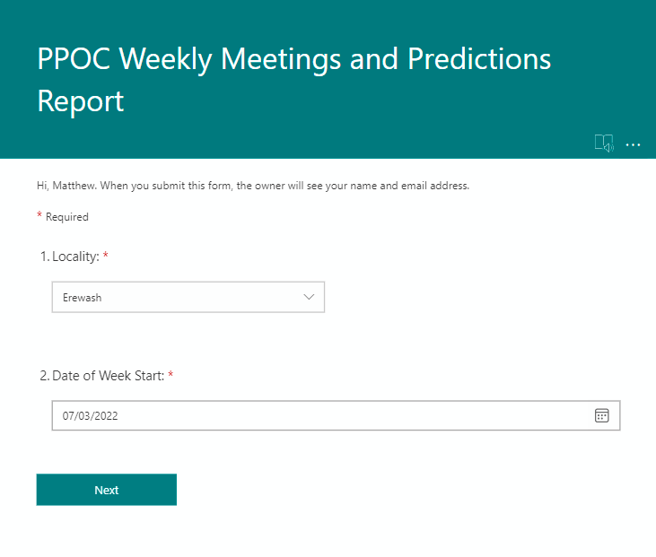
Page 2 is to be filled in for any children who’s estimated assessment start date (peach cell) has been added or has changed this week. If all the children’s estimated assessment start dates have stayed the same as the previous week, leave questions 3 – 5 blank and answer ‘No’ to question 6.
- Select the date of the Monday which was at the start of the week.
For example if you are filling in the form on Friday 11th March, you would type 07/03/22 for this question as that was the Monday that the week started on.
- Fill in which locality you are filling in the form for
Page 2:
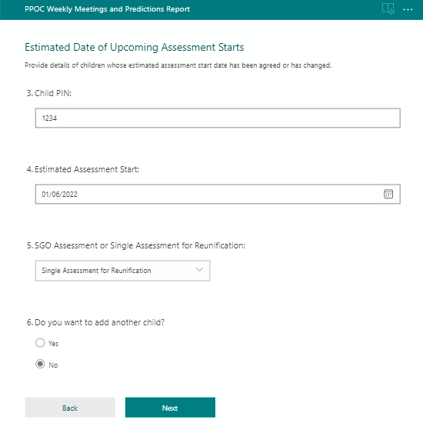
If there is another child you want to change the date for, answer ‘Yes’ to the last question and you will get the same page shown again to fill out for another child.
If you don’t have any more children to change, click ‘No’.

If there is child who previously had an estimated assessment start date entered which needs to be removed due to a change in circumstances, fill this form in for them but leave the date box blank. This will remove their previous predicted date and take them off the list.

- For each child that has had an estimated assessment start date added or changed, enter their PIN here
- Write the date that we now estimate that we will start the SGO or Single Assessment for Reunification
- Select from the dropdown whether the assessment is for an SGO or for Reunification

Page 3:
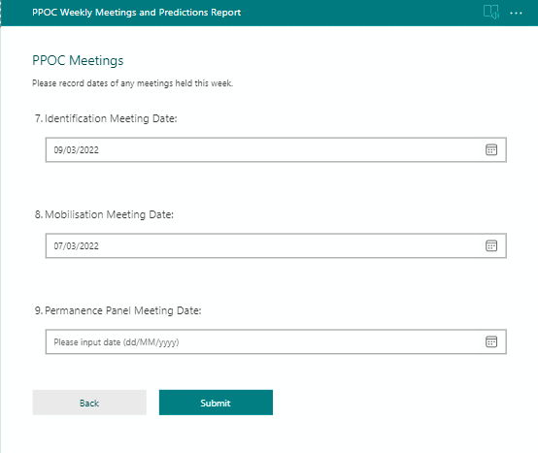
- If you had an Permanence Panel Meeting this week, fill in which date that took place. If you didn’t have this type of meeting, leave this blank.
- If you had an Mobilisation Meeting this week, fill in which date that took place. If you didn’t have this type of meeting, leave this blank.
- If you had an Identification Meeting this week, fill in which date that took place. If you didn’t have this type of meeting, leave this blank.

Tips & Advice

- Communicate with your team openly.

- Don’t be afraid to ask questions.

- Don’t be afraid to redirect conversation to an answer if you are unsure what to input.

- Try and keep TM / PS on track with the tracker – use the column headings to do this.

- When it comes to adding actions on both the SGO & Reunification tabs, number the job and who needs to action it.
(E.g.) 1. Get finance information 1. PS/Manager (Use Alt & Enter key to get a new line in same cell)

