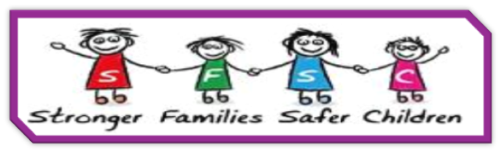
STRONGER FAMILIES, SAFER CHILDREN PRACTICE MODEL

One-page profiles; Important to, Important for; Relationship Circles; Community Mapping.
Individuality, independence, respect, partnership, choice.

Tools & Methods
Stronger Families, Safer Children
A strength based; evidence based, practice model. It is transparent, inclusive and has helpful tools.
The voice of the child is central. It helps build resilience and sustainable changes for families.
Handbook & Toolkit; Threshold document; Safety & Well-being grid with mapping guide;
Multiple training courses available on Derbyshire Learning Online

Common Third; Head, Heart, Hands. 3P’s
Building relationships; shared responsibility; holistic learning; empowerment

Cultural genograms; ecomaps; behaviour mapping; safe uncertainty; questions.
Language, context, relationships, patterns, curiosity, hypotheses.
Person Centred
Social Pedagogy
Systemic Practice
Strength Based Approaches
Derbyshire’s Practice
Model

