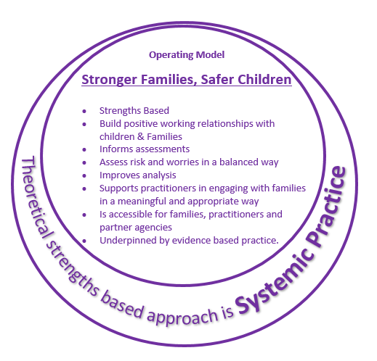

* Always show professional curiosity
* Think relationally – how is everyone connected to and impacted by each other?
* Build on strengths
* Consider the context & function of behaviours
* Create multiple hypotheses to explore
* Listen to everyone’s story, what is their dominant narrative? Is it a helpful one?
* Pay attention to language used
* Explore the family structure & functioning
* Identify patterns
* The problem is the problem, not the person

***Support to help embed Systemic Practice***

* Introduction to Systemic Practice Course
* 12 day Systemic Practice Training for Social Workers
* 4.5 Day Systemic Practice Training for Children’s workforce
* Courses for Managers and supervisors of practice
* Individual systemic based supervision
* Team Reflective Supervision
* Sharing of good practice across Children’s Services
* Systemic Refresher Courses

***Systemic Fundamental Values to guide practice***

***Systemic Core Tools to use in practice***

***Systemic Key Ideas to inform practice***

* Genograms & ecomaps
* Family Life Cycle Mapping  
  *transitions, developmental stages, stressors, failed solutions*
* Family Scripts & repeated patterns of functioning
* Safe Uncertainty Matrix
* Solution focus goal setting
* Questioning   
  *Linear, circular, reflexive, strategic & scaling*
* Exploring circularities & feedback loops
* Exploring stories
* Shifting problems into solutions
* Social GRACES  
  *diversity, power & equal opportunities*
* The individual is seen as the expert in their life. The Worker becomes a ‘Collaborative Explorer’ with children & their families
* Individuals are part of bigger systems which must be acknowledged
* Change happens within relationships – build good relationships with children & their families
* Language used should be jargon free, check for understanding and be curious about meanings
* Avoid labelling & blame