Practice Matters
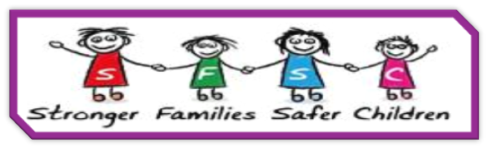
Personalisation of case work recording

What is meant by the personalisation of case work recording?
Personalisation of case work recording is the tailoring of our recording, so each individual child’s file tells their story, being clear about both the strengths and risks within their family system, whilst ensuring their file focuses on them as individuals. Whilst some details of other family members are needed, the level of explicit detail on other persons should be considered / minimized. Where the level of detail may be necessary for readers to understand why decisions / actions are taken – the location of that information (on that individual’s file) should be referred to.

Why should you personalise case work recording?
Lots of people read case files, which includes lots of personal information, including children when they are older and members of their family. Personalisation of case work recording ensures we are treating each individual with respect, valuing their right to privacy, protecting their data and complying with the law around data protection and processing (GDPR).

How to personalise case work
- At starting point, contacts records to be put on all known children in the family and other than exceptional circumstances, where needed an assessment workflow to be sent on all children.
- Assessments / S47s (Early Help Assessment or Single Assessment) should consider each child in the family as a unique individual and should analyse how any identified risks, needs are already or are likely (in the future) to impact on each child. This analysis should then inform the decisions on which (if any) child needs a plan lead by children’s services (or a partner agency) following that assessment. See Step down to partner agencies. Where there is explicit and detailed information on a child that level of detail should only be put only on that child’s file – it’s recommended this level of detail is put in an invidual case note (and referenced in the assessment) so it isn’t accidentally shared inappropriately.
- Plans – Every plan should be focused on the individual child’s needs. This may mean that a child needs to be ‘ungrouped’ to enable that to happen (you can add the child to the group again for future workflows). At each Child’s Plan Review, the team around the family should consider (using the joint threshold document) if each invidual child still needs a plan. Case should close to children’s services where appropriate. This ensures we only remain involved where appropriate and for as long as is necessary for each child.
- Strategy discussions / case supervision - should consider all children in the family. Recording those discussions on a child’s file should consider how much detail on individual child is recorded on their siblings and should reflect the impact of risk and how that is being managed for the individual child
- Visit workflows – the visit workflow should be recorded on the file of all children present at that visit. If 1 or more children are not present for a visit they should be ‘ungrouped’ for that visit. If very explicit / personal information is shared by a child during the visit that level of detail should only be put only on that child’s file – it is recommended this level of detail is put in an invidual case note (and referenced in the assessment) so it isn’t accidentally shared inappropriately.
- Case Notes and Recording style – the individual child should always be at the center of your case recording. Recording as if you are writing to the child helps you to remain child focused, consider what needs to be recorded on an individual child’s file and really think about how you write / the language you use. A good case record is focused and written clearly, concisely and in clear, non-judgmental, straightforward language to communicate the meaningful “story” and decision-making for that particular child. Writing to the child does not mean that risks / concerns for their safety are watered down; it does mean they are recorded in a way the child would understand and should be set out along with the strengths and safety within their family.

