

**Starting Point  
Handbook**



|  |  |  |  |
| --- | --- | --- | --- |
| **Version Control** | **Date** | **Authors** | **Changes** |
| 1.1 | 06/08/2015 | S Cottee |  |
| 1.2 | 28/07/2022 | R Harrisson |  |

**Welcome to the Starting Point handbook**

Starting Point is Derbyshire County Council’s multi-agency and multi-disciplinary front door to children’s services and early help. It ensures that all referrals into Children’s Services are effectively considered by applying timely informed decisions based on the needs of the child/family, multi-agency information sharing and a consistent application of the Derby and Derbyshire Safeguarding Partnership threshold. The aim is that children and families who require help receive it at the most appropriate lowest level of intervention, receiving the right help at the right time.

|  |  |
| --- | --- |
| **CONTENTS** | Page No. |
| Working Together 2018 Guidance | 4 |
| Starting Point Process | 4 – 5 |
| Starting Point Workflow | 6 |
| Roles and Responsibilities | 7 – 8 |
| Co-location | 8 |
| Child Protection Strategy Meetings | 9 |
| Starting Point Advice and Consultation Line | 10 |
| The Electronic Referral Form | 11 |
| Quality Assurance Processes | 11 |
| Starting Point Tools and Links to Stronger Families Safer Children | 12 |
| Appendix A - Referral Process Flowchart | 13 |
| Appendix B - Starting Point Staffing Structure | 14 |

**Working Together to Safeguard Children (2018) government guidance states:**

*Everybody who works with children has a responsibility for keeping them safe. No single practitioner can have a full picture of a child’s needs and circumstances and, if children and families are to receive the right help at the right time, everyone who comes into contact with them has a role to play in identifying concerns, sharing information and taking prompt action.*

Once the referral has been **accepted** by local authority children’s social care, the lead practitioner role falls to a **social worker**. The social worker should clarify with the referrer, when known, the nature of the concerns and how and why they have arisen.

Within **one working day** of a referral being received, a local authority social worker should acknowledge receipt to the referrer and make a decision about next steps and the type of response required.

**This will include determining whether:**

* the child requires immediate protection and urgent action is required
* the child is in need and should be assessed under section 17 of the Children Act 1989
* there is reasonable cause to suspect that the child is suffering or likely to suffer significant harm, and whether enquiries must be made, and the child assessed under section 47 of the Children Act 1989
* any services are required by the child and family and what type of services
* further specialist assessments are required to help the local authority to decide what further action to take to see the child as soon as possible if the decision is taken that the referral requires further assessment.

1. **Starting Point Process**

Derbyshire County Council has statutory responsibilities to safeguard and promote the welfare of children. Improving outcomes for children and families is the key priority. *The Starting Point Operating Model* aligned with the joint [Derby City and Derbyshire Threshold Document](https://www.proceduresonline.com/derbyshire/scbs/user_controlled_lcms_area/uploaded_files/Threshold%20Document%20Final%20September%202022.pdf) seeks to ensure that the thresholds are consistently applied at the lowest most appropriate intervention.

The principles of Derbyshire’s Stronger Families Safer Children (SFSC) integrated practice model commences right at the start of a child’s journey, introducing the child and their family to a strengths-based model of practice that will follow them throughout their involvement with early help or specialist and safeguarding services should there be a need for them to do so. [Stronger Families Safer Children Handbook](https://proceduresonline.com/trixcms/media/7091/stronger-families-safer-children-handbook.pdf)

**What does Starting Point do?**

* Undertake daily screening and triage of all initial contacts and referrals into children services
* Undertake daily multi-agency child protection strategy meetings
* Provide advice and signposting to other agencies to support and facilitate children and families accessing help or protection at the right level to meet their needs and at the right time.

**Starting Point Workflow**

1. An Initial Contact is made where Children’s Services are contacted about a child, who may be a child in need of Early Help, Child in Need or in Need of Protection. Initial Contacts are also generated where there is a request for advice, information or other service within the partnership early help arena.
2. Social Workers and Team Managers within the **Starting Point Initial Contact Team** consider all Initial Contacts alongside the Threshold Document and make decisions on the sameworking day regarding the most appropriate level of response required.
3. The**Starting Point Initial Contact Team** identifies all ***child in need*** and ***child protection*** contacts.
4. **Child in need** referrals are sent to **children’s social care** for assessment and the referrer notified of the outcome within **one working day**.
5. **Child Protection** contact/referrals are immediately sent to the **Starting Point** **Child Protection Team** for further work and a strategy meeting leading to a final outcome within **one working day.** The referrer is notified of the outcome.
6. All other cases which require further action are passed to the **Starting Point** **Early Help Team** to make further enquiries to determine appropriate support and intervention, this will involve discussion with the referrer (as appropriate), partner agencies and family members before an outcome is confirmed.This activitysupports theconsistency of threshold decisions and partnership engagement and informs next steps which could include access to targeted early help support or providing signposting and advice. Should the **Starting Point** **Early Help Team** identify a ***child in need*** then there will be timely step up to children’s social care for a single assessment in one working day. Similarly, should ***a child in need of protection*** be identified there will be an immediate step up to the **Starting Point** **Child Protection Team**.
7. The screening and consultation process in the front door is crucial to supporting positive outcomes for children. It is imperative that children and families access support from the most appropriate agency, at the most appropriate level of intervention, at the right time without the intrusion of Social Care intervention if a lower intervention can meet the needs of the child and family.

**Starting Point Workflow**

Contact received via Call Derbyshire or email inbox online

Cases must step up immediately if a child is identified to be a child in need or child protection

Manager to sign off final decisions and

assign to locality if further assessment is required

Actions to be completed by the worker

Case allocated to worker with clear

actions

Strategy discussion to take place if required

Actions to be completed by the worker

Outcome

Contact screened by the

**Starting Point Initial Contact Team**

**Starting Point**

**Early Help Team** completes further work on early help referral to determine support.

No Further Action (NFA)

* CS call back and advice given or signposted
* CS Threshold not met
* Information Noted
* Referrer notified of the outcome

Child in Need referral outcome passed to social care for Single Assessment and the referrer notified of the outcome within **one working day**

Child Protection contact/referral immediately passed to **Starting Point**

**Child Protection Team**

Case allocated to worker with actions

Manager to sign off the outcome and the referrer notified within **one working day**

Manager to assign to the locality team if further assessment is required

1. **Roles and Responsibilities**

**Call Derbyshire**

Call Derbyshire Customer Care Assistants (CCAs) receive all telephone calls from professionals working with children in Derbyshire where there are concerns for the immediate welfare of a child/ren. Call Derbyshire CCAs will record the detail of the referral on an Initial contact record and task this immediately to Starting Point. Call Derbyshire CCAs will advise referrers to follow up their verbal referral with written confirmation through the completion of an electronic referral document which can be found at: [www.derbyshire.gov.uk/startingpoint](http://www.derbyshire.gov.uk/startingpoint).

Members of the public also contact Call Derbyshire with a range of concerns and requests. In all these instances Contact Records are created in Mosaic and tasked to Starting Point.

**The Starting Point Initial Contact Team**

Starting Point’s Initial Contact Team is managed by a Social Care Team Manager – Social Workers within this team screen all contacts received using Derbyshire’s Stronger Families Safer Children practice model (SFSC), to apply a threshold decision regarding next steps within **one working day**. Referral coordinators support this process by completing consultation calls with partner agencies such as the early help service, health, police, education and adult related services such as Probation to support the consistent application of threshold decisions being made in a timely way. Quality Assurance activity is also undertaken within this screening process and appropriate challenge is provided as required to referring agencies. For example, on referrals lacking appropriate information or consent, unless obtaining consent would place a child at greater risk of harm then agencies will be asked to gain consent from parents before the contact is accepted. All Initial Contacts identified as Child in Need or Child Protection are promptly progressed to children’s social care in one working day.

**The Starting Point Child Protection Team**

This team is led by Social Care Team Managers and contains Social Workers and referral coordinators. Practitioners within this team undertake triage and information gathering to prepare cases for strategy discussions. The team are supported to prioritise their work by Managers and Social Workers providing clear direction and actions on each case at the time of allocation. The SFSC practice model is applied during the information gathering process with our partners from health and police in Starting Point, and many other external partners, to help us understand what life is like for the child.

The Team Manager and Social Workers leading the team are highly responsive to emerging information received and provide clear direction and support to ensure robust decisions and timely outcomes are identified.

Highly effective strategy meetings are undertaken in a timely way, attendance at these meeting by partners is expected, and good quality conversations and professional curiosity is applied within the discussions to enable the partnership to develop a shared understanding of the risks and implement next steps and actions without delay.

**The Starting Point Early Help Team**

This team is led by a Social Care and Early Help Team Manager. The Early Help and Social Care Team Manager reviews the actions applied by the Initial Contact Team and ensures that work is appropriately prioritised. The Team Managers provide clear direction during this process to facilitate responsive and robust decision making regarding next steps. Cases within this team are subject to regular review and scrutiny as new information emerges to ensure that robust decisions are made and that outcomes are progressed without delay. Should the needs of a child change during this process then the case will be stepped up as previously described on page 6.

**Business Services Team**

Business Services Assistants support the day to day running of the front door. The team records contact information received through electronic referrals, onto contact records in Mosaic, including uploading relevant documents, creating and updating individual case records as required. They manage delivery and receipt of information exchange requests between agencies through secure email. They attend child protection strategy discussions to take notes of actions, supporting the Chair whose responsibility will be to ensure that the notes are a clear reflection of the meeting and the agreed outcomes.

1. **Specific Service Developments**

**Co–location**

Starting Point is the co-location accommodation of partner agencies in the multi-agency safeguarding arrangements for children in Derbyshire. Following Covid 19, partners have adopted a hybrid approach to working arrangements, however a presence from all agencies is expected within the hub to ensure effective multi agency decision making to safeguard children. Co-location benefits all agencies through an increased understanding of each other’s roles, responsibilities, and key functions which leads to a sharing of knowledge, skills and language. Information can be shared face to face (or via teams) and in real time thus avoiding delay and ensuring that the most up to date and relevant information is available for robust decision making.

**Derbyshire Constabulary**

Derbyshire Police Safeguarding Coordination Hub (SCH) co-locate a Detective Sergeant and one civilian support staff in Starting Point. They bring with them their databases for information access and a number of functions including Child Abuse, Domestic Abuse, Missing Children and Children Missing Education. Police staff dealing with Child Exploitation remain at their HQ, supported by a co-located Child Protection Manager with a view to potentially co-locate within Starting Point when accommodation allows.

**Derbyshire Community Health Services**

Colleagues from DCHS currently provide a hybrid approach to co-location within Starting Point. They bring with them their databases for information access, and this will include direct access to the 0-19 Children’s Service health records. Where information is required from acute services, A & E, Minor Injuries units, Midwifery, GPs, Paediatricians or East Midlands Ambulance Service, arrangements are in place to have access to their information either through the electronic health record or direct contact by health staff co-located with Starting Point.

**Child Protection Strategy Meetings**

Whenever there is reasonable cause to suspect that a child is suffering or is likely to suffer significant harm an initial strategy meeting will take place at Starting Point. The strategy meeting will involve Children's Social Care, Police, Health, Education and any other involved agency. A further strategy discussion can take place at any time following a referral including during the assessment process.

The purpose of the initial strategy meeting is to determine if the threshold for Section 47 investigation is met (s47 Children Act 1989) and, if agreed, to plan rapid future action to ensure that the child is safeguarded.

All attendees at the meeting will be sufficiently senior to make decisions on behalf of their agencies. Attendees will include a Team Manager from Starting Point chairing the meeting, alongside a Business Service Assistant taking notes. The meetings are undertaken via hybrid MS Teams model, which supports more engagement from other involved agencies.

**The Professional Consultation and Advice Service**

The professional consultation and advice line is open between the hours of 10:00 and 16:00 daily, Monday to Friday. This is a separate telephone number to Call Derbyshire. The telephone number is **01629 535353**. The consultation and advice service does not record referrals. If, during the process of the call, the advice is that a referral should be made, callers will be asked to complete an electronic referral form for services that fall below the threshold for child protection. If the issues raised indicate that there is reasonable cause to suspect that a child is suffering, or is likely to suffer significant harm, the Social Worker will accept the referral over the telephone to prevent delay. Callers will be asked to confirm their verbal referral by completing the electronic referral form.

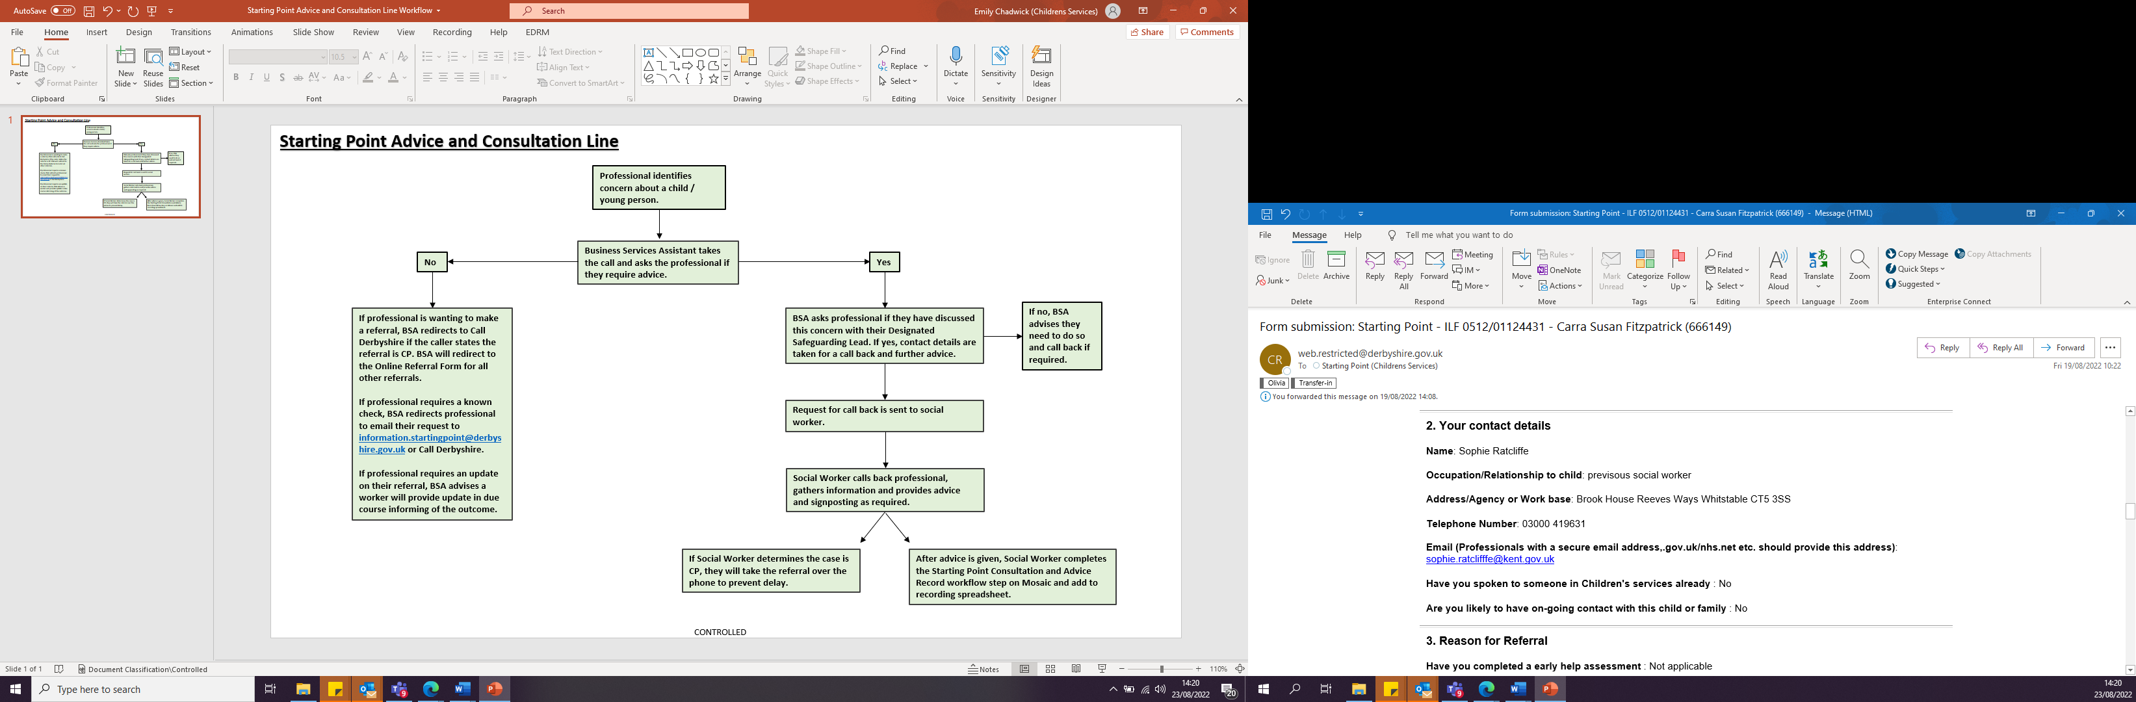

**The Electronic Referral Form**

Starting Point provides a single point of access for contacts requesting support or raising concerns for children across Derbyshire. **All telephone calls regarding immediate safeguarding concerns will be received via the established Call Derbyshire number 01629 533190.** A contact record will be raised and tasked to Starting Point. Partner agencies should consider the [Derby City and Derbyshire Threshold Document](https://www.proceduresonline.com/derbyshire/scbs/user_controlled_lcms_area/uploaded_files/Threshold%20Document%20Final%20September%202022.pdf) ahead of contacting Call Derbyshire or completing the online referral form.

**All other referrals which fall below the threshold for Child Protection will be received through the completion of the electronic referral form. The form can be found at:** [www.derbyshire.gov.uk/startingpoint](http://www.derbyshire.gov.uk/startingpoint)

**Quality Assurance Processes**

* Daily review of the management information to support compliance with one working day decision making is undertaken in Starting Point.
* Monthly performance meetings are held which involve feedback from QA and an Independent Performance Officer. This helps the Starting Point workforce to exercise professional curiosity and challenge regarding emerging themes and current practice.
* Daily professional reflective discussions are undertaken between practitioners promoting professional challenge and debate.
* Fortnightly reflective supervision with the Social Workers is undertaken alongside monthly one to one supervision for workers with their managers.
* Bi-monthly peer reflection sessions with pod workers and Social Workers are undertaken.
* Managers and Practice Supervisors undertake reflective case reviews and dip sampling / threshold application reviews and feedback is reviewed and shared with workers and agencies.
* Quarterly thematic multi-agency reflective case reviews are undertaken within the multi-agency partnership this support reflection space, learning and development for all agencies.
* The Starting Point Strategic Partnership Board is held bi-monthly to allow the partnership to continue to review and develop front door activity.
* Starting Point Team Managers liaise closely with their allocated Children’s Services locality Team and Head of Service. Locality feedback regarding the quality of the work received from Starting Point is an important factor in the quality assurance learning processes for Starting Point.
* In addition to the above, Starting Point is subject to the established Practice Learning Day processes within Derbyshire.

1. **Starting Point tools and the link with Stronger Families Safer Children Derbyshire’s Integrated Operating Model** 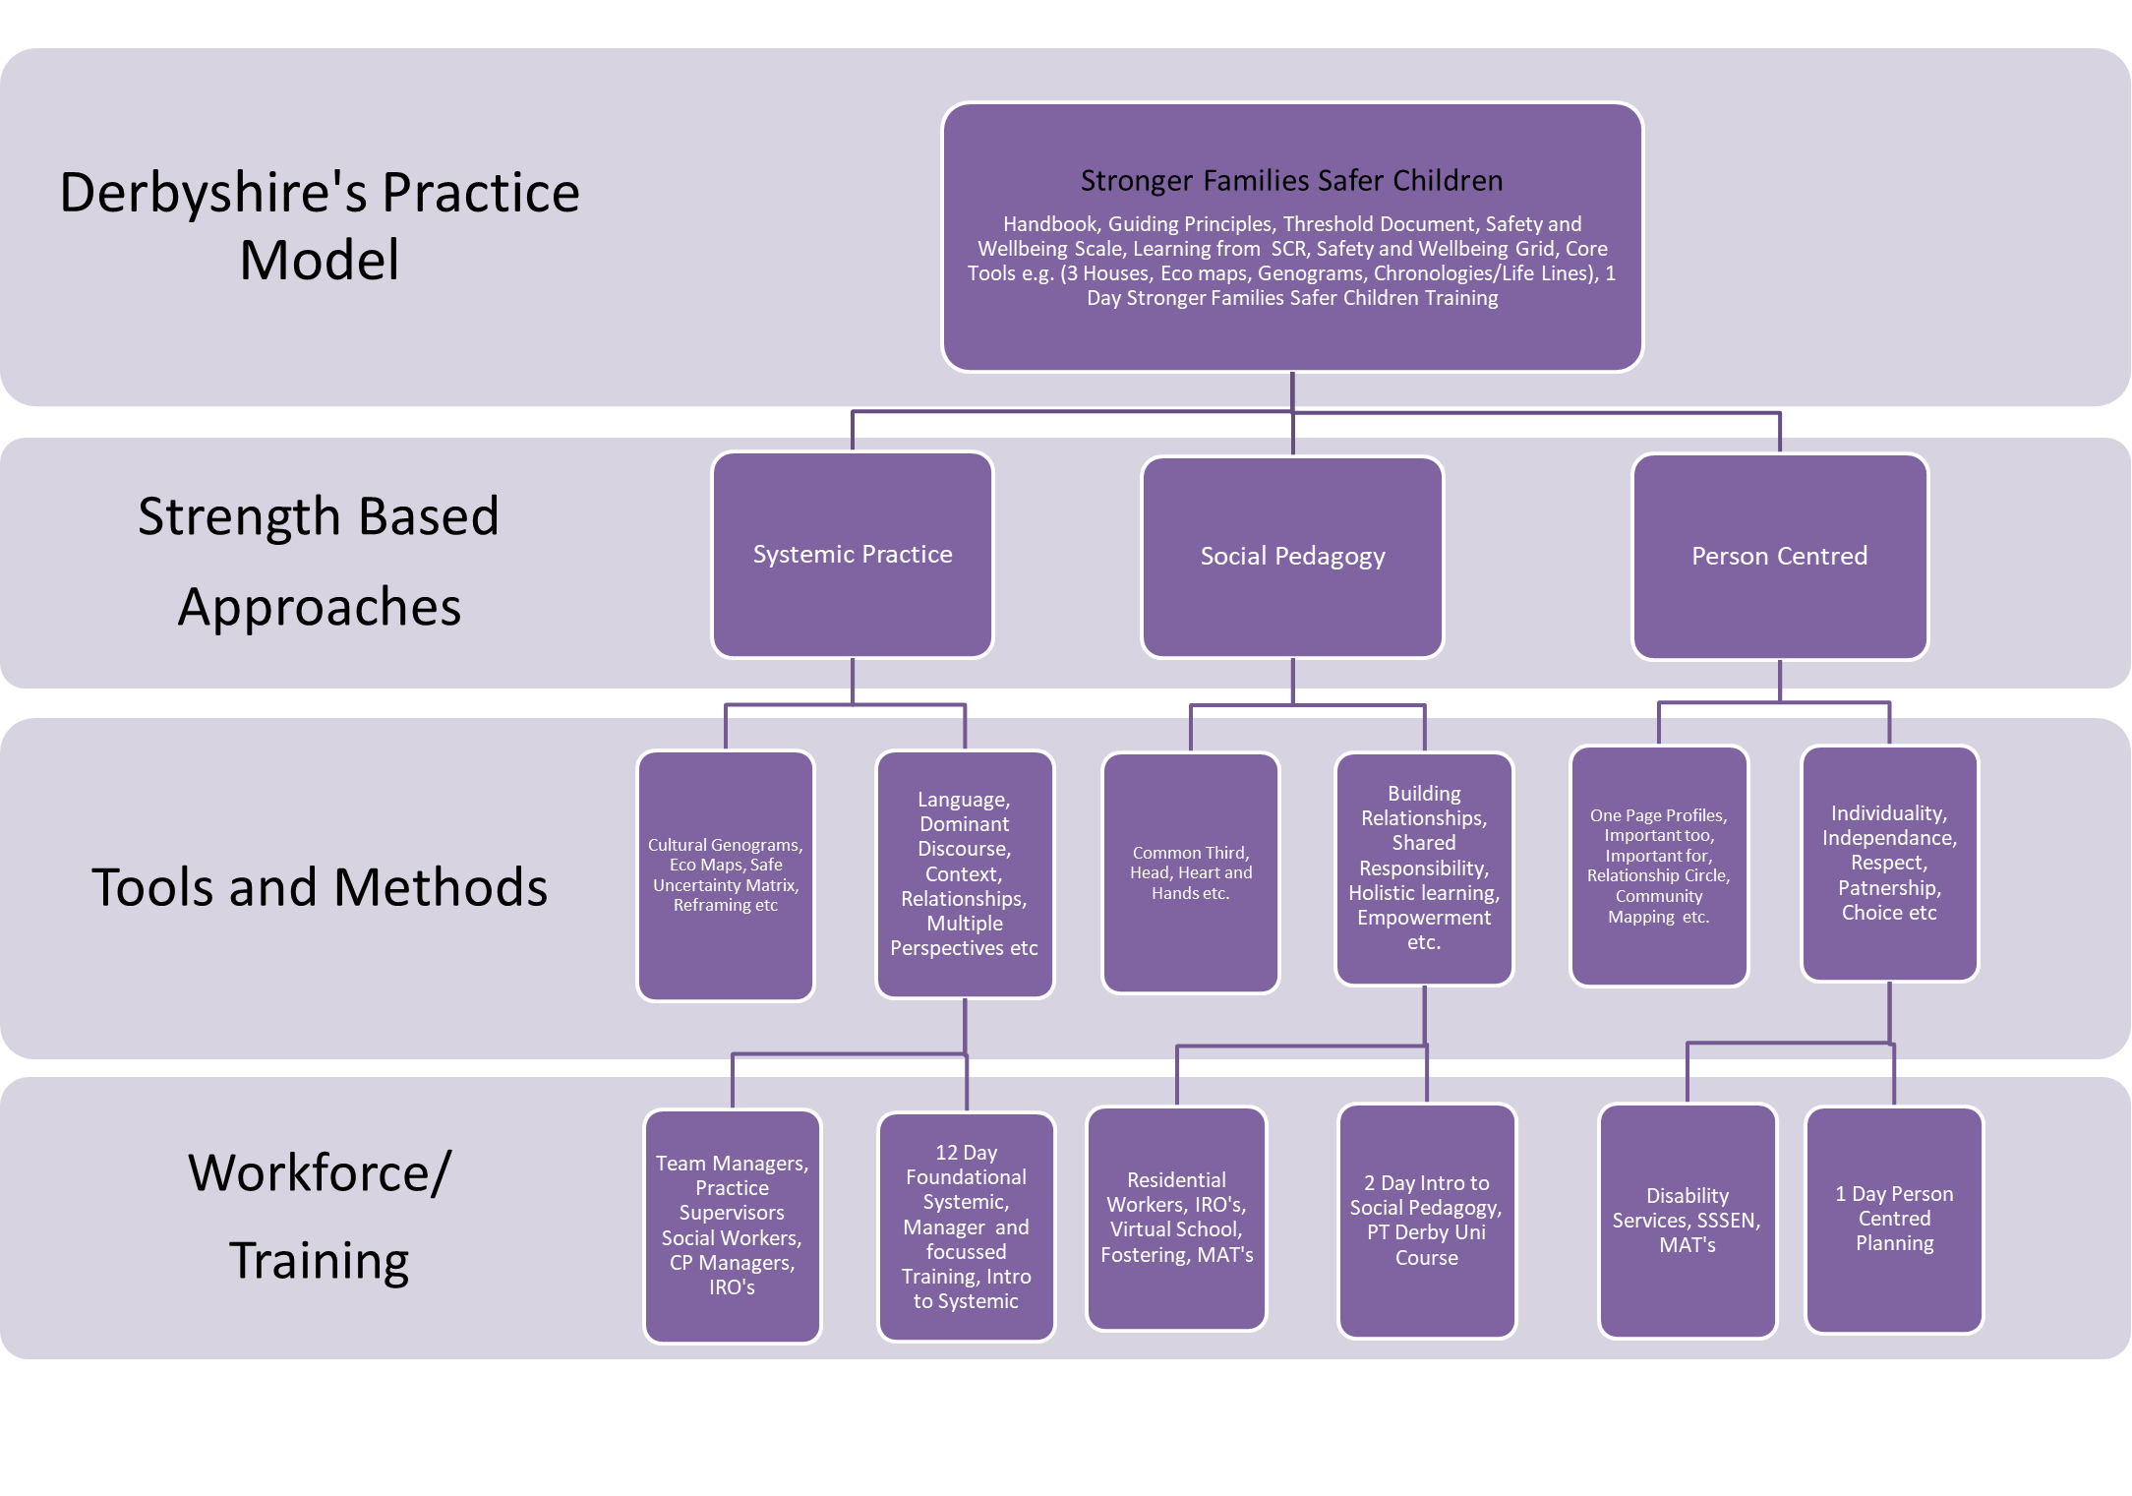

**Appendix A – Referral Process Flowchart (*Working Together To Safeguard Children July 2018)***

**Appendix B**

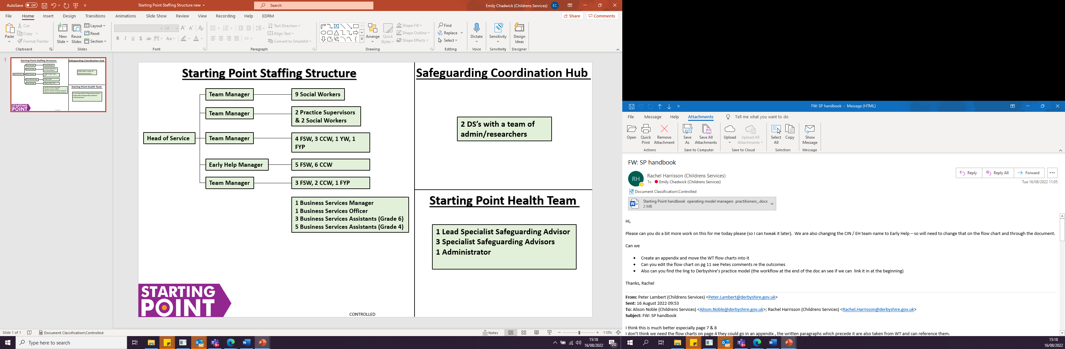

**Co-located with**

**Starting Point Health Team  
1 Lead Specialist Safeguarding Advisor  
3 Specialist Safeguarding Advisors  
1 Administrator**

**Safeguarding Coordination Hub  
2 DS’s with a team of admin/researchers**