POLICY: JOINT INFANT FEEDING POLICY

Document History
Modified Date: | [Date Approved]
Version Number: | [Version] | Reference Number:  [Reference No.]
Next Revision Due: | 3 Years  [Review Date]
Review Status | [Review Status]
Author: | MARTIN, Philippa (DERBYSHIRE COMMUNITY HEALTH SERVICES NHS FOUNDATION TRUST)
Policy Sponsor: | [Sponsor]
Team: | [Published Team]
Approved or Rejected by: | [Committee Approving or Rejecting] |  | Date:[Date Approved]
Category: | 16
Sub Section: | 96
Type of Document: | 141
Have you assessed the Equality Impact of this policy? | (please see section 10)
Contact Name for Policy Queries
Contact Name for SharePoint document upload
All Comments
Key Words | [KeyWords]

Please indicate which groups have discussed this policy: | [Governance Group]  [Peer Group]
Date(s) discussed:

Has this Policy previously been known under another title? If so please state previous title.
Date changed:

Revision History
Version | Revision date | Summary of Changes
2 | July 2022 | Infant weight monitoring information ahs been moved to a separate guidance document.  Safe sleep information updated in line with Lullaby Trust and Keeping Babies Safe information.  Website links updated.  Tools updated in appendices in line with current practice.

To help ensure that this policy is as accessible as possible, it has been left-aligned and is available in alternative formats and languages. To obtain a copy of the policy in large print, audio, Braille (or other format) or in a different language, please contact The Communications Team, by Tel: 01246 515224 or email dchst.communications@nhs.net

Table of Contents
1. AIM/PURPOSE 3
2. INTENDED USERS 3
3. DISCLAIMER STATEMENT 3
4. DEFINITIONS AND AN EXPLANATION OF TERMS USED 4
5. FULL DETAILS OF THE POLICY 4
6. SUPPORT AND ADDITIONAL CONTACTS 4
7. SUPPORTING DOCUMENTS OR RELEVANT REFERENCES 4
8. APPROVAL 4
9. MONITORING/AUDIT 4
10. EQUALITY IMPACT 5
11. APPENDICES 6
Appendix 1 – MONITORING/AUDIT TOOL 6
APPENDIX 1 – MONITORING/AUDIT TOOL 7
APPENDIX 2 - FLOW CHART 8

AIM/PURPOSE

The purpose of this joint policy is to ensure that all staff at Derbyshire Community Health Services (DCHS) and Derbyshire County Council (DCC) Children’s Centres understand their role and responsibilities in supporting expectant and new mothers and families to feed and care for their baby in ways which support optimum health and well-being in line with UNICEF UK Baby Friendly Standards. All staff should work to ensure that this policy is implemented within their everyday practice, considering local needs.

Throughout this policy the term “we” should be taken to mean DCHS Children’s Services and DCC Children’s Centre staff.

We are committed to providing the highest standard of care to support expectant and new Mothers and their partners with feeding their baby and building strong and loving parent-infant relationships. This is in recognition of the profound importance of early relationships to future health and well-being and the significant contribution that breastfeeding makes to good physical and emotional health outcomes for children and mothers.

We will ensure that all care is Mother and family centred, non-judgemental and parents feel their decisions are supported and respected.

Breastmilk is the optimal food for baby. It not only provides all the nutrients the baby needs, it also changes composition to meet the needs of the growing baby, helps develop the baby’s brain and provides protection against significant disease for the mother and her baby. Victora et al (2016) demonstrated that not breastfeeding increases the risk of otitis media, tooth decay and malocclusions, chest infections, gastroenteritis, death from gut problems in premature babies, overweight and obesity in later life, sudden infant death syndrome, childhood cancer and that breastfeeding improves education attainment and brain development. For the Mother, breastfeeding reduces the risk of breast and ovarian cancer, reduces the risk of diabetes, can help with baby spacing and is linked with lower rates of depression.
However, a recent world-wide analysis Victora et al (2016) stated that just 1 in 5 children in high income countries are breastfed to 12 months with the UK having the lowest breastfeeding rate in the world, with only 1% of babies exclusively breastfed at six months.

We are committed to improving breastfeeding rates by implementing the Baby Friendly Standards. This includes giving information to parents about the value of breastfeeding, ways to get it off to the best start, ways to develop a close and loving relationship with their baby, supporting them to breastfeed for as long as they want and protecting parents from the unethical marketing practices by formula milk companies that undermine breastfeeding. It also encourages collaborative working across professional boundaries and organisations to improve infant feeding support for all families.

Leaders and clinicians within the organisation are expected to take responsibility for making the UNICEF UK Baby Friendly Standards a reality and work together across disciplines and organisations to improve mothers’ / parents’ experiences of care.

Where this guidance uses the term ‘woman’ or ‘mother’, this should be taken to include those who do not identify as female.

INTENDED USERS

Table of Intended Users:

Include the table and wording below

DCHS
Chief Executive’s Department | YES
Finance Performance and Information | YES
Quality | YES
Strategy | YES
Operations | YES
People & Organisational Effectiveness | YES
General Practices (GP) | YES

Within this policy where it states “all employees”, please note, that it relates to all the employees who are highlighted in the table above

N.B If the policy also applies to people who are not directly employed by DCHS; they should also be listed here

DISCLAIMER STATEMENT

It is a requirement that the reader follows this policy and accepts professional accountability and maintains the standards of professional practice as set by the appropriate regulatory body applicable to their professional role and to act in accordance with the express and implied terms of your contract of employment, in accordance with the legal duties outlined in the NHS Staff Constitution (section 3b). If there are any concerns with this document then the reader should initially discuss the specific issue with their line manager or raise it through appropriate “raising concerns” channels. The line manager should agree a course of action that is appropriate and reflect this in the patients notes and with the policy sponsor.

DEFINITIONS AND AN EXPLANATION OF TERMS USED

FULL DETAILS OF THE POLICY

5.1 Outcomes
This policy aims to ensure that the care provided improves outcomes for children and families, specifically to deliver:

- An increase in breastfeeding rates at 6-8 weeks.
- Amongst parents who chose to formula feed at least 80% doing so responsively and as safely as possible in line with nationally agreed guidance
- Increase in the proportion of parents who introduce solid food to their baby in line with nationally agreed guidance, with support for continuing breastfeeding beyond the first six months through accurate, impartial information on when to introduce appropriate foods.
- Improvement in parents’ experiences of care with at least 80 % score on all items on the Baby Friendly mother’s audit.
- Services which promote responsive parent child relationships

5.2 In support of this policy
- All new staff will be familiarised with the policy on commencement of employment.
- All staff will receive training to enable them to implement the policy as appropriate to their role. New staff who are expected to give breastfeeding management support, will receive this training within six months of commencement of employment.
- The International Code of Marketing of Breast-milk Substitutes (WHO, 1981), and subsequent amendments, is implemented throughout DCHS health visiting service and DCC Children’s Centres.
- All documentation fully supports the implementation of these standards.
- All materials and programmes produced for staff or families reflect the standards and are reviewed by the DCHS Infant Feeding Specialist team to ensure compliance.
- Parents’ experiences of care will be listened to through regular audit, parents’ experience, user satisfaction surveys, and other mechanisms that are available locally.

5.3 Care standards
This section of the policy sets out the care that the health visiting service is committed to giving each and every expectant and new mother. It is based on the UNICEF UK Baby Friendly Initiative standards for health visiting (UNICEF 2014), Guidance on Maternal and Child Nutrition (NICE, 2008), NICE Guidance on Postnatal care (NICE, 2021) and the Healthy Child Programme Pregnancy and the First Five Years (PHE, 2021).

5.3.1 Pregnancy
All pregnant women will have the opportunity to discuss feeding and caring for their baby with their health visitor, including the practical and emotional aspects and the impact this may have on feeding. This discussion will include the following topics:

- The value of connecting with their growing baby in utero.
- The value of skin contact for all mothers and babies, both immediately after birth and continuing in the following weeks and months.
- The importance of responding to their baby's needs for comfort closeness and feeding after birth, and the role that keeping their baby close has in supporting this.
- Feeding, including:
  - an exploration of what parents already know about breastfeeding
  - the value of breastfeeding as protection, comfort and food
  - getting breastfeeding off to a good start
  - appropriate information on formula milks and responsive bottle feeding as required, including paced bottle feeding.

Children’s Centre staff will signpost pregnant women to information and support, including local groups and peer support services.

5.3.2 Support for continued breastfeeding
A formal breastfeeding assessment using the Breastfeeding Assessment Tool will be carried out at the ‘new baby review’ to ensure effective feeding and well-being of the mother and baby. This includes recognition of what is going well and the development, with the mother, of an appropriate plan of care to address any issues identified.

For those mothers who require additional support for more complex breastfeeding challenges a referral to the specialist service should be made via SystmOne. Other professionals or volunteers without access to this can refer by email to:
DCHST.Breastfeeding-SpecialistReferrals@nhs.net

Mothers will have the opportunity for a discussion about their options for continued breastfeeding (including responsive feeding, expression of breast milk and feeding when out and about or going back to work), according to individual need.

The health visiting service will work in collaboration with Derbyshire County Council Children’s Centres and other local services to make sure that mothers have access to social support for breastfeeding.

All breastfeeding mothers will be informed about the local support for breastfeeding which can be found on the Derbyshire Family Health Service website (https://www.derbyshirefamilyhealthservice.nhs.uk/) and those local business that have achieved the Derbyshire Breastfeeding Welcome Here Award.

Details of local volunteer peer support groups in Derbyshire are also available via the Breastfeeding Network website https://www.breastfeedingnetwork.org.uk/derbyshire/.

These discussions will be recorded on the Post Natal Conversation Prompt (PNCP) - see Appendix.

All mothers are welcome to breastfeed in all Derbyshire County Council and Derbyshire Community Health Services premises.

5.3.3 Exclusive breastfeeding
Mothers who breastfeed will be provided with information about why exclusive breastfeeding leads to the optimal outcomes for their baby. Women will be encouraged to breastfeeding exclusively for the first 6 months, with continued breastfeeding alongside the introduction of complementary feeding for at least a year, or as long as they both wish.

When exclusive breastfeeding is not possible, the value of continuing partial breastfeeding will be emphasised and mothers will be supported to maximise the amount of breast milk their baby receives.

Mothers who give other feeds in conjunction with breastfeeding will be enabled to do so as safely as possible and with the least possible disruption to breastfeeding. This will include appropriate information and a discussion regarding the potential impact of the use of a teat when a baby is learning to breastfeed.

5.3.4 Storage of expressed breast milk
Breastfeeding mothers may encounter unforeseen reasons for separation from their infants, but more often women express and store milk for planned events, lifestyle, flexibility, and returning to work. Knowledge of appropriate human milk handling and storage is essential for breastfeeding success in these situations. (See Appendix - Milk Storage guidelines).

5.3.5 Modified feeding regime
There are a small number of clinical indications for a modified approach to responsive feeding in the short term. Examples include: preterm or small for gestational age babies, babies who have lost more than 10% of their birth weight or have not regained their birth weight by 21 days, babies who are gaining weight slowly. The Modified Feeding Regime flowchart can be found in the Infant Weight Guidelines. For further guidance in relation to faltering growth refer to Infant Weight Guidelines for Health Visiting Teams.

5.3.6 Support for formula feeding
At the New Birth visit mothers who formula feed will have an assessment using the Bottle Feeding Assessment Tool (see appendix), alongside a discussion about how feeding is going. The Health Visitor will ensure that they have evidence-based information on safe preparation and storage of formula milk and are able to implement this as safely as possible. The Health Visitor may need to offer a demonstration along with a discussion about how to prepare infant formula, checking parental understanding. Other professionals working with a family should support these messages.

On observation and discussion between the Health Visitor and the parents, the Health Visitor will ascertain that they understand about the importance of responsive feeding including:

- recognising and responding to cues that their baby is hungry
- holding baby close in a semi-upright position, encouraging eye-contact, inviting their baby to draw in the teat rather than forcing the teat into their baby’s mouth
- pacing the feed so that their baby is not forced to feed more than they require
- recognising their baby’s cues that indicate when they have had enough milk. This will avoid their baby to take more milk than the baby wants.

The health visitor will signpost to appropriate resources via: https://www.derbyshirefamilyhealthservice.nhs.uk/

5.3.7 Introducing solid food
All parents will have a timely discussion regarding the introduction of solid food including:

- solid food should be started around six months
- babies’ signs of developmental readiness for solid food
- how to introduce solid food to babies, including “Baby Led Weaning”
- appropriate foods for babies
- safety aspects of introducing solid food
- signposting to appropriate resources including the “Start4Life” “Introducing Solid Foods” leaflet via:

DCHS 0-19s service website: https://www.derbyshirefamilyhealthservice.nhs.uk/

5.3.8 Support for parenting and close relationships
All parents/ carers will be supported to understand a baby’s needs (including encouraging frequent touch and sensitive verbal/visual communication, keeping babies close, responsive feeding and safe sleeping practices).

Parents/ carers who bottle feed are encouraged to hold their baby close during feeds and offer the majority of feeds to their baby themselves.

Parents will be given information about local parenting support that is available including:
- groups and other support that is available from local Children’s Centres
- dates and venues of local breastfeeding volunteer peer support
- contact details of other local volunteer support (charities, parent and toddler groups etc).
- signposting to the Derbyshire Family Health Service Website https://www.derbyshirefamilyhealthservice.nhs.uk/.

5.3.9 Safer Sleep
All parents are to be supported to understand information about safer sleep and reducing the risk of sudden infant death with their health visitor as recommended by NICE (2021) CG37 and Three Steps to Baby Safety (DDSCP, 2021) https://www.proceduresonline.com/derbyshire/scbs/user_controlled_lcms_area/uploaded_files/Keeping%20Babies%20Safe%20Strategy%20Feb%202021.pdf. It is important to listen and offer information appropriate to their needs. Acknowledge with parents that young babies wake frequently in the night and that this is normal and not modifiable, as young babies are not capable of ‘learning’ to defer their needs.

As part of the discussion with all parents use the Lullaby Trust ‘Safer Sleep: Saving Babies Lives – A Guide for Parents’ or the UNICEF UK leaflet ‘Caring for your Baby at Night’. Also refer parents to the Baby Sleep Information Source (BASIS) (http://www.basisonline.org.uk/ )
.
Discuss how parents can greatly reduce the incidence of SIDS by following key messages: -

Safer sleep message | Key points
Put babies on their back for every sleep | - Premature babies should sleep on their back when they go home even if this was not the case in hospital.  - It is not safe for a baby to sleep on their side and they should never be propped into a sleep position. Babies with reflux or colic should not be placed on their front or side. If there are health concerns and families feel that sleep position is detrimental they should seek a medical opinion before changing the safe sleep position.  - Babies may seem more settled and sleep longer on their tummy but longer deeper sleep is not safe sleep. The risk of SIDS is much higher for babies who sleep on their tummy.  - It is important that all family members including grandparents are educated on safe sleep  - to ensure there is a think family approach to the message.
Babies should sleep in a clear flat sleep space | - Babies should sleep in the same room as their parent or carer (day and night) for the first  - six months.  - Check if this is possible, and advise for the next best alternative if it is not possible  - Babies need a firm, flat mattress with no raised or soft sides  - No pillows, quilts or duvets, bumpers  - No pods, nests or sleep positioners  - Make sure their baby’s head is kept uncovered so they don’t get too hot  - If the baby sleeps in a sling or baby carrier make sure parent are aware of the TICKS guidance for safe use
Keep babies smoke free day and night | - Discuss smoking with the family - this will have already been raised during pregnancy but sometimes families need support to help make the decision to quit and you might make all the difference  - Refer for specialist support – families do not need to tackle this alone  - Ask about smoking beyond the immediate family – what about visitors, other members  - of the family, do the parents feel able to tackle this or do they need support?  - Remember smoky places; are parents aware of keeping the baby smoke free at all times?

Other risk factors: Inform parents that other factors, can increase the risks associated with bedsharing. The risk assessment tool in ‘Three Steps to baby Safety’ should be used with every infant to identify additional risk factors.

Support breastfeeding to reduce the risk of SIDS:

SIDS risk is halved in babies who are breastfed for at least 2 months (Lullaby Trust)
- In the antenatal period, discuss infant feeding and how to get breastfeeding off to a good start
- Let families know that breastmilk is all a baby needs for the first six months, and thereafter alongside other foods for two years and beyond
- Refer families to support networks to aid and support the continuance of breastfeeding including local feeding advisors and UNICEF UK
- If the family is not high risk (see risk assessment below) then parents should be supported to find a comfortable and safe position for mum to breastfeed her baby in whilst lying down in bed. This will allow mum to get more rest overnight which may allow her to continue breastfeeding for longer and provide ongoing protection for her baby in reducing the risk of SIDS (UNICEF UK).
If mums are not supported to do this they may choose to try and feed in a more dangerous position such as sitting up in bed or on a chair or sofa.

Bed Sharing

Explain that around half of all parents will sleep with their babies at some point be this planned or unplanned, and, although SIDs is very rare it is much more likely to happen in certain circumstances. Bed sharing needs to be discussed with families to ensure they are aware of the dangers if they fall asleep accidentally.

The incidence of SIDS is higher in the following groups:

- Parents in low socio-economic groups
- Parents who are talking any drugs or prescribed medication that may make them sleep
- If either parent smokes (including during pregnancy)
- Any alcohol use for either parent
- Young mothers with more than one child
- Infants born preterm (before 37 weeks) and those with low birth weight (<2.5kg)
- Out of routine sleep situations, such as when away from home or when a baby is unwell and doesn’t usually bedshare
- Parents are very tired (less than 4 hours sleep in 24 hours)

Parents within these groups will need more face to face discussion to ensure that these key messages are explored and understood. They may need some practical help, possibly from other agencies, to enable them to put them into practice. NICE (2021) advocates that all parents are empowered by midwives, health visitors and GP’s with the information to enable them to make informed decisions regarding their individual risk factors for SIDS. NICE refer practitioners to the resources available from the Baby Information Source (BASIS) to support them in their discussions with parents, to be used alongside the UNICEF “Caring for Baby at Night” information.

The risk assessment (see appendix) should be shared with all parents and completed by the midwife or health visitor at least once. Parents should be advised to review the risk assessment if their circumstances change, for example when away from home or if a parent starts taking a new medication. This empowers parents to make informed decisions about each bedsharing episode.
All parents should be advised they should never fall asleep with their baby on a sofa or armchair.

All professionals supporting families who bedshare or are considering bedsharing should promote safer bedsharing, including the following messages:

• Never drink alcohol
• Never take illicit drugs
• Some prescribed drugs will cause drowsiness if these have been taken never bed share
• Ensure there are no pillows, sheets, blankets or other items in the bed that can overheat the baby or move over the baby’s head. A high proportion of babies who die of SIDS had their heads covered with loose bedding.
• Make sure the baby cannot fall out of bed or become trapped between the mattress and the wall
• Never leave the baby alone in bed

The three key messages are the same even when bed sharing
• Put babies on their back for every sleep
• Babies should sleep in a clear flat sleep space
• Keep babies smoke free day and Night

- Although it is recognised that not all patients have the ability to understand or give informed consent, efforts should still be made to communicate to patients according to their ability. This will need to be recorded in the patient’s treatment plan. If informed consent is not able to be given then staff should consider the application of the Mental Capacity Act and use of a Best Interest Decision in regard to the necessary treatment. Further advice is available from the Safeguarding Service on 01773 850000 (9-5 Monday to Friday).

SUPPORT AND ADDITIONAL CONTACTS

The name(s) of the people responsible for developing the document and from whom additional support and advice can be obtained in order to implement the document.

Infant Feeding Specialist Team Address:
Gosforth Valley Medical Practice,
Gorsey Brigg, Dronfield
S188UE

Gill McCavana, Infant Feeding Specialist
Email: Gillian.mccavana@nhs.net

Denise Pemberton, Infant Feeding Specialist
Email: Denise.pemberton1@nhs.net

SUPPORTING DOCUMENTS OR RELEVANT REFERENCES

This section should include the names of other DCHS policies and guidelines this links to – it may be appropriate to include hyperlinks to the other documents.

Department of Health 2009 Healthy Child Programme Pregnancy and the First Five Years of Life https://www.gov.uk/government/publications/healthy-child-programme-pregnancy-and-the-first-5-years-of-life

Department of Health 2012 Public Health Outcomes Framework 2013 to 2016: https://www.gov.uk/government/publications/healthy-lives-healthy-people-improving-outcomes-and-supporting-transparency

Derby and Derbyshire Safeguarding Children Partnership (2021) https://www.proceduresonline.com/derbyshire/scbs/user_controlled_lcms_area/uploaded_files/Keeping%20Babies%20Safe%20Strategy%20Feb%202021.pdf

NICE 2014 Guidance on Maternal and Child Nutrition: http://www.nice.org.uk/ph11

NICE 2021 NG194: https://www.nice.org.uk/guidance/ng194

Scientific Advisory Committee on Nutrition (SACN), 2018 Feeding in the first year of life https://assets.publishing.service.gov.uk/government/uploads/system/uploads/attachment_data/file/725530/SACN_report_on_Feeding_in_the_First_Year_of_Life.pdf [accessed on 21/03/2022].

Victora CG, Bahl R, Barros AJD, França GVA, Horton S, Krasevec J, Murch S, Sankar MJ, Walker N, Rollins NC, (2016) The Lancet Group Breastfeeding Series

The Lullaby Trust Safer Sleep: Saving Babies Lives professionals’ guide: https://www.lullabytrust.org.uk/about-us/safer-sleep-week-2019/new-safer-sleep-publications/
The World Breastfeeding Trends Initiative report: https://ukbreastfeeding.org/wbtiuk2016/

UNICEF 2013 A Guide For Health Workers To Working Within The International Code Of Marketing of Breastmilk Substitutes http://www.unicef.org.uk/BabyFriendly/Resources/Guidance-for-Health-Professionals/Writing-policies-and-guidelines/A-guide-for-health-workers-to-working-within-the-International-Code-of-Marketing-of-Breastmilk-Substitutes/

UNICEF 2019 The UNICEF UK Baby Friendly Initiative audit tool (2019 edition)

UNICEF 2014 Updated Baby Friendly standards: www.unicef.org.uk/babyfriendly/standards

UNICEF 2017 Achieving Sustainability: Standards and Guidance

UNICEF: The Right ingredients: the need to invest in child nutrition p. 28: UNICEF.org.uk

UNICEF: Co –sleeping and SIDS: A guide for health professionals
https://www.unicef.org.uk/babyfriendly/wp-content/uploads/sites/2/2016/07/Co-sleeping-and-SIDS-A-Guide-for-Health-Professionals.pdf [replace with lullaby trust guide for professionals].

WHO 1981 International Code of Marketing of Breastmilk Substitutes (the Code) http://who.int/nutrition/publications/infantfeeding/9241541601/en/ accessed 14.09.2014

First Steps Nutrition Trust (2022). First Steps Nutrition. Available at: https://www.firststepsnutrition.org/ [accessed on 8th July 2022].

First Steps Nutrition Trust (2022). Infant Milk Info. Available at: https://infantmilkinfo.org/ [accessed on 8th July 2022].

NICE (2021). Postnatal care. Available at: https://www.nice.org.uk/guidance/ng194 [accessed on 18th October 2021].

Public Health England (2021). Best start in life and beyond: Improving public health outcomes for children, young people and families. Guidance to support commissioning of the healthy child programme 0 to 19 Commissioning guide 2: model specification. Available at: Guidance to support commissioning of the healthy child programme 0 to 19: Commissioning guide 2: model specification (publishing.service.gov.uk) [accessed on 21st June 2021].

APPROVAL

This policy will be approved by the Children’s Services Governance Meeting [Committee Approving or Rejecting] group/committee on a 3 Years basis.

MONITORING/AUDIT

It is necessary to routinely check whether or not a policy is being followed. Appendix 1 should be completed for all clinical policies and can be used to determine compliance for all policies. This section should also be used to make reference to any other monitoring of this policy (e.g. planned audits).

EQUALITY IMPACT

To help populate this section, please refer to the Policy Development Framework (Section 5.3.2.1) and complete the DCHS’ Equality Impact Assessment ‘Assessing Equality Relevance’ forms, which can be found - here.

What effect or impact will the new/changed policy have on each of the Protected Characteristics (age, gender, disability, gender reassignment, marriage or civil partnership, pregnancy or maternity, race, religion or belief, sexual orientation)?

The policy supports informed feeding choices for all parents and carers, including those with protected characteristics. It acknowledges the need to include those with gender reassignment when assessing feeding needs. It also acknowledges the impact of health inequalities on infant feeding and risks to infants and seeks to reduce this.

If this effect or impact is negative or disadvantages one or more of the Protected Characteristics, what changes are going to be made to either remove entirely or minimise this effect or impact? (Note: if the policy could be discriminatory, seek immediate advice from the Head of Equality, Diversity and Inclusion)

APPENDICES

Appendix 1 – MONITORING/AUDIT TOOL

Guidelines for Completion of the Core Standards Template

- The core standards template must be used for all clinical policies but can be completed for any policy.
- All new policies will have the core standards template already included in the policy template
- All existing policies which are due for renewal will need to be formatted into the new policy template which will include the core standards template.
- The purpose of the template is to identify the standards with which to undertake audits and gain assurance that the standards are being met consistently.
- The core standards will provide all managers at all levels a toolkit to measure and demonstrate performance against the policy.
- This template is designed to be used locally by service providers e.g. Ward Managers/Matrons/Team Leaders.
- The number of standards required will be variable and should relate directly to the policy.
- Below is an example of the template, (refer to Policy Development Framework Appendix 3 for an example of a completed template).

If you require further information regarding Clinical Policies please contact
Matron for Professional Standards and Safe Care

APPENDIX 1 – MONITORING/AUDIT TOOL

CORE STANDARDS (relevant to this policy)

Indic. No | Description of the Core Standard | Standard (%) | Exception’s | Definitions and Instructions
1 | An increase in breastfeeding rates at 6-8 weeks.  . | 100% |  | Measured using data collected and reviewed quarterly with commissioners.
2 | Amongst parents who chose to formula feed at least 80% doing so responsively and as safely as possible in line with nationally agreed guidance | 100% |  | Reviewed via mother’s audit.
3 | Increase in the proportion of parents who introduce solid food to their baby in line with nationally agreed guidance, with support for continuing breastfeeding beyond the first six months through accurate, impartial information on when to introduce appropriate foods. | 100% |  | Reviewed via mother’s audit.
4 | Improvement in parents’ experiences of care with at least 80 % score on all items on the Baby Friendly mother’s audit | 100% |  | Reviewed via mother’s audit.
5 | All new staff will be familiarised with the policy on commencement of employment. | 100% |  | Monitored by locality manager within induction and probation processes.
6 | All staff will receive training to enable them to implement the policy as appropriate to their role. New staff who are expected to give breastfeeding management support, will receive this training within six months of commencement of employment. | 100% |  | Monitored by locality manager within induction and probation processes.

APPENDIX 2 -
Guidelines and Recommended Resources

First Steps Nutrition – Infant formula guide | https://www.unicef.org.uk/babyfriendly/baby-friendly-resources/bottle-feeding-resources/infant-formula-responsive-bottle-feeding-guide-for-parents/
UNICEF – Start4life Guide to bottle feeding | https://www.unicef.org.uk/babyfriendly/baby-friendly-resources/bottle-feeding-resources/guide-to-bottle-feeding/
UNICEF – Start4life  Introducing solid foods | https://www.unicef.org.uk/babyfriendly/baby-friendly-resources/breastfeeding-resources/introducing-solid-foods/
Caring for your baby at night  Change this to lullaby trust? | https://www.unicef.org.uk/babyfriendly/baby-friendly-resources/sleep-and-night-time-resources/caring-for-your-baby-at-night/
Safer Sleep: Saving Babies Lives – A Guide for Professionals  Lullaby Trust resources | https://www.lullabytrust.org.uk/about-us/safer-sleep-week-2019/new-safer-sleep-publications/

Appendix 3
Guideline for Storage of Expressed Breast Milk

Breastfeeding mothers may encounter unforeseen reasons for separation from their infants, but more often women express and store milk for planned events, lifestyle, flexibility, and returning to work.
Knowledge of appropriate human milk handling and storage is essential for breastfeeding success in these situations.

Preparation for fresh breast milk storage
- Hand washing- wash hands with soap and water before milk expression to prevent transmission of viruses and bacteria that may cause illness.
- Breast milk collection kits do not need to be sterilised for full-term healthy babies, to clean them they must be completely dismantled, washed in hot soapy water and rinsed or washed in a dishwasher and thoroughly air dried or dried with paper towels (ABM Clinical Protocol #8: Human Milk Storage Information for Home use for full term infants)
- Storage into a clean food grade plastic container. If using plastic bags for breast milk storage these need to be sturdy, sealed well, and stored in an area of freezer where damage to bag would be minimised.

Location of storage | Temperature | Maximum recommended storage duration
Room temperature | 16 -29C (60 – 85F) | 4 hours optimal
Refrigerator (back of fridge and not door) | ~ 4C (39.2F) | 5 days optimal
Freezer  Freezer compartment in a fridge | <-18C or lower | Up to 6 months  Up to 2 weeks

Using Stored Breast Milk
- Containers and feeding devices used to feed the infant should be cleaned and sterilised
- Use any freshly expressed breast milk first as it has a greater immunological activity compared to frozen milk
- Thawing frozen milk: by placing container in the refrigerator overnight, by running it under warm water or container of warm water.
- Warming human milk: most infants drink milk cool, at room temperature, or warmed; infants may demonstrate a preference. Warming thawed human milk if needed quickly is done by standing the bottle in a jug of warm water until the milk is the right temperature. Gently shake to mix the creamy separated particles then use immediately.
- Microwaves should not be used to heat or defrost as controlling the temperature is difficult causing the milk to heat unevenly resulting in hot spots that can cause injury.

- Using thawed milk: previously frozen human milk that has been thawed for 24 hours should not be left out at room temperature for more than 2 hours.

Reference:
- ABM Clinical Protocol #8: Human Milk Storage Information for Home use for full term infants, Breastfeeding Medicine Volume 12 2017
- Mothers & others Guide Issue 13
- UNICEF Start4life Off to best start leaflet

Appendix 4

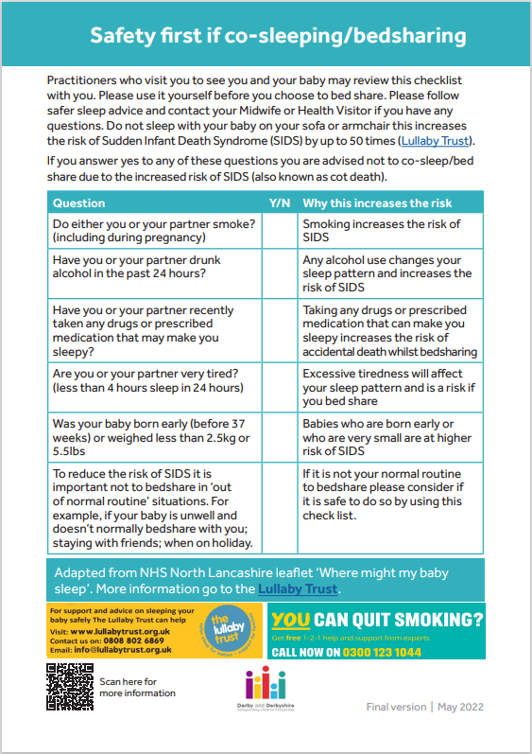

Appendix 5

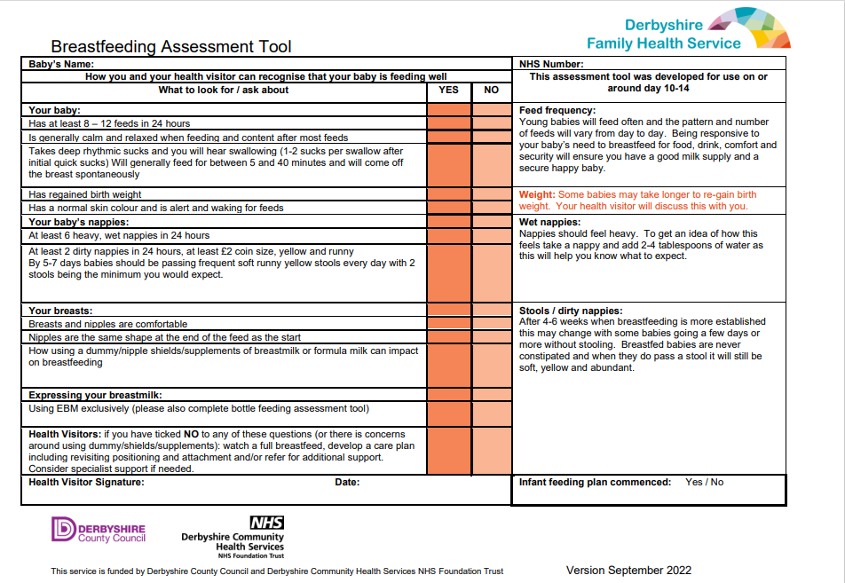

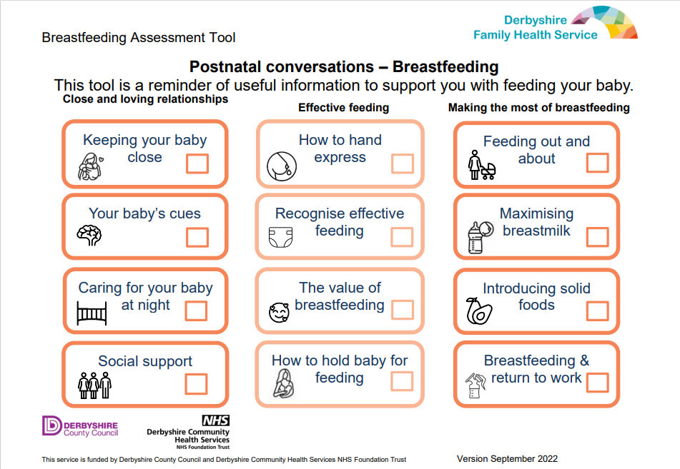

Appendix 6

