Continuum of Need

This document is for use by all practitioners working with children and their families across Dorset, Bournemouth, Christchurch and Poole. It may be seen as the ‘threshold document’ required by Working Together 2018.
The purpose of the document is to help identify a child’s degree of need, ensure support is offered by the right agencies, at the right time and prevent their needs escalating to a higher level. It will help identify when referrals to specialist Children’s Social Care services are required.
The document should be used alongside the Pan-Dorset multi-agency safeguarding policy and procedures.
At no time must disagreement about levels of need prevent a child being safeguarded. The Escalation Policy provides guidance for those concerned that a child’s needs are not recognised.

Contents:

- Levels of vulnerability and need
- Flowchart to support decisions
- Indicators of need
- Sources of further information

Guidance:
- This document refers to children, but includes the unborn, infants, children and young people. Agencies will be aware of child development, rather than chronological age, in applying to individuals. Principles of working with children will always involve their families and networks. They will form part of the ‘Team Around the Family’.
- In the majority of cases, it should be the decision of parents/carers when to ask for help or advice, but there are occasions when practitioners may need to engage them actively to help them and prevent their difficulties from becoming more serious. If seeking consent increases the risk to the child, it can be over-ridden.
- Children who are disabled are entitled to a Section 17 Child in Need (CiN) assessment.
- The need identified in any assessment at Early Help or Children’s Social Care level may be met from across the continuum of need, ie. at different levels of vulnerability.

Levels of Vulnerability and Need
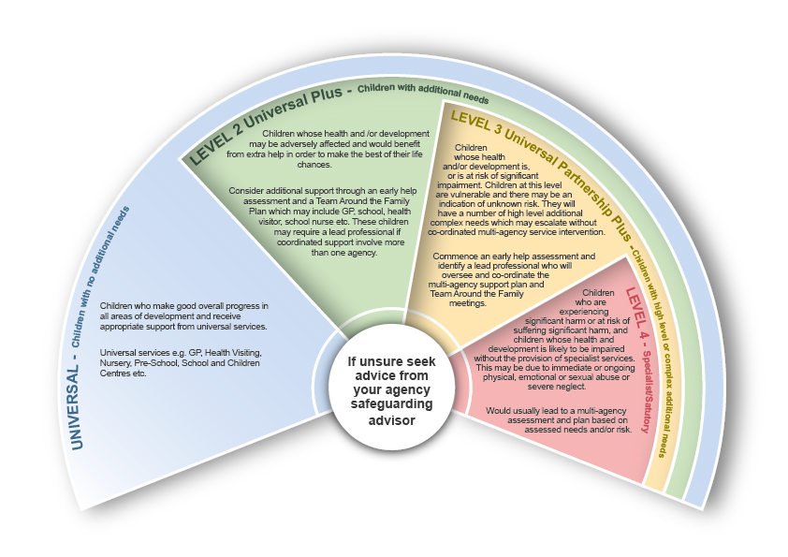
Providing effective support to children and families

Indicators of need at different levels
Note: this is an illustrative rather than comprehensive list of indicators
Childs Developmental Needs  Health, Learning, Emotional and Behavioural Development, Identity, Relationships | Universal | Universal Plus | Universal Partnership Plus | Specialist
 | • Is generally physically well  • Nutritious diet  • Adequate hygiene and dress  • Development and health checks /immunisations up to date  • Developmental milestones and motor skills appropriate  • Good mental health  • Good quality early attachments  • Able to adapt to change  • Understands others’ feelings.  • Takes responsibility for behaviour  • Sexual activity is age-appropriate  • Responds appropriately to boundaries and constructive guidance  • Can discriminate between safe and unsafe contacts.  • Has positive self-image  • Stable and affectionate relationships with family  •Able to make and maintain friendships  • Access to books and toys  • Is provided with appropriate education and learning  • Enjoys and participates in learning activities  • Has experiences of success and achievement  • Sound links between home and education provider  • Planning for career/ adult life  - Unborn with needs met | • Delay in reaching developmental milestones  • Minor concerns re diet, hygiene or clothing  • Dental difficulties untreated/some decay  • Missing some routine and non-routine health appointments  • Concerns about developmental progress: e.g. overweight/underweight, bedwetting/soiling  • Experiments with tobacco/alcohol/ illegal drugs  • Some difficulties with adult or peer relationships e.g. ‘clingy’, anxious or withdrawn  • Limited engagement in play with others/has few or no friends  • Vulnerable to emotional difficulties, perhaps in response to life events such as parental separation  • Finds accepting responsibility for own actions difficult  • Showing early signs of anti-social behaviour/offending  • Some insecurities re identity eg. low self-esteem, lack of confidence, sexuality, gender identity  • May experience bullying or be exhibiting bullying behaviour  • Child/young person in behaviour and or appearance places self at risk of exploitation  • Lack of positive role models  • Has some difficulties sustaining relationships  • Disability limits amount of self-care possible  • Has some identified additional learning needs  • Language and communication difficulties  • Not reaching education potential  • Poor punctuality/pattern of regular education absences/fixed term exclusions  • Not always engaged in play/learning, poor concentration  • No access to books/toys  - Pregnancy with complications or impact of parental lifestyle | • Chronic/recurring health difficulties are not treated or are badly managed  • Developmental milestones are not being met due to parental care  • ‘Unsafe’ sexual activity  • Emerging mental health issues e.g. anxiety, depression, eating disorder  • Self-harming behaviours  • Age inappropriate sexualised behaviour  • Child appears anxious, angry or phobic  • Young carer with development compromised through caring role  • Ongoing, challenging behaviour at school, possible risk of exclusion  • Changed behaviour, reference to radicalised thoughts/ threats to act  • Starting to commit offences/re-offend  • Presentation (including hygiene) significantly impacts on relationships  • Distances self from others  • Significantly poor self-image/identity  • Few positive relationships  • Relationships with carers characterised by unpredictability  • Disability prevents self-care in a significant range of tasks  • Child lacks a sense of safety and often puts him/herself in danger.  • Consistently poor education attendance and punctuality  • Consistently not reaching educational potential  • Child reported missing from home | • Failure to thrive, likely to be due to care provided  • Refusing medical care endangering life/development  • Seriously obese/seriously underweight  • Serious decay from persistent lack of dental care  • Dangerous sexual activity and/or early teenage pregnancy  • Disclosure or suspicion of physical, sexual or emotional abuse or neglect  • Non-accidental injury and/or unexplained injury, particularly in non-mobile children  • Disclosure of abuse/physical injury caused by a professional  • Acute mental health difficulties e.g. severe depression or risk of suicide  • Physical/learning disability needing constant supervision  • Puts self or others in danger  • Persistent and/or high-risk episodes of missing  • Persistent and significant disruptive/challenging behaviour at school, home or in the community  - Serious or persistent offending behaviour  - Evident mental health needs.  • Relationships with family experienced as negative (‘low warmth, high criticism’)  • Rejection by a parent/carer, family no longer willing to care for, or have abandoned child/young person  • Child/young person is out of education or not receiving education due to parental neglect.  • Serious professional concern; family declining services  • Unaccompanied refugee/asylum seeker  • Privately fostered  • Child displaying sexually harmful or abusive behaviour  • Suspected risk of Female Genital Mutilation  - Child involved with serious, persistent, high risk substance misuse  - Unborn baby impacted in utero by neglect/abuse
Parenting Capacity and Family  Basic Care, Ensuring Safety, Emotional Warmth, Stimulation,  Guidance and Boundaries, Stability | Universal | Universal Plus | Universal Partnership Plus | Specialist
 | • Provide for child’s physical needs, e.g. food, drink, equipment, appropriate clothing, medical and dental care  • Protection from danger or harm  • Shows warm regard, praise and encouragement  • Ensures stable relationships  • Ensure the child can develop a sense of right and wrong  • Child/young person accesses play/activities/leisure facilities as appropriate to age and interests  • Good relationships within family, including when parents are separated | • Basic care is not provided consistently  • Parent/carer requires advice on parenting issues  • Inappropriate child care arrangements and/or too many carers  • Some exposure to dangerous situations in the home or community  • Unnecessary or frequent visits to doctor/casualty  • Parent/carer stresses starting to affect ability to ensure child’s safety  • Low level parental substance misuse  • Inconsistent responses to child/young person  • Parents struggling to have their own emotional needs met  • A child/young person is taking on a caring role in relation to their parent/carer or is looking after younger siblings  • No effective support from extended family.  • Parent/carer offers inconsistent boundaries  • Lack of routine in the home  • Provides limited access to new experiences or leisure activities  - Parents sometimes find it difficult to positively resolve conflict in their relationship | • Exposed to domestic abuse or chronic parental conflict within the household or family  • Parent’s mental health difficulties or substance misuse affect care of child/young person  • Child has multiple carers, some of whom may have no significant relationship with them.  • Parental substance misuse impacts on ability to consistently meet child’s needs  • Parents unable to set effective boundaries e.g. too loose/tight  • Parents are consistently unable to act as positive role models  • Parents do not provide access to positive experiences | • Persistent and high-risk parental substance misuse  • Parent/carer’s mental health or substance misuse significantly affects care of child  • Pregnant parents/carers who have been unable to care for previous children  • Parent/carer is failing to provide safe physical care or emotional support to child  • Parents/carers involved in violent or serious crime or criminal offences against children  • Non-compliance of parents/carers with services where risk of harm to child has been identified  • Parents/carers own needs mean they are unable to keep child/young person safe  • Severe disability – parents who require additional support and breaks in care to meet care needs  • Chronic and serious domestic abuse in the home  • Disclosure from parent of abuse to child/young person  • Suspected/evidence of fabricated or induced illness.  • Child has no-one to care for him/her  • Request for child to be accommodated.  • No effective boundaries set by parents/carers  • Child beyond parental control  • Contact with individual posing a suspected or known risk to children  • Family home used for drug taking, sex trade or other illegal activities
Environmental and Contextual Factors  Community, Social Integration, Income and Employment  Housing, Criminal and Exploitation Risks | Universal | Universal Plus | Universal Partnership Plus | Specialist
 | • Accommodation has basic amenities and appropriate facilities to meet family needs  • Managing budget to meet individual needs  • Is able to access local services and amenities  • Family feels part of the community | • Family seeking asylum or are refugees  • Periods of unemployment of parent/carer  • Parents/carers have limited formal education or are impacted by other disadvantage  • Low income or financial/debt difficulties/rent arrears  • Unsuitable accommodation/intentionally homeless  • Not in education, employment or training post-16  Some social exclusion or conflict experiences or victim of crime or bullying  • Child subject to persistent discrimination, e.g. racial, sexual, disability  • Difficulty accessing community facilities  - Parent/carer serving a prison sentence  - Emerging behaviours which are seen as being anti-social or violent | • Chronic unemployment or poverty that severely affected parents’ ability to meet the child’s needs  • Home conditions present a risk to child’s safety or health  • Family have physical and mental health difficulties impacting on their child  • Community is hostile to family.  • Child/young person experiences persistent discrimination which is internalised and reflected in poor self-image  • Known to be at risk of exploitation, sexual exploitation, violence, criminality or radicalisation | • Homeless, or imminent homelessness if not accepted by housing department  • Home conditions are dangerous or seriously threatening to health  • Physical accommodation places child in danger  • Extreme poverty/debt impacting on ability to care for child  • Child/young person is assessed as at risk of sexual or criminal exploitation, including through trafficking, cuckooing and County Lines  • Child/young person is at risk of radicalisation  • Child/young person is known to be carrying weapons  • Child/young person has known involvement with gangs or organised crime group  - Child/young person persistently involved with the supply of illegal substances

Sources of further information:

- Early Help Services:

- Dorset area – see Dorset Council Children’s Advice and Duty Service numbers below
- Bournemouth,Christchurch and Poole area – https://www.earlyhelppartnership.org.uk

- Children’s Social Care

BCP Area Children’s First Response Hub - 01202 123334
childrensfirstresponse@bcpcouncil.gov.uk
There is also a revised Inter-agency referral form for practitioner referrals

Dorset Council Children’s Advice and Duty Service: Professional’s Helpline – 01305 228558
Early Help (same numbers) – request Early Help Hub Families and the general public helpline – 01305 228866
childrensadviceanddutyservice@dorsetcouncil.gov.uk
Referral via telephone consultation, no requirement to complete inter-agency referral form.

3. Child and Adolescent Mental Health Services (CAMHS)
- Referral Guidance
- Referral form
4. Pan-Dorset Multi Agency Safeguarding Policies and Procedures
Includes: Making a Good Referral, Information Sharing Guidance and the Escalation Policy
5. Government Guidance
- Working Together to Safeguard Children 2018 (Statutory Guidance)
- Keeping Children Safe in Education
- The Children Act 2004 – This Act sets out the primary duties for all agencies in Sections 10 and 11

