 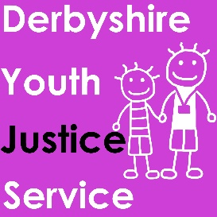

**Co-Production Strategy**

**Giving young people a voice in**

**Derbyshire Youth Justice Service**

**Introduction: Listening to our children and young people in the youth justice system. Our vision:**

Services which seek to prevent crime and address the needs of victims are more likely to be effective if they are informed by and co-designed with young people drawing upon their experience and creativity.

We believe that all children and young people in the youth justice system should have:

* The opportunity to be involved in decisions about their care and supervision
* The ability to tell us what should be in any plan made with them
* The opportunity to regularly meet as a group to feedback and contribute to service development
* Access to the services they need and a say in how those services work.
* Involvement in who, we and our partners appoint to jobs
* Involvement in any decisions which change how we work with children and families
* The right to formally complain and be supported in doing so
* Representation by a young person, or young people at meetings which make big decisions

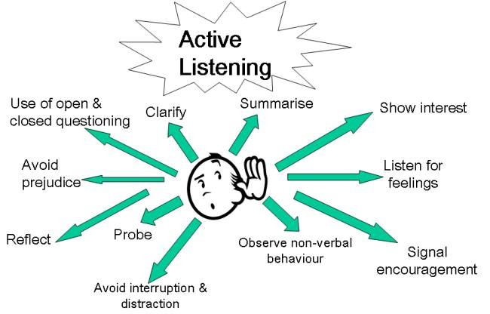

Engaging with and listening to children and young people is essential in achieving these aims and will be at the heart of service design and delivery for all partners. At the end of each calendar year, we, with young people will produce a report outlining what activities and influence our young people have had.

***‘Participation is a process where someone influences decisions about their lives, and this leads to change’. - Treseder's (1997)***

**Our approach to participation:**

Participation can also be described as co-design, co-production or shared decision making – but at its heart it means work with and by young people, not merely work for them. This can range from them giving opinions on a particular issue, (consulted and informed) to choosing their own agenda and taking their own approach (child initiated and directed).

We want to see Article 12 of the United Nations Convention for Rights of the Child become a reality for children in the youth justice system:

*Children have the right to say what they think should happen, when adults are making decisions that affect them, and to have their opinions considered.*

*Values*

* Children and young people have equal worth to adults
* All children and young people are experts in their own lives
* Children and young people have the right to be involved in all decisions making that affects their lives
* Children and young people’s participation in decision making is key to improving their well being
* Participation is about making everyday choices as well as seeking to influence wider public decision making and social change
* Everyone who works with children and young people has a responsibility to encourage and support their active involvement in decision making
* A commitment to children's human rights is key to achieving improved outcomes for children and young people

**Standards**

To get better at listening to the voices of young people, we will follow standards for participation practice as detailed by The Youth Justice Board. These are the core principles that will underpin our work around participation:

**1. Voluntary** -participation must be voluntary and children and young people should have enough information and time to make informed decisions.

**2. Inclusive** - every child and young person has the same chance to participate in a way that they are comfortable with and that they understand.

3. **Young people’s voices are to be heard and respected** – young people’s views will be taken seriously and listened to.

**4. Young people will get something out of it** – activities will be interesting, enjoyable, and young people should learn something from the experience.

**5. We will let young people know what has happened** – young people will be told what difference their involvement has had. Time will also be taken to explain why some suggestions could not be acted on.

**6. Improving services** – young people’s views should be used to improve services and achieve better outcomes for them and their communities.

The above model compliments the ‘Lundy Model’ of Co-Production used across Derbyshire County Council. This is a simple approach that is used when considering how to include a child’s voice in our work. This approach consists of 4 elements:

**Space:** Children must be given safe, inclusive opportunities to form and express their view.

**Voice:** Children must be facilitated to express their view.

**Audience:** The view must be listened to.

**Influence:** The view must be acted upon, as appropriate.

**Derbyshire Youth Justice Service will introduce the following activities in relation to Participation and Co-Creation:**

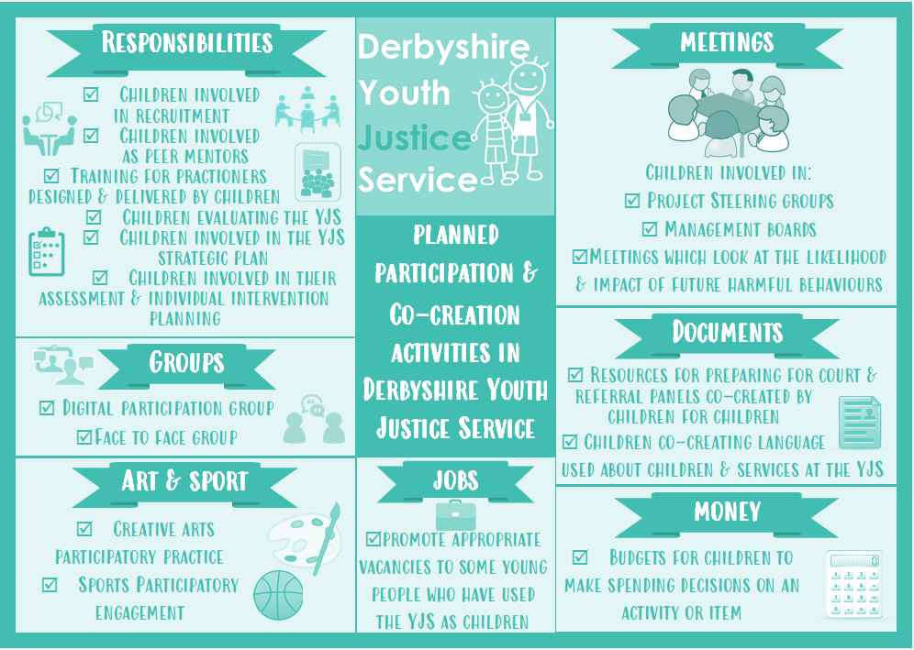

**How we will achieve our vision:**

The following tables set out our action plan for delivering this participation strategy. These are the practical ways we will start to make sure the voices of young people

listened to and taken account of in our work.

|  |  |  |  |
| --- | --- | --- | --- |
| Participation and Co Creation - Change Required | How it will be achieved | Stakeholder(s) | Completion Date |
| Establish clear processes for participation and co-production within DYJS | - Appoint team champions to lead on participation and co creation.  - Set up bi-monthly Youth Forum for Children and Young People (CAYP) with experience of YJS.  - Obtain views of CAYP around full range of possible participation and co-production activities using methods from Lundy Model. | YJS Management Team/ YJS staff  YJS staff/ CAYP  YJS staff / CAYP/ DCC Digital Media department/ DCC Central participation team. |  |
| Devolved budget for activities around participation and co-production | -Agree how CAYP will be paid for their time.  -Agree extended budget for Personalised Health Budget.  - Produce projected spend for budget. | CAYP / Lead manager and team champions / Partnership Board. |  |
| Compile annual plan for participation and co-production. | -Analyse results of action 1 and 2 above.  -Co produce Action Plan.  -Present to Partnership Board for approval.  -Remunerate CAYP for their time. | -Youth Forum / Team Champions.  Youth Forum / Team Champions.  Representative from Youth Forum.  Team Champions. |  |