Bournemouth, Christchurch, and Poole
Practice Guidance for Frontline Practitioners
Working with Victims/Survivors of Domestic Abuse

Protective Marking | None
Produced by: | Lisa Dowry, Domestic Abuse and Sexual Manager, Safer Poole, Manager
Version | 22 (August 2017)
Updated: | June 2023 to remove references to Dorset now that the HRDA arrangements have replaced MARAC in Dorset.

Contents Page

- Introduction 3

- Recognising Domestic Abuse 4

- Responding to Disclosures of Domestic Abuse 5

- Staff Training 9

Appendices

- SAFELIVES DASH Risk Indicator Checklist 11
- Useful Contact Numbers 12
- Safety Planning 16
- Impact of Domestic Abuse on Children and Young People 20
- Power and Control Wheel 21
- Equality Wheel 22

1. Introduction

Purpose of the Guidance

This guidance has been developed to assist frontline practitioners when responding to disclosures and supporting victims/survivors of domestic abuse.

It is important to use this guidance to ensure there is a consistence response to victim/survivors across all agencies, with the aim to reduce the risk and harm caused to victims/survivors and their families.

Who should use this guide
Social workers
GP’s
Midwives
Health Visitors
Accident and Emergency staff
Drug and Alcohol workers
Children’s Centre staff
Schools
Police
Probation Officers
Housing Officers

Please note the above is not an exhaustive list.

Definition of domestic abuse/violence
The cross-government definition of domestic abuse violence is:
“Any incident or pattern of incidents of controlling coercive or threatening behaviour, violence or abuse between those aged 16 or over who are or have been intimate partners or family members regardless of gender or sexuality. This can encompass but not limited to, the following types of abuse: psychological, physical, sexual, financial and emotional.”

Controlling behaviour is a range of acts designed to make a person subordinate and/or dependent by isolating them from sources of support, exploiting their resources and capacities for personal gain, depriving them of the means needed for independence, resistance and escape and regulating their everyday behaviour.

Coercive behaviour is an act or a pattern of acts of assault, threats, humiliation and intimidation or other abuse that is used to harm, punish, or frighten their victim

This definition incorporates abuse between family members (including children to parents/grandparents, between siblings), partners in intimate relationships and includes honour based violence, forced marriage and female genital mutilation.

2, Recognising Domestic Abuse

There is no way to tell for sure if someone is experiencing domestic abuse. Those who are abused, and those who abuse, come in all personality types. Victims are not always passive with low self-esteem, and abusers are not always violent or hateful to their partner in front of others. Most people experiencing relationship abuse do not tell others what goes on at home.

Signs to look for:

- Explanation for visible injuries seems questionable. Where there are repeated visible injuries, the abused partner may talk about being clumsy, or have elaborate stories of how the injuries occurred.
- There may be references to the abusive partner’s anger.
- One partner keeps changing or losing jobs or "cannot" work because of their partners' disapproval or actions.
- Appointments may be continually cancelled for vague or spurious reasons. The victim may lack independence, due to lack of transport or money, and may not be given access to a telephone.

Things you may see:

- If you meet with both partners, you are aware that one fears the other.
- The non-abusing partner may always be accompanied by his/her partner or another person.
- Someone who, on their own, appears to have confidence and a healthy self esteem is without confidence and self esteem in the presence of his or her partner. This happens because the non-abusing partner "walks on egg shells" in the presence of the abuser.
- You may notice one partner taking all of the blame for things that go wrong and the other partner blaming. If you notice this happening a lot, it may be a sign that the person taking all of the blame is being abused.
- One partner puts the other down, for example, by name-calling, constant criticism, or humiliation (often disguised as a joke).
- One partner gets angry in a way that scares the other partner or observers.
- The abuser may try to speak for the non-abusing partner in order to control the information that is shared.

It is important to remember that abusers are often very charming and convincing to everyone – including their partners, until the abuse starts - and then they often continue to be very charming to everyone else except their victim. This often has the effect of making the victim feel "it must be my fault," especially since the abuser is usually telling them it is.

3, Responding to Disclosures of Domestic Abuse

Barriers to disclosures

There are many barriers to someone disclosing domestic abuse. A victim/survivor may:

- Minimise their experiences and/or not define them as domestic abuse
- Fear that the child/ren will be taken into care
- Fear the perpetrator will find them again through lack of confidentiality
- Believe the perpetrators promise that it will not happen again
- Many victims/survivors do not necessarily want to leave the relationship, they just want the violence to stop
- Feel shame and embarrassment and may believe it is their fault
- Feel they will not be believed
- Fear they will be deported
- Fear that the status of the perpetrator will be exposed and the victim/survivor will be punished with an escalation of violence
- Be scared of the future (where to go, what to do for money, whether they will have to hide forever and what will happen to the children)
- Be isolated from friends and family or be prevented from leaving the home or reaching out for help

Enabling Disclosure

Screening for domestic abuse/ violence through safe enquiry
Incorporating safe enquiry about domestic abuse into assessments is an effective way of increasing disclosure: and evidence suggests that victims of domestic abuse are more likely to disclose if asked directly.
Safe enquiry can be incorporated into a standard assessment or carried out if there is a suspicion a person may be experiencing domestic abuse.
Victims/survivors are usually too afraid or uncomfortable to raise the issue of domestic abuse themselves. There are a range of questions that will enable a disclosure. Questions must be asked sensitively and incorporated into the conversation and not asked as a list of questions.
Indirect questions:
- Is everything all right at home?
- Is your partner supportive?
- Do you ever feel frightened of your partner or other people at home?

Direct Questions:
The conversation can be started by saying “I don’t wish to cause you any offence but we know domestic abuse is common and that many people experience abuse in the home at some time during their life. Can I ask if this has ever happened to you?

- Are you in a relationship in which you have been physically hurt or threatened by your partner?
- What happens when you and you partner disagree?
- Has your partner destroyed things that you care about?
- Does your partner try to control you? For example: prevented you from leaving the house, seeing friends, getting a job or continuing in education?
- Is your partner verbally abusive? For example, insults you or makes you feel bad about yourself.
- Do you fell you have to walk on eggshells around your partner?

Disclosure of Domestic Abuse
If a person discloses they are experiencing domestic abuse or a disclosure is made through safe enquiry the following procedure must be followed:

Safeguarding Children and Vulnerable adults
Any concerns regarding the welfare of a child or vulnerable adult must be reported to either children’s or adult social care. Speak to your manager and always follow your safeguarding policies and procedures. You have a legal duty to protect children and vulnerable adults from harm.

Risk Assessment
Complete the SAFELIVES Domestic Abuse Stalking and Honour Based Violence Risk Indicator Checklist (DASH). (Appendix A).
Before completing the form for the first time we recommend that you read the full practice guidance and Frequently Asked Questions and Answers. These can be downloaded from http://www.safelives.org.uk/node/516

Referral criteria for MARAC:

- Cases can be referred to MARAC: If a professional has serious concerns about a victim’s situation, they should refer the case to MARAC. There will be occasions where the particular context of a case gives rise to serious concerns even if the victim has been unable to disclose the information that might highlight the risk more clearly. This could reflect extremes level of fear, cultural barriers particularly in cases of honour based violence. This judgement would be based on the professionals experience and/or the victims perception of the risk even if they don’t meet the criteria below

- ‘Visible High Risk’: If you have ticked 14 or more ‘yes’ boxes, the case would meet the MARAC referral criteria

If the person meets the criteria a MARAC referral should be made by completing a MARAC referral form. This can be found in Appendix 1 or on the following website:
Risk assessment and how to refer to the MARAC (bcpcouncil.gov.uk)

Please note all referrals must be sent through a secure email address and emailed to MARAC@Dorset.PNN.Police.uk

Alternately you can seek advice from your MARAC representative, if your agency is represented at the MARAC.

Domestic Abuse Advisors
The Police refer all referrals to MARAC to a Domestic Abuse Advisor (DAA). A DAA is a professional case worker for domestic abuse victims whose primary purpose is to address the safety of ‘high risk’ victims and their children. Serving as point of contact, DAAs normally work with their clients form the point of crisis to assess the level of risk, discuss the range of suitable options and develop coordinated safety plans. DAA’s implement safety plans which include practical steps to protect victims/survivors and their children, as well as longer term solutions.

For information on MARAC training please contact: http://www.poole.gov.uk/communities-andpeople/crime-and-disorder/safer-poole-partnership/training/

When a case does not meet the MARAC criteria, it is recommended that the person is referred to local domestic abuse outreach services. Contact numbers can be found in Appendix B

If the person declines the referral ensure you give the victim/survivor information on local domestic abuse services, should the victim/survivor decide to contact them at a later date.

Supporting Victims/Survivors

When providing support to victims/survivors it is important to do the following:

- Assess the circumstances and need of victims/survivor
- Assess the pattern and history of the abuse
- Assess the immediate safety need of the victim/survivor – are they in immediate danger? Where is the Perpetrator now? Where will the victim/survivor be spending the night? What is the risk to the children?
- Respect the wishes of the victim/survivor. The wishes of the victim/survivor are of the upmost importance when dealing with reports or disclosures of domestic abuse. The circumstances of each victim/survivor are different and may require a different approach or response. Your role is not to stop the violence or take the victim/survivor out of the abusive situation. Your role is to: support and assist the victim/survivor in his/her circumstances. It is important to bear in mind that not all victims/survivors are prepared to leave the violent environment and there may be a multiplicity of factors influencing the victim’s action, inaction, decision or indecision.
- Advise the victim/survivor of their options in relation to housing, injunctions, reporting to the police and target hardening. This list is not exhaustive.
- Do not attempt to coerce a victim or complainant to seek further assistance or take more action than s/he wishes.
- If the victim/survivor says that s/he feels s/he is in danger, take this very seriously.
- If the victim/survivor is planning to leave the perpetrator, advise them that this needs to be planned and support them with planning to leave. Always advise them not to leave when their partner is around.
- Never advise a victim/survivor to leave their partner. It has to be the victims/survivors decision to leave, when they are ready to do so. Leaving an abusive relationship is difficult and is a process. It is normal for victim/survivors to leave and return many times. The risk to victims/survivors increases upon separation, so if they do decide to leave it has to be carefully planned.
- Make referrals to other relevant agencies, for example, mental health and substance misuse services, should the victims present with these issues.
- Refer to specialist domestic abuse services. A list of services can found in Appendix 2.
- Provide the victim with information about domestic abuse, ensuring that there is a safe place to store the information and the perpetrator is not able to catch sight of it.
- Never suggest mediation between the victim/survivor and perpetrator.

Listen to the victim/survivor and provide validating messages:
- "You don’t deserve this. There is no excuse for domestic violence. You deserve better."
- "I am concerned. This is harmful to you (and it can be harmful to your children)."
- "This is complicated. Sometimes it takes time to figure this out."
- "You are not alone in figuring this out. There may be some options. I will support your choices."
- I am glad you told me. I want to work together to keep you as safe and healthy as possible."
- "Stopping the abuse is the responsibility of your partners, not yours"

Safety Planning
Safety planning is the process of evaluating the risks and identifying ways to reduce those risks. A safety plan is a way of helping victims/survivors to protect themselves and their children. It helps to plan in advance for the possibility of future violence and abuse and helps victims/survivors to think about how they can increase their safety either within the relationship, or if they decide to leave.
It is best practice when working with people who are experiencing domestic abuse to routinely develop a safety plan with them, as the safety of the victim/survival is crucial.
Examples of safety plans can be found in Appendix 3. Please note that these are only guidelines. When developing a safety plan it should be based on the individual circumstances and the risks identified. It is important to consider the risk to the children; safety plans should recognise and address the risks identified to the children.

Protective Factors
Protective factors are factors which the victim/survivor has in place which can reduce the risk. These are as follow:
- Victim/survivor acknowledges the domestic abuse and does not minimise or deny the abuse
- Victim/survivor understands the impact of the abuse on the children
- There is the presence of a stable adult (usually a non substance user)
- Victim/survivor has good support networks
- There is a positive family environment
- Victim/survivor calls police
- Victim is engaging with specialist domestic abuse services
- Victim/survivor is protected by bail conditions, restraining order or injunction
If none of the protective factors are present. There will be an increase in the risk of harm to the victim/survivor and children.

Record Keeping
- Keep detailed, accurate records about a victim/survivor’s injuries and what they reveal to you.
- Ensure that records are safe from interception/sighting by a third party e.g. in the case where entire families are included in one file. Never record information where the perpetrator could gain access to the file
- Keep a record of the content of the discussion
- Use client’s own words. Avoid words like alleges and claims, they imply disbelief. For example write “Mary told me that...”
- Even if your suspicions of abuse haven’t led to a disclosure, keep a record of what was discussed.

4, Staff Training

All staff members and/or volunteers (whether new employees/volunteers or persons employed or volunteering for some time) who are likely to interact with victims/survivors of domestic abuse should receive training to sensitise them to the needs, vulnerabilities, difficulties and issues affecting victims of domestic abuse.

For more information on domestic abuse training: http://www.poole.gov.uk/communities-andpeople/crime-and-disorder/safer-poole-partnership/training/

Referral Pathway for Domestic Abuse
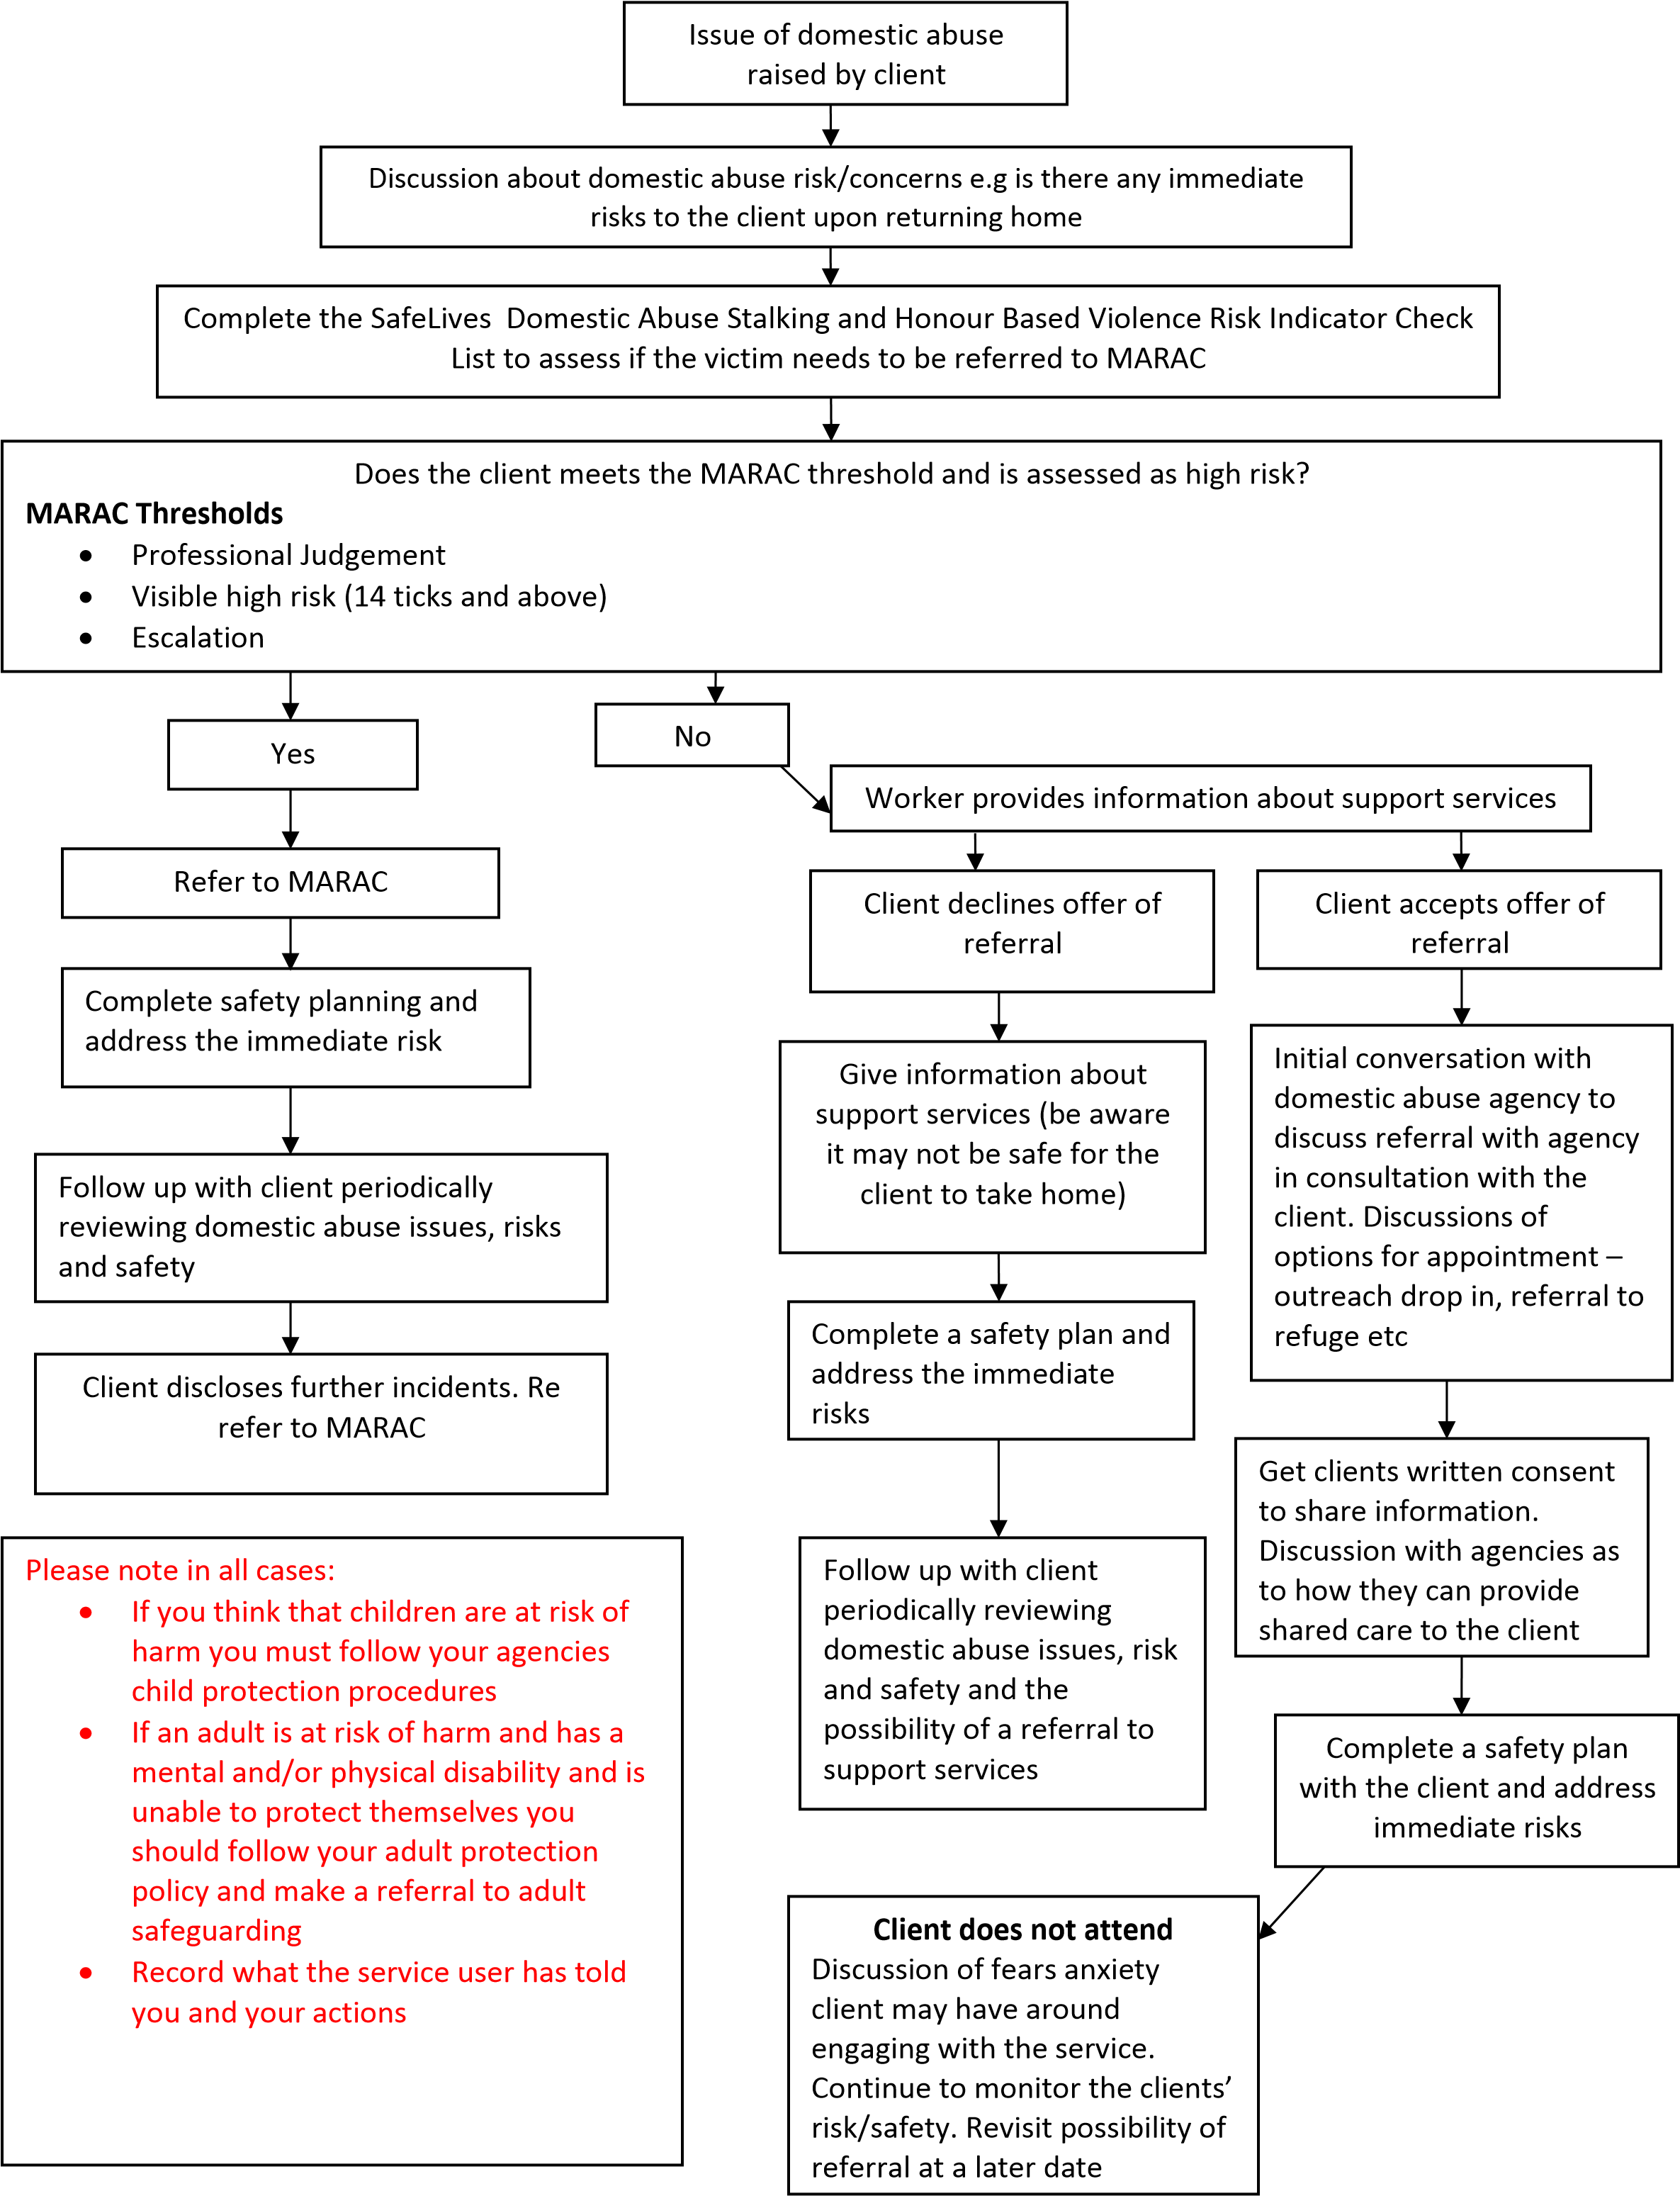

SafeLives Dash risk checklist Quick start guidance
You may be looking at this checklist because you are working in a professional capacity with a victim of domestic abuse. These notes are to help you understand the significance of the questions on the checklist. Domestic abuse can take many forms but it is usually perpetrated by men towards women in an intimate relationship such as boyfriend/girlfriend, husband/wife. This checklist can also be used for lesbian, gay, bisexual relationships and for situations of ‘honour’-based violence or family violence. Domestic abuse can include physical, emotional, mental, sexual or financial abuse as well as stalking and harassment. They might be experiencing one or all types of abuse; each situation is unique. It is the combination of behaviours that can be so intimidating. It can occur both during a relationship or after it has ended.

The purpose of the Dash risk checklist is to give a consistent and simple tool for practitioners who work with adult victims of domestic abuse in order to help them identify those who are at high risk of harm and whose cases should be referred to a Marac meeting in order to manage their risk. If you are concerned about risk to a child or children, you should make a referral to ensure that a full assessment of their safety and welfare is made.

The Dash risk checklist should be introduced to the victim within the framework of your agency’s:
- Confidentiality policy
- Information sharing policy and protocols
- Marac referral policies and protocols

Before you begin to ask the questions in the Dash risk checklist:
- Establish how much time the victim has to talk to you: is it safe to talk now? What are safe contact details?
- Establish the whereabouts of the perpetrator and children
- Explain why you are asking these questions and how it relates to the Marac

While you are asking the questions in the Dash risk checklist:
- Identify early on who the victim is frightened of – ex-partner/partner/family member
- Use gender neutral terms such as partner/ex-partner. By creating a safe, accessible environment LGBT victims accessing the service will feel able to disclose both domestic abuse and their sexual orientation or gender identity.

Revealing the results of the Dask risk checklist to the victim
Telling someone that they are at high risk of serious harm or homicide may be frightening and overwhelming for them to hear. It is important that you state what your concerns are by using the answers they gave to you and your professional judgement.
It is then important that you follow your area’s protocols when referring to Marac and Children’s Services. Equally, identifying that someone is not currently high risk needs to be managed carefully to ensure that the person doesn’t feel that their situation is being minimised and that they don’t feel embarrassed about asking for help. Explain that these factors are linked to homicide and serious harm and that if s/he experiences any of them in future, that they should get back in touch with your service or with the emergency services on 999 in an immediate crisis.

Please pay particular attention to a practitioner’s professional judgement in all cases. The results from a checklist are not a definitive assessment of risk. They should provide you with a structure to inform your judgement and act as prompts to further questioning, analysis and risk management whether via a Marac or in another way. The responsibility for identifying your local referral threshold rests with your local Marac.

Resources
Be sure that you have an awareness of the safety planning measures you can offer, both within your own agency and other agencies. Be familiar with local and national resources to refer the victim to, including specialist services. The following websites and contact details may be useful to you:

- National Domestic Violence Helpline (tel: 0808 2000 247) for assistance with refuge accommodation and advice.
- _{‘Honour’ Helpline} (tel: 0800 5999247) for advice on forced marriage and ‘honour’ based violence.
- Sexual Assault Referral Centres (http://www.rapecrisis.org.uk/Referralcentres2.php) for details on SARCs and to locate your nearest centre.
- Broken Rainbow (tel: 08452 604460 / web: www.brokenrainbow.org.uk) for advice for LGBT victims) for advice and support for LGBT victims of domestic abuse.

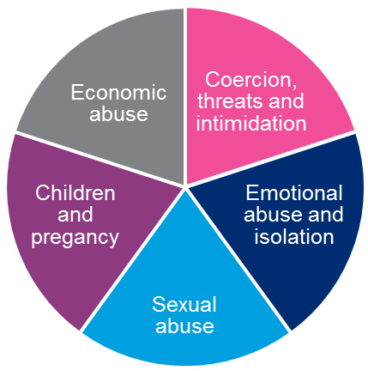
Asking about types of abuse and risk factors

Physical abuse
We ask about physical abuse in questions 1, 10, 11, 13, 15, 18, 19 and 23.

- Physical abuse can take many forms from a push or shove to a punch, use of weapons, choking or strangulation.
- You should try and establish if the abuse is getting worse, or happening more often, or the incidents themselves are more serious. If your client is not sure, ask them to document how many incidents there have been in the last year and what took place. They should also consider keeping a diary marking when physical and other incidents take place.
- Try and get a picture of the range of physical abuse that has taken place. The incident that is currently being disclosed may not be the worst thing to have happened.
- The abuse might also be happening to other people in their household, such as their children or siblings or elderly relatives.
- Sometimes violence will be used against a family pet.
- If an incident has just occurred the victim should call 999 for assistance from the police. If the victim has injuries they should try and get them seen and documented by a health professional such as a GP or A&E nurse.

Sexual abuse
We ask about whether the victim is experiencing any form of sexual abuse in question 16.

- Sexual abuse can include the use of threats, force or intimidation to obtain sex, deliberately inflicting pain during sex, or combining sex and violence and using weapons.
- If the victim has suffered sexual abuse you should encourage them to get medical attention and to report this to the police. See above for advice on finding a Sexual Assault Referral Centre which can assist with medical and legal investigations.

Coercion, threats and intimidation
Coercion, threats and intimidation are covered in questions 2, 3, 6, 8, 14, 17, 18, 19, 23 and 24.

- It is important to understand and establish: the fears of the victim/victims in relation to what the perpetrator/s may do; who they are frightened of and who they are frightened for (e.g. children/siblings). Victims usually know the abuser’s behaviour better than anyone else which is why this question is significant.
- In cases of ‘honour’ based violence there may be more than one abuser living in the home or belonging to the wider family and community. This could also include female relatives.
- Stalking and harassment becomes more significant when the abuser is also making threats to harm themselves, the victim or others. They might use phrases such as “If I can’t have you no one else can…”
- Other examples of behaviour that can indicate future harm include obsessive phone calls, texts or emails, uninvited visits to the victim’s home or workplace, loitering and destroying/vandalising property.
- Advise the victim to keep a diary of these threats, when and where they happen, if anyone else was with them and if the threats made them feel frightened.
- Separation is a dangerous time: establish if the victim has tried to separate from the abuser or has been threatened about the consequences of leaving. Being pursued after separation can be particularly dangerous.
- Victims of domestic abuse sometimes tell us that the perpetrators harm pets, damage furniture and this alone makes them frightened without the perpetrator needing to physically hurt them. This kind of intimidation is common and often used as a way to control and frighten.
- Some perpetrators of domestic abuse do not follow court orders or contact arrangements with children. Previous violations may be associated with an increase in risk of future violence.
- Some victims feel frightened and intimidated by the criminal history of their partner/ex-partner. It is important to remember that offenders with a history of violence are at increased risk of harming their partner, even if the past violence was not directed towards intimate partners or family members, except for ‘honour’based violence, where the perpetrator(s) will commonly have no other recorded criminal history.

Emotional abuse and isolation
We ask about emotional abuse and isolation in questions 4, 5 and 12. This can be experienced at the same time as the other types of abuse. It may be present on its own or it may have started long before any physical violence began. The result of this abuse is that victims can blame themselves and, in order to live with what is happening, minimise and deny how serious it is. As a professional you can assist the victim in beginning to consider the risks the victim and any children may be facing.

- The victim may be being prevented from seeing family or friends, from creating any support networks or prevented from having access to any money.
- Victims of ‘honour’ based violence talk about extreme levels of isolation and being ‘policed’ in the home. This is a significant indicator of future harm and should be taken seriously.
- Due to the abuse and isolation being suffered victims feel like they have no choice but to continue living with the abuser and fear what may happen if they try and leave. This can often have an impact on the victim’s mental health and they might feel depressed or even suicidal.
- Equally the risk to the victim is greater if their partner/ex-partner has mental health problems such as depression and if they abuse drugs or alcohol. This can increase the level of isolation as victims can feel like agencies won’t understand and will judge them. They may feel frightened that revealing this information will get them and their partner into trouble and, if they have children, they may worry that they will be removed. These risks are addressed in questions 21 & 22.

Children and pregnancy
Questions 7, 9 and 18 refer to being pregnant and children and whether there is conflict over child contact.

- The presence of children including stepchildren can increase the risk of domestic abuse for the mother. They too can get caught up in the violence and suffer directly.
- Physical violence can occur for the first time or get worse during pregnancy or for the first few years of the child’s life. There are usually lots of professionals involved during this time, such as health visitors or midwives, who need to be aware of the risks to the victim and children, including an unborn child.
- The perpetrator may use the children to have access to the victim, abusive incidents may occur during child contact visits or there may be a lot of fear and anxiety that the children may be harmed.
- Please follow your local Child Protection Procedures and Guidelines for identifying and making referrals to Children’s Services.

Economic abuse
Economic abuse is covered in question 20.

- Victims of domestic abuse often tell us that they are financially controlled by their partners/ex-partners. Consider how the financial control impacts on the safety options available to them. For example, they may rely on their partner/ex-partner for an income or do not have access to benefits in their own right. The victim might feel like the situation has become worse since their partner/ex-partner lost their job.
- The Citizens Advice Bureau or the local specialist domestic abuse support service will be able to outline to the victim the options relating to their current financial situation and how they might be able to access funds in their own right.

We also have a library of resources and information about training for frontline practitioners at http://safelives.org.uk/practice-support/resources-frontline-domesticabuse-workers-and-idvas

Other Marac toolkits and resources
If you or someone from your agency attends the Marac meeting, you can download a
Marac Representative’s Toolkit here: http://safelives.org.uk/sites/default/files/resources/Representatives%20toolkit_0.pdf. This essential document troubleshoots practical issues around the whole Marac process.

Other frontline Practitioner Toolkits are also available from http://safelives.org.uk/practice-support/resources-marac-meetings/resources-peoplereferring. These offer a practical introduction to Marac within the context of a professional role. Please signpost colleagues and other agency staff to these toolkits where relevant:

A&E  Ambulance Service  BAMER Services  Children and Young People’s Services  Drug and Alcohol  Education  Fire and Rescue Services  Family Intervention Projects  Health Visitors, School Nurses &  Community Midwives  Housing  Independent Domestic Violence  Advisors | LGBT Services  Marac Chair  Marac Coordinator  Mental Health Services for Adults  Police Officer  Probation  Social Care Services for Adults  Sexual Violence Services  Specialist Domestic Violence Services  Victim Support  Women’s Safety Officer

For additional information and materials on Multi-agency risk assessment conferences
(Maracs), please see the
http://safelives.org.uk/sites/default/files/resources/The%20principles%20of%20an%20 effective%20MARAC%20%28principles%20only%29%20FINAL.pdf. This provides guidance on the Marac process and forms the basis of the Marac quality assurance process and national standards for Marac.

SafeLives Dash risk checklist

Aim of the form
- To help front line practitioners identify high risk cases of domestic abuse, stalking and ‘honour’-based violence.
- To decide which cases should be referred to Marac and what other support might be required. A completed form becomes an active record that can be referred to in future for case management.
- To offer a common tool to agencies that are part of the Marac process and provide a shared understanding of risk in relation to domestic abuse, stalking and
‘honour’-based violence.
- To enable agencies to make defensible decisions based on the evidence from extensive research of cases, including domestic homicides and ‘near misses’, which underpins most recognised models of risk assessment.

How to use the form
Before completing the form for the first time we recommend that you read the full practice guidance and FAQs. These can be downloaded from: http://safelives.org.uk/sites/default/files/resources/FAQs%20

Recommended referral criteria to Marac
- Professional judgement: if a professional has serious concerns about a victim’s situation, they should refer the case to Marac. There will be occasions where the particular context of a case gives rise to serious concerns even if the victim has been unable to disclose the information that might highlight their risk more clearly. This could reflect extreme levels of fear, cultural barriers to disclosure, immigration issues or language barriers particularly in cases of ‘honour’-based violence. This judgement would be based on the professional’s experience and/or the victim’s perception of their risk even if they do not meet criteria 2 and/or 3 below.

- ‘Visible High Risk’: the number of ‘ticks’ on this checklist. If you have ticked 14 or more ‘yes’ boxes the case would normally meet the Marac referral criteria.

- Potential Escalation: the number of police callouts to the victim as a result of domestic violence in the past 12 months. This criterion can be used to identify
about%20Dash%20FINAL.pdf. Risk is dynamic and can change very quickly. It is good practice to review the checklist after a new incident. Please pay particular attention to a practitioner’s professional judgement in all cases. The results from a checklist are not a definitive assessment of risk. They should provide you with a structure to inform your judgement and act as prompts to further questioning, analysis and risk management whether via a Marac or in another way. The responsibility for identifying your local referral threshold rests with your local Marac.

What this form is not
This form will provide valuable information about the risks that children are living with but it is not a full risk assessment for children. The presence of children increases the wider risks of domestic violence and step children are particularly at risk. If risk towards children is highlighted you should consider what referral you need to make to obtain a full assessment of the children’s situation.

SafeLives Dash risk checklist for use by Idvas and other non-police agencies for identification of risks when domestic abuse, ‘honour’- based violence and/or stalking are disclosed

Please explain that the purpose of asking these questions is for the safety and protection of the individual concerned.  Tick the box if the factor is present. Please use the comment box at the end of the form to expand on any answer.  It is assumed that your main source of information is the victim. If this is not the case, please indicate in the right hand column | YES | NO | DON’T KNOW | State source of info if not the victim (eg police officer)
1. Has the current incident resulted in injury?  Please state what and whether this is the first injury. | ☐ | ☐ | ☐
2. Are you very frightened?  Comment: | ☐ | ☐ | ☐
3. What are you afraid of? Is it further injury or violence?  Please give an indication of what you think [name of abuser(s)] might do and to whom, including children. Comment: | ☐ | ☐ | ☐
4. Do you feel isolated from family/friends?  Ie, does [name of abuser(s)] try to stop you from seeing friends/family/doctor or others?  Comment: | ☐ | ☐ | ☐
5. Are you feeling depressed or having suicidal thoughts? | ☐ | ☐ | ☐
6. Have you separated or tried to separate from [name of abuser(s)] within the past year? | ☐ | ☐ | ☐
7. Is there conflict over child contact? | ☐ | ☐ | ☐

8. Does [name of abuser(s)] constantly text, call, contact, follow, stalk or harass you?  Please expand to identify what and whether you believe that this is done deliberately to intimidate you? Consider the context and behaviour of what is being done. | ☐ | ☐ | ☐
9. Are you pregnant or have you recently had a baby (within the last 18 months)? | ☐ | ☐ | ☐
10. Is the abuse happening more often? | ☐ | ☐ | ☐
11. Is the abuse getting worse? | ☐ | ☐ | ☐
12. Does [name of abuser(s)] try to control everything you do and/or are they excessively jealous? For example: in terms of relationships; who you see; being ‘policed’ at home; telling you what to wear. Consider ‘honour’-based violence (HBV) and specify behaviour.

13. Has [name of abuser(s)] ever used weapons or objects to hurt you? | ☐ | ☐ | ☐
14. Has [name of abuser(s)] ever threatened to kill you or someone else and you believed them?  If yes, tick who:  You ☐  Children ☐  Other (please specify) ☐ | ☐ | ☐ | ☐
Tick the box if the factor is present. Please use the comment box at the end of the form to expand on any answer. | YES | NO | DON’T  KNOW | State source of info
15. Has [name of abuser(s)] ever attempted to strangle / choke / suffocate / drown you? | ☐ | ☐ | ☐
16. Does [name of abuser(s)] do or say things of a sexual nature that make you feel bad or that physically hurt you or someone else? If someone else, specify who. | ☐ | ☐ | ☐
17. Is there any other person who has threatened you or who you are afraid of?  If yes, please specify whom and why. Consider extended family if HBV. | ☐ | ☐ | ☐

18. Do you know if [name of abuser(s)] has hurt anyone else?  Consider HBV. Please specify whom, including the children, siblings or elderly relatives:  Children  ☐  Another family member  ☐  Someone from a previous relationship ☐  Other (please specify)  ☐ |  | ☐ | ☐ | ☐
19. Has [name of abuser(s)] ever mistreated an animal or the family pet? |  | ☐ | ☐ | ☐
20. Are there any financial issues?  For example, are you dependent on [name of abuser(s)] for money/have they recently lost their job/other financial issues? |  | ☐ | ☐ | ☐
21. Has [name of abuser(s)] had problems in the past year with drugs (prescription or other), alcohol or mental health leading to problems in leading a normal life?
If yes, please specify which and give relevant details if known.
Drugs
☐
Alcohol
☐
Mental health
☐
22. Has [name of abuser(s)] ever threatened or attempted suicide?
23. Has [name of abuser(s)] ever broken bail/an injunction and/or formal agreement for when they can see you and/or the children?
You may wish to consider this in relation to an ex-partner of the perpetrator if relevant.
Bail conditions
☐
Non Molestation/Occupation Order ☐
Child contact arrangements
☐
Forced Marriage Protection Order ☐
Other
☐
24. Do you know if [name of abuser(s)] has ever b trouble with the police or ha If yes, please specify:  Domestic abuse  Sexual violence  Other violence  Other | een in  s a criminal history?  ☐  ☐  ☐  ☐ | ☐ | ☐ | ☐
Total ‘yes’ responses

For consideration by professional
Is there any other relevant information (from victim or professional) which may increase risk levels? Consider victim’s
situation in relation to disability, substance misuse, mental health issues, cultural / language barriers, ‘honour’- based systems, geographic isolation and minimisation.
Are they willing to engage with your service? Describe.
Consider abuser’s occupation / interests. Could this give them unique access to weapons?
Describe.
What are the victim’s greatest priorities to address their safety?

Do you believe that there are reasonable grounds for referring this case to Marac? |  |  |  | Yes No |  |  |  | ☐ | ☐
If yes, have you made a referral? |  |  |  | Yes No |  |  |  | ☐ | ☐
Signed |  |  |  | Date
Do you believe that there are risks facing the children in the family? |  |  |  | Yes No |  |  |  | ☐ | ☐
If yes, please confirm if you have made a referral to safeguard the children? |  | ☐ | Yes  No  ☐ | Date referral made
Signed |  |  |  | Date
Name

Practitioner’s notes

This document reflects work undertaken by SafeLives in partnership with Laura Richards, Consultant Violence Adviser to ACPO. We would like to thank Advance, Blackburn with Darwen Women’s Aid and Berkshire East Family Safety Unit and all the partners of the Blackpool Marac for their contribution in piloting the revised checklist without which we could not have amended the original SafeLives risk identification checklist. We are very grateful to Elizabeth Hall of CAFCASS and Neil Blacklock of Respect for their advice and encouragement and for the expert input we received from Jan Pickles, Dr Amanda Robinson and Jasvinder Sanghera.

MARAC Referral Form (revised 2019 and updated in June 2023)

OFFICIAL – SENSITIVE [when completed]

BOURNEMOUTH, CHRISTCHURCH & POOLE
MULTI AGENCY RISK ASSESSMENT CONFERENCE
(MARAC)
DOMESTIC ABUSE

REFERRAL FORM

Check guidance on Risk assessment and how to refer to the MARAC (bcpcouncil.gov.uk)prior to completing this
document (all the forms you need along with guidance can be found there)

MARAC referrals should be typed where possible, including specific information

on the case and submitted with an accompanying SafeLives DASH form from a

secure email address to: marac@dorset.pnn.police.uk

MARAC does not replace an individual organisation’s responsibility to any person involved
in this case

SECTION 1 – REFERRER DETAILS [Please provide your details so we can contact you if we need to clarify any of the information you have given us]
MARAC Area

Your name:

Organisation:

Contact details: | [Contact number, email address] | Date of referral:

SECTION 2 – PERSONS INVOLVED [Please take care to fill in as much information as possible paying attention to names and dates of birth. Please use full names where possible rather than abbreviations]
VICTIM DETAILS
First Name: |  |  |  |  | Surname:
Alias or other names: used: |  |  |  |  | DOB:
Address: |  |  |  |  | Telephone:
 |  |  |  |  | Is this number safe to call? |  | Y / N
Please provide any relevant contact information i.e. times to call:
Nationality: |  |  |  |  | First Language:
GP Details:
Relationship to Perpetrator: |  | [include whether still together or separated]
PERPETRATOR DETAILS
First Name: |  |  |  |  | Surname:
Alias or other names used: |  |  |  |  | DOB:
Address: |  |  |  |  | Telephone:
 |  |  |  |  | Occupation:
Relationship to Victim: |  | [include whether still together or separated]
Children and Young Persons Details [Include details of children who live with the victim/perp and those who stay regularly at the relevant address i.e. Step Siblings. Also use this section to include unborn children]
Name: |  |  |  |  | DOB:
Relationship to Victim: |  |  |  |  | Childs address:
Relationship to Perpetrator:
School: |  |  |  |  | GP:
Name: |  |  |  |  | DOB:
Relationship to Victim: |  |  |  |  | Childs address:
Relationship to Perpetrator:
School: |  |  |  |  | GP:
Any other children
[Use this box to detail any other children known as per format above]

Is Victim or Perpetrator pregnant? If so what is the due date:
Equality Information

Person | Gender |  | Nationality | BME |  | LGBT+ |  | Disability | Other
Victim
Perpetrator
Child 1
Child 2
Child 3
Child 4

SECTION 3 – REFERRAL INFORMATION [Please say why you are making the referral, highlighting the main areas of concern. Please include details of any specific, relevant historical information you may have]
Risk Score (14 ticks or more on SafeLives DASH) | Y – how many ticks? / N – Complete Professional Judgement below
Professional Judgement
[Summary of the most recent incident, including the date and if it has been reported and to whom. Please provide any relevant information specific to this case. Include any information know about the perpetrator i.e. risk to victim, others and/or agency staff]

MARAC repeat (further incident identified within twelve months from the date of the last referral) | Y/N  [Please provide the date and case number if known]
Housing – Rented | [State joint or sole tenancy and name of landlord]
Housing – Owned | [State whether owned alone or jointly]

SECTION 4 – SAFEGUARDING [Please provide details of any action which has been taken to help keep the victim / and any other persons safe already]
Details of any immediate risk management taken | [Details of any support or advice you have given already regarding safety planning i.e. referral for target hardening, personal safety advice, Non- Molestation; Refuge, Restraining order, Police Watch]  [Also, use this section to include any action you have taken regarding company policy i.e. informed line manager]
Has the victim had / or currently receiving support from outreach? | [Details of any support provided by outreach including; provider details, and key worker if known]
Are there children safeguarding issues? |  | Y/N
Are there adult safeguarding issues? |  | Y/N
If you have answered yes to either of the above have you made the appropriate referral in to safeguarding? If no, please give reason

SECTION 5 – Victim AGREEMENT to share

Is the victim aware of the MARAC referral?  If NO - record why | Y/N
Has the victim agreed for you to share this information? If NO - record why | Y/N
Is the victim afraid of anyone else?  If YES – state who | Y/N
Who does the victim feel safe talking to?

Who does the victim feel unsafe talking to?

To be completed by the MARAC Administrator [all referrals to be passed onto Maple for Domestic Abuse Advisor support]

Date of MARAC |  | MARAC AREA
Referrer informed of outcome |  | Y/N

Appendix 2

Useful contacts

Domestic Abuse: Sources of Help and Advice

Victims should always call the police on 999 if they or another family member are at immediate risk of harm.

Freephone 24 Hour National Domestic Violence Helpline 0808 2000
Provides support, information to women, men and children experiencing domestic abuse and plays a pivotal role in assisting women, men and children to access a place of safety in a refuge.

Men’s Advice Line (free from landlines and most mobile phones networks) 0808 801327 www.mensadviceline.org.uk
Rights of women provide free and confidential legal advice to women
Family Law Advice Line 020 7251 5677
Textphone 020 7490 2562
Immigration and asylum law advice 020 7490 8269
Textphone 020 7490 2562

National Centre for Domestic Violence 0808 8044999
Provides free, emergency injunction service to survivors of domestic violence regardless of their financial circumstances, race, gender or sexual orientation

Respect Phoneline 0808 8024040
A confidential helpline for domestic violence perpetrators (male, female, in heterosexual or same-sex relationships).

Information and advice can be found on Risk assessment and how to refer to the MARAC (bcpcouncil.gov.uk)

Local Domestic Abuse Services
Poole Domestic Violence Outreach Project 01202 710777
Bournemouth Domestic Violence Outreach Project 01202 547755
Dorset County, You First 0800 0325204
Outreach service provides a confidential community-based support service for women and men who have experienced or are experiencing domestic abuse. Help includes telephone support, drop-in home visits, and support with letter writing/form filling, signposting to other agencies. Poole Domestic Violence Project also provides support for children and young people.

Poole 24 hour helpline and refuge 01202 748488
Bournemouth 24 hour helpline 01202 547755
You First (Dorset County) 0800 0325204

Domestic Abuse Advisors (Dorset Police) 01202 223242

Victim Support 0845 389952

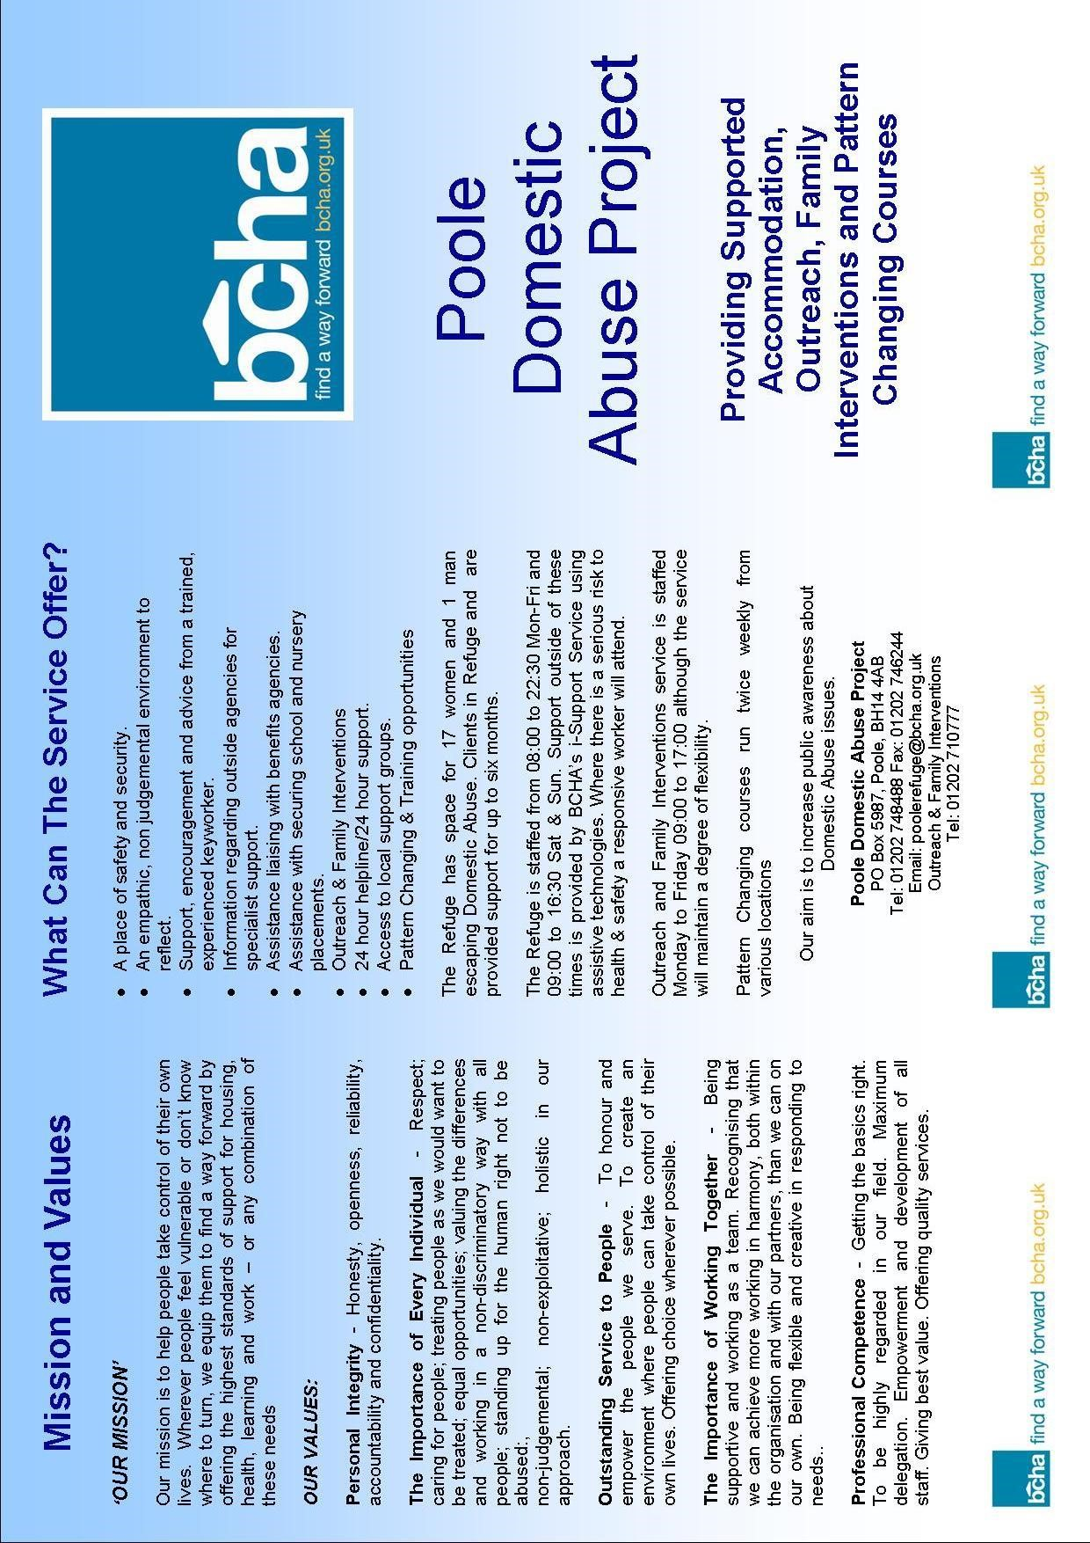

Appendix 3 Safety Planning

Safety planning for when the victim/survivor is in a relationship with the perpetrator.

Advise the victim/survivor to:
- Try to avoid an abusive situation by keeping yourself safe and leaving the situation.
- Rehearse an escape plan, so in an emergency the victim/survivor and the children can get away safely.
- Identify safe areas of the house where there are no weapons and there are ways to escape. If arguments occur, advise them to try to move to those areas.
- Don’t run to where the children are, as their partner may hurt them as well.
- If violence is unavoidable, make themselves a small target; dive into a corner and curl up into a ball with their face protected and arms around each side of their head, fingers entwined.
- If possible, have a phone accessible at all times and know what numbers to call for help. Ensure they know the phone number to their local refuge.
- Ensure they keep any important and emergency telephone numbers (for example, to domestic abuse support services; the police domestic violence unit; your GP; social worker, if they have one; the children's school; solicitor.
- Always call the police if they are at risk of being hurt
- Let trusted friends and neighbours know of their situation and develop a plan and have a secret code word they can text when they are in danger.
- Teach children how to get help. Advise the victim/survivor to tell the children not to get involved in the violence Plan a code word to signal to them that they should call the police, get help or leave the house.
- Tell children that violence is never right, even when someone they love is being violent. Advise the victim/survivor to tell they and the children, are not at fault or are the cause of the violence, and that when anyone is being violent, it is important to stay safe.
- Keep weapons like knives or sharp object locked away and as inaccessible as possible.
- Make a habit of backing the car into the driveway and keeping it fuelled. Keep the driver’s door unlocked and others locked — for a quick escape.
- Try not to wear scarves or long jewellery that could be used to strangle you.
- Advise the victim/survivor to call a domestic violence hotline periodically to assess their options and get a supportive understanding ear.
- Advise the victim/survivor to plan in advance how they might respond in different situations, including crisis situations.
- Advise to keep a small amount of money on them at all times - including change for the phone and for bus fares.
- If they suspect that their partner is about to attack them, try to go to a lower risk area of the house - for example where there is a way out and access to a telephone. Avoid the kitchen or garage where there are likely to be knives or other weapons; and avoid rooms where they might be trapped, such as the bathroom, or where they might be shut into a cupboard or other small space.
- Pack an emergency bag for yourself and your children, and hide it somewhere safe (for example, at a neighbour's or friend's house).

What to pack in an emergency bag
Ideally, they need to take all the following items with them if they leave. Pack an emergency bag and if not safe to leave at home leave it with a family member, friend or neighbour.
- Some form of identification.
- Birth certificates for them and their children.
- Passports (including passports for all the children), visas and work permits.
- Money, bankbooks, cheque book and credit and debit cards.
- Keys for the house, car, and place of work. (Advise to get an extra set of keys cut, and put them in the emergency bag.)
- Cards for payment of Child Benefit and any other welfare benefits they are entitled to.
- Driving licence (if they have one) and car registration documents, if applicable.
- Prescribed medication.
- Copies of documents relating to the housing tenure (for example, mortgage details or lease and rental agreements).
- Insurance documents, including national insurance number.
- Family photographs, jewellery, small items of sentimental value.
- Clothing and toiletries for yourself and the children. • The children's favourite small toys.
You should also take any documentation relating to the abuse - e.g. police reports, court orders such as injunctions and restraining orders, and copies of medical records.

Safety planning after the victim/survivor has left
Please note that the risk to victim/survivor would have increased now they have left the relationship. It is likely that the perpetrator will try every means to have contact with the victim and stalking and harassment can escalate at this point.
Advise to:
- Try to avoid places which put them in vulnerable position or isolate them. For example: dark isolated places
- Try to avoid any places, such as shops, banks, cafes, that they used to use when they were together.
- Try to alter their routines as much as they can.
- If they have any regular appointments that their partner knows about (for example, with a counsellor or health practitioner) try to change your appointment time and/or the location of the appointment.
- Try to choose a safe route, or alter the route they take or the form of transport you use, when approaching or leaving places you cannot avoid - such as their place of work, the children's school, or their GP's surgery.
- Tell their children's school, nursery or childminder what has happened, and let them know who will pick them up. Make sure the school does not release the children to anyone else, or give their new address or telephone number to anyone. (They may want to establish a password with them, and give them copies of any court orders, if they have them.)
- Consider telling their employer or others at their place of work - particularly if they think their partner may try to contact them there.
If they have moved away from their area, and don't want the abuser to know where they are, then they need to take particular care with anything that may indicate their location; for example:
- Mobile phones could be 'tracked'; this is only supposed to happen if they have given permission, but if their partner has had access to their mobile phone, the perpetrator could have sent a consenting message purporting to come from the victim/survivor. If they think this could be the case, they should contact the company providing the tracking facility and withdraw their permission; or if they are in any doubt, advise that they change their phone.
- Try to avoid using shared credit or debit cards or joint bank accounts: if the statement is sent to their partner, he will be able to see the transactions they have made.
- Advise the victim/survivor to make sure that their address does not appear on any court papers.
- Advise them to talk to their children about the need to keep the address and location confidential. This in particular when using social media.
Victims of stalking and domestic abuse are now allowed to join the electoral register anonymously, so ensure they are not put at risk, and do not lose the right to vote. Anyone wanting to register their details anonymously must provide evidence such as an order under the Family Law Act 1996 or the Protection from Harassment Act 1997. If an application is granted, the details that appear on the register only have a person’s electoral number and the letter N.
If they stay or return to their home after their partner has left, then they may have an occupation order or a non molestation order. Ensure they have copies of the orders with them at all times.
The victim/survivor can also have additional security measures installed into their home. For further information speak to your local housing departments.
Additional security includes the following:
- Changing locks
- Additional locks on doors and windows
- Smoke detectors
- Fire proof letter box
- Outside lighting (back and front) which comes on automatically when someone approaches.
This list is not exhaustive
To increase safety they may consider:
- Inform the neighbours that their partner no longer lives there, and ask them call the police - if they see him nearby.
- Changing their telephone number and making it ex-directory.
- Using an answering machine to screen calls.
- Keep copies of all court orders together with dates and times of previous incidents and call-outs for reference if you need to call the police again.
If their expartner continues to harass, threaten or abuse them, make sure they keep detailed records of each incident, including the date and time it occurred, what was said or done, and, if possible, photographs of damage to their property or injuries to yourself or others. Advise that If their partner or ex-partner injures them, they see their GP or go to hospital for treatment and the visit is documented. If they have an injunction with a power of arrest, or there is a restraining order in place, they should report any contact from their expartner to the police immediately.

Appendix 4
The Impact of Domestic Abuse on Children and Young People
Children can witness domestic abuse in a variety of ways. For example, they may be in the same room and may get caught in the middle of an incident, perhaps in an effort to make the violence stop: they may be in the same room but be able to hear the abuse or see the non abusive parent’s physical injuries following an incident of violence; or they may be forced to take part in verbally abusing the victim. Children are completely dependent on the adults around them, and if they do not feel safe in their own homes, this can have many negative physical and emotional effects.
These are some of the effects of domestic abuse on children:
- Become anxious or depressed
- Have difficulty sleeping
- Have nightmares or flashbacks
- Complain of physical symptoms such as tummy aches
- difficulty sleeping
- Have temper tantrums
- Behave as though they are much younger then are
- May have problems at school or start truanting
- They may become aggressive
- Internalize their distress and withdraw from people
- Low self esteem
- Use alcohol or drugs
- Self harm or attempt suicide
Domestic abuse can interfere with children’s social relationships: and they may feel unable to invite friends round (or may be prevented from doing so by the abuser) out of shame, fear, or concern what their friends may see. This can make children and young people feel very isolated. They may feel guilt, and think the violence is their fault, or they ought to be able to stop the abuse in some way. There can be an impact on school attendance and achievement: some children attempt to stay at home in an attempt to protect the nonabusive parent, or because they are frightened what may happen if they go out. Worry, disturbed sleep and lack of concentration can all affect school work.

Appendix 5
POWER AND CONTROL WHEEL

Domestic abuse is more than just physical abuse. The power and control wheel describes the behaviors that are used together as a system in violent relationships. The wheel is drawn with violence as the outer rim and the other behaviors as spokes. Just like a wheel, they depend upon and reinforce each other. Together this system of behaviors builds barriers to a victims/survivors escape.

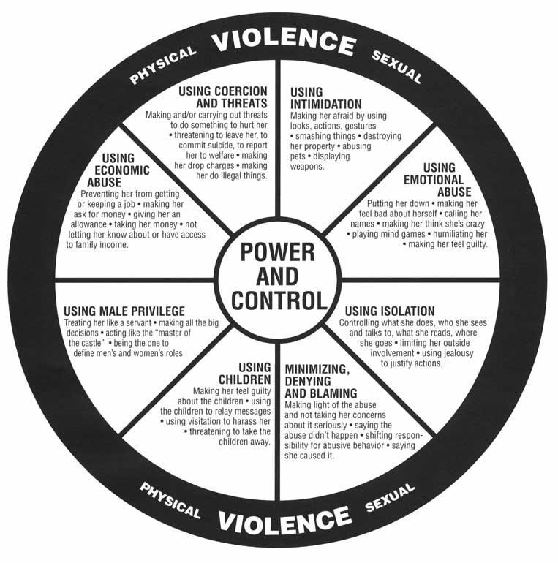

Appendix 6

Equality Wheel

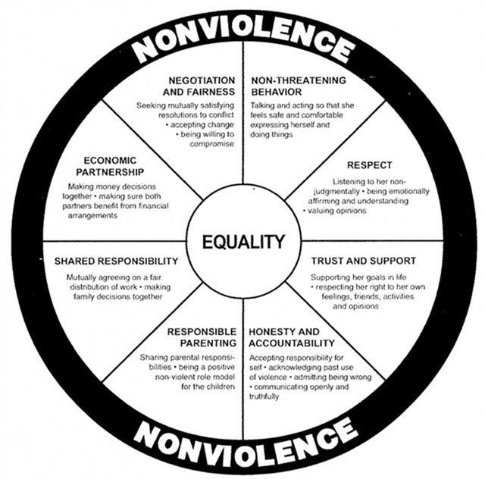

‘A crime or incident which has or may have been committed to protect or defend the honour of the family and or community’ Honour Based Violence is where a person is being punished by their family or community for actually or allegedly undermining what they believe to be the correct code of behaviour. By not conforming it may be perceived that the person may have brought shame or dishonour to the family.
For further information about Marac please refer to the 10 principles of an effective Marac: http://www.safelives.org.uk/marac/10_Principles_Oct_2011_full.doc
Note: This checklist is consistent with the ACPO endorsed risk assessment model DASH 2009 for the police service.

