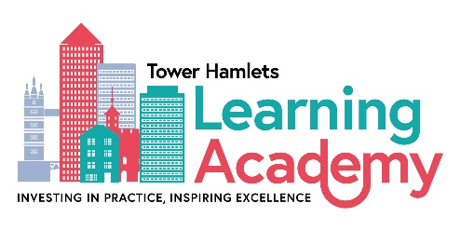
One Minute Guide to Better Together

Better Together is the Practice Framework within Tower Hamlets’ Supporting Families Division. It was developed through consultation with staff and partners in 2021-22 and is our shared vision of what we are trying to achieve. It reminds us how we are expected to work with children and families, and each other, irrespective of which part of the division we work in. This framework is based on the ideas and concepts which underpin Restorative Practice and draws from other strength based approaches, such as Systemic and Trauma Informed Practice. The Better Together framework has shaped the work developed in relation to our priority areas of Domestic Abuse, Harm Outside the Home and Neglect; it will continue to inform all other workstreams within the division.

Better Together encapsulates 3 key components:

- The Vision

We believe that the best place for children is to be raised within their own families, immediate or wider, wherever it is safe and appropriate to do so. In Tower Hamlets we are committed to building relationships and strengthening families by working with people in a compassionate and understanding way. We are ambitious for Tower Hamlets children and families and endeavour for every child and young person to be healthy, safe and successful.

- The Shared Behaviours
Together, we have agreed that we will:
- Be open and honest – do what we say we’ll do and explain what happens next
- Listen to understand – be curious, not judgmental
- Value families’ experience – work with families, don’t ‘do to’ or ‘do for’ them
- Work to prevent harm and repair damage – to people and relationships
- Empower people – giving high support and having high expectations

- Our C-Change approach
Our C-Change approach sets out “6 Cs” which we will all do as we work with children, young people their parents and carers, and each other:
- We will spend time connecting with each other and building relationships
- We will be curious about what is happening, rather than making assumptions
- We will work to build a culturally relevant community of support around a child, young person and their caregivers
- We will use the ideas and expertise of those we are working with to ensure that plans are co-produced - putting the child, young person and their parent/carer at the heart of decision making about what will help
- We will work collaboratively, utilising the skills we and others possess to help bring about change, resolve conflict and repair harm
- We will check back to see if our plans/actions are making a positive difference or need to change; and we will create a culture where we are willing to give and receive constructive feedback
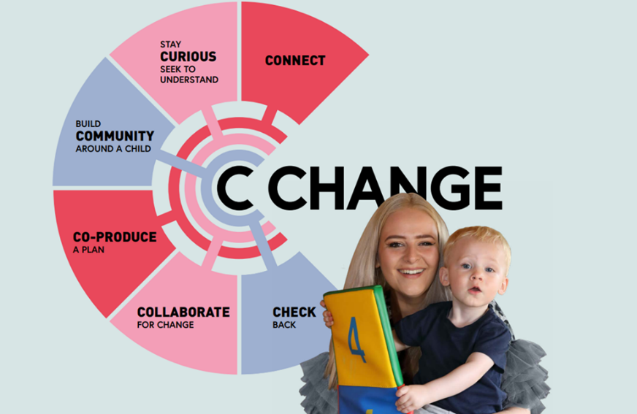

- Resources to support you in this work
There are a range of guides and practical tools that will help you embed this way of working in your part of the service. They are in the Supporting Families Division Teams folder but can also be accessed via these links:
- Better Together Resources
- Better Together - Tools and Resources
- Better Together Practice Handbook Final
- Better Together Practice expectations One Minute Guides
- Better Together Training Offer
For more information regarding the Better Together Framework, including how to get involved as a Practice Champion, please contact Marie.Larvin@towerhamlets.gov.uk – Better Together Lead within the Learning Academy.

