# Connected People Referral V1.0

1. Make sure you are on the front page of the prospective carers record – i.e. the adult that you are referring for assessment

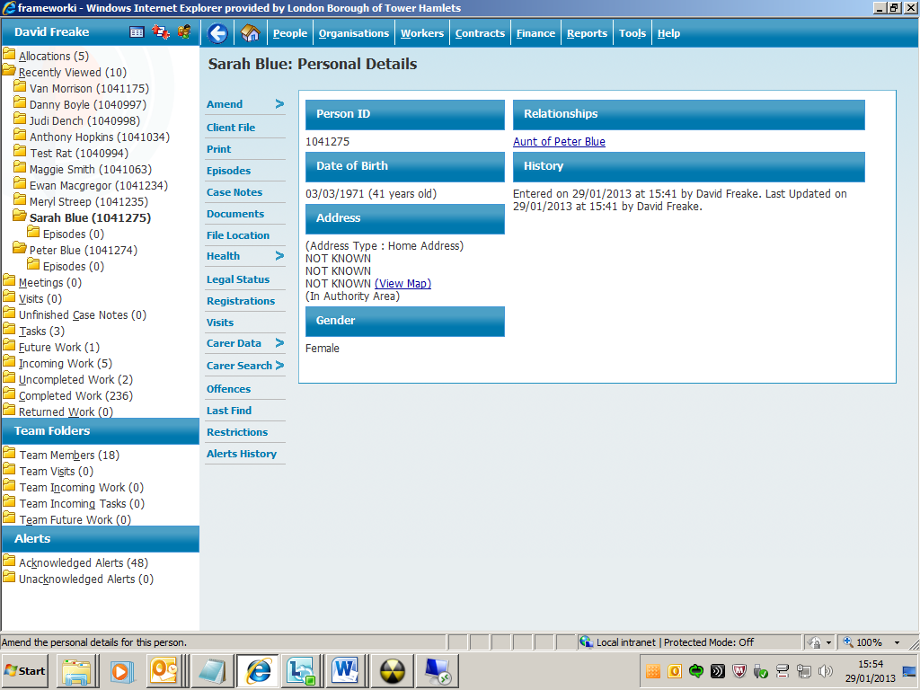

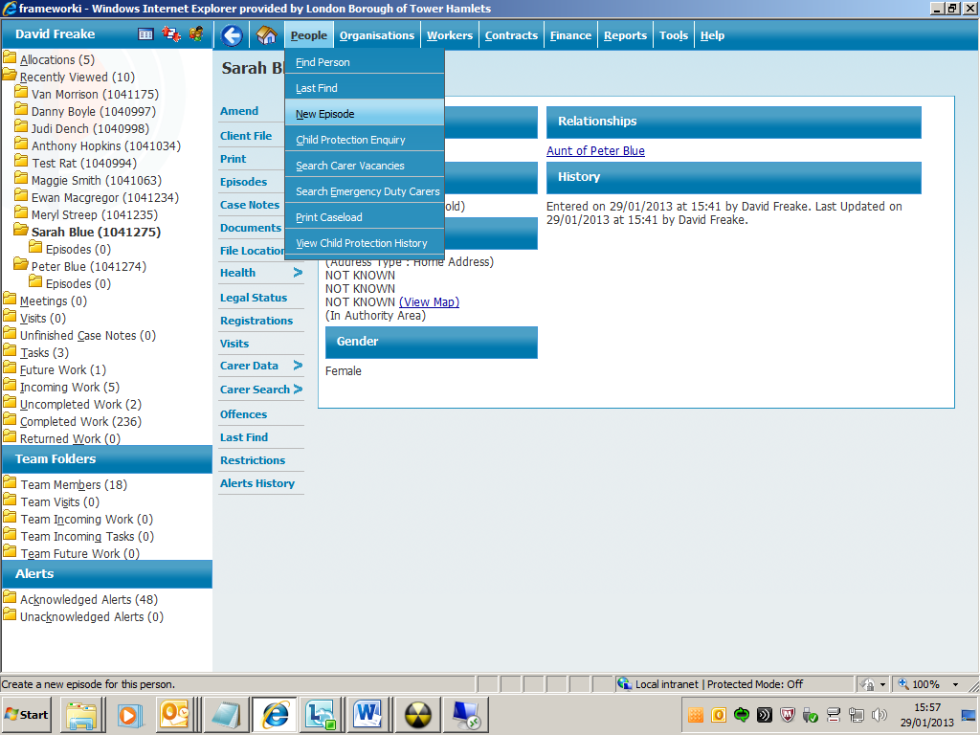

*2. Click People and then New Episode*

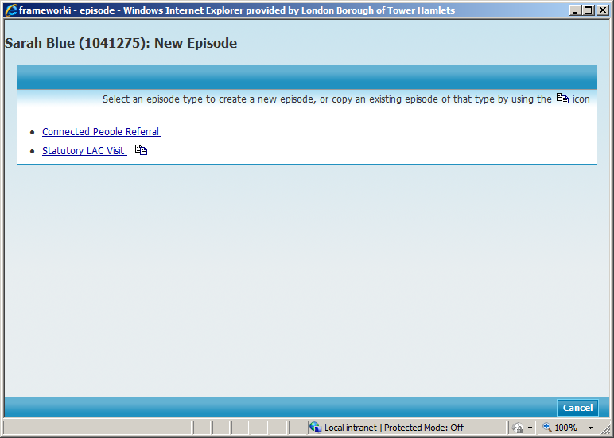

*3. Click on the Connected People Referral*

|  |  |
| --- | --- |
| Tips  If the Connected People Referral episode isn’t showing then you are probably on the child’s record and not the carers. |  |

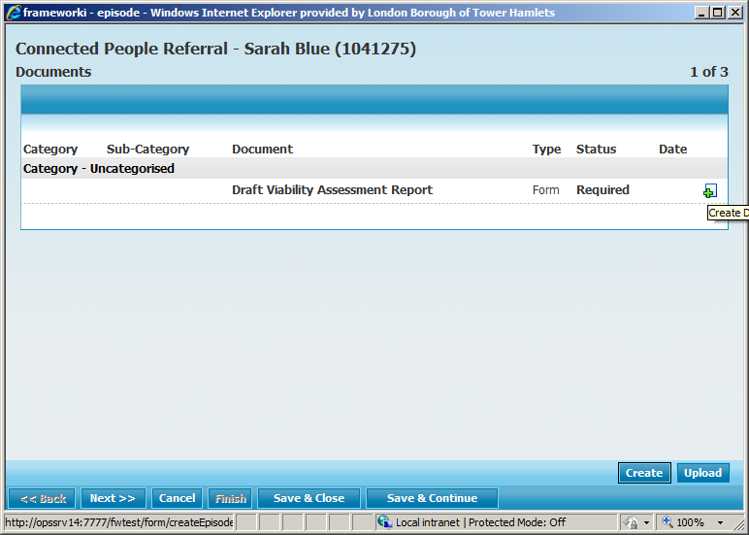

*4. Click the green* ***+*** *to start the document*

5. Complete the Viability Assessment Report below

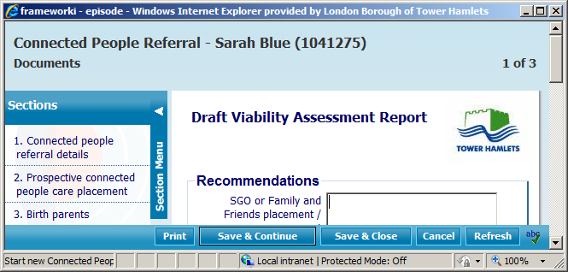

*6. Click Save and Close once report completed*

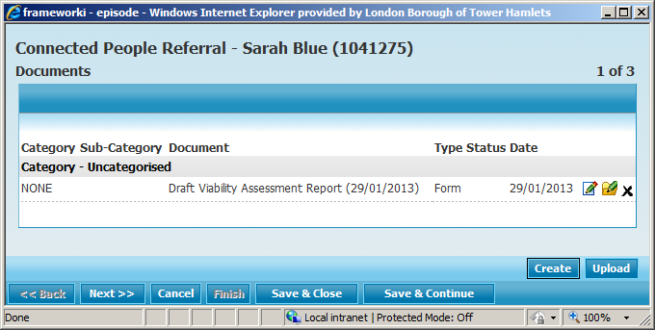

*7. Click Next to go to the Tasks Screen*

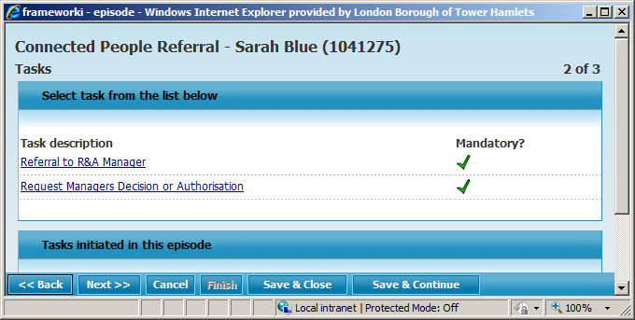

8. The Social Worker sends the task

*Request Managers Decision or Authorisation*

to their line manager.

9. The Line Manager looks at the Viability Assessment Report and if they judge it to be complete and accurate then they complete the *Request Managers Decision or Authorisation* task sent to them by the Social Worker

10. The Line Manager would then send the task:

*Referral to R&A Manager*

This task can only be sent to the Duty Manager R&A

|  |  |
| --- | --- |
| Essential  The Task  Request Managers Decision or Authorisation  must be completed before the task  Referral to R&A Manager    is sent to the Duty Manager R&A. |  |

11. A manager in the Recruitment and Assessment team will view the Viability Assessment Report and complete the task *Referral to I&A Manager* if they are accepting the referral. This manager will also choose suitable outcomes and finish the Connected People Referral episode.

|  |  |
| --- | --- |
| Essential  The Social Worker will need to do a separate Connected People Referral for each prospective carer. |  |