Safety Planning with Young People-Harm Outside the Home

Keep in mind:
- For a safety plan to work it’ll need personalised answers, with information the young person and their network can use.
-Once completed the safety plan should be shared with the young person, parent/carer, and professional network.
-Their safety plan is to be kept in an accessible but secure place. The young person may also wish to give a copy to a trusted safe friend/family friend.

Areas the young person should be supported to explore:
In the Community/at home
-Always carrying their phone, important telephone numbers and spare cash.
-Keeping in touch with someone they trust about where they are or what they’re doing.
-Staying out of isolated places and areas with knows risk due to affiliations.
-Avoiding places where their exploiter or their friends/family are likely to be.
-Keeping the doors and windows locked when at home, especially alone.
-If they are feeling unsafe in the community seek out places where there are people who can help them such as shops.
-Having emergency contacts and calling 999 if they feel their safety is at risk.
-Investigate getting a protective order re. legal support in keeping a known abuser away.
-Being aware of police powers such as Child Abduction Warning Notices (CAWNS)
-Reminding them that the exploitation/abuse is not their fault, and they deserve to be safe.
-Parent/Carers being able to track mobile phone/oyster card.

Keeping safe socially
-Asking trusted/safe friends to keep their mobile phones with them while they are them in case they get separated. Contact numbers of friends to be shared with parent(s)/carer(s)
-If possible, going to different shopping centres, banks, supermarkets, cinema’s, etc. than the ones their abuser goes to or knows about.
-Not going out alone where possible, especially at night.
-Being aware of how to leave frequented locations safely in case of an emergency.
-Encouraging them to leave if they feel uncomfortable in a situation, no matter what friends are doing.
-Encouraging them spend time with people who make them feel safe, supported and good about themselves.

Keeping safe online and with their phone:
-Not saying or doing anything online that they wouldn’t in person.
-Setting all online profiles to be as private as they can be.
-Saving and keeping track of any abusive, threatening, or harassing comments, posts, or texts.
-Never giving passwords to anyone other than parents/guardians.
-If abuse and harassment does not stop, changing usernames, email addresses, and/or
mobile phone number. Using the block feature.
-Not answering calls from unknown, blocked or private numbers.
-Check if their phone company can block abuser’s phone number from calling my phone.
-Encouraging them not to communicate with their abuser/exploiter using any type of technology.

Example Safety Plan Questions:

Staying safe at school/college/work
The safest way for me to get to and from school/college/work is:

If I need to leave these places in an emergency, I can get home safely by:

If a friend or family member can accompany me whilst commuting/in between classes. I will ask: .......................................................................................... and/or.....................................

I will eat lunch and spend free periods in an area where there are people nearby. These are some areas at school/college/work where I feel safe:

I could talk to the following people at school/college/work if I need to rearrange my schedule in order to avoid my exploiter/abuser, or if I need help staying safe at these places:

At home/placement
I can tell this person about what is going on in my relationships:
......................................................................................................................................
There may be times when no one else is home. During those times, if I can have people stay with me. I will ask: ......................................................................................................................................
The safest way for me to leave my house/placement in an emergency is:

I will be home by curfew, the time I need to be home is: ………………………………...

If I must leave in an emergency, I should try to go to a place that is public, safe and unknown by my exploiter/abuser. I could go here: ......................................................................................................................................
and/or here: .............................................................................................................

I could use a code word so I can alert my family, friends, and neighbours to call for help without my abuser knowing about it.

My code word could be: .....................................................................................................

If living with an abuser/missing
Where possible have a bag ready with these important items in case they need to leave quickly (check all that apply):

Mobile phone and charger
Spare money
Keys
Provisional/Driver’s license/ other form of ID
Copy of restraining order if applicable
Copy of birth certificate
National Insurance Card
Immigration papers and other
Other important documents
Change of clothes
Medications
Special photos / valuable items
If I have children, anything they
may need (important papers,
formula, nappies)
Other:

Staying safe emotionally (Relationships/friendships/associations)

My boyfriend/girlfriend/friend often tries to make me feel bad about myself by saying or doing this:

When he/she does this, I will think of these things I like about myself:

I will do things I enjoy, like:

I can attend clubs or organisations that interest me, like:

If I have the urge to self-harm, I can………………………………………………………
I can also contact……………………………………………………………………………
If I need support around sexual health I can contact……………………………………

During an emergency, I could call the following safe friends/family/carer(s) at any time
of day or night:

Name/Phone Number:
..............................................................

Name/Phone Number:
..............................................................

Name/Phone Number:
..............................................................

Safe Addresses I can go to:
…………………………………………….
Emergency Contacts:
Family/Friends
For emergencies: 999
Professional Network/Other Agencies

Staying Safe in my community-Mapping Exercise:

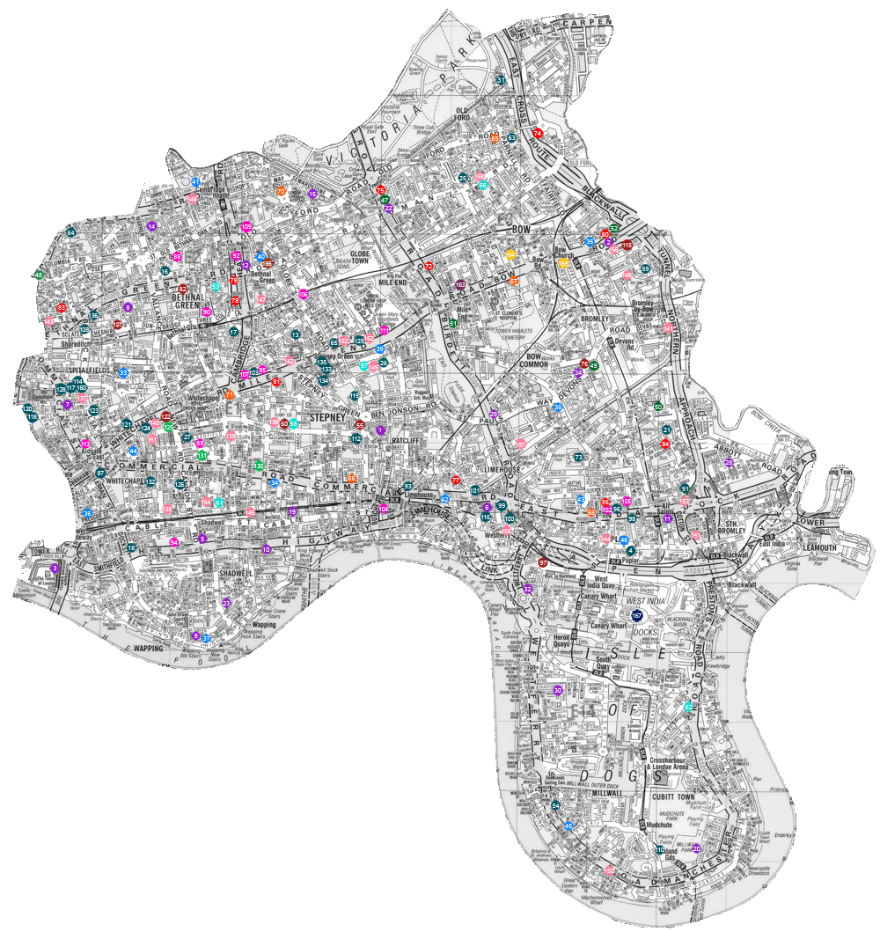

Mark areas using red, amber and green: I feel safe (green), I could be safe (amber), I do not feel safe in this area (red).

Prompts to think about in particular areas:
- What would you do if they feel unsafe?

- Is there anyone they know there who they could go to for help?

- What would they expect that person to do to help keep them safe?

Do they have contact details accessible?

Locations, people and further details
I feel safe in this area.
I could be safe in this area
I do not feel safe in this area
Safety Plan

