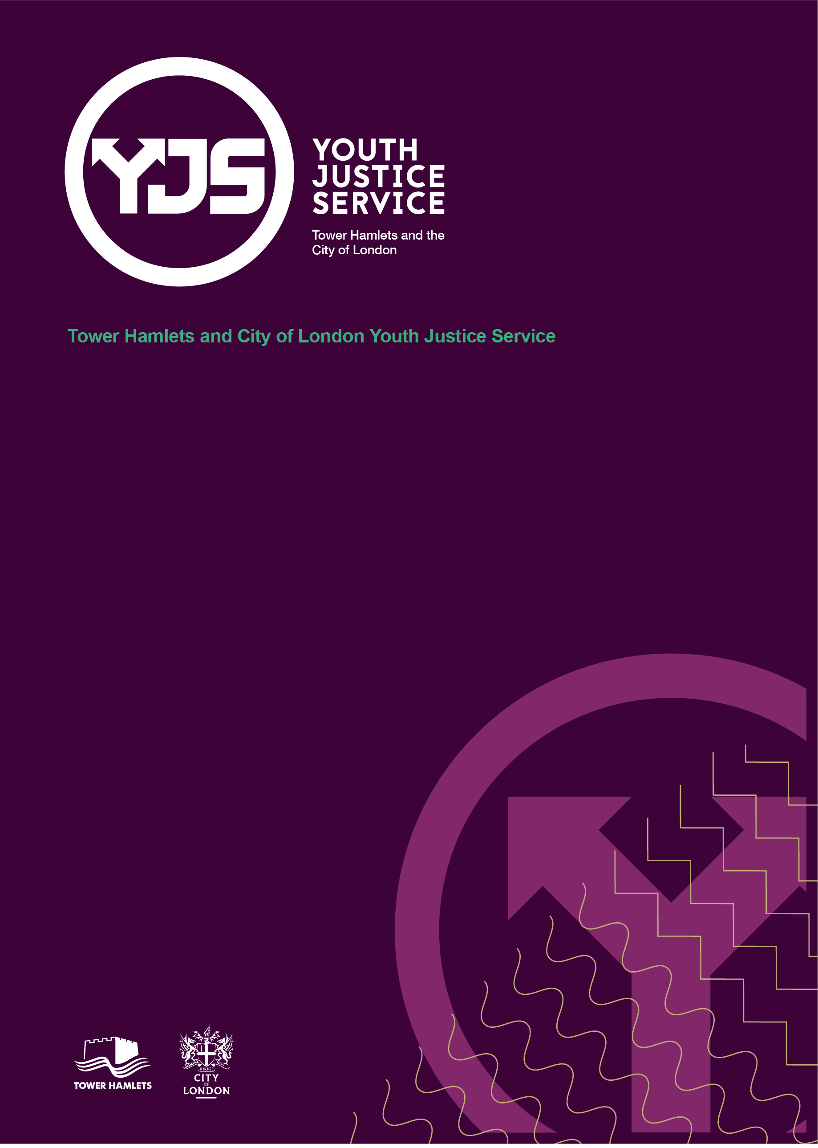

YJS Communication Plan
June 2023

Contents
Introduction 2
Communication Framework for the Youth Justice Service: 3
Our Communication Strategy 3
Communication Practice Guide 0

Introduction
“Any problem, big or small, within a family, always seems to start with bad communication. Someone isn’t listening.”
Emma Thompson

  - As part of the development of the Youth Justice Improvement Plan, there is an important focus to strengthen our communication and engagement across the Youth Justice Service and wider partnership. There is a wide range of stakeholders with whom effective communication and engagement is critical and fundamental to ensure smooth service delivery and that outcomes for children are improved. ​

  - This plan aims to set out the approach and provides an overarching framework to the way that the Youth Justice Service communicates and engages with stakeholders and partners.

  - The objectives of this communication and engagement approach are to:​

- Create a coordinated approach to the management and delivery of communication across the service;
- Provide a clear connection between the Youth Justice Executive Board, Youth Justice Operational Board and the frontline Youth Justice Service;
- Use methods which provide a range of opportunities for dialogue and feedback;
- Use an approach will support the dynamic communication as well and planned communication;
- Ensure colleagues feel empowered with information which enables them to deliver services;
- Improve information & communication channels through the service by creating a knowledgeable and well-informed workforce;
- Have an increased awareness of the priorities, procedures, services and achievements relating to the work we do and;
- Work with partners to ensure that we deliver best practice for the children and families that we work with.

Communication is essential to ensure we are all clear about the aims, vision and purpose of the service. ​

Communication Framework for the Youth Justice Service:
  - Having a framework for accessing support, sharing good practice and equip the workforce to communicate in the most effective ways are crucial. The below provides the framework in which we can achieve it:

Communication Practice Guide
  - We know, as Youth Justice practitioners and partners, that communication is impacted by learning styles, speech and language communication needs and our cultural and lived experiences as well as the person’s emotional and physical in that moment of receiving or delivering information. This is also relevant to our own personal situation at any given time.

  - Therefore, communication is a skill that we need to work upon and develop and adapt in different places but there are key skills that we can use at all times:

  - Communication Styles

  - ​All staff need to be committed to the following in regards to communication

- We ensure that our methods of communication are appropriate for the audience that we are present. If children are present, it may be that additional methods of communication are used – for example, visual aids, Language Maps or interpreters. Even when we are in Court, we will be mindful of the child who is present.
- We start all communications in a place of trust. We trust others in the meeting to be respectful of us, our experiences and our contributions. This is key.
- We will consider our body language, this is especially important when using the camera in online/hybrid meetings. If a camera is not being used, it implies that the person is not engaged. We expect all cameras to be on unless there is a valid explanation and no other method of communication.
- We take ownership of what we say using ‘I’ statements and specific examples rather than generalizing statements that do not enable us to deliver the same context to the communication.
- We find our own ‘voice’ as well as actively listening to others. We also accept that it is acceptable to say ‘no’.
- Where communication has not been effective, we deal with this at the lowest level. We agree to speak up when things have not worked so that we can seek resolution.

Communication Plan
The following information highlights our clear goals for our communication strategy, demonstrating key lines of sharing information from the children to the Executive Board.

What​ | The right information (why)​ | At the right time (when)​ |  | To the right people (who)​ | In the right medium (how)​ |  |  | Owner​
Youth Justice Executive Board (YJEB)​ | - Policy legislation and guidance​;  - Youth Justice Improvement Plan​;  - Youth Justice Service performance​;  - Profile of children the YJS are working with​;  - Finance;​  - Workforce Development;​ |  | Bi-monthly ​ | YJEB Board members​  YJS​ staff |  | YJEB Papers​  YJS Team Meetings​  Corp Director Bulletin​  YJB Comms​  Staff observation​ | Corporate Director​
Youth Justice Operational Board (YJOB)​ | - Improvement plan update​;  - Participation in proposed development for YJS and partnership​;  - Operational data and information sharing;​  - Key update from partnership​; |  | Monthly​ | YJEB​  YJOB Members​  YJS​ staff |  | YJOB Papers​  YJOB Meeting​  YJS Newsletter​ | Director of Supporting Families​
Youth Justice Service Meeting​ | - Key updates from YJEB/YJOB​;  - Improvement plan​;  - Partnership presentation;  - Good practice​; |  | Monthly​ | YJS​ staff  Multi-agency partners​  YJEB​ |  | Face to face Team Meeting​  Papers for meeting​ | Head of Youth Justice and Young Peoples Service
Weekly Brief​ | - Dynamic updates at strategic and tactical level​;  - Opportunities and staff team to raise issues and ask clarifying questions​  - Updates from suggestions box​;  - Introduction of new starters​; |  | Weekly​ | YJS staff ​  Multi-agency partners​ |  | Face to Face briefing​ | Deputy Head of Youth Justice
Supervision​ | - One to one and group supervision focused on child level case work and staff non child facing;​ |  | Monthly ​ | TM/YJS Officers​ |  | Face to face​  Records of supervision​ | Deputy Head of Youth Justice
Youth Participation​ | - Establishment of Youth Justice Forum​; |  | Monthly | Children  YJS​ staff  Youth Council​ |  | Face to face  Various Methods best to engage children | Deputy Head of Improvement

What​ |  | The right information (why)​ | At the right time (when)​ | To the right people (who)​ | In the right medium (how)​ | Owner​
Cherry Blossom​ | - All staff events​  - Corporate values and vision ​  - Strategic priorities​  - Reconnecting, reflecting and renewal​  - Coproduction ​ |  | 6 monthly​ | Directorate Wide​ | Face to face ​ | Corporate Director​
Team Manager Forum​ | - Leadership group​  - Reflect on progress so far​  - Set priorities and ambition for the division​ |  | Monthly​ | Directorate Wide​ | Face to face​  Virtual​ | Director of Supporting Families
Practice Week​ | - Leadership team to share best practice​  - Meet with other senior leaders​  - Learn and share in each other's service areas​  - Hear from experts and those with lived experience ​ |  | Annual​ | Directorate Wide​ | Face to face​ | Corporate Director​
Partnership Newsletter​ | - To share improvements within YJS​  - To inform the partnership of good practice and good news stories​  - To keep partnership abreast of changes​  - Workforce development​ |  | Monthly​ | Partnership Wide​ | Email​ | Head of Youth Justice and Young Peoples Service
Daily Intel Briefing ​ | - Information sharing across the partnership ​  - Public protection​  - Risk management​ |  | Daily​ | Partnership Wide​ | Face to face​  Virtual​ | Head of Exploitation
Court User Group​ | - ​Information sharing across the partnership ​  - Feedback from staff to Court users  - Scrutiny of practice |  | ​Quarterly | ​Partnership Wide | Face to face​ | ​Deputy Head of Youth Justice

This document should be read in conjunction with the Staff Charter which was devised by the YJS and YPS Service in December 2022.

