Darren McAughtrie
Corporate Director of Adult Care & Quality Standards

Address: Waltham Forest Town Hall, Fellowship Square, Forest Road, London, E17 4JF
Direct line: [IF APPLICABLE]
Switch board: 020 8496 3000
Compliments and complaint line: 020 8496 3000
Email: [EMAIL]
Date: [INSERT DATE]

Dear [RESIDENT NAME]

RE: Work completed

Thank you for meeting with me to complete [INSERT]. I will now be ending my involvement with you.

Following our conversation, I have [INSERT].

Next steps are [INSERT]

Please find attached a copy of your [REVIEW/REPORT/OTHER].

Do not hesitate to contact me on the number above or via email if you spot any errors.

Should your needs change, please contact Waltham Forest Direct on 020 8496 3000 and we will be pleased to support you. Our office hours are 9.00am to 5.15pm Monday to Thursday and 9.00am to 5.00pm on Friday.

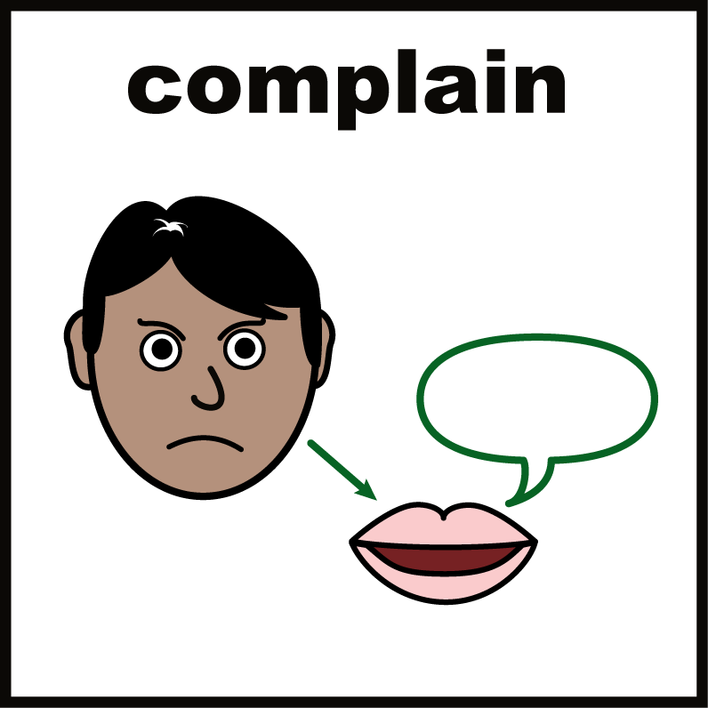
Making a complaint

If there is anything you are not happy with, or if you would like to leave a compliment, you can contact us via our website on
https://www.walthamforest.gov.uk/council-and-elections/making-complaint-compliment-or-claim/complaints-and-compliments

You can also make a complaint by calling us on 0208 496 3000 or by email to Information.officer@walthamforest.gov.uk


Feedback

If you haven’t done so already, I would appreciate if you could spare a few minutes of your time to complete a short survey. It would really help us understand your experience and your feedback will influence how we improve our services.

Either scan the QR code beneath using your smartphone or copy the link into your browser:

https://www.surveymonkey.co.uk/r/adultsocialcare10



It has been a pleasure working with you.

Yours sincerely,

[INSERT NAME]
[TITLE]

