Darren McAughtrie
Corporate Director of Adult Care & Quality Standards

Address: Waltham Forest Town Hall, Fellowship Square, Forest Road, London, E17 4JF
Direct line: [IF APPLICABLE]
Switch board: 020 8496 3000
Compliments and complaint line: 020 8496 3000
Email: [EMAIL]
Date: [INSERT DATE]

Dear [RESIDENT NAME]

RE: Transferring to a new Social Work Team

Thank you for your time in working with me. I will now be ending my involvement with you and your case will be transferred to a different team in Adult Social Care.

Your case is now with [INSERT NAME]. You will be contacted by your new allocated Social Work Practitioner in due course. This might take a short amount of time so we ask for your patience whilst we prepare to continue to support you.

If you need to speak to someone of if your needs change while you wait, please contact Waltham Forest Direct on 020 8496 3000 and we will be pleased to support you. Our office hours are 9.00am to 5.15pm Monday to Thursday and 9.00am to 5.00pm on Friday.

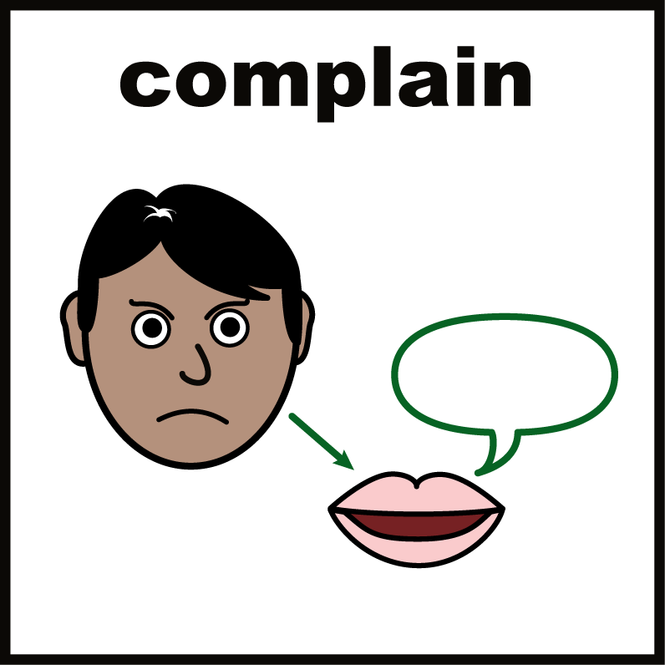
Making a complaint

If there is anything you are not happy with, or if you would like to leave a compliment, you can contact us via our website on
https://www.walthamforest.gov.uk/council-and-elections/making-complaint-compliment-or-claim/complaints-and-compliments

You can also make a complaint by calling us on 0208 496 3000 or by email to Information.officer@walthamforest.gov.uk

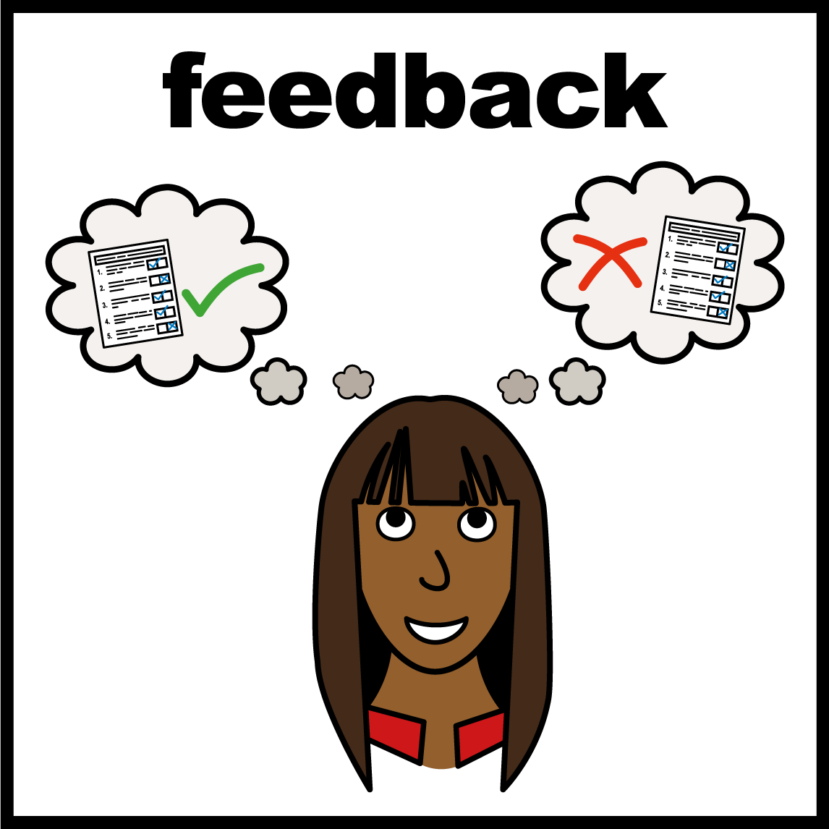
Feedback

If you haven’t done so already, I would appreciate if you could spare a few minutes of your time to complete a short survey. It would really help us understand your experience and your feedback will influence how we improve our services.

Either scan the QR code beneath using your smartphone or copy the link into your browser:

https://www.surveymonkey.co.uk/r/ascare5



It has been a pleasure working with you.

Yours sincerely,

[INSERT NAME]
[TITLE]

