

|  |
| --- |
| Adult Care and Quality Standards |
| **Quality Assurance Framework**  **Audit Guidance** |
| Practice Improvement and Audit Team  Adult’s Services |

Contents

1. Quality Assurance 3

2. Scope of the audits 3

3. Auditing Process 4

3.12 Dispute Resolution Process for Audits 7

3.13 Discussion of Audit Findings 7

3.14 Moderation activity 8

3.15 Escalation Process 8

4. Learning and Improvement 9

**Appendix A : Flow Chart - Monthly Audit Cycle** 10

**Appendix B: Flow Chart – Alert Process when concerns arise in respect of an adult’s safety during the audit process:** 11

# 1. Quality Assurance

The purpose of quality assurance processes is to improve practice and the quality of the service we provide, with the intention of improving outcomes for adults and young people through a process of continuous learning.

The Audit framework serves two basic functions:

1. It identifies good practice and where practice needs to improve through a systematic approach to sampling mosaic ; and
2. Provides senior management with assurance as to the quality of our work.

The auditing of practice is an integral part of quality assurance systems. This Audit Framework sets out how Waltham Forest Council can improve practice through audits. To achieve this, a range of audit activity is undertaken, which considers both quantitative and qualitative information. Quantitative audits focus on compliance and consist, for example of basic compliance related data; documents updated and uploaded, funding approval sought as and where necessary, through processes being followed and timescales met. Qualitative audits provide a detailed analysis of mosaic, and judgements on overall quality and content.

Audit is integrated into daily practice as a meaningful and useful method for mosaic review and which supports supervision, professional development, and continuous improvement.

The primary use of the intelligence gathered from auditing is to find out how practice can improve. The purpose of audits is to:

* Identify and evidence the extent to which interventions are helping adults, young people and their families to improve their lives by supporting them to make sustainable, positive changes
* Evidence, promote and cascade good practice so that there is a growing understanding of what works well
* Ensure compliance and improve the quality of practice and recording
* Provide a framework for responding to areas of concern
* Identify potential areas of improvement as early as possible.

The collation of both qualitative and quantitative data and information from audits is analysed with recommendation for practice improvement/development, across adult’s social care, in Waltham Forest.

Whilst the audit process has a scrutiny role to evidence practice is undertaken in line with the agreed standards, it is important to highlight auditing also has a supportive and educative function, providing an opportunity for learning, that guards against complacency and helps to embed a culture of continuous improvement.

# 2. Scope of the audits

A major emphasis is for audits to provide a **learning opportunity** for practitioners and managers; therefore, the practitioner should be involved in this process. Auditors are expected to arrange a meeting with the practitioner to discuss their findings and provide space for reflection.

Audits are identified across adult social care teams (care management, learning disability, Review and Special Educational needs and disability). The selection of audits is fair, spread across all teams so no one practitioner has two audits in a month, but rather one audit every 2 to 3 months. Audits are selected within some parameters (work that has been allocated for 3 months where possible, so practitioners have time to achieve progress in your work)

2.1 The process of auditing is a responsibility shared by all those who are accountable for the quality of practice within Adult Social Care. This enables more audits to be completed, ensures robust scrutiny of the quality and effectiveness of practice and facilitates the development of baseline good practice across services.

2.2 Additionally, monthly audits of the MASH service are completed by Managers and Senior Managers in Quality Assurance.

2.3 Re audits are completed monthly by senior managers with Home First Service, Care and Support service and Quality Assurance.

2.4 Every third month senior managers will carry out a moderation activity of the audits completed in the previous months.

2.5 The monthly audit process is complemented by themed audits, where audits are based on recommendations from serious case reviews, issues arising from performance, or as agreed and requested by senior management.

2.6 It is expected the outcomes of audits, alongside other available performance information, is used in supervision and appraisal to support practitioners to improve the quality of their practice and the delivery of good outcomes for the families who use services and tackle any issues is respect of performance. In addition, audits should inform team and service development and can reflect wider systemic issues which impacts on service delivery.

2.7 The audit process should not delay immediate action being taken to safeguard an adult/young person if a situation of imminent risk has been identified by the auditor/manager.

2.8 The audit process aims to achieve a culture that is open to scrutiny, challenge and accountability, but it is important for this to be undertaken in the most positive way so that it can be heard and received as well as be acted upon in such a way that it leads to an improved service to adults and their families

2.9 The outcome of audits will be collated in monthly, quarterly and annual reports and findings and key themes will be shared with practitioners and managers through a variety of channels to include Managers Forum, practice forums, team meetings and service meetings.

# 3. Auditing Process

There are 10 audit cycles per calendar year for all services (monthly except for August and December)

-MASH

-Home First Service

* + Community Active Recovery Team (CART)
  + Hospital Active Recovery Team (HART)
* Care Management Team
* Community Learning Disability Team
* Review Team
* SEND (Special Educational Needs and Disability Service for young adults aged 17+)
* North East London Foundation Trust (OMHT, BITS and CRT)
* Re-audits of all the above

Each audit cycle generally runs from the first to the last working day of the month. Audit allocations are sent to all auditors, team managers and practitioners by the Audit and Practice Improvement Team.

**Re-audits** are allocated each month for work graded Requires Improvement or Inadequate. At least one month is given between an audit being completed and a re-audit being allocated to ensure time for the practitioner and their manager to work on the Improvement Plan identified.

Different audit activities planned during the year which includes, 7 audits and 3 Themed audits (themed audit topic could vary form practice related topics or audit of the specific service area)

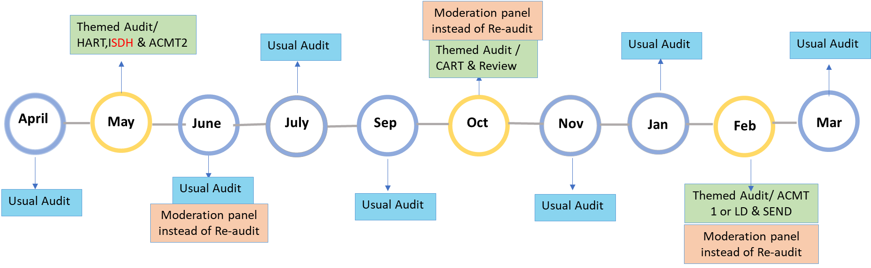

* 1. The audit process as outlined below is the same for both types of audits, monthly audits and re audits
  2. **Three times a year SLT will carry out a moderation activity instead of reauditing activity**
  3. Please see Appendix A: Flow Chart- Monthly Audit and Re-audit Cycle.
  4. The auditor has one **calendar month to complete the audit** and **improvement plan** (should one be needed). The audit covers the **preceding 6 months** of involvement, although this might be shorter if involvement started during this 6-month period. Evidence should be provided to support the grading awarded and should highlight areas of good practice. Each domain of the audit tool where applicable, should be completed, and auditors must provide sufficiently detailed comments in order to explain their rationale for the grading given and ensure qualitative data is available to inform the learning. Auditors are asked to address each relevant aspect of the key lines of enquiry in each domain. Auditors are expected to give gradings (for each applicable domain and overall) after having reviewed the recording of the adult/ young person on Mosaic.

3.5 It is the **expectation each auditor/re-auditor meets with the Practitioner** as part of the audit/ re-audit process to discuss their draft audit findings and engage in a reflective discussion to explore areas of practice strengths and areas requiring further focus. Any additional information obtained through this conversation needs to be noted in the audit report. The auditor is expected to give another grading (for each applicable domain and overall) following this conversation with the practitioner.

3.6 If a **re-audit finds no evidence of progression** the re-auditor may recommend a further re-audit. In the instance of a second re audit, it is the **expectation the re auditor meets with the Practitioner and Team Manager** to discuss in order to enhance understanding as to why things have not progressed as agreed.

3.7 Following the conversation with the practitioner and having recorded this in the audit report, the auditor **emails the report to the Audit and Practice Improvement Team for the purpose of quality assurance;** the team will advise within one working day of any necessary review/ revision required. Following this, the auditor sends the report to the practitioner and their Team Manager **before uploading the audit report onto Mosaic with the accompanying case note (Example given below).** **An alert needs to be sent on Mosaic to the allocated practitioner, Team Manager as well as to the Head of Service for audits graded inadequate.**

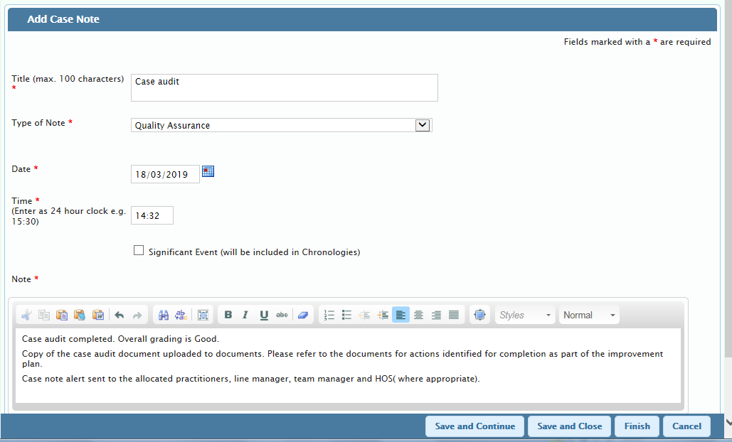**Example of case note accompanying a completed audit**

3.8 As the audit period covers the 6 months preceding the audit date, it is possible there has been a change in practitioner and/or teams during that time. If the auditor identifies practice completed by the previous practitioner/ team shows particular strengths or highlights areas of concern, it is expected the auditor feeds this back to the relevant practitioner and team manager where possible.

3.9 If **any immediate concerns** arise in respect of the person’s safety during the course of the audit, **the auditor is responsible for ensuring that the Team Manager is notified as a matter of urgency**, so that remedial action can be undertaken. For further information **on the alert process, please go to Appendix B.**

3.10 Audit Grading Description

Each audit requires the auditor to determine a grading for the quality of practice in each domain as well as

overall. **The gradings are as follows**:

|  |  |
| --- | --- |
| **GOOD**  **Practice that exceeds minimum requirements**   * Areas of needs clearly evidenced * Focussed gathering and evaluation of information; Providing a clear rationale for the decision made and the support requested. * Well-structured and clear recording * Management directions followed * Intervention is proportionate and robust * Person is held at the centre of all decisions | **OUTSTANDING**  **Practice that significantly exceeds minimum requirements**  Meets all the standards of GOOD plus work that is:   * Structured with detailed information and analysis * Practitioner evidences knowledge, attention to detail and application of policy, procedure and guidance * Exemplary practice |
| **REQUIRES IMPROVEMENT**  **Practice that only meets minimum requirements**   * Only partial evidence of good practice * Limited evaluation of information gathered * Insufficient recording to evidence Care Act or other legislative compliance | **INADEQUATE**  **Practice that does not meet minimum requirements and there are concerns about the safety of a child/ young person and/ or there is no record available to evidence the intervention attempted**   * Areas of evidence insufficient or incomplete * Poorly organised recording * No evaluation of information * Directions/instructions not followed * Insufficient recording to evidence Care Act or other legislative compliance |

3.11 Auditors are expected to refer to the **audit grading criteria document (link provided below)** when grading

each domain and awarding an overall grade to ensure consistency across the process. Equally, practitioners and Team Managers receiving an audit report are expected to use this audit grading criteria when wishing to challenge an audit.

Please refer to the link below for further information Audit Grading guidance.

**Link for Grading Criteria**: Audit Grading Criteria

## 3.12 Dispute Resolution Process for Audits

In instances where there is disagreement about the audit findings and the auditor and the practitioner/ Team

Manager do not agree with the grading, the following process is followed:

|  |  |
| --- | --- |
| **Informal**  (Practice Improvement & Audit Team to be kept informed by being copied into relevant email communication) | Practitioner/ Team Manager prepares a written response to the areas identified by the auditor that they disagree with, to include rationale of disagreement and evidence of work undertaken to address the identified areas  ➢ Practitioner and Team Manager shares the written response with the auditor and arrange a meeting within 5 working days  ➢Discussion between Auditor, Practitioner and Team Manager to seek resolution  ➢ Discussion summary and outcome to be shared by Team Manager via email with the auditor and Practice Improvement & Audit Team within 2 working days:   * **If resolved:** final (amended) audit report to be emailed by the auditor to the Practitioner/ Team Manager and Practice Improvement & Audit Team * **If unresolved:** Formal process to be followed as outlined below |
| **Formal** | * Audit report and Team Manager’s rationale of disagreement, detailing the specific areas, to be emailed to the Practice Improvement & Audit Manager   ➢ Practice Improvement & Audit Manager discussed with the PSW within 5 working days and agrees on appropriate course of action (including reviewing and auditing the Mosaic independently)  ➢ Practice Improvement & Audit Manager or PSW provides a written response to the findings and points of disagreement to the Team Manager, Auditor and relevant Head of Service within 5 working days:  ✓ **If resolved:** final audit report uploaded onto Mosaic by the auditor and to be used by Practice Improvement & Audit Team as part of the monthly audit analysis  ✗ **If unresolved:** dispute to be escalated by PSW to Assistant Director/ QA and relevant Assistant Director to discuss within 5 working days  ✓ **If resolved:** final audit report to be uploaded onto Mosaic by the auditor and to be used by Practice Improvement & Audit Team as part of the monthly audit analysis  ✗ **If unresolved**: in exceptional circumstances, dispute to be escalated by Assistant Director/ QA to the Divisional Director |

3.13 It is expected all audits/ re-audits are completed within the month allocated. Where an auditor is unable to complete for any reason (such as annual leave or sick leave, work commitments) the expectation is for the Team manager/ Head of Service to identify another member of staff within their service area to complete the audit.

## 3.13 Discussion of Audit Findings

* For audits graded inadequate and re-audits maintaining the same ‘requires improvement’ or ‘inadequate’ grading as the original audit or where the re-audit is downgraded, the expectation is the Team Manager and Practitioner will discuss the audit findings and agree on smart actions on how practice will be improved and the identified concerns addressed; this is to be done **within 5 working days** upon receipt of the completed audit/ re-audit. It is the responsibility of the Team Manager and Practitioner to ensure this is done.
* For audits judged as requiring improvement, the expectation is the team manager and practitioner discuss the findings **within 10 working** days upon receipt of the audit or re-audit to consider how a better service can be delivered to the adult and/or their carer.
* For audits graded Good or Outstanding, the expectation is the line manager will discuss this achievement with the practitioner in order to acknowledge good practice.
* Managers are expected to record their discussions within a supervision or management oversight case note on Mosaic. These will be reviewed by the QA Audit team and any issues around non-compliance will be escalated to the relevant Head of Service.

## 3.14 Moderation activity

* Every 3rd month the Senior Leadership Team will convene a moderation panel to review the audit findings and gradings awarded for previous audits.
* The audits for moderation will be randomly selected by the Practice Improvement and Audit team and sent in good time to moderators.
* Moderators will have 1 working month in which to complete the moderation process, record their findings and meet with the auditors.
* Moderators will provide written feedback (using the Moderation template) to the auditors and to the Practice Improvement and Audit team. The template will be uploaded on mosaic.
* The Practice Improvement and Audit team will include the findings from the Moderation Panel in their quarterly reports.

## 3.15 Escalation Process

**3.15.1 Escalation Process for re audits**

* **Re audits** need to be emailed to the allocated Practitioner, Team Manager and Head of Service. It should also be uploaded to Mosaic with an alert send to the allocated Practitioner and Team manager.
* Re audits that have been re audited before and still require further re audit to ensure progression will need to be emailed to the allocated Practitioner, Team Manager and Head of Service and will also need to be brought to the attention of the Principal Social Worker
* It is expected the Head of Service will follow up the discussion of audit findings and agree on actions as part of the improvement plan with the Team Manager and Practitioner to monitor appropriate actions are undertaken in a timely way.
* If, at 2nd re-audit work has still not achieved required outcomes, this should be brought to the attention of the Head of Service, Assistant Director, and Director.

**3.15.2 Escalation Process in relation to quality and non-completion of audit reports**

* **Quality Assurance of completed audit reports**: completed audit reports are quality assured by the Audit and Practice Improvement Team within a day and sent back to the auditor with clear details on areas that need reviewing, if relevant. Auditors are asked to provide an amended report as soon as possible ( **within 2-3 days)**; in acknowledgement that there are some occasions where a discussion with the auditor would be beneficial, this will be offered by the Audit and Practice Improvement Team and it is expected for the amended audit report to be completed **within 3-4 days**; if amendments/improvements are not made within the agreed timeframe, the audit will not be accepted. The auditor will be asked to complete the audit in time for inclusion in the next audit cycle. Nb. They will still be allocated a new audit in the subsequent audit cycle.
* **Non-Compliance of allocated audits**: non-completion of audits is reported to Heads of Service on a monthly basis for them to follow up. This is also reported to the senior managers on a monthly basis via the Year-to-date compliancy spreadsheet.

# 4. Learning and Improvement

The primary aim of the information gathered from auditing is to find out how practice across the

organisation can improve. Audit outlines: what is good about practice; where there is good practice, how this can be expanded into different areas; where there are concerns around quality of work and what should be done to rectify.

It is not just about the individual audit but is about making bigger changes that impact on good practice. To achieve this there needs to be a circle of continuous improvement. The information from audit is shared at all levels and overall findings are reported monthly to the senior management and also shared with the respective teams. Quarterly Quality Assurance audit reports will be submitted to the Senior Leadership Group, including the themes from audit and the actions taken to address any identified issues.

**The role of audit and practice improvement in Quality Assurance**

The team supports practitioners and managers at different levels to develop practice by:

* A􀆩ending team meetings to inform and explore audit findings;
* Meeting with Social Workers and supervising managers to consider individual audits and reflect on practice to consider learning and remedial actions in relation to the work completed;
* Providing briefings and practice development forums and workshops including the learning from audits;
* Identifying practice themes (strengths and risks) arising from audits and contribute to quarterly audit reports;
* Supporting the Principal Social Worker in identifying and developing different strategies to improve practice across services;
* Facilitating and holding regular induction to new staff to provide an overview of practice standards, how is monitored and the support systems available to them;
* Collating good practice examples and utilise them to disseminate good practice;
* Providing support to operational teams to implement policies and procedures.

## **Appendix A : Flow Chart - Monthly Audit Cycle**

**First working day of the month:**

The Practice Improvement and Audit Team sends out the audit/reaudit allocation to Auditors, Practitioners, Team Managers and Heads of Service, including all relevant documents

If any immediate concerns arise in respect of adults safety during the course of the audit process then the auditor is responsible for ensuring the Team Manager is notified as a matter of urgency.

* **See Appendix B**

Auditor to make contact with the Practitioner and arrange a date to meet to discuss audit findings (to take place before last working day of the month)

Practitioners have the opportunity to review the Mosaic recordings and encouraged to communicate with the auditor to arrange a date for a meeting

Auditor to review Mosaic recordings and compile draft audit/re-audit report including grading.

Auditor and Practitioner meet on the arranged date and discuss audit/re-audit findings and engage in a reflective discussion (auditor to add grading following the discussion)

*(if it is a second re audit it is the expectation that the Team Manager is also part of this discussion)*

**Before last working day of the month:** Auditor to send completed audit/re-audit report to Audit and Practice Improvement Team for quality assurance purposes – Audit and Practice improvement Team to QA within one day.

**By the last work day of the month:** Auditors send final audit/re-audit (after agreed with quality assurance) report to:

* Practitioner and Team Manager
* Audit and Practice Improvement Team, upload this to Mosaic and send case notes alert to the practitioner, and line managers.

**Audit and Practice Improvement Team** analyse all audit findings including findings/grading following the discussion with the practitioners and produce:

* A monthly audit Highlight report
* Monthly audit spreadsheet to Heads of Service
* Year to date Compliance spreadsheet

**Discussion of Audit Findings between Team Manager and Practitioner and recording on Mosaic:**

* Audits
  + Within 5 working days for audits graded inadequate
  + Within 10 working days for audits graded requires improvement or above
* Re Audits:
  + Within 5 working days for re audits graded inadequate or downgraded
  + Within 10 working days for all other re-audits

**Appendix B: Flow Chart – Alert Process when concerns arise in respect of an adult’s safety during the audit process:**

If any immediate concerns arise in respect of an adult’s safety during the course of the audit process, the auditor is responsible for ensuring the Team Manager is notified as a matter of urgency, following the process below

**Auditor identifies concern/s following audit or other QA activity**

**Stage 1**

**Discussion summary & outcome recorded on Mosaic**

**Stage 2**

**Email sent to AD**

**Response required within 5 working days**

**Resolved**

**Discussion with relevant TM to seek resolution Alert QA team**

**Not resolved**

**Email sent to HOS**

**Response required within 5 working days**

**In exceptional circumstances concerns escalated to Director for final decision**

**Alert resolved**

**Not resolved**

**If stage 1 is unsuccessful QA team will escalate to HoS**

**Discussion summary & outcome recorded on Mosaic**

**Stage 3**

**Alert resolved**

**Discussion summary & outcome recorded on Mosaic**