Transition Protocol from Children’s services to Adult Social Care

24/10/2023

Table of Contents

Introduction …………………………………………………………………………………3
Purpose of the Protocol……………………………………………………………………4
Year 9 Information Sharing………………………………………………………………..5
Transition referral Pathways……………………………………………………………...7
Operational Leads Meetings………………………………………………………………8
Disagreements between Teams………………………………………………………….9
Appendix 1. Transiton pathway to Adulst Social Care………………………………..10
Appendix 2 – Transtion from Child and adolescent services to …………………….11
Adult Mental Health services: East London NHS Foundation Trust Protocol
Appendix 3 – Useful information………………………………………………………..12

1.0 Introduction.
This protocol is designed to support the transition process from Children’s services to Adult Social Care and is aimed at staff working in Children’s and Adults services.
Transition to Adult services is also referred to as ‘Preparing for Adulthood’ and starts when a young person is approximately 14 years of age until the 25th birthday.
This can be an exciting time for young people but can also be a challenging time for the young person and family/carers to navigate.

Preparing for Adulthood means preparing for:
• further/higher education and/or employment – including options for supported internships, apprenticeships, self-employment, volunteering, college and university
• independent living – this means young people having choice, control and freedom over their lives and the support they have, their accommodation and living arrangements, including supported living as far as reasonably possible
• participating in society, including having friends and supportive relationships,
• participating in, and contributing to, the local community
• being as healthy as possible in adult life

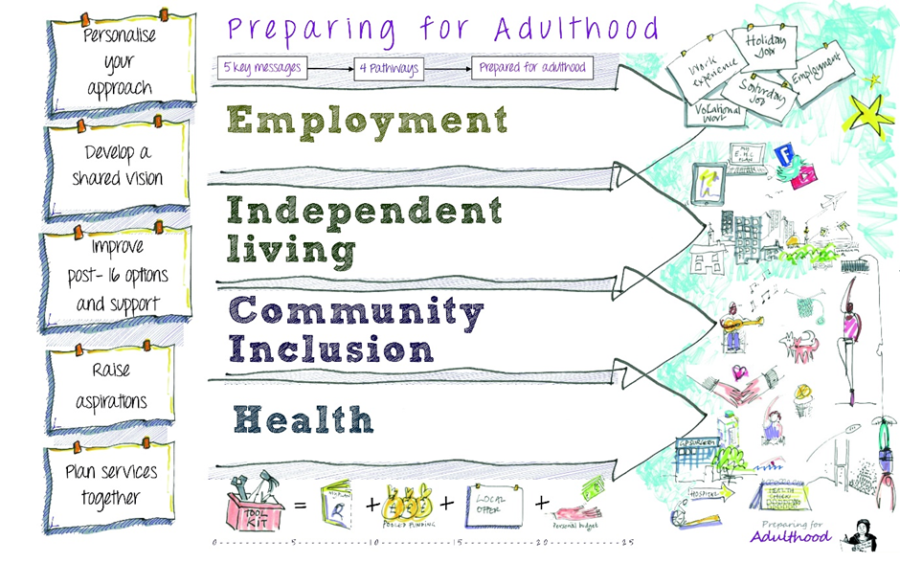
Preparing for Adulthood - NDTi

2.0 Purpose of the protocol

In Tower Hamlets we have a developed a pathway approach to the Preparing for Adulthood/Transition process. This protocol relates to the process for transition to Adult Social care. It is recognised that not all young people who have an Education, Health and Care Plan (EHCP) will require support from Adult Social care of have eligible needs under the Care Act. For Young people who may need support from Adult social care a referral to a key team based on individual presenting needs will be made.
This protocol outlines the process at key stages of the Transition process to support the Transition pathways to Adult Social Care and can be read in conjunction with the Tower Hamlets Transition Pathway to Adult Social Care (Appendix 1)

There are several key steps within the Transition Process; this protocol does not replace person centred individual work to support young people and their family/carers but is to support staff to understand the key steps and processes to support young people.

3.0 Year 9 Information Sharing Day/Transition Tracking
The information sharing day takes place on an annual basis in the academic term soon after September and involves all current Year 9 students who have an EHCP. The purpose of this process is to review the current presenting need and to identify the proposed key team for transition to adult services.

Key membership:
Education lead
Children with Disabilities Lead
Children Looked After Lead/ Through Care.
Careers service Lead
CLDS Transition Manager and CLDS Health representation
Initial assessment Team / Localities Teams
CAMHS

Optional membership:
Neighbourhood Mental Health Team Lead

Information Sharing Day Process

The Year 9 cohort of young people with an EHCP is shared by SEND. EHCPs are shared via a shared folder or accessed via Mosaic. These are reviewed in the meeting with the following possible scenarios and outcome or proposed future key team in adult services.

- Not currently receiving Children’s’ social care and identified for the Education, Employment and training pathway (Careers Service)
- Not currently receiving Children’s social care as needs are met within the family but identified as needing a Care Act eligibility assessment for Adult services.
  - In most cases this will result in a referral to Tower Hamlets Connect. The process of signposting or referral to the Initial assessment team will be followed.
  - For Young people where there is evidence of a Learning Disability the key team will be identified as CLDS who will screen the referral.
  - For young people with Mental health issues who are open to CAMHS the transition pathway in terms of the health need will be determined nearer to the 18th Birthday in line with the East London NHS Foundation Trust (ELFT) Transition process (Appendix 3)

- For Young people who are currently receiving support from Children’s social care and will need assessing under the Care Act for eligible needs as an adult.
For young people who have a social care package from Childrens’ services the key team in Adult Social Care will be identified.

    - Learning Disability – Community Learning Disability Service (CLDS)
    - Physical Disability, Visual Impairment to a Locality Team
    - Mental Health issues a referral may be made to a Locality team or an Adult Mental Health service depending on identified needs at the time of transition
    - Autism without other needs – Locality Team
    - Autism with evidence of a Learning Disability – CLDS
    - Autism and a Mental Health diagnosis – Neighbourhood Mental Health Team or Locality Team depending on needs at the time of transition.

- Details of proposed key team will be recorded on the master spreadsheet
- Key teams will be notified of the outcome from the information sharing day of the proposed transition cohort to their team. This will also be referred to at the Transition Operational meetings.
- For young people identified for CLDS, a letter will be sent to parent added to a transition list for possible referral to CLDS from age 16 years and a letter sent to the GP to include the young person on the LD register for an annual health check.

4.0 Transition referral pathways
Age 14-16
- Transition tracking lists available in each service area from the Information Sharing day.
- Link from each service area will need to maintain the list of clients who are due to transition.

- Year 9 annual review . The Year 9 annual review will focus on preparation for adulthood. This includes employment, higher education, independent living skills, community involvement and staying healthy.

Age 16 – 17
- For Young People open to Children with Disabilities Team a referral will be made directly to the Adult social care key team Identified.
- For Young people not receiving support from CWD team the referral will need to be made to TH Connect or to CLDS for young people with a Learning Disability. This can be made by the School, Children’s teams, GP etc

Age 17-18
- In Adult Social Care a Care Act Assessment will be conducted by the appropriate key team, continuing to work in partnership with Children’s services and Education before the young person turns 18 years of age.
- Partnership working with Education is key for details of continuation of Education post 18 which includes preparation for further education including University placements to ensure sufficient support has been assessed and is in place.
- Referrals to Neighbourhood Mental Health teams from CAMHS are made at 17.5 years of age in line with eh ELFT Policy (Appendix 3)
- Care and support plans relating to assessed need under the Care Act in ASC are to be in place by the 18th birthday.
- For young people who are known or have been referred to Occupational Therapy in Children’s services there may be a need to transfer to an Adult Service, based on the need of the young person. If the young person is currently on an OT waiting list in CWD team, following a discussion with the key team, this will be transferred and added to the waiting list at the date the original referral was made to CWD.
- For referrals made to TH Connect a contact will be added to Mosaic. Information and advice will be provided. If a referral is indicated for ASC a Contact will be added to Mosaic with the Planned Entry (Transition) selected.

Transition Operational leads meetings
A Transitions operational leads meeting will be held on a bi-monthly basis to take forward and support the outcomes from the Transition Information Sharing day.

The aims of this meeting is to:
- Review and update the data collated from the Transition Information Sharing Day. This will review the key team which has been identified.
- The key team may change as further information may be available. The ASC Interface documents can be used to support the ongoing process.
- Update progress and review transition planning for Young People open to Children’s Social care including CWD, Looked After Children
- Identify any young people open to CSC who have moved into the borough.
- To also review at these meetings any young people who are currently open to Children’s social care who are part of an ongoing Legal Casework, safeguarding to share information and plan Transition to ASC team.
- Discuss any complex cases including NHS CHC, hospital admissions and Transforming care, Residential school placements NRPF

Key membership:

CWD Team Manager/ Transition social worker
Looked After/Through Care team
CLDS Transition Manager/ Deputy team manager
Initial assessment team/ Localities Team Rep
NMHT operational lead rep

Optional: CAMHS

Disagreements between Teams
- The principles guiding this Transition protocol is that each case should be allocated to the most appropriate team to support the individual based on the information and details received.
- Allocation of a Key team at the Information Sharing day is based on the information available at the time and is not definitive. Once a full referral is received, identified needs may change or further information may mean a different service is more appropriate.
- It is expected that all practitioners model best practice by communicating effectively with each other when agreeing or discussing the most appropriate team for the individual or to agree any handovers to another team when required
- Any disagreement concerning which team should hold the case should not inhibit the provision of necessary assessments and care and support, and actions should always be taken on a without prejudice basis.

The Transition Board has oversight of the Transition process and pathways. Any issues can be brought to the Transition Board meeting including any disputes or lack of progression for the young person

Appendix 1: Transition pathway to Adult Social care

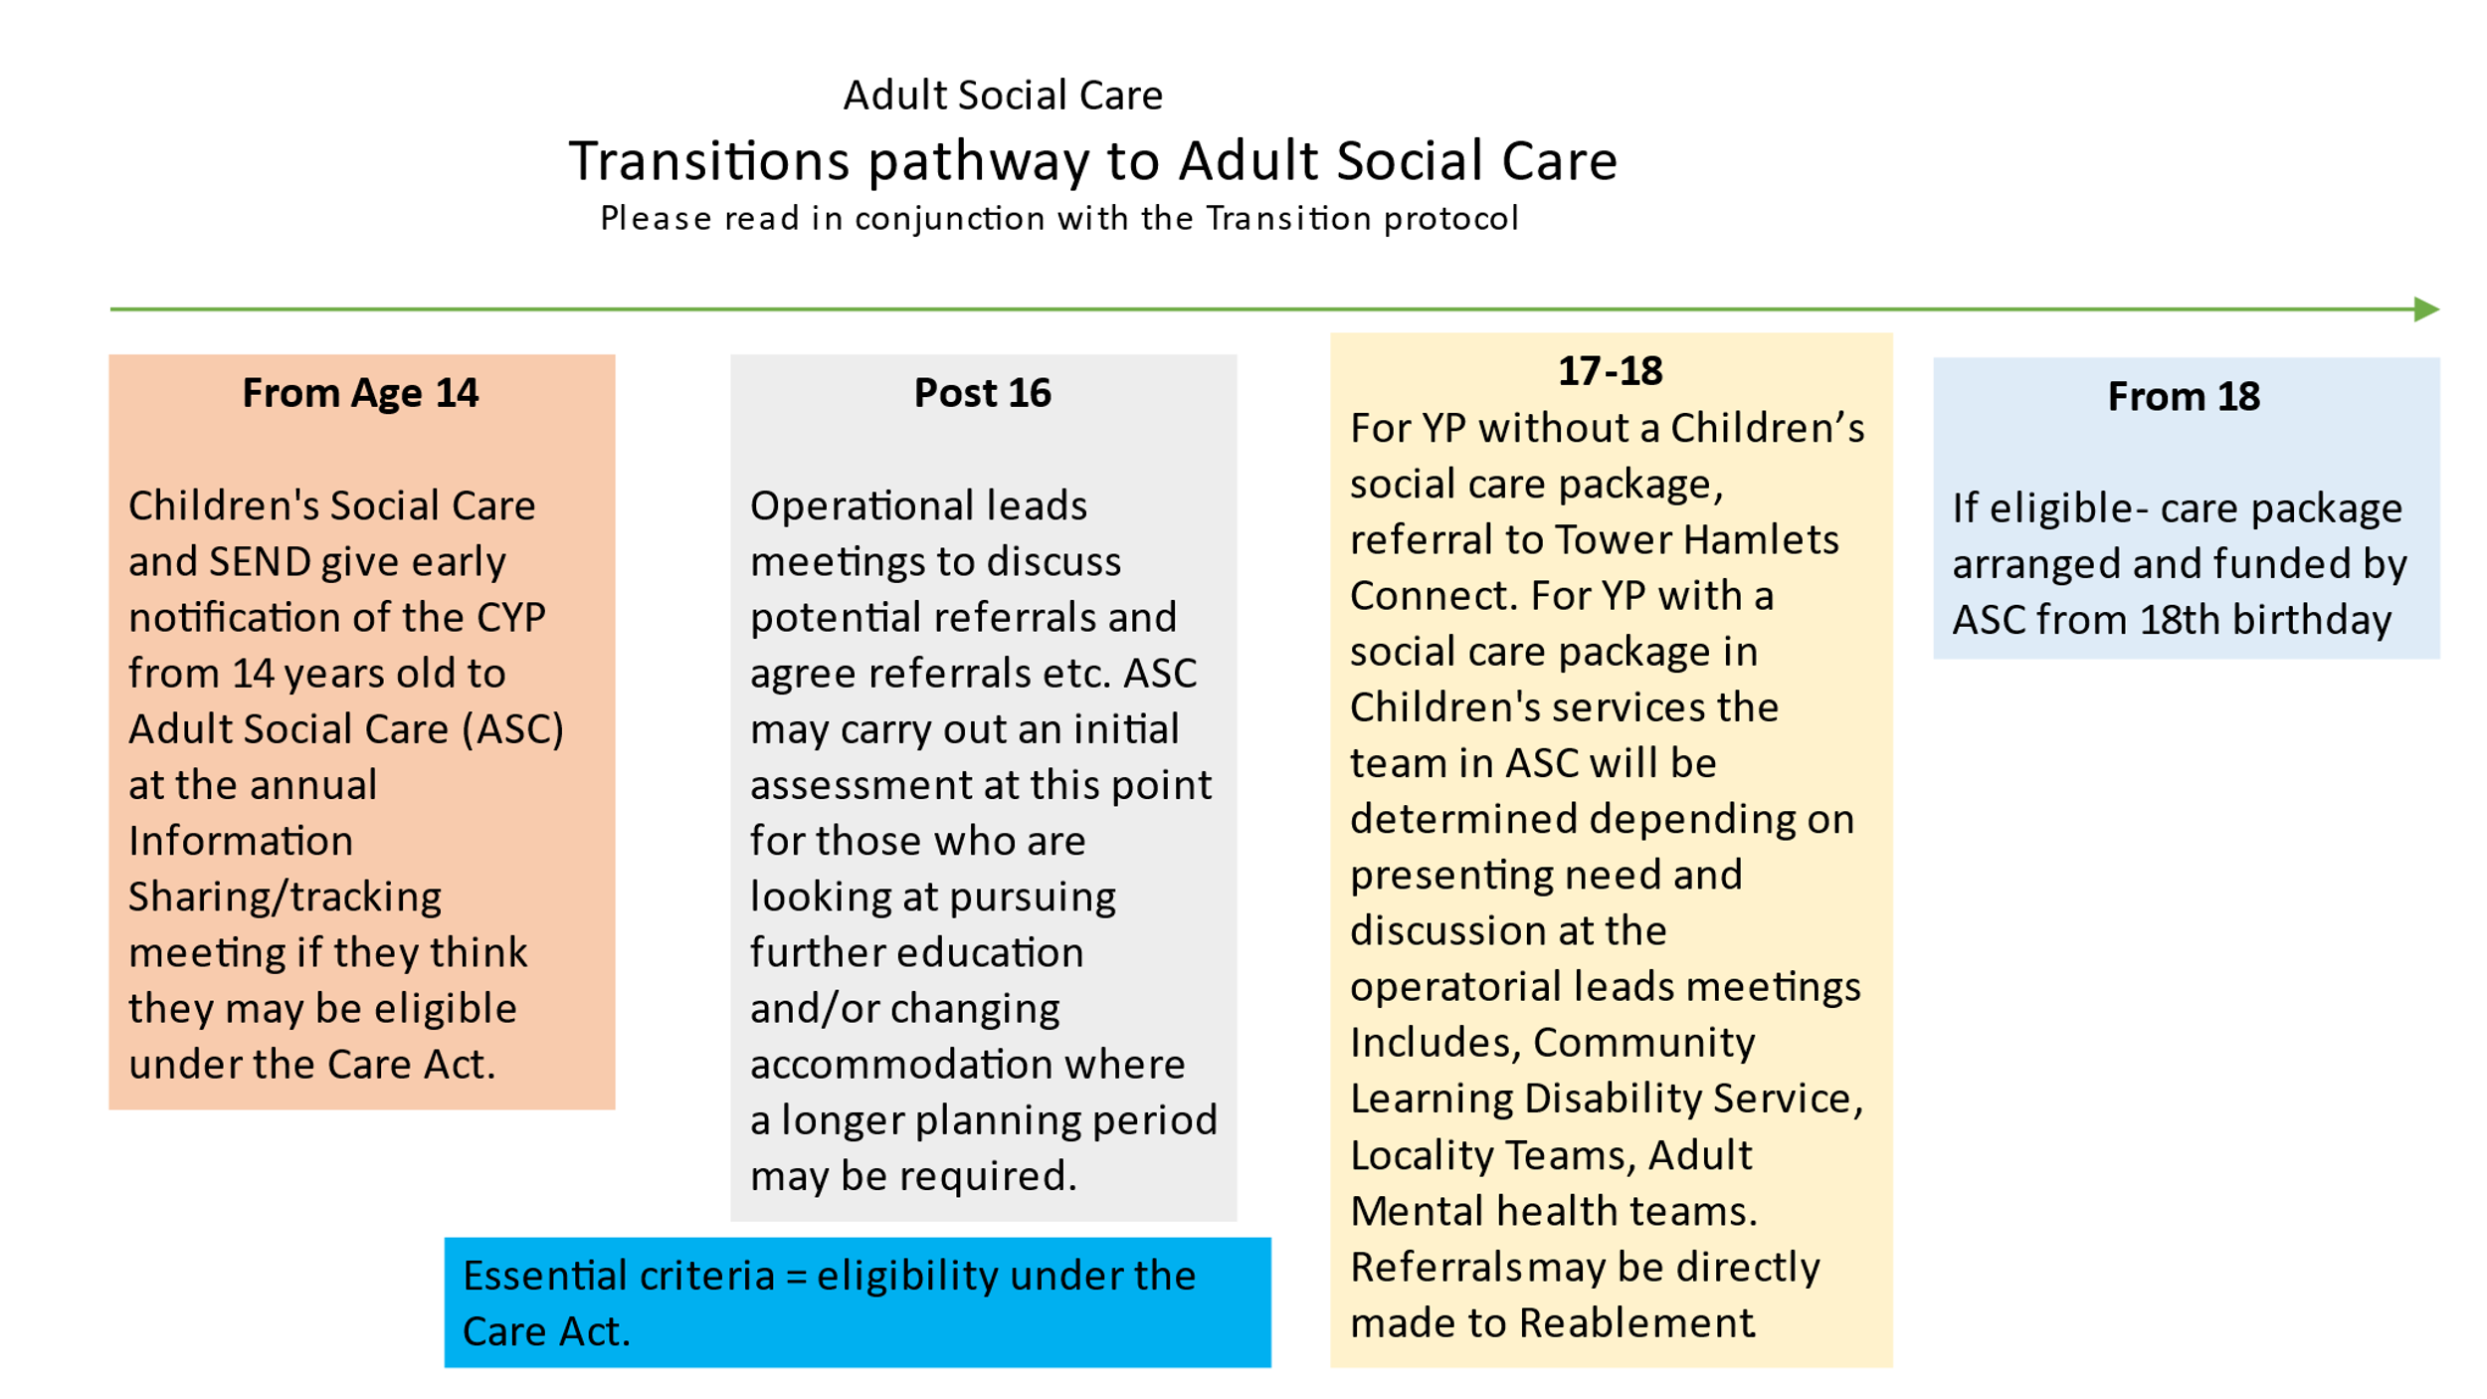

Appendix 2

Transition from Child and Adolescent
Mental Health Services to Adult Mental Health
Services Policy 2022

Appendix 3 Useful information .

LBTH Transition Moving from Children’s services to adult services – leaflet.

The Local Offer:
https://www.localoffertowerhamlets.co.uk

National Development Team for Inclusion (NDTI) Preparing for Adulthood - NDTi

