Tips for completing a Care Tech referral
We received some very helpful feedback about the interim Care Tech referral process and as a result, the referral process is changing on 12/2/24. From this date onwards, LBBD staff will now be able to complete an online referral form via a link that will be embedded into Liquidlogic within the Care Tech assessment form. You may still contact Alcove over the phone for advice but phone referrals from LBBD staff will no longer be accepted.
This document provides advice and guidance about completing the new referral form. Please read it carefully prior to completing your first online Care Tech referral to ensure Alcove receive all of the information they require to make an accurate and appropriate assessment of which Care Tech devices will meet the person's needs. Please note than any incomplete information on referral forms could result in delays in installing devices if Alcove need to contact the referrer to clarify anything so please ensure the form is completed fully.
How to access the online Care Tech referral form
On Liquidlogic, select the ‘Care Technology Referral Form’ from the documents listed.​​
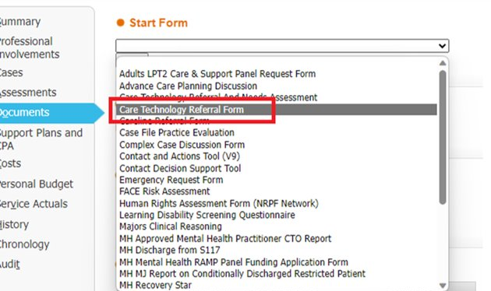
After clicking on this document, you will see the following information which includes a summary of the tech available and a link to the referral form.

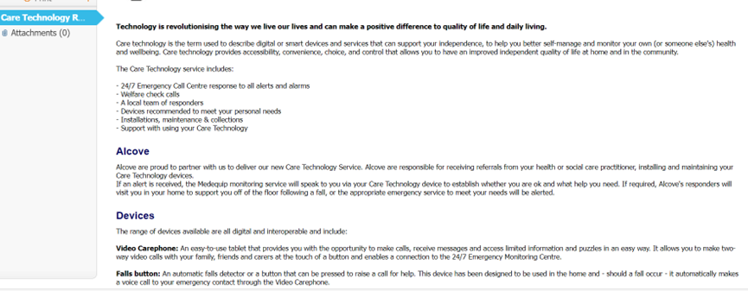

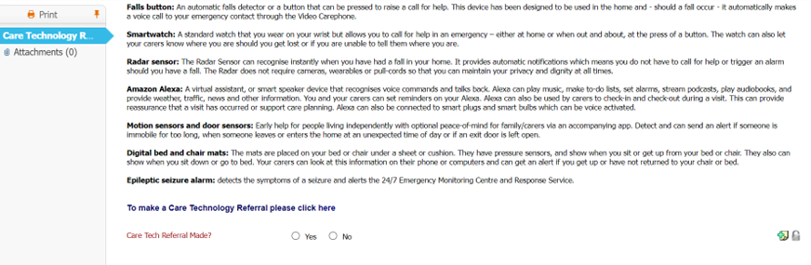

Filling out the form
General tips
- Fill in the form as thoroughly as possible to avoid Alcove having to come back to you to clarify anything which can delay installation
- Many of the questions have a symbol next to them, the letter “I” in a grey circle. Hovering your mouse over this will bring up some suggestions about what needs to be included in the box

Step 1: Client Reference number
Please add the service users Liquidlogic number to the “Client identifier” box as shown below. The NHS number is only to be used where a person does not have a Liquidlogic number.
If you add a liquid logic ID and the client is already on the system, their details will be auto populated on the form and you will just need to check that their details are still relevant, update any boxes where information has changed, and add a new product then press submit.

Step 2: Referral originator details
Please enter your name in the referral originator box, not a team name. Alcove need to know who placed the referral to report back to referrer with any questions, concerns and to confirm installation has been completed so it is important you provide your own name and contact details. If you need to provide an additional name/email address/phone number for a colleague who Alcove can contact in your absence, you can do this later in the form in the “Add a contact” section.
Where possible, please use the pre-populated drop-down list when completing the “Select referrer team” section. Some of the names in the list might reflect service areas rather than specifying the exact team underneath that over-arching service area for example, CHAT 1 and CHAT2 are collectively referred to as the Assessment and Home from hospital service in the drop down list. You may use the free text box underneath to specify exactly which team you are in if you wish.
If your service area isn’t listed, please select “Other” from the drop-down list and type your team name in the text box below.
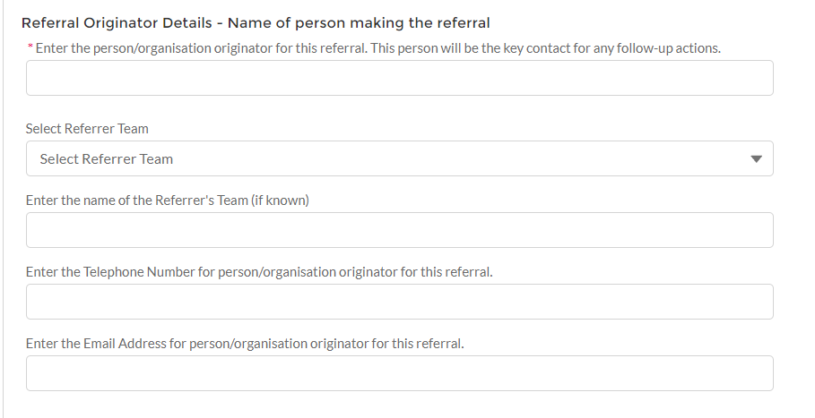

Step 3: Service user details
It is vital that you fill out of the contact details for the service user to avoid delays in scheduling installation. This section must include only the service users contact details. If they require a representative to liaise with Alcove on their behalf to schedule installation, the contact details for their representative can be added later in the form in the “Add a contact” section.
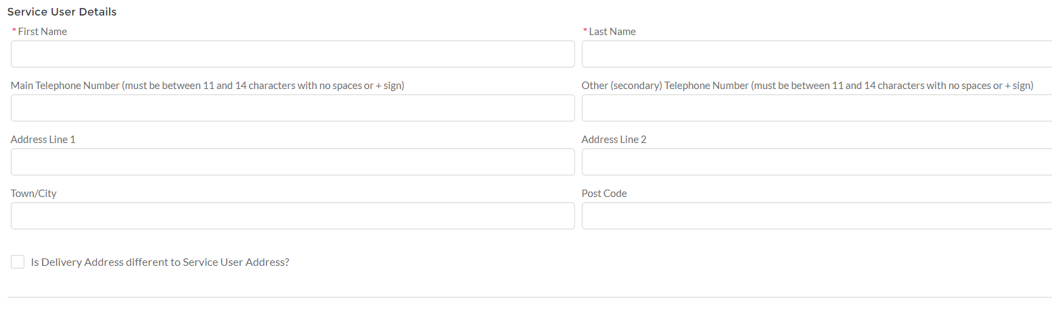
The “Additional set up requirements” box is a free text box in which you can fill out specific requests for the ATEC devices that are being installed, for example:
- Where you want sensors to be placed
- What reminders you want adding to the devices
- Any specific alerts that are required e.g. door opening at night, not out of bed by 9am, not returned to their chair after 30 minutes etc. Alerts can be tailored to meet individual needs but Alcove require guidance from the referrer on what is required
- Whether there is a specific target date for installation, for example to align with hospital discharge or a change to a care package
- Any contact details that need adding to the devices so that family receive alerts
- Any family members that need to have access to the portal to view sensor data and alert history
The question about whether the service user has a pacemaker is very important as some pacemakers must be kept more than six inches away from mobile phones and care technology devices so this may mean that a wrist worn device is required rather than a device on a lanyard for example, to ensure the device doesn’t interfere with the pacemaker. If you do not know the answer to this question, please check with the service user or their family/health professional. If the person has a pacemaker please tick the check box.

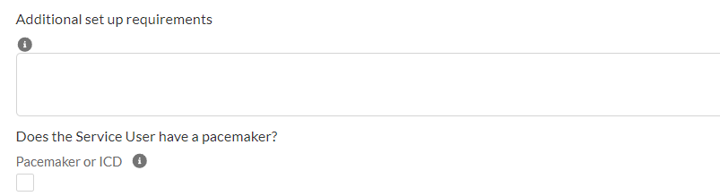
Step 4: Referral information
When completing this section, please keep in mind that Alcove do not have access to Liquidlogic in order to read any information about the service users presenting problems, medical history, care needs etc so this is the only information they will see that will help them to make an appropriate assessment of the persons care technology needs. It is therefore vital that this section is filled out as thoroughly as possible.
Reasons for referral
When completing the “Reasons for referral” text box, include as much detail as you can about why you are referring for Care Technology. This might include information about falls risks, risks of wandering, medication management issues, environmental risks within the home e.g. risk of fire or floods due to cognitive impairment, information about seizures, the need for data for sensors to inform assessment of care needs, the need for tech to support with communication with family members/professionals etc. This is not an exhaustive list but a guide to what sort of information might be included in this box.
Do you know if Monitoring and/or Response services are required?
If a service user has family or representatives who will monitor alerts from their care tech devices, it might be decided that Monitoring is not required and that Alcove are simply to provide the care tech devices and set them up to allow the service users support network to monitor independently. If this is the case, please select “No monitoring” from the drop-down list.
If family or service users’ representatives are unable to utilise technology to monitor alerts, but live near to the service user and would be able to go out and respond to an alert if they received a phone call to tell them they were needed, select “Monitoring only”. Please also select this option if the service users needs are too complex for a response service to visit them i.e. they would need urgent medical attention if an event were to occur or they require more than one person to support them after a fall, for example, due to complex moving and handling needs.
Has the client provided consent themselves for this equipment or is there a Best Interest decision maker?
Please note, Alcove do not make best interest decisions so the service user must have either consented to the referral, or their representative if they lack capacity, or a professional has made a best interest decision that care technology is the best way of meeting their needs. If you select “Don’t know” to this question, Alcove will come back to you for further information which will delay installation until the question can be answered.
Is there a keysafe present?
If the answer to this question is “No”, Alcove will arrange installation of a key safe if the response service is required as the response service need to be able to access the property in an emergency. The response service does not hold keys.
Where the response service is required, is client safe for a single-handed responder service?
Alcove are only able to send one staff member to respond to an alert. If the service user requires more than one person to assist them, for example due to complex moving and handling needs or potential risk to Alcove staff i.e. if known to be abusive, Alcove cannot offer the response service for this person and emergency services would be called if an incident occurred.
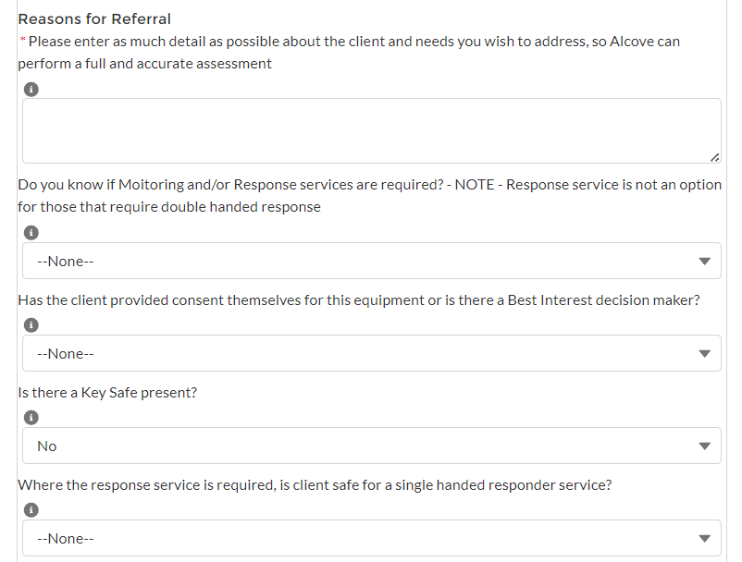
Monitoring Centre information
This is a free text box in which you will input any information that is important for the monitoring centre to know. Alcove will pass this information directly to the monitoring centre therefore if there is information you have covered in previous questions that is also relevant to the monitoring centre, please include it in this box too.
Information relevant to the monitoring centre includes:
- GP surgery details
- Care agency details
- Relevant medical conditions
- Important medications
- Whether there is a DNAR in place
- Whether they are on blood thinning medication
This is a guide and not an exhaustive list. Please use your professional judgement about what is important for the monitoring centre to know.
What is the priority level for this installation (Urgent or Standard)?
Alcove aim to arrange all standard referrals within 5 working days and all urgent referrals within 48 hours however this is a guide only as there are many factors that will impact on the speed of installation such as:
- Incomplete referral information requiring clarification from the referrer
- Alcove unable to contact the service user/their family to schedule the installation due to incorrect contact details or them not answering the telephone (Alcove will contact the referrer if this occurs and request alternative contact details)
- Service user preference, i.e. they would like installation on a specific day

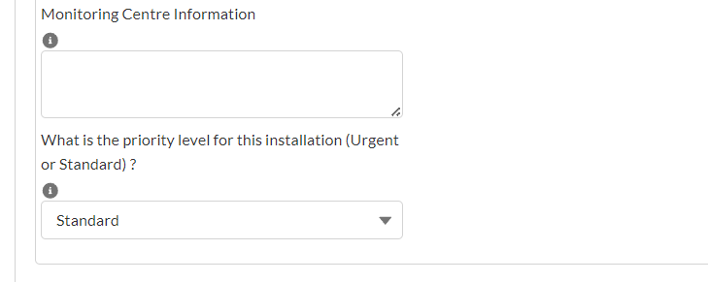
Step 5: Risks
This section helps to ensure the safety of Alcove staff visiting to install the care technology devices and of response service staff. Please select the relevant risk from the list on the left hand side the click the right arrow. Multiple options can be added to the chosen box.
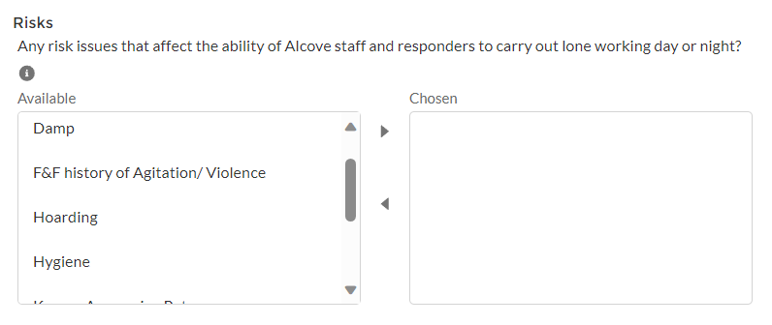
Step 6: Products
This section can be left blank if you would like Alcove to assess and decide on the appropriate devices, however, if you have a particular device in mind or have spoken with the service user and they have agreed to have a particular product, you can add the details in this section.
Click the “Add/remove package” button as shown below
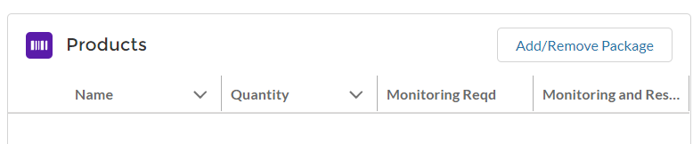
This will then bring up a drop-down list of all available products. Please select the check box next to the ones you require (you may select multiple) then click “Add products”.

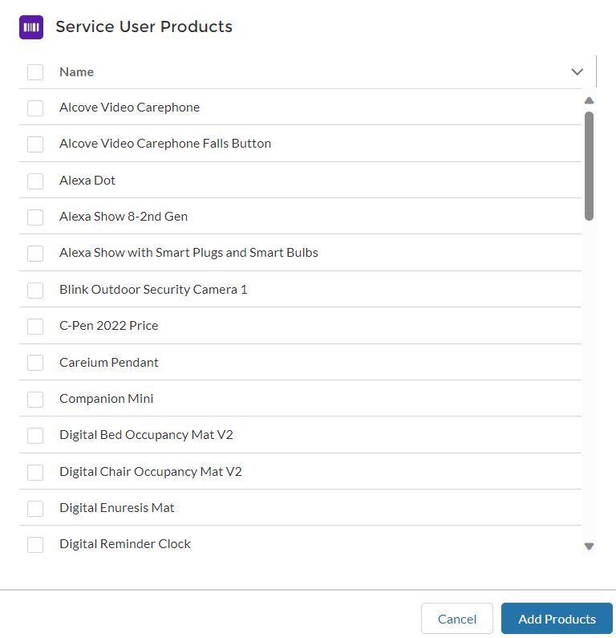
Once the products have been added to the list, you are able to edit the “Quantity”, “Monitoring Required” and “Monitoring and Response required” columns by clicking on the pencil icons that will appear when hovering your mouse over the respective rows/columns.
Remember to click the “save button once you have added all of your devices and edited the relevant columns.

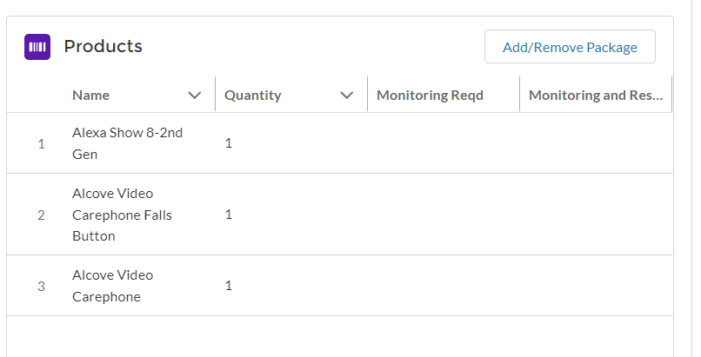
Step 7: Outcomes & Financial Benefits
This section is vital to demonstrate the impact of the service. Outcomes and financial benefits will be regularly reported to commissioners and leadership and will support with decision making regarding future investment in the service.
Please select only one referral benefit from this pre-populated list. There may be situations where multiple options are applicable but please select the primary/most important outcome in these situations.
Please select the required option then click the right arrow to move it to the chosen box.
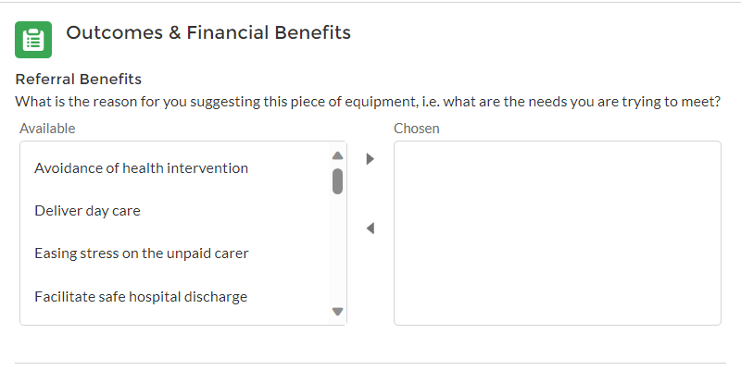
The financial benefits section enables us to attach a figure attributed to either cost avoidance e.g. prevention or delay in care needs, or direct financial savings such as a direct reduction in their care package that will be achieved through provision of care technology.
Please select one option from this list out of the following:
- Deliver a reduced service from its current level
- Avoid an increase in service from its current level
- Technology to meet a new service need i.e. they do not yet have a care package in place as it is a new need and provision of care technology will prevent the need for formal care and support

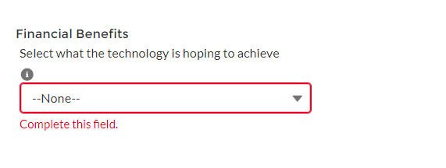
Upon selecting an option from this list, a list of more detailed options will appear below. Please select only one option from this list. Click on the required option then the right arrow to move it to the chosen box.
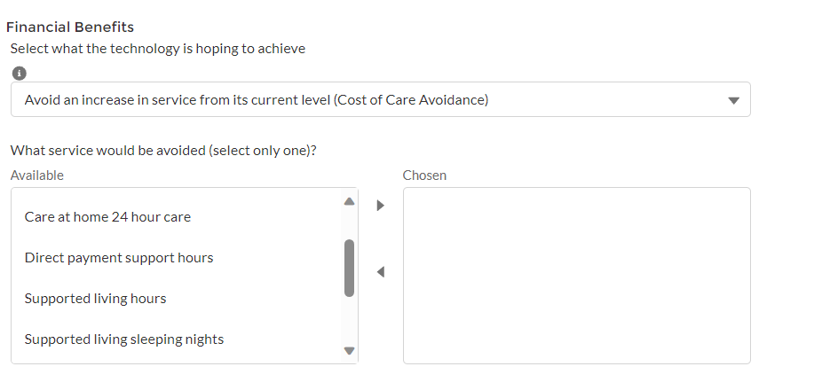
Once an option has been added to the chosen box, a new question will appear below, asking you to specify how many hours could be reduced/saved each week by technology implementation. Options such as care home placements which are not usually purchased in hours will not require you to input hours saved.
Please use your professional judgement when completing the hours saved question as this will vary based on individual needs. Please remember it is hours saved per week, not per day.
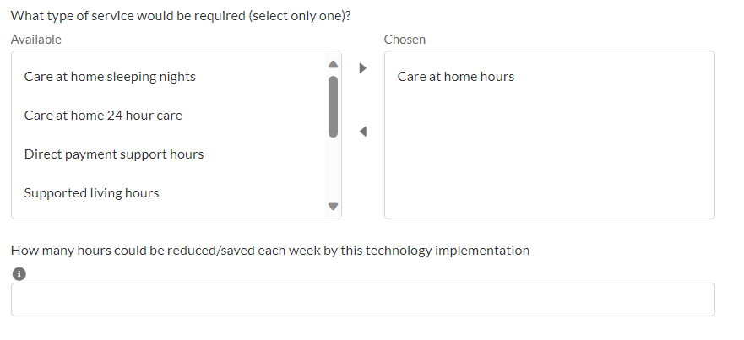
Step 8: Add a contact
This section is used to add any important additional contacts needed including family members who might support with arranging installation and receiving unplugged/low battery alerts for example, professionals who might need to be kept up to date with the referral progress, best interest decision makers, or representatives who will act as responders.
Please complete the name, telephone number, email address (where available) and relationship boxes for each person so that Alcove know who the person is, what to contact them in relation too and how to get hold of them. Please also select from the drop-down box whether the person is a family member or a professional or carer. You may use the comments box below if you wish to expand on any of this, for example if you are providing a colleagues contact details you may want to specify when to contact them instead of yourself, e.g. your non-working days.
There are optional check boxes which can be ticked if the contact is the service users representative or will be a responder. You are able to tick both of these boxes for each contact if relevant.
Once you have completed all boxes, click the “Add contact” button and the contact will move to the table below, clearing the “Add a contact” form for you to use to add details of the next person you want to add to the list.
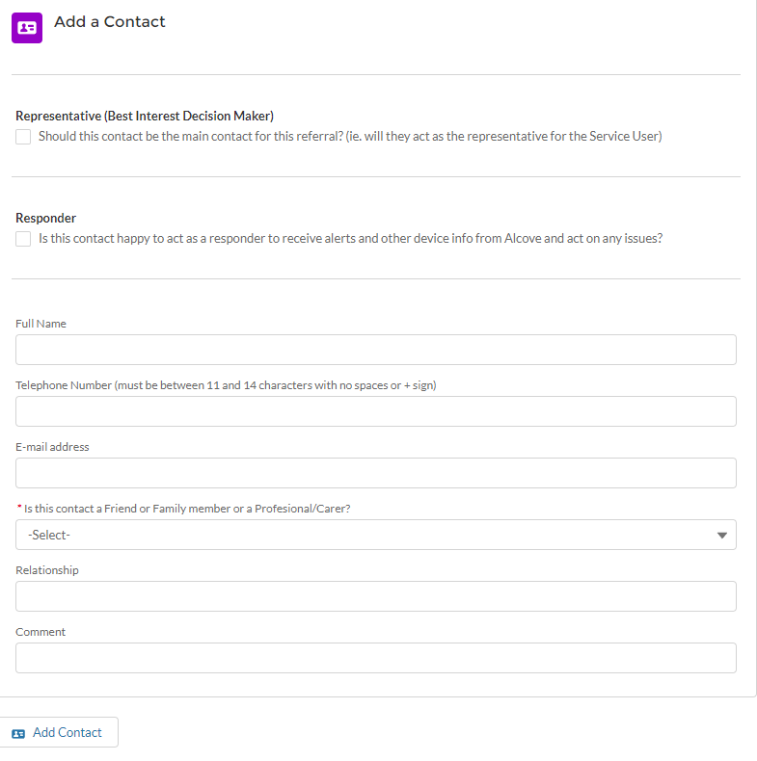

Step 9: Submit all data
Once the whole referral form is complete, please click on the “Submit all data” button in the bottom right-hand corner to submit the referral to Alcove.

