What is Reunification?
Reunification is when a Child Looked After returns home to live with their birth family. In England and Wales in 2019/20, of those that leave care, 29% of Children Looked After return to the care of their birth family.
Reunification is most successful when it is well planned, based on robust assessment of risk which includes the child and the birth family, which allows children to go home slowly over a period and where appropriate services are put in place to support the family for as long as they are needed.

Why is effective reunification work important?

For reunification to go well, it's important that everyone involved can plan and work together. Our experience tells us that it is important that:
- Reunification is supported by a clear and thorough assessment of the child’s needs.
- Support from appropriate services for the child and their family is available.
- We make sure that we plan and prepare for the return home and offer good support and advice after the child has returned.
Effective reunification work is important first and foremost because it is in the best interest of the child or young person that any consideration of the possibility of a return home to their birth family is structured, evidence-based, well-planned and involves the child, their family and key multi-agency practitioners.
What does reunification look like in Tower Hamlets?
The Edge of Care team was trained in the NSPCC reunification framework in 2019. The Department of Education funded the NSPCC to create evidence-informed practice guidance for local authorities to support successful reunification work. Following the training, we completed a Reunification Pilot project for 18 months, using the NSPCC reunification framework to monitor and evaluate practice and identify better ways in which support can be provided to families following return home.
Our reunification work has strong links to our restorative practice approach including the use of Family Group Conferences at various stages of the assessment and planning. In addition, we link with the Lifelong Links team aiming to build positive, lasting support networks for children and young people who have lost or broken connections with family members and supportive people during their time in care.

What do we all need to know?
We all need to be aware about the reunification framework and that children and young people are being identified where it may be appropriate for them to return home.
Social workers together with others involved with the child, possibly through a family group conference, will use the reunification framework and practice guidance to support the work to consider reunification. Other practitioners working with the child will become involved at different stages of the process.
The reunification framework has five stages:
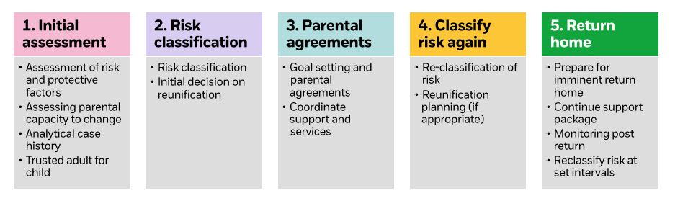This resource is a framework for planning and undertaking the reunification of children to their parents following a period of living out of home.
In the Edge of Care team, we offer two types of reunification support. The appropriate reunification processes will also be discussed with the referrer at the Resources Panel.
Some more information about our reunification support offer in the team:
One form of reunification support is offered when the plan is for a young person returning home or if a return home has happened at short notice or unplanned. The Edge of Care Service provides around six months of help to support individualised reunification plans with a family. The NSPCC model is not used as part of this support.
The other reunification support involves helping the decision-making process. It is about assessing whether it is safe enough for a return home to happen or to identify what support is needed to make it safe enough for a young person to return home. The Edge of Care Service can help the social work team in this work. The service is guided to use the steps of the NSPCC Evidence-informed framework for return home practice work where the steps of the model are followed. The framework supports practitioners and managers to apply professional judgment to complex decisions about whether a child should return home.
If reunification work is completed, (steps of NSPCC model), evidence of an analytical Chronology, Themes and patterns of the risk, the risk classification, a co-produced reunification plan are all completed and uploaded on documents. The social worker is then required to complete an updated assessment to consider a return home decision or if unplanned return to capture the change of situation.
As it is a framework document it appears lengthy, at 128 pages. If not implementing the full framework, it still contains many useful tools for better planning and understanding the needs of the child and family during reunification.
To download:
https://learning.nspcc.org.uk/media/1095/reunification-practice-framework-guidance.pdf

Key contacts and to request more information:

Charlotte Moodie (Team manager- Edge of Care team) Charlotte.Moodie@towerhamlets.gov.uk

