Buckinghamshire Council Adoption Service

Moving to Adoption –

Guidance for working with Under 3’s

Author: Debbie Cavell, Pre-Adoption Life Story Worker
Date: June 2022

Contents
Introduction 3
Carers Role in Moving under 3s on 3
How we can support you 4
Under 3’s Transition Process 5
Under 3’s Transition Consultation Checklist 6
Talking about Moving On 8
Book suggestions for under 3’s 10
Transition Play Ideas for under 3’s 12
Countdown Calendar – One day at a time 13
Countdown Calendar –Moving Week 14
Countdown Calendar – Number of Sleeps 15
Under 3’s Adoption Journey – TEMPLATE 16
Under 3’s Moving on picture book – TEMPLATE 17
What is Theraplay®®? 19
The 4 Dimensions of Theraplay®® 20

Introduction
It is important that children are prepared to move on to their new family home and have an understanding that is happening. Under 3’s may not fully understand the concept of adoption, but they will be very much aware they are moving on and can still be prepared for this with your help. It is an important part of the foster carer role to guide and support children through this process.
Life story workers help prepare children to move onto their new homes and we are there to support you and give you some tips and recommendations to help you support your child.
If you would like this support, please get in touch with your supervising social worker or the child’s adoption family finder who can make a referral for you.

Carers Role in Moving under 3s on
It is important for children to know they are moving on and the transition and introductions process is gradual to help your child manage the transition. However, preparation for the transition can begin much earlier, and we can help you with this.
There are lots of ways you can help your child to prepare for moving on.
Your child may have a memory box, or you might have begun one for your child. You can continue to create and treasure memories with your child adding mementoes. Also, taking photos can be an easy way to create memories for your child and something they can treasure later on.
You can read stories with your child about being in care and adoption (please see reading list for ideas).
You can talk with your child about living with a foster family, about their birth family and new adoptive family when the time comes.
Your child will be given a moving on book once the adoptive family have been approved at panel. This is for you to read and share with the child to help familiarise them with their new family, give an opportunity to share and look at the photos together, whilst helping to promote the move positively for the child.
You might like to create your own photo album for your child to take with them when they move on.

How we can support you
We are here to support you with the transition and can offer an initial consultation with tips and ideas to help you and additional support if needed during the process. Here is an example of how we can help you:
 | Foster Care Role | Life Story Worker support
Before Transition | - Giving the child a narrative and understanding  - Reading story books about foster care and adoption  - Theraplay® games | - Language and narratives  - Book recommendations  - Theraplay® Support
When family Identified | - Moving on play  - Memories for Wish You Well family time | - Creative play ideas for transitions  - Ideas for Wish You Well family times
Bump into/meeting family | - Preparation conversation  - Repetition of conversation | - Support with scripts and the beginning of the narrative for transition.
Introductions/transition | - Sharing photos and things from new family | - Moving On Book  - Photos  - Countdown Calendar
If you would like our support, please let your supervising social worker or child’s social worker know for a referral for this support.

Under 3’s Transition Process

Steps 1-5

Step 1- Referral from family finder
Family finders complete a form for every child who requires life story work. The form will indicate if the child is between 2-3 years old and if the foster carer will need support with transitions. This is then sent to Assistant TM Family Finding who will allocate the child to one of the life story workers in the life story hub.

Step 2- Consultation with Foster carers
Once the case has been allocated the life story worker will arrange to meet with the foster carer to assess what support is needed. The life story worker has a checklist, to make sure they cover all parts of the preparation and transition process. This is also an opportunity for the foster carers to share any concerns or questions they might have about the transitions. The life story worker will ask about the child to understand what the most helpful and engaging resources will be.

Step 3- Offer support and services
Following on from the consultations, the life story worker will share resources and ideas to help to prepare the child for the transitions. This may include books, play ideas, or language. They may also discuss the transitional tools the life story worker can provide the child at the beginning of the transitions such as moving on books or countdown calendars.

Step 4- Set action plan
The life story worker and foster carers will discuss if further support is needed or if the one consultation was sufficient. If ongoing support is agreed, a plan will be set out which may include check-ins with the life story worker and/or how to introduce different resources and play ideas at different times. If it is felt the child needs direct work with the life story worker, this will also be discussed, however this will need to be agreed by a manager before this work can begin.

Step 5- Review
The support offered will be reviewed within the check-ins to see if more support or alternative resources are needed, this can be ongoing until the transition to the adoptive placement has happened.

Under 3’s Transition Consultation Checklist

Foster Carer:
Child:
Date of consultation:
Proposed Move Date:

Additional Notes:

 | Foster Care Support | LSW support
Before Transition | Books  Theraplay® | Glossary/language  Book recommendations  Theraplay® Support
When family Identified | Moving on play  Memories for WYW family time | Creative play ideas for transitions
Bump into/meeting family | Preparation conversation  Repetition of conversation | Support with scripts and the beginning of the narrative for transition.
Introductions/transition | Sharing photos and things from new family | Moving On Book  Photos  Countdown Calendar

Consultation Checklist
Pen portrait of the child – development, language etc.
What does the child like to do?
Toys/books/craft/play?
What does the child understand about foster care/adoption/birth family?
Does the child have family time? Who with?
Do you have any photos of birth family or memory box?
What resources do you have? Training?
Do you have any experience of Theraplay®?
Have you done a transition before with 2–3-year-old before? What are your previous experiences in transition?
What support/advice have you been given so far?
What support would you like?

We are focussing on the present and the transition.
Support:
- Books
- Language/glossary
- Theraplay®
- Modelling play
- Resource recommendations
What to expect from the transition process

Review – check in – e.g.
- When family identified/selected
- After panel/ADM
- At introduction/transition stage

Recommendations

Completed by:
Date:

Talking about Moving On
Living with a foster family can be a confusing and unsettling time for your child. They may not know how long they might be staying, wonder when they might be returning to their birth parents or refer to you as Mummy or Daddy.
It can be useful to have a script that all your family use to ensure the child is getting the same message from everyone. Here are some examples of words and phrases that might help you explain the transition with your child.
Growing Up Family or Forever Family – an adoptive family – e.g., Sam (social worker/family finder) is looking for just the right growing up family for you. Be mindful that your child may have a same sex new family or single parent, so it’s best to avoid “Mummy and Daddy.”
Looking after family – a foster family – e.g. We are a foster family. We are your looking after family and it’s our job to take good care of you. Try to encourage your child to call you by your names. Some children like to refer to foster carers as Mummy or Daddy and this can be confusing if they are moving on.
Tummy Mummy/ Names of birth family – It can be helpful to refer to birth parents by their first names as time goes on. E.g., “Mummy” becomes “Mummy Jane” and as transition approaches can be addressed as “Jane”. Similarly, the child can address the new family by their names and gradually add “Mummy” or “Daddy” as they feel comfortable to.
First Family – birth family – you might like to refer to the child’s birth family as their first family.
XXXX Couldn’t always take good care of you - your child might want an explanation of why they can’t return to their birth family. We can provide some sheets to help explain this if needed.
Wish You Well family time session – You child may have their final family time session with parents or siblings as they approach the move on. This final session can be made special for your child by providing an activity for them to do during the contact or as a gift for family to help the child say goodbye. This could be a photo or some artwork or handprints for example.
Introducing the new family – once you have confirmation that a family has been matched at panel with your child you can begin to share the Moving On Book, photos, and video clips that you have been given. You can place photos around the home, so your child becomes more familiar with them. You might like to wonder with your child what the new family are doing and think about their home and what it might be like.
Saying goodbye/providing reassurance – it can be hard to say goodbye to your child and the introduction and transition period can be a very busy and stressful time as there are so many things to do and plan for – as well as sharing your home with the new family! Try to plan some time to say goodbye to your child, throw a simple tea party or make something together to keep and treasure in the future. Let the child know you will be remembering them and that you wish them well with their new family.
Sleepover/ number of sleeps – your child might be anxious, nervous, or excited to move to their new family and might like a countdown calendar or know how many sleeps to go. You can make a countdown calendar, or we can provide one for you.

Book suggestions for under 3’s
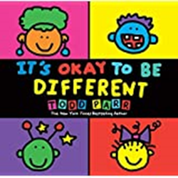 | It’s Okay To Be Different, Todd Parr  It's Okay to Be Different cleverly delivers the important messages of acceptance, understanding, and confidence in an accessible, child-friendly, including adoption.
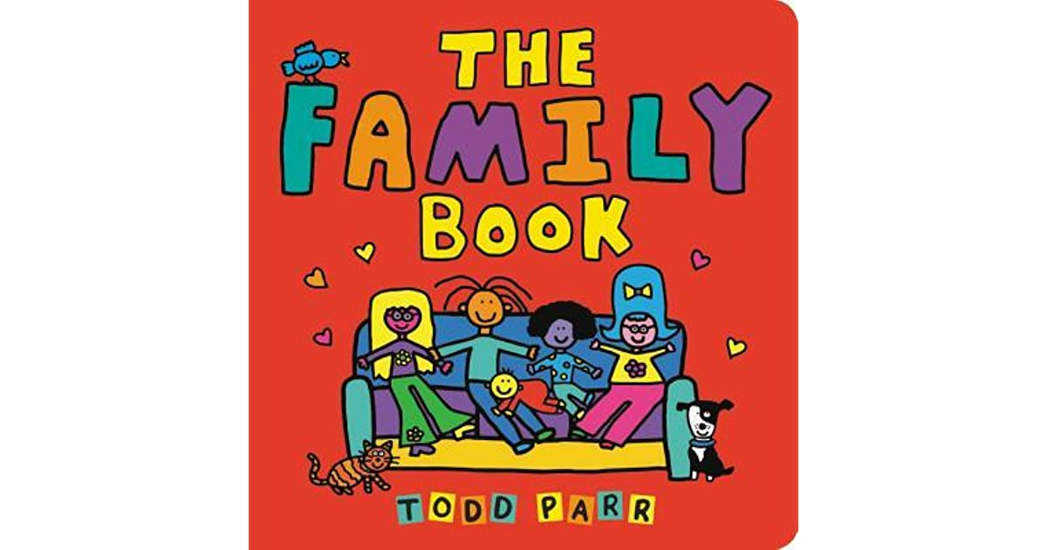 | The Family Book celebrates the love we feel for our families and all the different varieties they come in. Whether you have two mothers or two dads, a big family or a small family, a clean family or a messy one, Todd Parr assures readers that no matter what kind of family you have, every family is special in its own unique way.
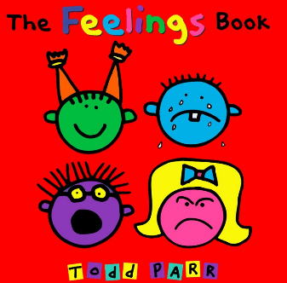 | The Feelings Book vibrantly illustrates the wide range of moods we all experience. Kids and adults will appreciate Todd Parr's quirky intelligence as he pays special attention to the ever-changing, sometimes nonsensical emotions that we all feel.
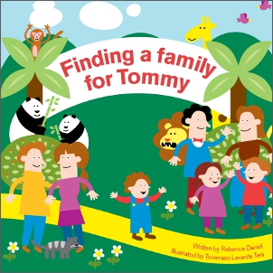 | Finding a Family for Tommy provides carers and social workers with an opportunity to discuss the meaning of family and belonging. The book can be read in preparation for a move from foster care and during introductions to permanent carers or adopters, helping to reassure children at every stage of the process.
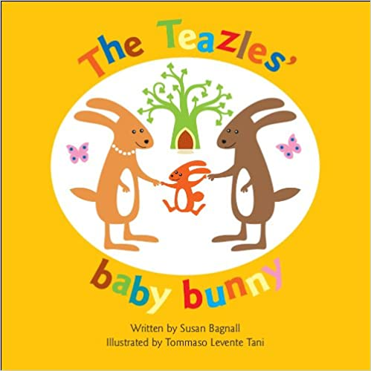 | The simple tale and clear, colourful pictures provide a gentle introduction to broaching the subject of adoption and will help any adopted child to recognise how special they are and how much they are wanted.
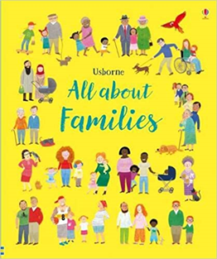 | All About Families, Felicity Brooks  Families come in all shapes and sizes and from all sorts of backgrounds. This book lets children explore questions such as `What is a family?', `What different sorts of families are there?' and includes same sex families and foster and adoptive families.
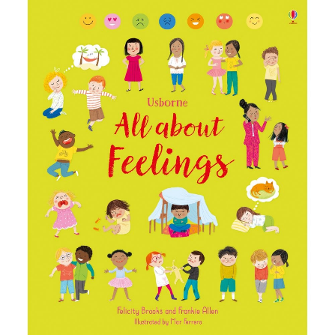 | How are you feeling today? This lively and engaging exploration of emotions helps young children learn to answer this important question. Topics covered include learning to describe feelings, how your feelings can change, and being kind to yourself.
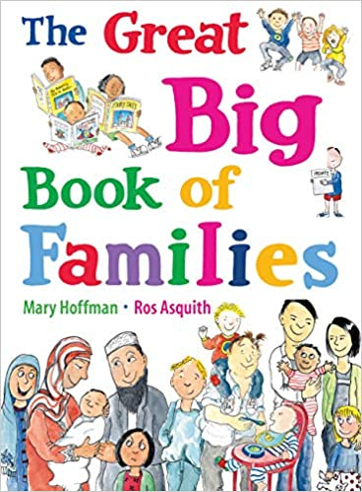 | What is a family? Once, it was said to be a father, mother, boy, girl, cat and dog living in a house with a garden. But as times have changed, families have changed too, and now there are almost as many kinds of families as colours of the rainbow - from a mum and dad or single parent to two mums or two dads, from a mixed-race family to children with different mums and dads, to families with a disabled member.
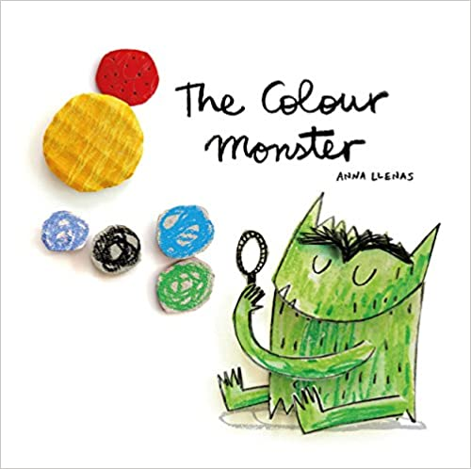 | One day, Colour Monster wakes up feeling very confused. His emotions are all over the place; he feels angry, happy, calm, sad and scared all at once! To help him, a little girl shows him what each feeling means through colour.

Transition Play Ideas for under 3’s
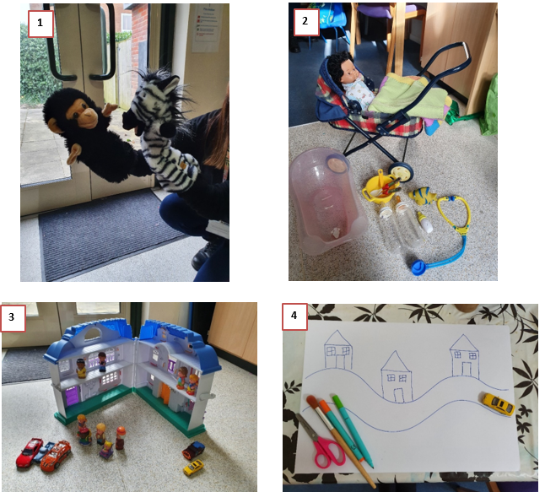
1
1

Here are some play ideas:

- Using puppets, dolls or figures to talk about families, meeting new people, moving, what is happening next.
- Using toys to demonstrate how adults take good care of children.
- Using figures, houses, cars etc. to represent different adults and the move to a new family and home.
- Showing the places a child has lived and will be living through art work and cars.

3

Here are some play ideas:

- Using puppets, dolls or figures to talk about families, meeting new people, moving, what is happening next.
- Using toys to demonstrate how adults take good care of children.
- Using figures, houses, cars etc. to represent different adults and the move to a new family and home.
- Showing the places a child has lived and will be living through art work and cars.
3

Countdown Calendar – One day at a time
4
3

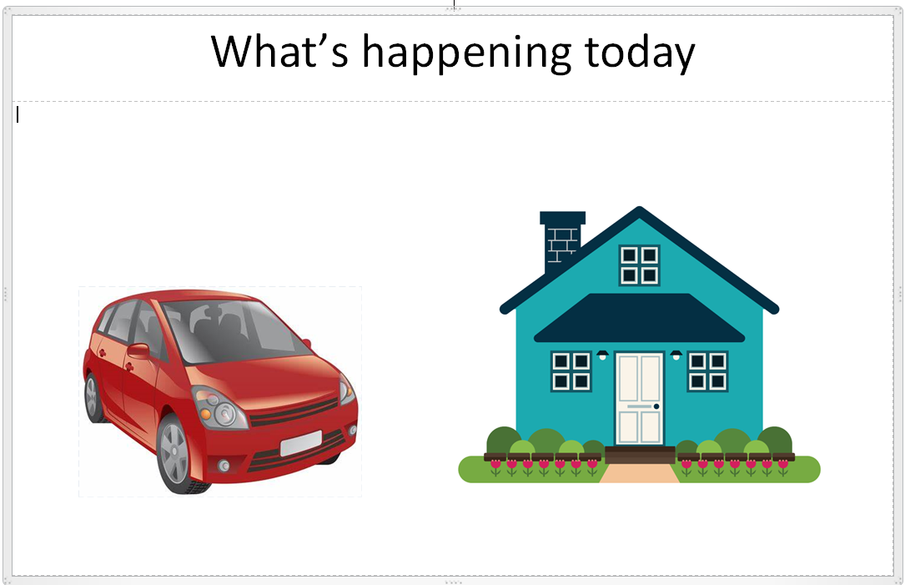

Countdown Calendar –Moving Week

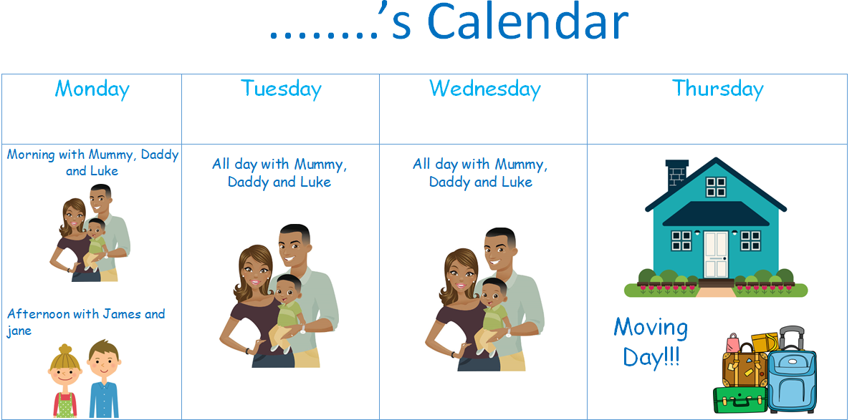

Countdown Calendar – Number of Sleeps

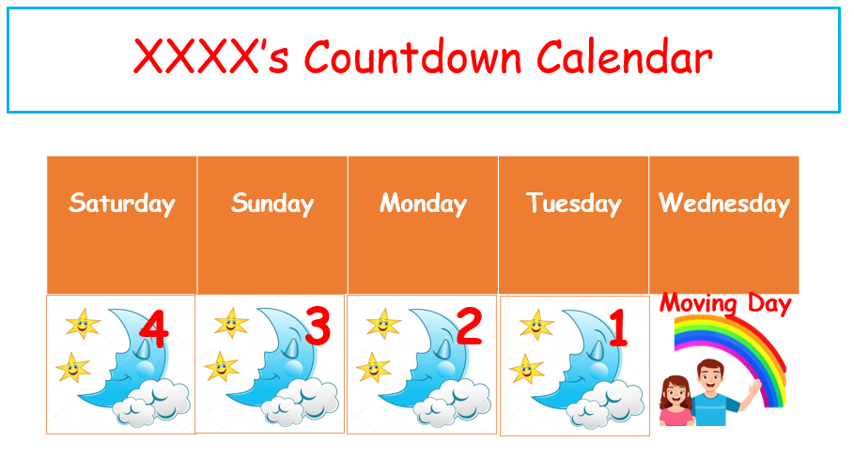

Under 3’s Adoption Journey – TEMPLATE
4

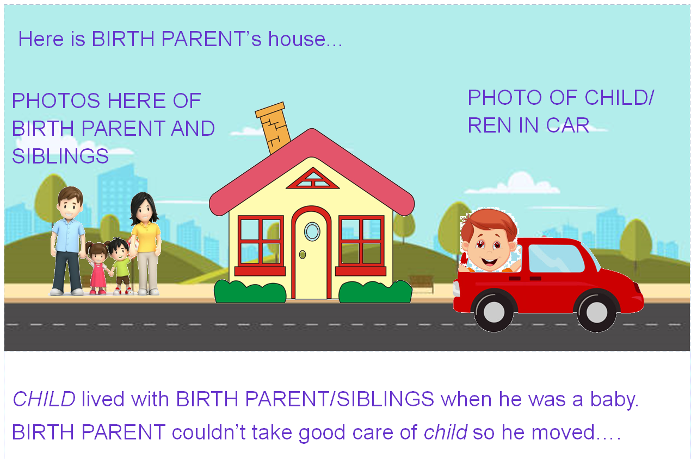
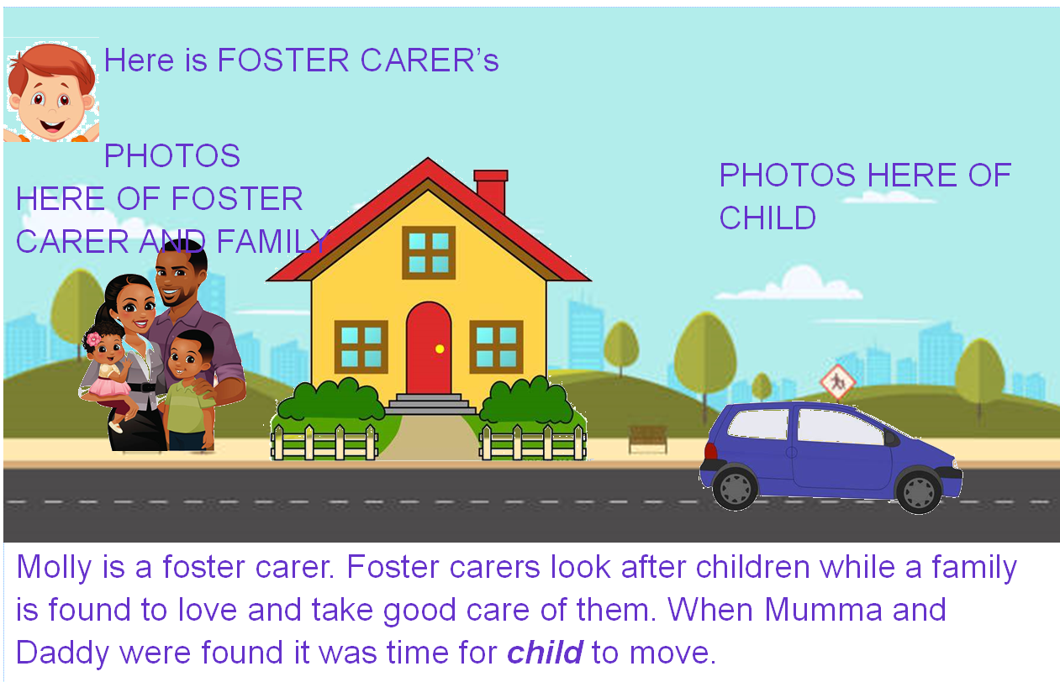

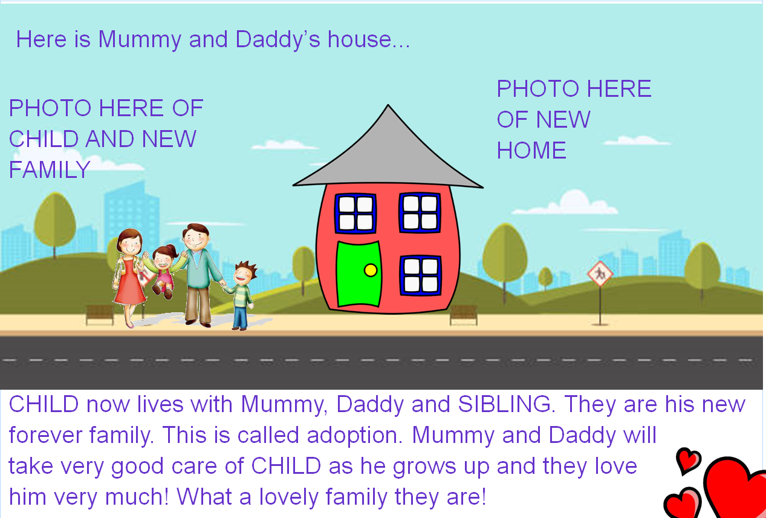

Under 3’s Moving on picture book – TEMPLATE

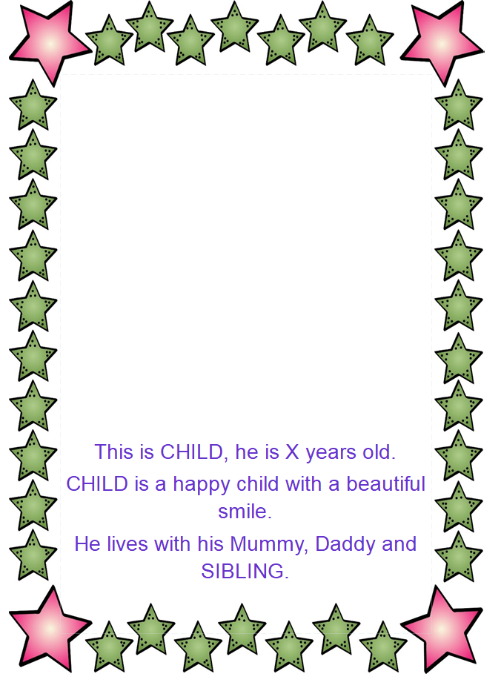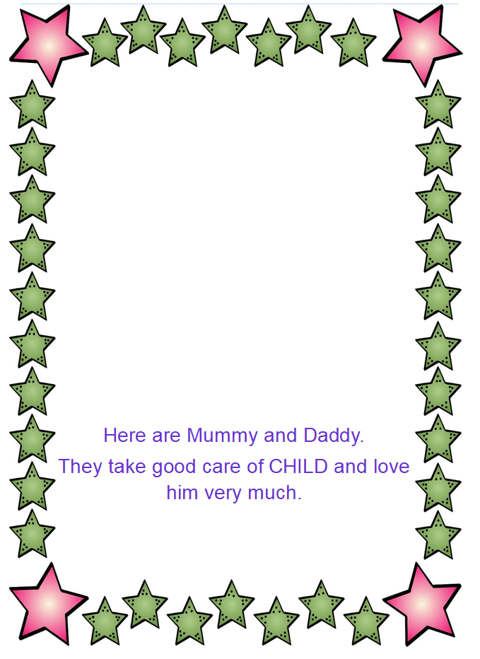

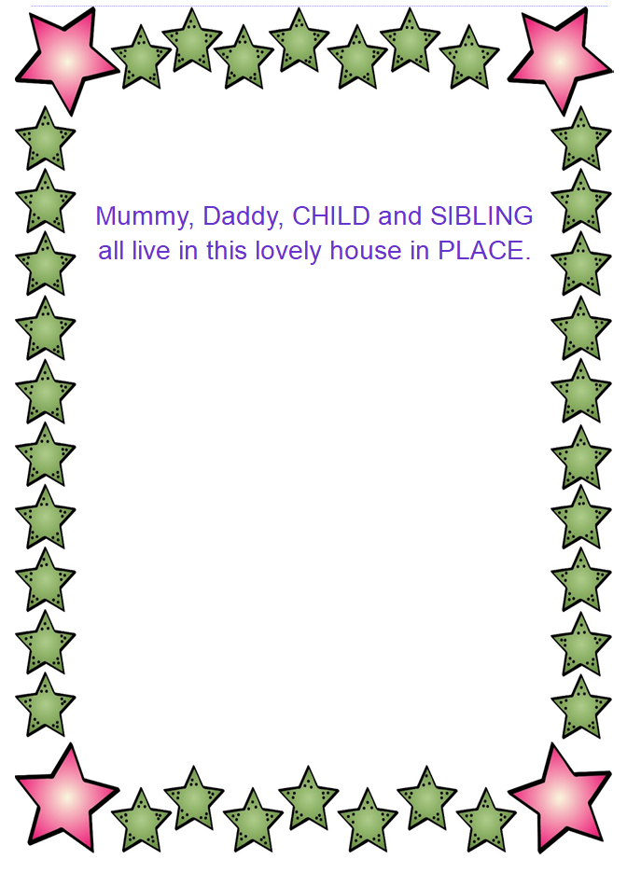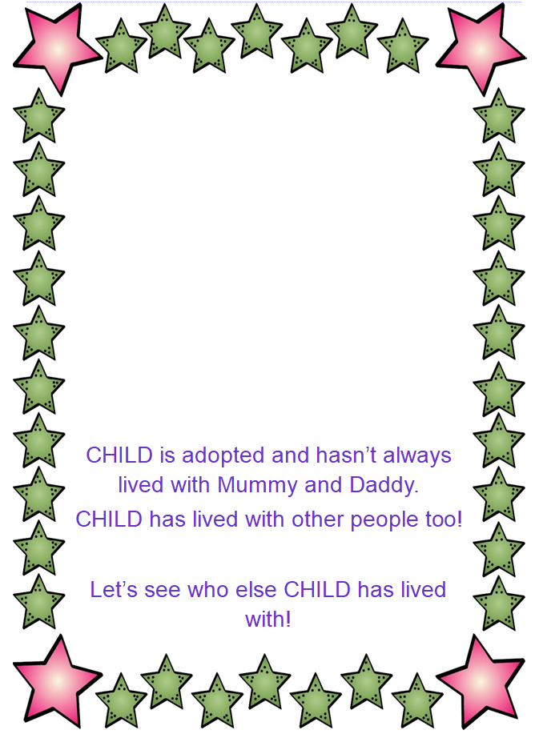

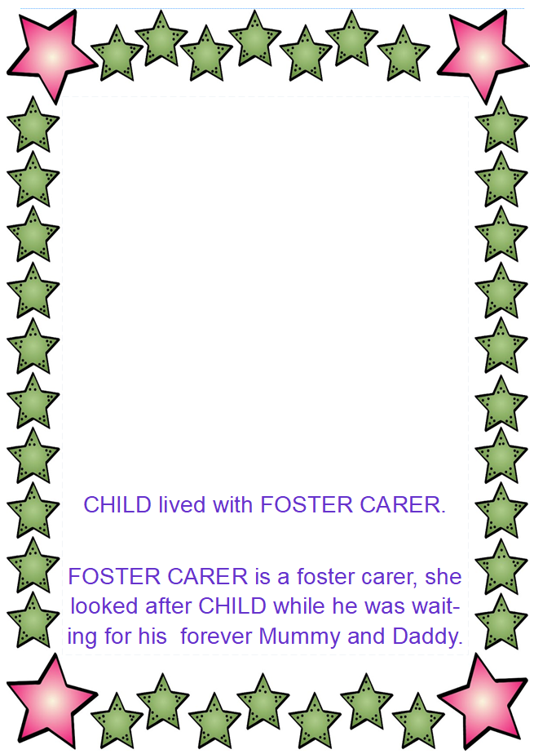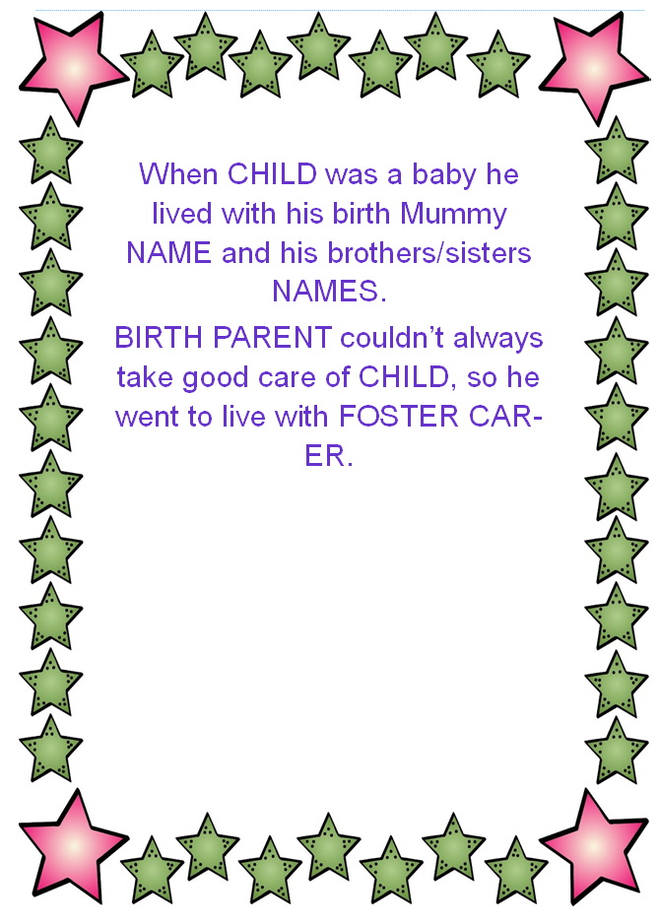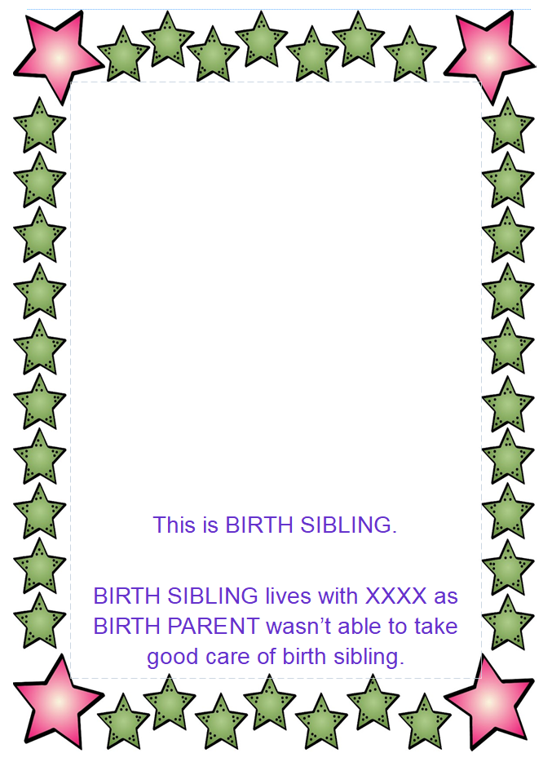

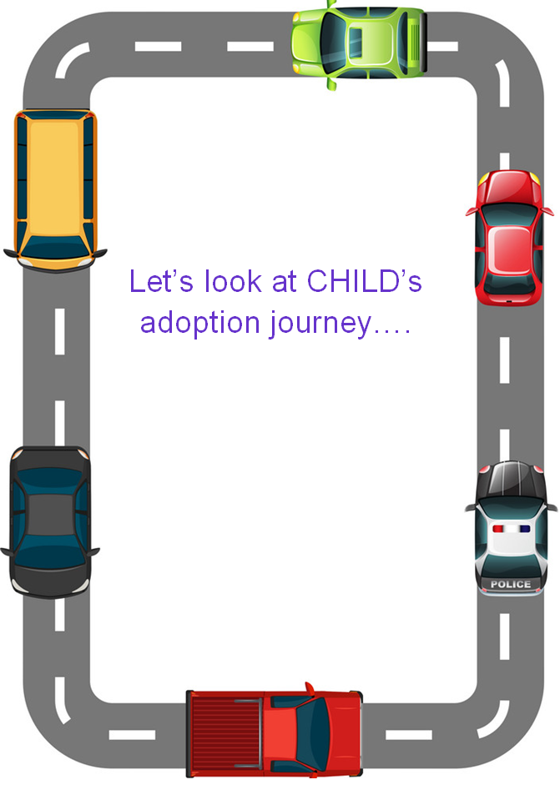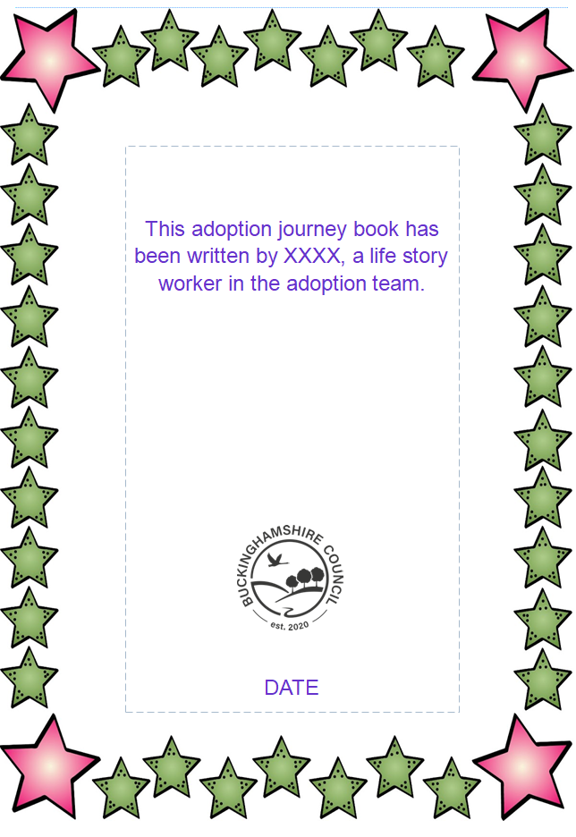

What is Theraplay®®?
Theraplay®® is a therapeutic intervention that focuses on the relationship between the parent/carer and the child. It is based on the notion that play connects parents/carers with child.

Theraplay®® based activities are used to promote positive attachments and bonding with the family and attunement with the child. The activities make the child feel special and valued and can also help with regulation, self-esteem and building confidence in the child. They can be used with your child and shared during the transition for the new family to continue.

Theraplay®® has 4 dimensions structure, nurture, challenge and engagement and the activities are based on one or more of these dimensions. The activities don’t need any special equipment and can be carried out anytime you feel you and your child might like to be playful.

Structure | Nurture
Red light, green light  Follow the leader/ copy me  Beep Honk  Peanut butter jelly  Feather/ cotton wool touch  Bean bag game  Cotton ball blow  Hand stack  Mirroring  Simon says  Toilet-paper-bust-out | Feather hairdressing  Volcano breathing  Feeding  Describing food (crunch etc)  Cradling and swinging  Singing (Twinkle, twinkle)  Lotioning  Checking for hurts  Hand/footprints
Challenge | Engagement
Newspaper cut  Wastepaper bin challenge  Toilet roll breakout  Cushion balance and jump  Hide and seek (with cotton wool ball)  Push back  Balloon or bubble tennis  Straight face challenge | Bubble play  Bubble tennis  Cotton wool blow game  Nursery rhymes e.g., row, row and ring o roses  Hand stack  Pizza back/ weather report  Blow me over  Create a special handshake

The 4 Dimensions of Theraplay®®
STRUCTURE | ENGAGEMENT
Concepts: Safety, Organisation, Regulation | Concepts: Joy of companionship, Attunement, Now moments
Useful for:  Children – overactive, unfocussed, over-stimulated, controlling  Adults – poorly disorganised, difficulty setting limits, under-stimulating | Useful for:  Children – withdrawn, avoidant of contact, anxious or rigid (slow down for autism)  Adults – disengaged, preoccupied, inattentive, out of sync with child, rely on verbal engagement, do not enjoy the child
Activities:  Imitation, non-verbal dialogues, mirroring and attunement | Activities:  Eye contact, warmth in tone, in the moment engagement
Touch:  Holding hands, taking steps together, feeling touch with cotton wool ball | Touch:  Hand clapping games, handstack,
NUTURE | CHALLENGE
Concepts: Security, Self-worth, Stress reduction | Concepts: Competence, Mastery, Play
Useful for:  Children – overactive, aggressive, anxious, pseudo-mature  Adults – dismissive, harsh, punitive, have difficulty with touch or displaying affection | Useful for:  Children – Anxious, withdrawn, timid, rigid, resistant  Adults – unrealistic expectations, competitive
Activities:  Soothing, calming, trust that the adult will provide comfort and safety, hands-on activities, rhythmic, good touch | Activities:  Mild, age-appropriate risk, promote confidence, non-competitive, fun  Play can serve as a form of affection if caregiving is rejected
Touch:
Taking care of hurts, feeding, cuddling, rocking, lotion, band-aids,

Theraplay®® Exercises

Structure
Drawing around hands, feet, or bodies: Make a picture of the child’s foot by drawing it on a piece of paper. Be sure to maintain verbal contact as you draw.

Cotton Ball Hockey: Lie on the floor on your tummies. Blow cotton balls back and forth trying to get past your partner’s defence.

Pop the bubble: Blow a bubble and catch it on the wand. Have the child pop the bubble with a particular body part, for example finger, toe, elbow, shoulder, or ear.

Measuring: Measure the child’s height, length of arms, legs, feet, hands and so forth. Measure surprising things such as the child’s smile, the length of his ears, how high he can jump and so forth.

Red Light, Green Light: Ask a child to do something, for example run, jump, move arms. Green light means go, red light means stop.

Funny ways to cross the room: Adult directs the child to come towards them in a certain way, for example hopping, tiptoeing, crawling, or walking backwards. Child is greeted on arrival. Can take turns of coming up with a funny way of crossing the room that each can try.

Engagement
Beep and Honk: Press child’s nose and say “beep!” then press chin and say “honk!” Guide child to touch your nose and chin. Make appropriate beeps and honks as you are touched.

Blowing over: Sit facing the child holding hands. Have child ‘blow you over’. Fall backwards as the child blows. Once the child understands the game you can blow them over.

Check-ups: Check body parts such as nose, chin, ears, cheeks, fingers, toes, knees to see if they are warm/cold, hard/soft, wiggly/quiet, and so on.

Hand clapping games: This can be simple (patty cake) or complex and can have a variety of chants.

Mirroring: Face the child, move your arms, face or other body parts and ask child to move in the same way. Take turns being the leader.

Peek-a-boo: Hold child’s hands (or feet) up together in front of your face. Peek around or separate the hands (or feet) to ‘find’ the child.

Row your boat: Sing the song, adding the child’s name at the end (“Erin’s such a dream”). Small children can be held in your lap. Older children can sit facing you.

Special handshake: Make up a special handshake together, taking turns adding new gestures.
Nurture
Caring for hurts: Check hands, feet, face and so forth for scratches, bruises, hurts or “boo-boos”. Put lotion on or around the hurt, touch with a cotton ball, or blow a kiss.

Cotton ball touch: Have child close eyes. Touch child gently with a cotton ball. Have child open eyes and indicate where she was touched.

Feeding: Take child on lap or face seated child. Feed the child, listening for crunches, noticing if the child likes the snack and when the child is ready for more. Encourage eye contact.

Lotion or powder prints: Apply lotion or powder to the child’s hand or foot and make a print on the paper.

Lotioning/ powdering: Lotion or powder the child’s arms/hands, legs/feet.

Lullaby: Cradle the child in your arms in such a way that eye contact can be maintained, Sing your favourite lullaby or any quiet, soothing song. Add details about a particular child to the traditional words.

Soft and floppy: Have the child lie on the floor and help him get “all soft and floppy.” Gently jiggle each arm and leg and let it flop on the floor. If the child has difficulty getting floppy, have him get “stiff like a board” and then let go. Once the child is relaxed, ask him to wiggle just one part of his body: his tummy, his tongue, his big toe and so forth.

Decorate child: Make rings, necklaces, bracelets with play-doh.

Special kiss: Butterfly kiss- parent places cheek against the child’s cheek and flutters eyelashes so that the child feels the brush of their eyelashes.

Challenge
Balancing activities: Balance pillows, books etc on child’s head and have them walk across the room. Can also get them to lie on the floor with feet up in the air. Help child to balance objects on their feet.

Balloon between two bodies: Hold a balloon between you and the child (such as between foreheads, shoulders, elbows) and move across floor without dropping or popping the balloon.

Balloon tennis: Keep balloon in the air using specific body parts; heads, hands etc.

Bubble tennis: Blow bubbles high into the air between you and the child. Choose a bubble and blow it to child. Child blows back. Continue until it pops.

Co-operative cotton ball race: Take turns blowing a cotton ball to other side of the room.

Cotton ball or feather guess: Have child close her eyes and tell you where you have touched her and whether you did it with a cotton ball or a feather.

Newspaper punch: Stretch a single sheet of newspaper tautly in front of the child. Have the child punch through the sheet when given a signal. You must hold the newspaper so firmly that it makes a satisfying pop when the child punches it. Extend by adding further sheets.

Pick up something with toes: Have child pick up a cotton ball with his toes (shoes and socks off). You can make this more challenging by having the child hop around the room with the cotton ball between his toes.

Straight face challenge: Child has to keep a straight face while you try to make him laugh either by gently touching him or by making funny faces.

