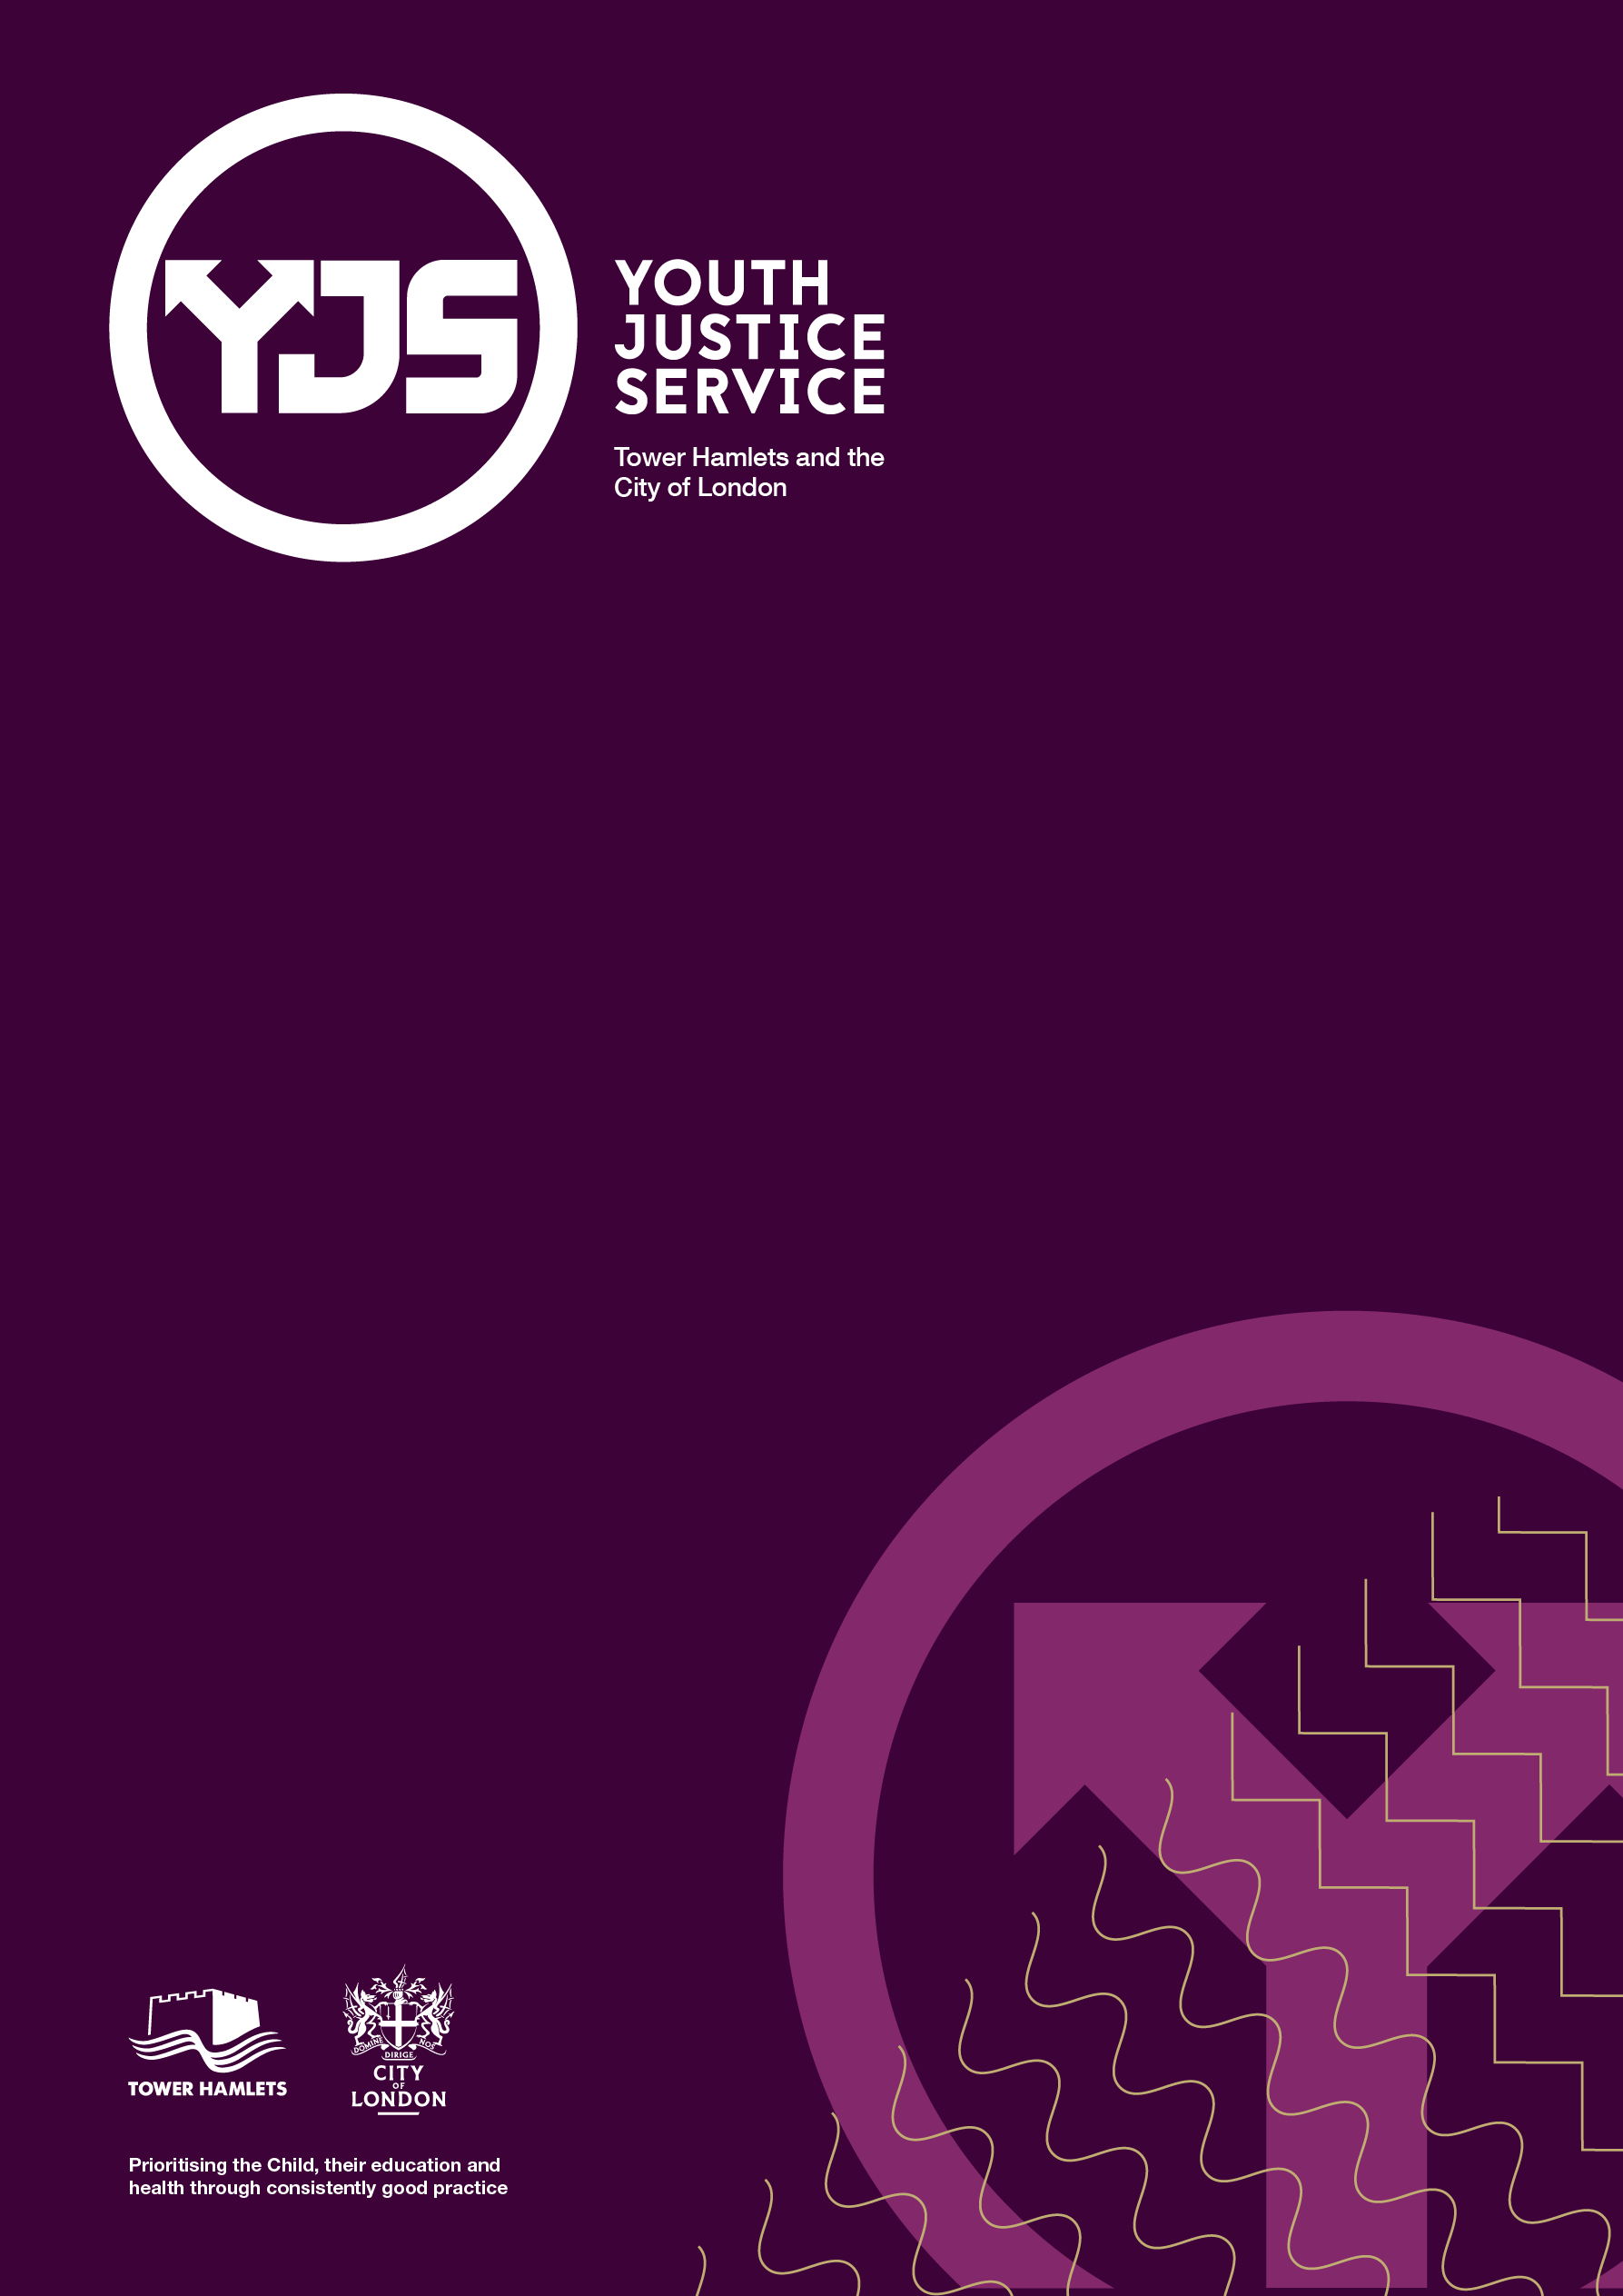

Safeguarding Policy
August 2024

Version | Who | Date
V0.1 | Youth Justice Ops Group | August 24

1. Introduction 2
2. Policy 2
3. Thresholds 2
4. Level 2- Early Help Pathway 3
5. Level 3- Child in Need Pathway 4
6. Level 4- Child Protection Pathway 4
7. What is the MAST? 5
8. Harm outside of the home (Exploitation and Serious Youth Violence) 6
9. Child Sexual Exploitation 6
10. Serious Youth Violence 7
11. Co-Offending Groups and Gangs 7
12. NRM (National Referral Mechanism) 8
13. Missing 8
14. Missing child: Response 9
15. MACE 10
16. The Daily Governance and Intelligence Briefing: 11
17. Local Authority Designated Officer (LADO) 12
18. Extremism and Terrorism 13
19. Children and Adolescents Mental Health Services (CAMHS) and Emotional Wellbeing 13
20. Multi Agency Risk Assessment Conference (MARAC) 14
21. Harmful Sexual Behaviour 14
Contents

Introduction
  - This document has been devised to ensure Youth Justice Service (YJS) staff have a consistent, timely, informed, and proportionate response to safeguarding children, that are open to the service. As well as giving an overview of the internal policies, procedures and referral processes within the council that support best practice, and should be read in conjunction with the Childrens Act 1989, Working Together to Safeguard Children 2023, and London Safeguarding Children Procedure

Policy

  - Early identification of potential safeguarding not only reflects good practice but also promotes the core aims of the Youth Justice Service – to reduce offending, safeguard children and promote their well-being and to protect the public. It is the responsibility of managers to provide clear guidelines, training and support for staff. It is also the responsibility of individual staff to take necessary steps to adhere to these guidelines and therefore ensure their own safety and that of others.

  - All members of staff should receive a copy of this policy and in house training regarding its implementation. This guidance will be reviewed annually and updated as required by the task force. Any suggestions on changes, additions or improvements to the guidance should be submitted in writing to the YJS Senior Management Team.

Thresholds
  - To ensure children and families have the right level of support it is important that staff are familiar with the “Safeguarding Thresholds” (for a more detailed overview please click here)

LEVEL 1 | Should be met within universal settings; including low level additional needs.
LEVEL 2 | Which meet the criteria for more formal targeted services delivered as part of the early help offer; multi-agency intervention, a lead professional and a team around the family approach in addition to support in universal services
LEVEL 3 | Which meet the threshold for social work assessment and support under S.17 Children Act 1989 (child in need)
LEVEL 4 | Which meet the threshold for statutory child protection by social work teams delivered under S.47 Children Act 1989, in addition to provision in universal settings and by targeted services. This may also include children subject to a Care Order or children looked after under S.20 (duty to accommodate) of the Children Act 1989

  - Many of the children and families the YJS work with will fall within Level 3 and 4 of the threshold guidance.

Level 2- Early Help Pathway
  - An example of when Early Help referral maybe appropriate: An emerging pattern of the child’s attendance at school declining (less than 90%), they are at risk of becoming excluded, child is not being appropriately supervised at home, difficulties with peer relationships, mental or physical health needs of parents are impacting on the child negatively, they are bullying or being bullied (please note this is not an exhaustive list).

  - Referrals for Early Intervention Targeted support can be made as follows:
• External partners or a parent/carer can make a self-referral via the Early Help Hub they can do this by calling 0207 364 5006 and press option 2 or by using the Early Help Enquiry Form found here
• A family can self-refer by coming into a Children and Family Centre
• If an internal member of staff wants to make a referral, they can send an email detailing the family’s information, what they need and why.
  - Detailed information on Early Help practice guidance can be found here

  - Please remember that a referral to Early Help requires consent as engagement and participation is voluntary. (Guidance on consent can be found here)

Level 3- Child in Need Pathway
  - An example of when a child and family may require the support of a Child in Need Plan: Physical and emotional development raises significant concerns, chronic/recurring health concerns, statement of education needs (EHCP), missing from education, coming to the notice of the police regularly.

  - An Early Help Assessment (EHA) referral to MAST is required, with social care indicated as the preferred response.

  - Upon receipt of the referral, the duty team in MAST will review the EHA and will send a response to the referring agency within one working day. If it is agreed that level 3 needs are met, it will proceed to an assessment led by a social worker.
  - Please remember that a referral for Child in Need requires consent as engagement and participation is voluntary. (Guidance on consent can be found here)
If you have concerns that the child is being Neglected, then the Neglect assessment tool MUST be completed to provide evidence and support a referral to Childrens Social Care. Please ensure a copy of the tool is saved to Childview.

Level 4- Child Protection Pathway
  - An example when a child meets the Child Protection threshold: A complex disability that cannot be maintained in a mainstream setting or without additional support, Child is suspected to have suffered or be at risk of Female Genital Mutilation (FGM), Children consistently appear in dirty clothing/inappropriate clothing for climate, Child/young person is being exploited for criminal purposes, the child is under 13 and engaged in sexual activity.

  - If an agency identifies a child or young person thought to have suffered or be at risk of significant harm, a referral to MAST should be made immediately by calling 020 7364 5601 /5606 (or out of Hours 020 7364 4079) or by email (MAST@towerhamlets.gov.uk).

  - Where MAST identify that the case meets the level 4 needs, a child protection S.47 Enquiry will be initiated alongside a single assessment, supported by information sharing between agencies in the MAST.

  - If the referral is considered a Child Protection issue (Level 4) seeking consent may not be appropriate. In most cases it is appropriate to seek consent. However, there are some cases where it is not. Consent should not be sought if doing so would:
· Place a person (the individual, family member, worker or a third party) at increased risk of significant harm (if a child) or serious harm (if an adult).
· Prejudice the prevention, detection or prosecution of a serious crime - this is likely to cover most criminal offences relating to children.
· Lead to an unjustified delay in making enquiries about allegations of significant harm (to a child) or serious harm (to an adult)

What is the MAST?
  - The MAST is a team which brings together partner agencies (and their information) to identify risks to children at the earliest possible opportunity and to respond with the most effective interventions. The purpose of the MAST is to work together to ensure timely, effective, and necessary interventions, improving outcomes for vulnerable children and young people. The MAST consist of the following agencies within Tower Hamlets:
- Police
- Health
- Education
- Probation
- Housing
- Substance misuse service
- Mental health service
- Early Help
- IDVA (Independent Domestic Violence Advocate)

  - If you have completed a referral to either the Front Door (MAST) or MACE, this process should be recorded on the Referrals Tab on ChildView in order to track the process of the referral:

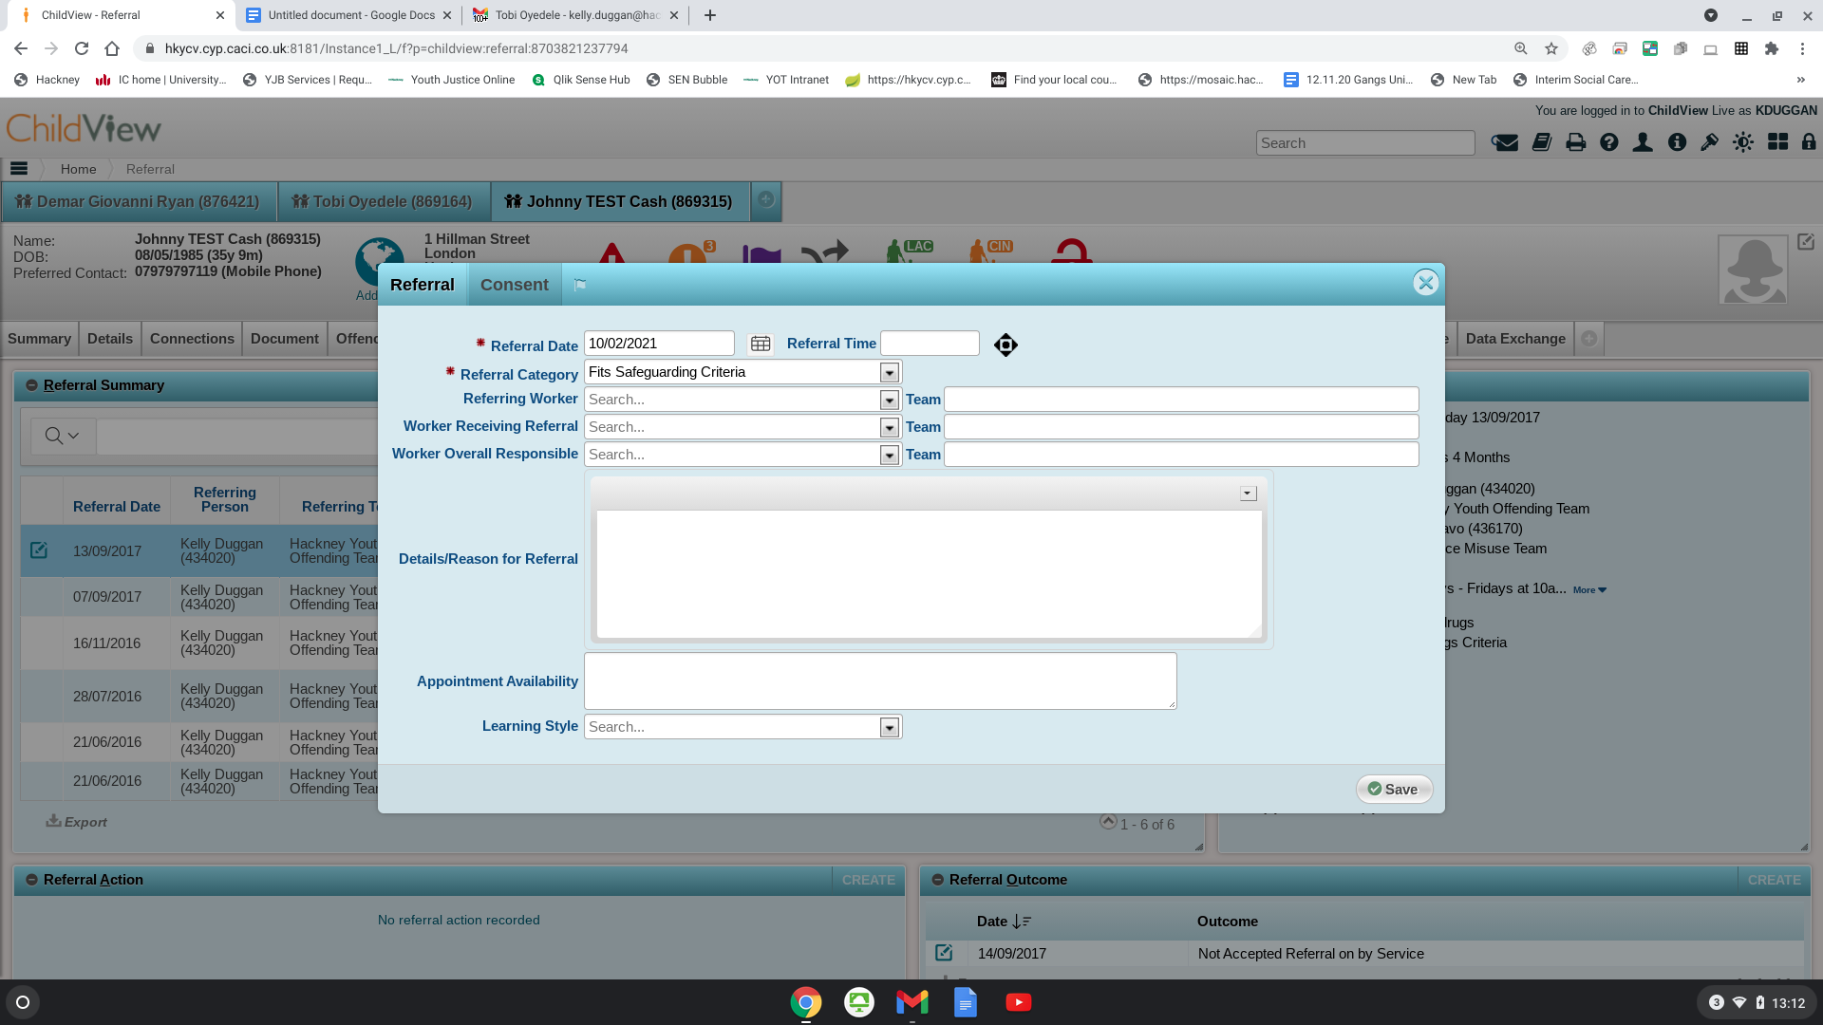

  - If you believe that a child’s safeguarding risk is increasing, a new ASSET+ will need to be completed in order to reflect the concerns that you have raised. Any safeguarding concerns should be discussed with a member of the YJS management team

Harm outside of the home (Exploitation and Serious Youth Violence)
  - Child Criminal Exploitation

  - Child criminal exploitation is when someone uses a child (under 18 years old) to commit crimes for them.

  - It includes things like forcing a child to work on a cannabis farm, or targeting, grooming, coercing and exploiting a child to sell drugs in county lines operations. Child criminal exploitation can involve bribery, intimidation, violence and/or threats. The child does not need to have met whoever is exploiting them - children can be exploited via the internet or using mobile phones. They can also be targeted via social media platforms and gaming forums. A child may have been exploited even if it looks as if they have been a willing participant. Many children do not see themselves as victims.

  - Signs of exploitation:
- displaying aggressive/violent behaviours
- often going missing from home or school and being found away from their normal area
- unexplained money, clothes, designer wear, jewellery, gadgets or mobile phones
- having multiple mobile phones
- getting lots of phone calls or texts
- use and/or possession of drugs and/or alcohol
- possession of hotel key cards/keys
- committing theft/shoplifting
- relationships with older people
- unexplained injuries
- carrying weapons
- abandoning friends and their social circle
- school performance getting worse
- self-harm
- changes in well-being
- significant emotional changes (like becoming angry or sad), or becoming fearful, withdrawn or isolated
- using different language/terminology
- new peer groups and/or relationships with unknown associates
- Any sudden change in a young person’s lifestyle could be because of criminal exploitation and you should talk to them about it

Child Sexual Exploitation
  - Child sexual exploitation involves situations, contexts or relationships in which a person under 18 is given something, such as food, accommodation, drugs, alcohol, cigarettes, affection, gifts or money in return for performing sexual activities or having sexual activities performed on them. It can also involve violence, coercion and intimidation, with threats of physical harm or humiliation.

  - Warning signs
Some examples are:
- going missing from home or care
- physical injuries
- misuse of drugs or alcohol
- involvement in offending
- repeat sexually transmitted infections, pregnancies or terminations
- absenteeism from school
- deterioration in physical appearance
- evidence of online sexual bullying
- evidence of vulnerability on social networking sites
- emotional distance from family members
- receiving gifts from unknown sources
- recruiting others into exploitative situations
- poor mental health
- self-harming
- thinking about or attempting suicide

Serious Youth Violence
  - Serious Youth Violence” is defined by the Home Office Assessment of Policing and Community Safety (APACS) as ‘any offence of most serious violence or weapon enabled crime, where the victim is aged 1-19’, i.e. murder, manslaughter, rape, wounding with intent and/or causing grievous bodily harm. ‘Youth Violence’ is defined in the same way but also includes assault with injury offences.

Co-Offending Groups and Gangs
  - A Street Gang is defined as ‘a relatively durable, predominately street-based group of young people who see themselves (and are seen by others) as a discernible group for whom crime and violence is integral to the group’s identity. Primarily identified through the local Trident Command Matrix.’ Due to the negative connotations surrounding the word ‘gangs’, including the impact of adultificaiton and not seeing the child as a victim, we use Co-Offending Groups.

  - A Co-offending Group (COG’s) is defined as ‘similar to a peer group, a small, semi-transient grouping, with limited organisation/structure, occupying the same space with a common history, but where criminal co-offending had become integral to their group identity.’

  - Any practitioner working with a child who they think may be at risk of Serious Youth Violence, CSE or CCE should follow the guidance set out as outlined within the Level 4 pathway. Where concerns about Child Sexual Exploitation are identified, the CSE screening tool should be completed. Where concerns about involvement in serious youth violence and/ or gangs are identified, the Co-offending Groups (COG) screening tool should be completed and sent via MAST (MAST@towerhamlets.gov.uk)

  - Children’s Social Care need to complete an exploitation risk & harm assessment and make a referral through an 87a to Child Abuse Investigation Team (CAIT).
If you believe a child is in immediate risk of harm, you should contact the police.
  - You can also contact the Exploitation team for advice and guidance on the following email address: exploitation.team@towerhamlets.gov.uk
If, when completing an assessment of the child, there are indicators that the child is at risk of exploitation, as part of the assessment, YJS practitioners MUST complete the additional screening tool/s to support their assessment and provide additional evidence to support any referrals into children’s social care. Where concerns about Child Sexual Exploitation are identified, the CSE screening tool MUST be completed. Where concerns about involvement in serious youth violence and/ or gangs are identified, the Co-offending Groups (COG) screening tool MUST be completed and attached to ChildView. In addition, the use of safety plans to address and imminent risks, should be utilised by the practitioner to safeguard the child, and a copy saved on ChildView.

NRM (National Referral Mechanism)

  - Modern slavery is an umbrella term encompassing slavery, servitude, forced or compulsory labour and human trafficking. Victims of modern slavery are unable to leave their situation of exploitation, controlled by threats, punishment, violence, coercion and deception.

  - A ‘first responder organisation’ is, in England and Wales, an authority that is authorised to refer a potential victim of modern slavery into the National Referral Mechanism (NRM). TH+C is a ‘first responder organisation’. As an employee of TH+C, you are considered to be a first responder.

  - First responder organisations have the following responsibilities. These responsibilities are invested in the organisation and it is for the organisation to decide how it will discharge these responsibilities:

- identify potential victims of modern slavery and recognise the indicators of modern slavery;
- gather information in order to understand what has happened to them;
- refer victims into the NRM via the online process;
- provide a point of contact for the SCA (Single Competent Authority aka NRM) to assist with the Reasonable and Conclusive Grounds decisions and to request a reconsideration where a first responder believes it is appropriate to do so

The TH+C NRM Process can be found here

  - The Home Office now operates an NRM digital system. This means that all referrals can be submitted online. Please be aware that the system does not allow you to save your progress and you only have one hour to complete the form. Therefore, please ensure that you have all of the information to hand before starting the referral form. In order to support you with being prepared, a hardcopy of the Referral Form can be found here

  - Case Managers can go to GOV.UK website and use the digital NRM referral form Please send your referrals to nrm@modernslavery.gov.uk

All children open to the YJS should have their NRM process recorded on ChildView, regardless of who is leading on the referral. It is important that the YJS ensure that any new incidents or information relating to exploitation is regularly updated on the NRM.

Missing
  - Children who are missing from home may be at greater risk of harm because of their basic need for food, safety, and shelter and/or from the people with whom they may come into contact. Risks can include but are not limited to, physical harm, sexual exploitation, drug abuse and involvement in a range of other criminal activities. Additional vulnerability due to their age, level of understanding or the significance and seriousness of the circumstances that led to the missing episode may also be present. Consideration should be given to any missing episode regarding any indication that something is not right in a child’s life.

  - The CE-CU Police Missing Person Unit (MPU) Single Point of Contact (SPoC) is based within the co-located Exploitation Service and can be emailed at CEMailbox.MissingPersonUnit@met.police.uk
  - The Central Met Police Missing Coordinator supports the CE-CU MPU SPoC.

  - The Police CE-CU MPU Strategic Lead is the Detective Superintendent for Public Protection.

  - The Local Authority Missing Children Strategic Lead is the Head of Exploitation.

  - Local authority definition:
- Unauthorised absence - a child in care whose whereabouts is known but who is not at their placement or place they are expected to be (absent) and the carer has concerns or the incident has been notified to the local authority (usually to the allocated Social Worker, the Emergency Duty Team, or Supervising Social Worker).

- Missing child is a child whose whereabouts cannot be established and where the circumstances are out of character, or the context suggest the child may be subject of crime or risk of harm to themselves or another and whose family or carers have reported them as missing to the police.

  - Police definition:
- Absent – The CoP APP defines Absent as:
There is no apparent risk or harm to either the subject or to the public. Actions to locate the child and/or gather further information should be agreed with the informant and a latest review time set to reassess the risk.

- Missing – The CoP APP defines Missing as:
Anyone whose whereabouts cannot be established will be considered as missing until located, and their well-being or otherwise confirmed.

Missing child: Response
Whereabouts of the child unknown. The child has been reported missing to the police. For children missing from home, this information is shared with the Exploitation Service daily by the Tower Hamlets Missing Persons Unit (Police). For Looked After Children placed out of borough, notifications are received from the Out of Hours Emergency Duty Team (EDT).
As part of good practice, Social Workers should also alert the Exploitation Service if a child they are working with has been missing, to ensure that relevant information is shared and the correct processes are followed

The Exploitation Service (Business Support) is responsible for recording the missing notification on the child’s file.

Child is missing from out of borough (i.e. child is placed in the local authority’s care out of the borough)
Child is missing from home (i.e. Tower Hamlets)

If the child has been missing for three of more days or if the child has been missing for three or more times within the month, a strategy meeting should be convened. The 87a referral form should be sent to the relevant BCU to ensure that the relevant police unit attends the meeting, depending on where the child is residing (The Exploitation Service will assist with providing the correct contact details for the BCU’s within the Met Police)

Strategy meeting takes place. A multi-agency discussion takes place about what strategies will be put in place to locate the child. If the child is deemed to be high risk or is a regular missing child, it should be discussed and agreed if a trigger plan is necessary. Weekly strategy meetings should be convened if the risk is high and the child has not been located. If the child has been missing for five or more days, a notification to be sent to the Divisional Director. The social worker should also consider completing a Harm Outside of the Home Risk Assessment , as part of assessing the risk and harm to the child

For more detail and step by step approach please refer to the missing protocol can be found here

MACE
  - MACE is a multi-agency meeting with the London Borough of Tower Hamlets (LBTH) partnership which has a dedicated strategic focus on child exploitation and missing.

  - MACE focuses on identifying the local picture of child exploitation, and communities vulnerable to exploitation, through monthly data reports, trend analysis reports from partners and partner verbal contributions regarding hotspots, emerging trends, disruption, and prevention activities.
  - It develops local multi-agency responses to disrupt child exploitation and provide support to complex cases.
  - It discusses multi-agency activity and responses to child exploitation across LBTH.
- Partners are also expected to share relevant discussions held in MACE in other connected forums.
- Provide their reflections on the bi-monthly and bi-annual data report.
- Share ideas on activities to raise awareness or tackle identified child exploitation.
- Participate in multi-agency plans and task & finish groups focused on specific issues/locations.
  - MACE meetings are held monthly.
  - Partners are expected to collate information from their organisation to share with MACE verbally about emerging trends and hotspots relating to child exploitation and missing.

The Daily Governance and Intelligence Briefing:

  - Morning briefing reviews all incidents that occurred in the previous 24 hours where children have been involved in offending behaviour (including drug supply, violence, county lines etc), children at risk of CSE, missing children and any other relevant concerns of harm outside the home. Actions are tasked to the relevant professionals across the co-located service to ensure information is shared and risk and harm is mitigated.

  - The weekly wider partnership meetings are attended by Exploitation, Children’s Social Care, Community Safety, Police and Youth Justice. This meeting ensures all information has been shared across the partnership and all actions are completed, the multiple contexts within which children exist are reviewed to support a comprehensive risk analysis and to agree actions that are most likely to reduce risks in these contexts. These include sharing intelligence and information about:

• A child’s friendship group and wider peer network

• Other associations and relationships when this may be a contributing factor to risk

• Geographical areas of risk including gang ‘territories, congregation points, anti-social behaviour and crime hot spots and physically unsafe areas

• Premises/venues of concern
• Virtual places including YouTube postings, sites created by young people and social network links.

  - Where concerns arise about the wider community Briefing will ensure that these are progressed by other existing structures or partners.

  - The morning & weekly briefing information reports into MACE and a monthly analytical report is produced for presentation at MACE each month.

  - Intelligence from briefings and from MACE are also shared through neighbourhood tasking meeting to allow for longer term planning around safer spaces and places

Local Authority Designated Officer (LADO)
  - The role of the LADO (or Designated Officer) is set out in Working Together to Safeguard Children and is governed by the Local Authorities duties under section 11 of the Children Act 2004.

  - The LADO is responsible for managing allegations against adults who work with children. This involves working with police, children's social care, secure training centres and young offenders’ institution employers and other involved professionals. The LADO does not conduct investigations directly, but rather oversees and directs them to ensure thoroughness, timeliness and fairness. Ordinarily, to ensure impartiality, the LADO will not have direct contact with the adult against who the allegation has been made, or the family of the child/children involved but will, as part of their role ensure that these have information regarding outcomes.
  - This guidance outlines procedures for managing allegations against people who work with children who are paid, unpaid, volunteers, casual, agency or anyone self-employed.
  - The LADO must be contacted within one working day in respect of all cases in which it is alleged that a person who works with children has:
- behaved in a way that has harmed, or may have harmed a child
- possibly committed a criminal offence against, or related to a child
- behaved towards a child or children in a way that indicates that they may pose a risk of harm to children
- behaved in a way that brings into question their suitability to be working with children
- Inappropriate Relationships
- Behaviour in Private Life

  - There may be up to 4 strands in the consideration of an allegation:

- a police investigation of a possible criminal offence;
- enquiries and assessment by children’s social care about whether a child is in need of protection or in need of services;
- a management inquiry into the conduct/behaviour of the member of staff concerned
- whether action with regards to the person making the allegation should be considered where the allegation has no foundation and may be malicious.

  - The LADO is responsible for:
- Providing advice, information and guidance to employers and voluntary organisations around allegations and concerns regarding paid and unpaid workers.
- Managing and overseeing individual cases from all partner agencies.
- Ensuring the child’s voice is heard and that they are safeguarded.
- Ensuring there is a consistent, fair and thorough process for all adults working with children and young people against whom an allegation is made.
- Monitoring the progress of cases to ensure they are dealt with as quickly as possible.
- Recommending a referral and chairing the strategy meeting in cases where the allegation requires investigation by police and/or social care.
- The LADO is involved from the initial phase of the allegation through to the conclusion of the case. The LADO is available to discuss any concerns and to assist you in deciding whether you need to make a referral and/or take any immediate management action to protect a child.

The LADO can be contacted via email: Melanie.Benzie@towerhamlets.gov.uk
For YJS staff it is particularly important to ensure that any child on remand or serving a custodial sentence in an STC or YOI, who has made an allegation against a staff member follows up with the establishment to ensure a LADO referral has been made to the local area in which to STC or YOI is located, and that the LADO in TH-LC is also notified and aware of the referral/allegation.

Extremism and Terrorism

  - As part of staff learning, all staff should undertake the following training below:

- Prevent Awareness – this module provides an introduction to Prevent and explains how it aims to safeguard vulnerable people from being radicalised to supporting terrorism or becoming terrorists themselves.
- Prevent Referrals – this module is aimed at staff who may notice signs of vulnerability to radicalisation. It is designed to provide staff with the confidence and ability to raise their concern when someone may be at risk.

  - If you have assessed a child as being at risk of extremism the first step is to discuss the child with a manager to have some direct oversight of the case.
  - Following this, either a referral will be made to Prevent and Channel colleagues in TH+C, via the Service Manager and/or the child’s case should be discussed at the Risk and Reflective Panel chaired by the Head of Service. If you feel that the risk is too great to wait for the panel, speak with your Team Manager and one can be convened at an earlier date. Information regarding children to be discussed at the Channel & Prevent multi-agency panel will be routinely shared with the Team Manager (Prevent Lead) and Secondee Probation Officer to further support information sharing and partnership working with the YJS.
  - For more detailed information on the above please refer to this page

Children and Adolescents Mental Health Services (CAMHS) and Emotional Wellbeing
  - If you are concerned that a child you are working with may have additional mental health and emotional wellbeing needs, like self-harm, suicidal ideations, low mood, anxiety, undiagnosed mental or emotional health needs, then please ensure the relevant sections of the assessment is completed to reflect the details and a referral made to CAMHS.
  - Referral process:
- Complete CAMHS referral form (attached) and send to CAMHS duty email: elt-tr.CAMHSTowerHamletsDuty@nhs.net
- For urgent and high-risk children where there may be more immediate risk of harm to self or others due to mental health difficulties/presentations call 0207 426 2375 to speak with CAMHS Duty Mon-Fri 9am-5pm. Once urgent children are discussed with Duty Clinician they will advise of next steps (e.g. this may be an urgent face to face appointment at CAMHS or request for urgent allocation via CAMHS front door or any other appropriate plan will be formulated depending on the needs/priorities of child).
- Out-of-Hours Mental Health Crisis Line (24 Hours) 0800 073 0003 who may require crisis/more urgent support management of their mental health symptoms out of hours. Support given by crisis clinicians, follow up provided by local CAMHS team.
- Should children present with/verbalise immediate risk to self/plans/ideations and there are significant concerns around safety please call 999 for emergency services or advise YP/ Parents/Carers to attend local accident and emergency for urgent Psychiatric assessment. During Mon-Fri 9-5 this can be discussed with Duty Clinician for further advise at first pointed where viable.

Multi Agency Risk Assessment Conference (MARAC)
  - MARAC aims to review and co-ordinate service provision in high-risk domestic abuse cases. The MARAC will facilitate, monitor and evaluate effective information sharing to enable appropriate actions to be taken to increase safety to individuals at risk of domestic abuse.

  - Domestic abuse includes: coercion/control; emotional/psychological; financial; sexual and physical abuse by a family member or intimate partner.
  - MARAC meetings are held bi-monthly and are attended by professionals only and it’s core members include: Police; Health partners; ELFT, Housing, Childrens’ Social Care, Adult Social Care, IDVA Services and Probation
  - Information and referrals
Access further information on MARAC, MARAC thresholds and how to refer here.
Domestic Abuse Team:
• Tel: 0800 279 5434 (Freephone from landlines only)
• Tel: 020 7364 4986
• Email: domestic.violence@towerhamlets.gov.uk

Harmful Sexual Behaviour
  - For guidance for guidance on Harmful Sexual Behaviour please refer to the Multi-Agency Assessments with Children and Young People who Display Harmful Sexual Behaviour, Policy and Procedure 2020.

