Step-Down and Step-Up Guidance

For all Social Care and Early Help Colleagues.
July 2024

Document Status | FINAL DRAFT
Version | 1.1
Date Issued | 01/06/2024

DOCUMENT CONTROL

Document Owner: | London Borough of Tower Hamlets

Version
Version | Date | Description | Author
0.1 | 20/05/2024 | Step Down and Step-Up Guidance
0.6 | 01/06/2024 | Step Down and Step-Up Guidance | Habon Ibrahim-Osman
1.1 | 02/06/2024 | Step Down and Step-Up Guidance | Mohammed A Jolil

Approval
(By signing below, all Approvers agree to all terms and conditions outlined in this Agreement.)

Approvers | Role | Date | Signature
Habon Ibrahim-Osman | Head of Service MAST, Assessment & Eva Armsby. | 03/07/2024 | Habon. ibrahim-osman
Mohammed A Jolil | Head of Early Help & Children and Families Service | 03/07/2024 | Mohammed Jolil

Contents
1. Step Down and Step-Up Guidance 4
2. Definitions 4
3. Stepping Down – From Child Protection/Child in Need 5
4. Stepping Down - From Early Help to Universal Provision 6
5. Step Up 8
6. Key Aspects of Step Up 9
7. Step Up to Early Help from Universal Provision 9
8. Dispute resolution / Escalation 11

Step Down and Step-Up Guidance
This guidance has been developed with the core principle that children and families should experience a seamless service regardless of need or the level of intervention within their lives. It is intended to ensure that children receive the right service at the right time and are supported by professionals with the right skills and expertise to help meet their individually assessed needs and progress their plan successfully and is based on collaboratively multi-agency working.
The needs of children, young people (YP), and families do not easily fit into categories or boxes. Circumstances can change quickly, and over time a child or young person will have differing needs dependent on variables within and surrounding their family. As such, the level of assistance required by individual families will differ. This guidance focuses on the processes for those families who may need to either 'Step Down' from having Social Care involvement to having Targeted Early Help support/universal service or Step Up' to Children's Social Care involvement from Targeted Early Help support. Regardless of where on the continuum of needs a child / YP / family are, it must be remembered that safeguarding children and promoting their wellbeing, is everyone's responsibility and, as such, the success achieved by/for children, and families is dependent on a culture of partnership working and co-production in line with Better Together Framework.

Definitions
Step Down enables professionals from Children's Services, and multi-agency early help services to support the child/family intervention and plan as they move from requiring statutory services, or coordinated early help provision, to universal services.
Step-down may happen when statutory services is no longer required and sufficient work has taken place meaning that s17(10) intervention is no longer required, but the family would benefit from co-ordinated services to achieve best outcomes. These may be identified following a family assessment or via the child in Need review meetings.
With the consent of the parents, children and their families should only transition to a lower level of intervention when their needs have decreased. This allows them to move from high-intensity interventions to more universal or targeted early help services. The process typically involves creating a detailed plan and ensuring clear communication between social workers, early help practitioners, and the family. This approach ensures a seamless transition and continued support at a reduced level of intervention. The ultimate goal is to maintain the family's stability while gradually reducing professional involvement.
Professionals from a range of services can offer coordinated early help and this is crucial to the step-down process as they offer continued support for families once statutory services step away. Step down is an extremely important function to ensure that children and families receive consistent, seamless support at the right time and from the appropriate professionals. When children/families have received a statutory intervention and have progressed positively, it is important that the progress made is sustained and that children and families do not feel that they are being passed from 'service to service' or left with a gap in provision.
Outcomes of Child and Family Assessments includes the following:
- A social worker is allocated, and a plan is developed to meet the need - this might be a Child in Need Plan or a Child Protection Plan.
- In rare occasions, emergency protective action may be taken, and the child becomes Looked After either in the short term or longer term.
- Ongoing Children's Social Work Service is not required, and the Early Help practitioner is given advice and information via the recommendations on accessing universal and targeted support to meet the child's needs.
- Closure to statutory social care, the family declined early help offer/ no further action required.
Step-down from Children's Social Work team takes place as an outcome of the Child and Family Assessments. The child’s needs may now be able to be met through a multi-agency Early Help Plan by a Team Around the Family (TAF) with a Lead Practitioner or through a single agency response or through universal services.
- A detailed TAF plan is coproduced to support the family with lower-intensity services. This includes identifying a new lead practitioner and ensuring a seamless handover.
- The Allocated social worker to arrange and chair the TAF meeting and minutes to the meeting to be evidenced on Mosaic within 10 working days of the conclusion of the Child and Family Assessment/s.
Clear documentation, effective handover, and management oversight are crucial, and this is to be evidenced via MOSAIC.

Stepping Down – From Child Protection/Child in Need
Child Protection: When concerns affecting the child/family no longer indicate a likelihood of significant harm it is important that this progress is recognised and within the child protection conference discussion takes place to decide what the next steps will be to ensure that positive change can be sustained. If there are still needs that can only be met by provision from Children’s Services, this may need to be a step-down to a Child in Need plan. If there is no longer a role for Statutory children’s services, there should be consideration of a coordinated early help response from those agencies who will continue to work with the family. Consent from the family is required for a child in need or co-ordinated early help plans. The lead professional role/s should be agreed upon at the conference.
Child in Need: When input from Children’s Services is no longer required, then the child in need plan can be stepped down to early help. Consent should be sought from the family and a lead professional identified. Plans to transfer to
Early Help should be discussed and agreed upon at the final Child in Need review meeting/s.
Steps should be taken to identify a Lead Practitioner from an agency already involved with the family or the relevant practitioner if a single agency response is the outcome. Following the final CIN meeting, the child’s file should be closed to the social worker who will provide a summary of recommendations via a TAF plan to the identified Lead Practitioner or single agency practitioner. This should give the reasons for the end of the plan and include the views of the practitioners involved, and the views, wishes, and feelings of the child/ young person and their parent/ carers.
Families will not be expected to undergo another assessment, or immediately attend another meeting as the final social work plan and the most current Child and Family Assessment will be shared with the early help lead Practitioner.
The Social Worker must ensure that the minutes from the CIN Review Meeting are sent to the Lead Practitioner/alerted via mosaic if in targeted early help services, or where a Lead Practitioner is not identified to the Early Help Co-ordinator within 10 working days, these must also be entered on to Mosaic along with the TAF plan.

The social worker should confirm what is happening in writing to the family and the relevant agencies.

Stepping Down - From Early Help to Universal Provision
When needs have been addressed satisfactorily and the child/ family no longer have additional needs the coordinated early help plan will no longer be required. The family should be made aware of the universal services that are still available to them. The practitioner should confirm what is happening in writing to the family and to the relevant agencies.

Table 1: Step Down Process Flow Chart



Step Up
Step Up processes are implemented when a family's circumstances require more intensive support than what Early Help can provide. This often occurs when there are significant concerns about a child's safety and well-being that cannot be managed through lower levels of interventions.

Key Aspects of Step Up
  - The decision to escalate is based on the severity of the concerns and the inadequacy of current interventions to ensure the child's safety and well-being. Refer to continuum of needs London child protection procedures documents.
  - The transition involves comprehensive assessments and collaboration among multiple agencies to ensure that the child's needs are met through statutory support.
  - There must be effective communication between Early Help and CSC practitioners is essential via the MAST. Multi-agency meeting/discussion/s are conducted to facilitate smooth transitions and ensure that all parties are informed and coordinated.

Step Up to Early Help from Universal Provision
Many children will require support for a single need; this issue in isolation doesn’t usually require a full early help assessment and may be met by universal provisions, such as signposting to community services or one agency. If however, the needs of the child/family amount to more than one single need, it may be appropriate to complete an Early Help Assessment with the consent of the family.
Working Together to Safeguard 2023 advises that practitioners should, in particular, be alert to the potential need for early help for a child who:
- is disabled and has specific additional needs
- has special educational needs (whether or not they have a statutory Education, Health and Care Plan)
- is a young carer
- is showing signs of being drawn into anti-social or criminal behaviour, including gang involvement and association with organised crime groups
- is frequently missing/ goes missing from care or home.
- is at risk of modern slavery, Trafficking or exploitation.
- is at risk of being radicalised or exploited
- is in a family circumstance presenting challenges for the child, such as drugs and alcohol, adult mental health issues and domestic abuse.
- is misusing drugs or alcohol themselves
- has returned home to their family from care
- is a privately fostered child
- has a parent/carer in custody.

The Early Help guidance and procedures set out the process to be followed. It is important that children and families receive help at the earliest possible opportunity as problems begin to emerge. When professionals have concerns it is important that they speak to parents/carers and the child (where appropriate) and also that these concerns are shared and visible to other relevant professionals.
If there is an immediate child protection concern, contact MAST (0207 364 5606/5601 or out of hours in an emergency only 0207 364 4079) and this should be followed up with a completed Multi-Agency Request for Support form. If it is an emergency call the police on 999 for advice.
There may be other times when professionals consider there is a likelihood of harm occurring for a child. This will require a referral that may lead to further investigation, an example would be where a family have agreed to an early help family plan, but progress is not being made and this is likely to cause the child harm. It could be when a family refuse consent to early help, and professionals consider that the lack of a coordinated approach is likely to result in harm in the future. It is important when escalating to Children's Services that you discuss and explain this with parents/carers unless this would result in placing somebody at further risk.

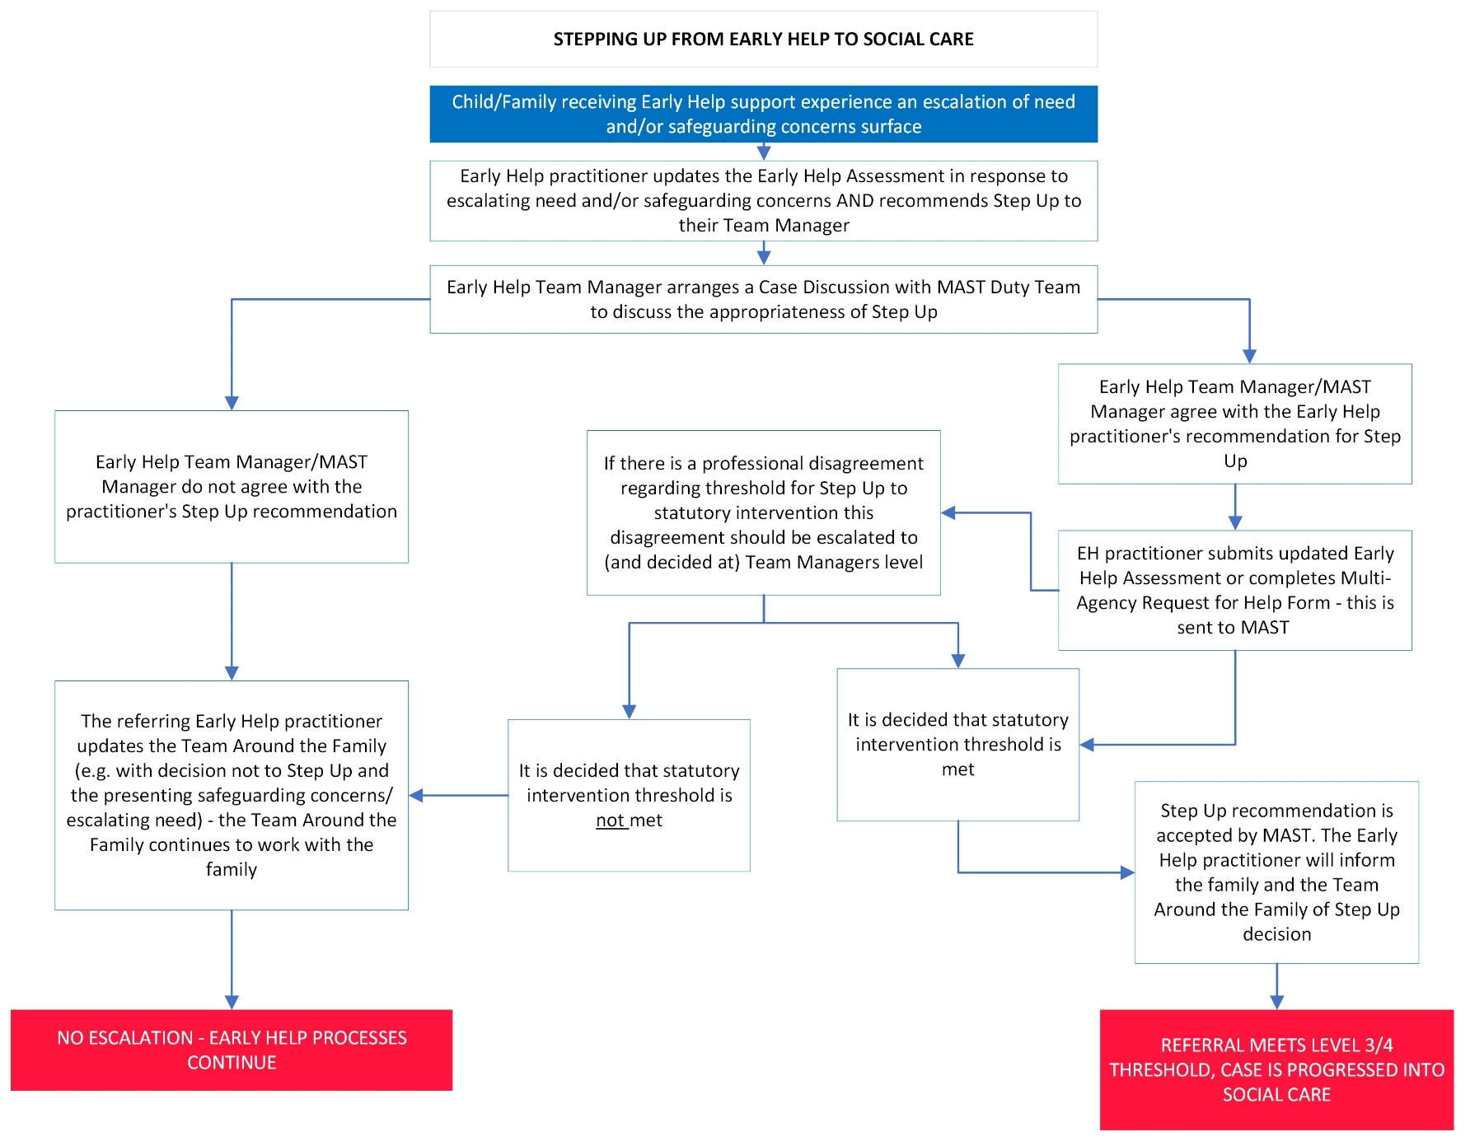
Table 2 - Step Up from Early Help to CSC

Dispute resolution/ Escalation
If there is a difference of opinion between professionals about a step up or step down process; for example, a professional is not willing to take a lead professional role to enable a step down or, despite all of the relevant information about an early help plan not progressing, a 'step up' is not accepted by MAST, the partnership dispute resolution/ escalation procedure should be followed.

