LBTH Pre-Birth Practice Guidance

This guidance has been developed in line with our Better Together Framework which incorporates our vision, behaviours and C-Change (often referred to as the 6Cs). These ideas, principles and values are essential reminders of how to work with those who are often in the most vulnerable situations – an unborn baby and a mother who has likely experienced traumatic events that have led to considering the need for a referral to Children’s Social Care.

Our Vision:

We believe that the best place for children is to be raised within their own families, immediate or wider, wherever it is safe and appropriate to do so.​

In Tower Hamlets we are committed to building relationships and strengthening families by working with people in a compassionate and understanding way. ​

We are ambitious for Tower Hamlets children and families and endeavour for every child and young person to be healthy, safe and successful.​

Our C- Change Better Together Framework:

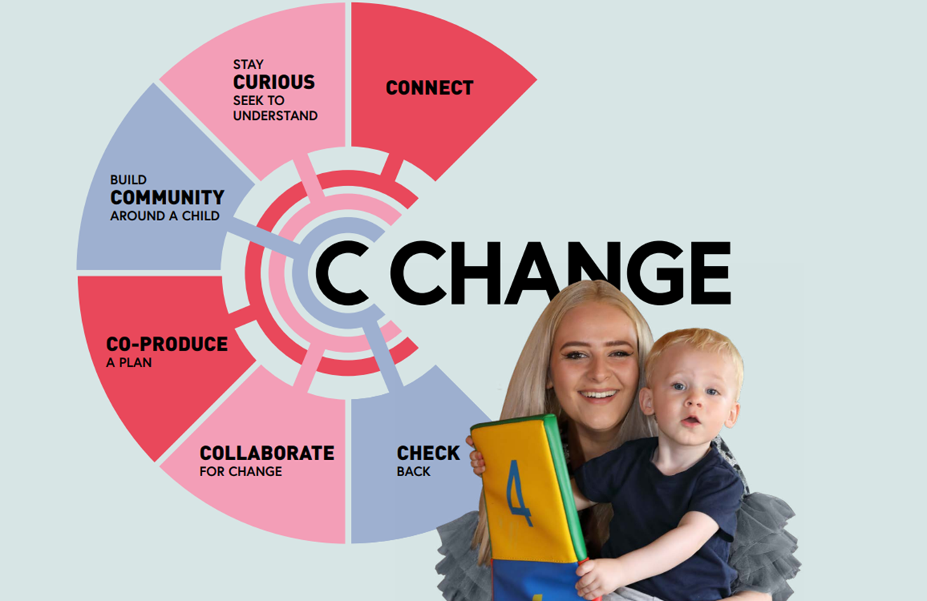

Proactive planning for the birth of babies in situations where concerns exist regarding a parent’s capacity to meet their unborn baby’s needs such that there could be a likelihood of significant harm to the child is crucial.

Audits completed on pre-birth referrals progressing to Legal Planning Meetings (LPM) have shown that improvements can be made in responses to early contacts by partner agencies, progression to referral and assessments leading to early identification of potential risks, provision of relevant support, including effective pre-birth pre proceedings intervention.

This guidance is intended to give clarity for best practice timing in which unborn children ought to be referred to CSC. The guidance will also give a clear emphasise on pre-birth planning at the earliest opportunity and planning for permanence in situations where care outside of parental care may be necessary.

When to refer:
Where agencies or individuals anticipate that prospective parents may need support services to care for their baby, or that the baby may have suffered, or be likely to suffer, significant harm, a referral to local authority children's social care must be made as soon as the concerns are identified. This would usually be around the 12-week scan. The referral should (wherever possible) highlight existing or previous areas of concern, alongside areas of potential strength.

Our work should follow the below timeline. This is a best practice timeline to follow in case of early referrals, but in circumstances of late referrals, prompt action, that reflects out restorative approach should be taken to ensure there are clear safety plans around the unborn baby. If a referral is made earlier in line with NICE guidelines (National Institute for Health and Care Excellence) consideration will be made by the MAST manager whether to triaged to Early Help or progress to A&I for a statutory assessment.

Weeks | Action
12 weeks | Contact/Progress to Referral
13 weeks | Post Referral Visit
19 weeks | Completion of Pre-Birth Single Assessment
20 weeks | Strategy discussion/Meeting (if required)
21 weeks | CIN review (if that’s the intervention pathway)
23 weeks | ICPC/LPM (if required)
25 weeks | Initial Pre-Proceedings Meeting
25-34 weeks | Support/Assessments
30 weeks | Review Pre-Proceedings Meeting
34-35 weeks | Final Pre-Proceedings Meeting
35 weeks | Preparation to issue (if that’s the care plan). Draft SWET to be ready
Day of Birth | Issue court application on first working day after birth

What happens next?

MAST will decide alongside partner agencies if the Contact should be progressed as a Referral. Consideration will be given to whether an Early Help offer is more appropriate.

If level of need is identified for statutory intervention, the work will progress for a pre-birth assessment in Assessment and Intervention Service. If the family is already supported by a team in CSC, the referral will be progressed for an assessment by that team.

Where contact is made for unborn children for whom at least one of their parents has been involved in care proceedings currently, or within 12 months of the last proceedings concluding, the referral and pre-birth assessment may progress directly to the CLA service. This will not be appropriate in every case, to include that it may be seen to be pre-empting the outcome of the assessment and proposed actions to follow. In such circumstances, discussion of the unborn child and their parents’ circumstances must take place promptly between respective Heads of Services to agree/confirm this and the appropriateness of the transfer before any transfer takes place. Discussion of the unborn child and their parents’ circumstances should take place promptly between respective Heads of Services to agree/confirm this and the appropriateness of the transfer.

Similarly, consideration must be given for progression of referrals directly to CLA in situations of relinquishments for pre-birth assessment and relinquishment support. Please refer to the following link for guidance on Relinquished children - Relinquished Children (proceduresonline.com).

The Pre-Birth Assessment should be completed by week 19 of the pregnancy to allow sufficient time for effective support plan to be in place prior to the expected due date. Pre-birth assessments should be consistent with the London Safeguarding procedures

In situations where pregnancy is confirmed later (i.e.; beyond the 12-week point), the Pre-Birth assessment should be expedited to allow for the maximum opportunity to assess risk and provision of support.

All Pre-Birth Assessments must ensure that all reasonable and appropriate attempts are made to engage with the birth father. In addition, any new partner (or household member) must be included in the assessment process.

A referral should be made to the Family Group Conference (FGC) Service. The FGC should consider wider family support available to the unborn baby and the parents. The FGC should adopt a parallel planning view in seeking to look at support and protection with the child within their family alongside options for alternative placement and permanency with Connected Persons.

In situations where significant harm is identified following a strategy discussion and Section 47 enquiry, an Initial Child Protection Conference should be convened by week 23 of the pregnancy. Earlier requests for ICPC will be considered where there is a known likelihood of a premature birth. Where late referrals are received, the process should be expedited so that an ICPC takes place as early as possible. The intention should always be to ensure that there is a clear multi agency plan to safeguard the baby that is understood by the parents and professional network.

Where assessments indicate significant risks to the unborn baby and alternative care arrangements may be required from birth, a referral should be made to LPM concurrent with progression to an ICPC at week 23, with a view to commence Pre-Proceedings.
This will:
- Avoid additional stress for the pregnant parent in the later stages of pregnancy;
- Provide an opportunity for the prospective parent(s) to obtain legal advice;
- Provide an opportunity to work with the family to explore what support they will be able to give;
- Provide an opportunity to commission specialist assessments; and
- If appropriate, to avoid the need for legal proceedings.
The timing for initiating Pre-Proceedings is critical. Where there is a serious concern about the welfare and safety of an unborn child, where the mother or father have had child(ren) removed from their care in the past and there is concern that any presently identified risks cannot be managed with the children remaining in the parents’ care, the unborn child/ren should be referred to Legal Planning Meeting (LPM) without delay.

The identification of needs, and the provision of support, identification of potential safe carers within the family and friends’ network should happen as soon as possible. Therefore, along with an FGC referral, a referral to Permanency Assessment and Support Team (PAST) should be made. PAST should be invited to the FGCs so that family and friends who attend FGC are provided with information on connected persons assessments.

LPM will consider the outcome of any pre-birth assessment and decide as to whether Pre-Proceedings should commence or an application for a Care Order needs to be made at birth. The SW team must recognise that this is a stressful time for expectant parents, and we want to work humanely and compassionately whilst also recognising the need to safeguard the unborn baby.

Upon completion of the pre proceedings process, if an application at birth is deemed necessary, then draft court documents (statement and evidence in support) should be sent to the legal team by 34-35 weeks of gestation. Consideration must be always given to the likelihood of early arrival of babies. An application must be made immediately after the birth of the child – on the day of birth or first working day after birth.

Placement options should be explored with the parents and with family members from the very beginning of the Local Authority’s involvement. Placement options will be discussed at LPM, and a decision made at LPM as to where and with whom the baby should live after discharge from hospital - parent-and-baby foster placements or fostering-to-adopt placements, placement with family members, to ensure that early permanence is achieved for babies, as appropriate.

Initial Child Protection Conference (ICPC) and Reviews:

In situations where significant harm is identified following a strategy discussion and Section 47 enquiry, an Initial Child Protection Conference should be convened by week 23 of the pregnancy. Earlier requests for ICPC will be considered where there is a known likelihood of a premature birth. If it is felt that the ICPC is required earlier, a consultation with the duty Child Protection chair or the Group Manager of the SQA team should be sought.

Where late referrals are received, the process should be expedited so that an ICPC takes place as early as possible.

Any pre birth child protection conference activity should be in line with the London Safeguarding procedures If the unborn baby is made subject to a CP plan at the initial pre-birth conference, then when the baby is born, a conversation should be held with the CP Chair to decide whether a Review Conference or a Core Group meeting should be held. This Review Conference or Core Group should be held within 10 days of the birth (20 days if the mother is not medically fit to attend a meeting within the first 10 days). If the decision is made to hold a core group, then it is particularly important to ensure that all relevant health professionals attend, including midwifery services.

Where the decision is made that the first meeting post birth is a core group meeting, the next Review Conference will be held within three months.

Discharge planning meetings:
The Discharge Planning Meeting will include consideration of any additional help and support needed by the parents/carers of the baby at birth; and clear expectations around duration of stay in hospital and plans for discharge when mother and baby are medically fit and it is safe to do so. If the baby is the subject of a child protection or child in need plan, consideration should be given to convening a core group / pre-discharge planning meeting to draw up a detailed plan prior to the baby’s discharge home.
Framework for consideration when undertaking pre-birth assessment and Pre-Birth Flowchart are below.

Framework for consideration when undertaking pre-birth assessment:

Tower Hamlets uses the National Assessment Framework of needs (often referred to as the Assessment Triangle) for completing the pre-birth assessment. This is consistent with the London Safeguarding Children Procedures.

Consideration to the following risks and vulnerabilities will be beneficial when completing a pre- birth assessment. Please note these are for guidance, and not an exhaustive list.

Pre-birth Process Flow Chart
Referral
By 12 weeks
Issue Proceedings
upon birth
Final Pre-Proceedings Meeting by week 34-35
initial Pre-Proceedings Meeting by week 25
Review Pre-Proceedings Meeting by week 30
LPM
By 23 weeks
ICPC
by 23 weeks
CIN Review
by 21 weeks
Strategy Discussion & S47
by 20 weeks

Pre-birth Single Assessment (completed by 19 weeks)

