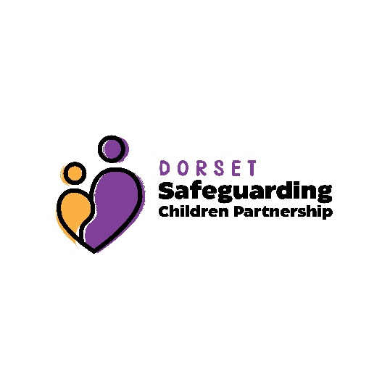
Dorset Extra-Familial Risk and Harm Panel Confidentiality Agreement

- Information discussed by the agency representatives within this meeting, is strictly confidential and must not be disclosed to third parties who have not signed up to the EFRH panel protocol and without the agreement of the partners of the meeting. It should focus on children and young people at risk of experiencing or causing extra-familial harm and a clear distinction should be made between fact and professional opinion.

- All agencies should ensure that all minutes and related documentation are retained in a confidential and appropriately restricted manner. These minutes will aim to reflect that all individuals who are discussed at these meetings should be treated fairly, with respect and without improper discrimination. All work undertaken at the meetings will be informed by a commitment to equal opportunities and effective practice issues in relation to age, sex, disability, race, religion and belief, sexual orientation, gender or gender identity.

- The panel will:

● Share information to increase the safety, health and well-being of children and the public.
● Construct and implement jointly risk management plans that provide professional support to all
those at risk and which reduce the risk of harm.
● Ensure that interventions to reduce harm are directed towards the context in which harm takes
place.
● Share information that may enable perpetrators to be held account and ensure they face sanctions.
● Ensure agency accountability.
● Provide support/guidance for staff involved in extra-familial harm cases.

The responsibility to take appropriate actions rests with individual agencies; it is not transferred to the EFRH panel.
The role of the EFRH panel is to facilitate, monitor and evaluate effective information sharing to enable appropriate actions to be taken to increase public safety.

By signing, I agree to abide by these principles.

Name and role:

Date:

