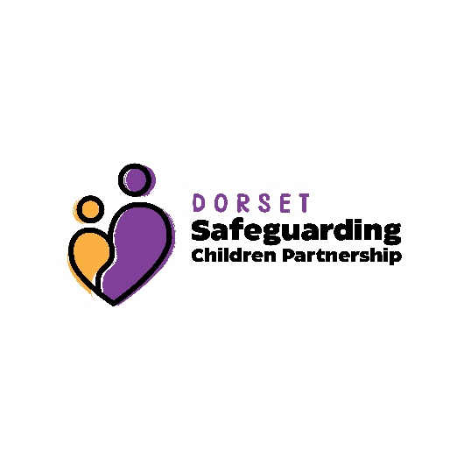
Multi Agency Extra-Familial Risk of Harm (EFRH) MACE Meeting
Chairs Toolkit
Youth Justice Service
Where the Youth Justice Team are involved they should always be involved in the MACE meeting to provide guidance on the range of support and interventions that can be offered to support planning.

Police
- Visit by officer to the child to discuss concerns

- Targeted education by Safer Schools Team, either individuals, small groups or schools

- NPT engagement and targeting of ASB

To be considered where Significant Risk of Exploitation identified:

- National Referral Mechanism Referral to the NCA

- Ibriefing slides for officers awareness and to gather intel

- Open Source research to identify possible threats and offenders

- FIB taskings for research and intel development. (This will need to be agreed and submitted by the IMPACT DS or DI).

- Criminal investigation into any suspected offences and orders on convictions, Restraining Orders, Sexual Harm Prevent Orders (SHPOs) and Slavery and Trafficking Prevention Orders (STPOs)

- Civil Legal Orders – Non-Molestation Orders, Sexual Risk Orders (SROs) and Slavery and Trafficking Risk Orders (STROs)

- CAWNs for 15 year olds and under, 16 and 17 years old require a full care order

Health

ChatHealth
ChatHealth is a confidential text messaging service that enables children and young people (aged 11-19) in Dorset to send questions via text message to their school nursing team. They will then receive a reply that includes signposting to additional services.
The service is available Monday to Friday between 8.30am-4.30pm. This includes school holidays but not bank holidays.
If a child or young person sends a text outside these hours they will receive an automated message with advice on where to get help if they require it urgently. The ChatHealth nurse will reply to the message when the service reopens.
Children and young people can text about a range of issues including:
- relationships
- weight
- anxiety
- depression
- drugs
- smoking
- stress
- alcohol
- self harm
- Sexual health.
We also offer these children the opportunity of support, virtually, via Attend Anywhere.
The ChatHealth text number is 07480 635511.

Health – Children in Care
All CIC have a CIC Nurse so they will represent health for these young people at all MACE meetings
A full health history can be provided from the IHA and RHAs completed.
The CIC Nurse will work alongside the team around the CIC and continue to meet with the YP or try to actively engage them.
The CIC Nurse can work with the YP on all health issues, helping them to make informed choices to improve emotional and physical health outcomes.

Emotional Wellbeing
Kooth – Online support for children and young people experiencing issues with mental wellbeing
https://www.kooth.com/
CAMHS – If CAMHS are involved with the Young Person they should always be involved in the MACE to provide advice about individual and family interventions that can be offered to support planning and reduce risk

Drugs and Alcohol - REACH
Team around the worker support – Should a YP not want or be ready for a referral to the service we can aid the worker with brief intervention worksheets/information to enable them to deliver some harm minimisation/education or advice. This would be a short piece of work to try and support the worker to encourage the YP to see they may have a problem and to receive specialist input via our team.
Brief Intervention
Brief interventions focus on harm minimisation, (education) & discussion around motivation and should be offered to people in limited contact with drug services (for example, those attending a drop in) if concerns about drug misuse are identified by the service user or another professional.
These interventions should normally consist of one or two sessions each lasting 10-45 minutes. Sessions will explore ambivalence about drug use and possible treatment, with the aim of increasing motivation to change behaviour, provide non judgemental feedback and signposting.
This could be a one off session where drug /alcohol education or Harm minimisation has been discussed and/or information emailed out especially for those YP who don’t want ongoing sessions.
Extended brief intervention
An extended brief intervention is similar in content to a brief intervention but usually each session lasts more than 30 minutes and consists of an individually focused discussion. It can involve a single session or multiple brief sessions lasting for no longer than six sessions over a 4-6-week time period.
Psychosocial Interventions
Psychosocial interventions for substance use are interpersonal or informational activities, techniques, or strategies that target biological, behavioral, cognitive, emotional, interpersonal, social, or environmental factors with the aim of improving health functioning and well-being.
Cognitive functioning is often compromised in young people presenting with drug and alcohol problems. This may be due to the impact of trauma (e.g. Abuse, neglect, crime, exploitation, home life etc), chronic alcohol and drug use on the brain, or the impact of pre-existing difficulties such as learning disability, acquired brain injury or mental health conditions. Those who have had a disrupted educational history may also experience literacy and numeracy difficulties.
To work on the presenting issues’ sessions are around 45 minutes and are structured, they include reviews of goals set and the making of any new ones. These interventions should last for up to 12 weeks in the first instance and the goals are to be reviewed every six weeks following that – this intervention really should not exceed a 12-month time period.

Education
Education and planned daily activity are significant protective factors for young people who are being exploited or at risk of exploitation. Therefore the registered education provider or Inclusion lead must be involved in the MACE meeting to consider individual education needs of the Young Person.

Sexual Health

Sexual health Dorset - https://sexualhealthdorset.org/
Links to all their services can be found here, including targeted outreach – online referral can be made via this site
Health – School Nursing
Invite school nurses to all MACE meetings – likely they will decline if not directly working with child but this will alert them to CE concerns.
Send all minutes to school nurses for recording as significant event – flag can be placed on the front of records to alert other System 1 users.
Invites and minutes to be sent to the school nurse duty hub – DHC.SafeguardingSN.Dorset@nhs.net
Dorset school nursing webpage - https://www.dorsethealthcare.nhs.uk/school-nursing
What school nursing provides
• health screening and assessments
• healthy eating, weight management and physical activity advice
• parenting advice
• emotional health & well-being support
• bed-wetting (enuresis) clinics
• hearing tests
• parent/carer/school staff drop-in sessions (primary schools only)
• 1:1 appointments with young people
• referrals and/or signposting to other services
• ChatHealth text messaging service
• NCMP growth measurements in Yr R and Yr 6
• training for school staff to deal with emergency epilepsy and allergic reactions
• support around safeguarding/child protection issues.
Requests for school nurse support can be made at the above website via e-form.
The website provides information for parents, children and professionals on a range of issues.

