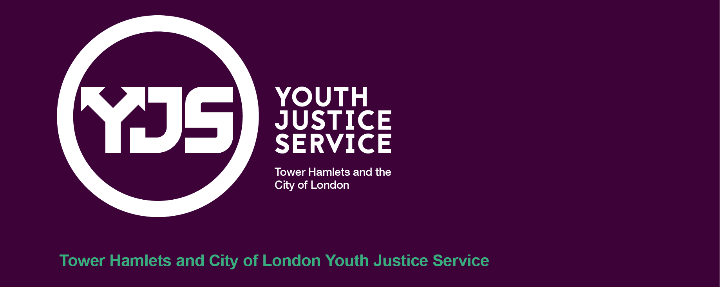
Duty Cover: Procedure and Governance

Date | November 2024
Review Date | November 2025

- Introduction
  - This procedure and guidance is for all staff team members in the Youth Justice Service (YJS). It details the way duty cover is carried out in the YJS for both Court and Office. It includes the key roles and responsibilities of the duty manager, duty officer, business support and relevant multi-agency partners.

- Rota
  - The duty cover rota will be circulated by the Team Manager for Practice Development and Specialisms at least one month prior to the end date of the rota in operation at the time. In the absence of the Team Manager, the Head of Youth Justice and Partnerships will complete the rota.
  - As part of preparing the duty cover rota an email will be sent by the relevant Team Manager to all staff team members requesting information about any unavailable dates (e.g. non-working days, annual leave or training). All staff team members are responsible for providing this information within the identified timescale so that unavailable dates can be taken into consideration at a service wide level when planning duty cover.
  - If a response hasn’t been received within the identified timescale, the assumption will be that the staff team member is available for the duration of the duty cover period. After the duty cover rota has been circulated business support will update the group calendar within five working days to reflect the staffing arrangements.
  - If there is a need to make a change to the duty cover rota once issued, it is the responsibility of the individual staff team member seeking to make the change to identify suitable cover. The staff team member should notify business support of the change by emailing grptowerhamlets.yot-admin@towerhamlets.gov.uk copying in their line manager. Business support will update the group calendar with any changes they are notified about.

- Office Duty
  - When undertaking office duty, the duty officer and duty manager should be based in the office from 9am-5pm. Off-site appointments should not be undertaken unless in exceptional circumstances which should be communicated to and agreed with the relevant duty manager. The duty officer and duty manager should communicate arrangements for lunch breaks to ensure there is always someone providing duty cover.
  - Below is an overview of the duty tasks.
Duty Task | Actions to be undertaken | Responsibility
Daily Arrest Notification | The daily arrest notification will be circulated by the police prior to 10am. This information will be routinely circulated to the YJS management team and business support.  The daily arrest notification will initially be reviewed by the duty manager for oversight purposes and then forwarded to the duty officer for information and action(s) where required. The duty officer should review ChildView and alert the allocated YJS case manager, case prevention officer and team manager in the YJS should the child be allocated within the service.  If the child’s allocated case manager, case prevention officer or team manager is absent from work (e.g. annual leave or sickness) immediate actions identified may need to be undertaken by the duty manager and/or duty officer.  For children allocated in the YJS, the arrest information is recorded on Childview by business support on the same date that the information is received. | - Police  - Duty Officer  - Duty Manager  - Business Support
Missing Children (Children Looked After) | The Exploitation Service circulate information daily regarding children looked after who have been reported missing from care to the police. This information is routinely circulated to the youth justice service management team.  This information will initially be reviewed by the duty manager for oversight and forwarded to the duty officer for information and action(s) where required. The duty officer should review ChildView and alert the allocated case manager and team manager. If the child’s allocated case manager, case prevention officer or team manager is absent from work (e.g. annual leave or sickness) immediate actions identified may need to be undertaken by the duty manager and/or duty officer.  For children allocated in the YJS, the missing information is to be recorded on Childview by business support on the same date that the information is received. | - Duty Officer  - Duty Manager  - Business Support
Missing Children (All) | All YJS service managers have access to the Metropolitan Police online ‘box folder’ which is the platform used to communicate information regarding all Tower Hamlets children reported missing to the police daily.  This will be accessed by the duty manager daily. This information will initially be reviewed by the duty manager for oversight and the PDF document will be forwarded to the duty officer. The duty officer should review ChildView and alert the allocated case manager, case prevention officer and team manager.  If the child’s allocated case manager, case prevention officer or team manager is absent from work (e.g. annual leave or sickness) immediate actions identified may need to be undertaken by the duty manager and/or duty officer.  For children allocated in the YJS, the missing information is recorded on Childview by business support on the same date that the information is received. | - Duty Officer  - Duty Manager  - Business Support
Daily Intelligence Meeting (DIB) | The multi-agency daily intelligence briefing, facilitated by the Exploitation Service, reviews all serious incidents that have occurred in the previous 24 hours (e.g. children arrested & children reported missing). This meeting is attended by the YJS Duty Manager.  For all children allocated in the YJS who are discussed at the daily intelligence briefing, the duty manager is to record a contact against the child’s current intervention reflecting that the child was discussed at the daily intelligence briefing as well as noting any agreed actions tasked to the relevant professionals across the co-located service to ensure there is a footprint of the child being discussed at the daily intelligence briefing as well as agreed actions. | Duty Manager
MAST Checks | MAST checks are sent by Children’s Social Care directly to the YJS management team and the generic YJS email address which business support oversee.  Business support are to forward the MAST notifications upon receiving them to the duty manager and duty officer so that this information can be reviewed and responded to.  For children allocated in the YJS who are subject to a MAST check, relevant information is to be provided to Children’s Social Care in advance of the MAST meeting to inform the safeguarding review. This task should be completed by the duty officer however there may need to be liaison with the allocated case manager, case prevention officer and team manager to inform the response provided to Children’s Social Care.  Representation at MAST meetings for children currently allocated in the YJS should be agreed by the duty manager and allocated team manager to determine who is best placed to attend (e.g. allocated case manager, case prevention officer, duty manager or duty officer).  If a child has previously been, or is currently, allocated in the YJS there will need to be representation from the YJS at the MAST meeting.  The duty officer is to record a contact against the child’s current intervention reflecting that the child is subject to a MAST check so that there is a footprint of this on ChildView. | - Duty Officer  - Duty Manager  - Business Support
Duty Phone Calls | Business support respond to all incoming calls into the YJS. If the enquiry relates to a child, business support should check ChildView to establish if a child is allocated in the service and if so the allocated case manager, case prevention officer and team manager should be notified via email if they are not in the office.  If the allocated case manager is absent from work (e.g. annual leave or sickness) the call should be directed to the duty officer. | - Duty Officer  - Duty Manager  - Business Support
Children & Families at Youth Justice Service Office | Duty officers are responsible for responding to any children and families that attend the YJS office for any unscheduled appointments where the allocated case manager is unavailable.  The duty officer is to record a contact against the child’s current intervention reflecting contact with the child and family.  If a child is scheduled to attend the YJS and the member of staff is absent from work (e.g. emergency annual leave or sickness) the team manager will determine whether the appointment should be rescheduled or whether the duty officer should meet with the child. | - Duty Officer  - Duty Manager  - Business Support
Strategy Meetings | If a strategy meeting is convened and the allocated case manager, case prevention officer and/or team manager is unavailable to attend this should be attended by the duty manager.  The duty manager is to record a contact against the child’s current intervention reflecting that a strategy meeting has taken place as well as noting any urgent/important agreed actions so that there is a footprint of this on ChildView. | Duty Manager
City of London | If a child is arrested and known to the City of London, the duty officer is to contact the City of London Children’s Social Care to share information and access information as required.  Telephone: 020 7332 3621 (Monday to Friday, 9am-5pm)  If you need to make a referral outside office hours, please phone the Hackney Emergency Duty Team on 020 8356 2710.  Early Help and Safeguarding Referral - City of London | - Duty Officer  - Duty Manager
Duty Log | The duty log located on Microsoft Teams is to be completed daily by the duty manager and duty officer to reflect that relevant tasks have been completed. | - Duty Officer  - Duty Manager

- Court Duty
  - The YJS provides routine court cover at Stratford Youth Court on a rota basis on alternate Mondays and Tuesdays. In addition to this there is an occasional court rota accounting for Saturdays, Friday Trials & Bank Holidays. A copy of these arrangements is detailed below which will be incorporated into the duty cover rota.

- Role in Court
  - It is important that duty court officers and duty managers are familiar with what is required, can support children and their families effectively, and confidently present reports when required to do so. Court duty involves:
- Ensuring the welfare and safeguarding of children;
- Engaging with children and their parents/carers and providing information to them about the court process and what to expect;
- Facilitating communication between the child, their parents/carers and the court to assist them to engage in the process;
- Sharing information with the Crown Prosecution Service (CPS) and defence lawyers prior to the start of hearings;
- Providing information to courts about children known to the YJS;
- Providing and presenting bail and remand assessments and bail supervision and support packages;
- Presenting a report (e.g. pre-sentence report, stand down and breach);
- Informing the Youth Custody Service of the outcomes of a case when placement in youth detention accommodation is required;
- Preparing documents for placement in youth detention accommodation;
- Ensuring the custodial warrant has been issued and is accurate prior to the child being taken to custody and;
- Undertaking post-court administration, including recording relevant information relating to the case and its outcome, and advising the YJS of any new orders which have been issued.
  - The relationship between the youth justice service and the court is an important one, the court needs to have confidence in the service it provides. This can be achieved by:
- Being well prepared. There is a pre-court meeting held weekly on a Wednesday with the duty officers scheduled to provide court cover, duty manager and business support. This meeting should be attended by all relevant staff team members as part of the preparation process;
- Providing the court with sufficient and appropriate information to help it to make decisions and;
- Ensuring that children and their families are well prepared and support them to present themselves positively and effectively.

  - Discrimination and disproportionate outcomes can occur at any stage of the criminal justice system, with different groups of people receiving less favourable outcomes because of their ethnicity or for other reasons. You should be mindful of this and be clear about what you can do to ensure disproportionate outcomes do not occur and how you can address concerns if they arise.
  - ‘Child First’ is the guiding principle for the youth justice sector and underpins the Standards for Children in the Youth Justice System and Case Management Guidance. A Child First approach means putting children at the heart of everything we do. The youth justice system should treat children as children, see the whole child, including any structural barriers they face and focus on better outcomes for children. This will also create safer communities with fewer victims.

- How to undertake Court duty role
  - Routine court duty work involves providing a service to the court, children and their parents/carers. This means attending:
- When children have been held overnight by the police to appear in court the next day (or at the first available court);
- For those who have been bailed from a previous hearing;
- For children who are being sentenced and;
- For children brought back for breach proceedings.
  - For scheduled returns to Court, you should know how to access information about who is expected to appear. To be fully prepared for court, you should have access to a final court list the day before to ensure any information which needs to be presented is available, avoiding unnecessary adjournments. Information on listings is provided through an automated email system.
  - The duty manager should review daily arrest notifications to establish whether any child has been held overnight and charged to appear in court. This is to ensure that the service obtains information about their offence(s), background and circumstances, whether there are likely to be to any objections to the granting of bail and what role the service can play in providing a bail supervision and support package. See how to manage bail and remands for further information.
  - If a child a sentenced at court, the duty court officer should request CPS documents whilst at court.
  - If there is a strong likelihood that the child will be remanded or sentenced to custody, you must alert the Youth Custody Service’s (YCS) Placement Team at least 24 hours before the hearing (unless the child has been produced overnight) by sending them all the relevant assessment information and the placement information form.
  - If the child is remanded or sentenced to custody, you should follow the placing young people in custody guide.
  - How to present yourself in Court
  - If undertaking court duty it is useful to understand the roles of the:
- Crown Prosecution Service
- Judge
- Jury
- Usher
- Court Clerk
- Barristers
- Solicitors
- Magistrates
  - You should also have knowledge of the local court etiquette. Prior to undertaking court duty for the first time, it is useful to shadow a more experienced case manager to learn about the environment and processes. When working in court, you are a professional providing a statutory service and so should:
- Dress smartly (in professional clothing);
- Wear your Tower Hamlets Council identification to ensure that your role is clear to other staff and the public;
- Arrive punctually with sufficient time to prepare for court; introduce yourself to the court clerk and give your name so that you can be formally addressed by the magistrates;
- Ensure that all relevant information prepared for court by your team is available and that relevant parties have received it;
- Address magistrates and district judges as “Madam” or “Sir”;
- Address a Crown Court judge (except in the Old Bailey) as “Your Honour”;
- Address a High Court judge, any judge in the Central Criminal Court (Old Bailey), a Court of Appeal or Supreme Court judge as “my Lady” or “my Lord”;
- When you talk to the Bench or when they talk to you, stand up and talk as clearly as possible - it might be you are told you can remain seated, but it is important to show respect for the formality of the process;
- If you have something you would like to say once the hearing has started, get the court clerk’s attention before standing or speaking and you will be invited to comment;
- If you need to ‘respectfully’ correct something which you know to be wrong, indicate to the clerk that you would like to address the matter;
- If during proceedings, you are unsure of something which should be factually checked to ensure that accurate information is put before the court, you can request a brief adjournment to make enquiries;
- Show respect for the workings of the court and the functions of the sentencers and be courteous to all concerned;
- If you do not agree with any decisions do not make your feeling obvious, there are ways to challenge outside of the court arena;
- Mobile telephones must be always silent;
- Be mindful of your surroundings - the relatives of a defendant and sometimes victims may be sitting in the public gallery or waiting room and care should be taken when discussing any aspect of a case outside of the court room. Staff team members should not directly or indirectly speak with the media and any enquiries should be escalated to the duty manager who can alert the councils media team via
Email - communications@towerhamlets.gov.uk
For more urgent queries or if a journalist contacts you directly, please call the press office on ext. 4389.
After 5pm, if you have an urgent query call (don't email) the on-duty communications officer on 07852 273984.
- How to support children, parents & carers in court
  - For scheduled hearings, you should ensure that the child and their family have been contacted and reminded of the court appearance (date and time) and the importance of attending. Depending on their circumstances you may also want to tell any other significant individuals they are in contact with about the appearance (e.g. their social worker), to ensure any additional support they require is provided.
  - Irrespective of whether the child and their parent/carers are familiar with the court process and setting, you should explain and check they understand what will happen, what is expected of them and how they should present themselves. This includes:
- Being on time;
- Not being under the influence of alcohol or drugs if identified as a potential concern and;
- Bring their parents or carers wherever possible.

  - Parents/carers should be encouraged to attend. If this is not possible, they should be asked to provide a statement to the court. This is to ensure their views are included and there are no negative connotations attached to their non-attendance, including a disproportionate outcome for the child who is appearing.
  - The service should work with defence solicitors to engage with parents to attend court where possible; or provide the court with statements or information as to why they were unable to attend. This should be done with all children; however, given the disproportionate outcomes experienced by children from Black and Mixed ethnicities and Gypsy, Roma and Traveller communities, it is of particular importance for these groups. Non-attendance at court may encourage stereotyped assumptions and unconscious bias in decision making. You should explore potential barriers that might make it more difficult for parents and carers to attend court and provide support where possible to overcome these.
  - Regardless of whether the child has appeared in court before or not, it is important to recognise they may be feeling apprehensive, anxious and nervous about attending and the possible outcome. Every court appearance is different and may bring its own challenges. It is important that irrespective of the reason for attending court, you are non-blaming, honest, open, empathetic and realistic about possible outcomes in your engagement with children and their parents/carers. The process of going to court can in itself have a negative and stigmatising effect, so it is important that you treat the child and parents or carers with respect and try to mitigate the impact of the experience.
  - You should explain that your role in court and that of others is to help them to understand what will happen and how you can support them. This includes ensuring the child and their parent/carer understands their rights to legal representation, legal aid and a duty solicitor. If they wish to engage their own defence lawyer, they should know they must make their own arrangements for this. It may also be helpful to explain who will be in the court room.
  - You should assist the child to put themselves across in a positive light, which may include:
- Discussing court etiquette;
- Helping them to understand the importance of listening to what is being said and;
- Preparing them that they may be asked questions about what has happened and their future plans.

  - Court attendance can be an intimidating experience for children. Nervousness and stress can affect their ability to understand what is going on, to engage and comprehend the process and outcome. Explanations may help them to feel more confident and they should know that despite the formality, the court will want to hear from them in their own words.
  - However, you should also be able to demonstrate how the child has worked with you to develop positive plans for the future, which are collaboratively developed and based on their strengths. If there are likely to be any difficulties in the child understanding what is going on (e.g. because of speech and language problems), their defence solicitor should be made aware (see also when a child may require an intermediary). You may also wish to add an opening statement in the pre-sentence report as to how the child may present and advise the court as to how best to engage with them.
  - There are various resources which may be of assistance when explaining to children and their families what court appearances entail. This includes:
- Advice to teenagers from Family Lives
- Information from the Citizen’s Advice Bureau
- ChildLine
- Just for Kids Law
- The Children’s Legal Centre Wales - also contains advice in the form of questions and answers for children who have to go to court.

- How to support children after their court hearing
  - After the hearing, if the child has received a community order, there is basic information they should be made aware of before leaving the court. Children may find it difficult to fully process information at this stage, because they feel overwhelmed and overloaded by the process. It is also likely they will want to leave the court as quickly as possible. This can make it challenging to get detailed information across and if, as court duty officer, you are facing other demands and have other children and families to support, there may be limited time. However, this is a critical time to build a relationship and avoid stigma, and it is important that where possible this is framed for the child as moving forward positively.
  - The following basic information should be exchanged:
- Details of the first appointment with the YJS (e.g. when, where and who with);
- Ensuring the child knows how to get to the location of their first appointment and are able to get there and that contact details are exchanged;
- Contact details for the YJS and child (and their parents/carers) and;
- Reiterate the seriousness of the situation and the need to meet with and engage with the YJS and any other requirements of the court order (restrictions, curfews and other conditions etc).
  - Children who are securely remanded or receive a custodial sentence will also require attention and assistance. They are likely to feel overwhelmed and unlikely to have processed the information fully. You should consider:
- Their immediate safety and well-being;
- Information the secure estate needs to know on reception and;
- Where they will be placed and how and when they will get there.
  - Any questions, anxieties and concerns should be discussed to ensure children feel supported and understand what will happen next.
  - The court duty officer is also responsible for carrying out a post-court check with the child in the cells. The purpose is to assess the child’s mood, reaction to court outcome and any self-harm or suicidal thoughts.
  - You should then ring the Youth Custody Service (YCS) on 0345 3636363 to book the child into a placement. You will need to have the following information:
- Child’s name, sex and date of birth;
- The court that the child is appearing at;
- Offence details- including dates;
- Court outcome and any future court appearances;
- Post court assessment information;
- Potential conflicts in custody information - including gangs associations or specific children the child is at risk from and;
- The placement recommendation and reasons for this.
  - After you have spoken with the Youth Custody Service, you must complete the ‘Post-Court Report’ Asset Plus stage. Once completed, you should request that a manager countersign it and send via connectivity to the Youth Custody Service. You should also record any concerns on the ‘Person Escort Report’ for the escort service.
  - Once the child’s placement has been confirmed you should communicate this with the child’s parent/carer, and to children’s services. You should make them aware of arrangements for visiting and assistance with the cost of this.
- Weekend Duty Cover
  - The YJS has a duty manager in place providing cover at weekends. This includes Saturday court cover via telephone and Sunday emergency contact for the intensive support & surveillance worker. In relation to any staff team member providing court cover at weekends this is paid as additional hours.
  - The duty manager providing cover at weekends should communicate with the YJS police each Friday afternoon to establish if there are any children in police custody. In addition, the duty manager should send an email each Friday afternoon to representatives from relevant neighbouring youth justice services to advise who is the duty manager and contact information. This information is to be communicated to Hackney, Waltham Forest and Newham YJSs.
  - The YJS Intensive Supervision and Surveillance (ISS) and Reparation Worker works on Sunday’s undertaking appointments with children allocated in the YJS who are the subject to an Intensive Supervision and Surveillance (ISS) intervention. The duty manager function in this context is to respond to any absence (e.g. sickness) so that necessary arrangements can be made as well as respond to any identified safeguarding concerns.
  - Children’s social care routinely circulate and share information with the YJS regarding Emergency Duty Team (EDT) arrangements to support liaison out-of-hours where necessary.
- Diverting the Youth Justice Service telephone number
  - The on-call duty manager should divert the YJS telephone on Saturday morning to their work mobile phone.
  - The process to divert calls is as follows:
(The Directorate account code is 278228)
- Dial 02073647811
- Dial tone
- **3278228#
- Dial tone
- *#711449your number#
- Hang up
- To cancel:
- 02073647811
- Dial tone
- **3278228#
- Dial tone
- *#81144#
- Hang up

- Appropriate Adults
  - Appropriate Adults UK are commissioned by the youth justice service to provide an appropriate adult for children in police custody.
- The telephone number for this service is 08000 787 191.
- https://www.appropriateadults.co.uk/

- Childview Recording Guidance
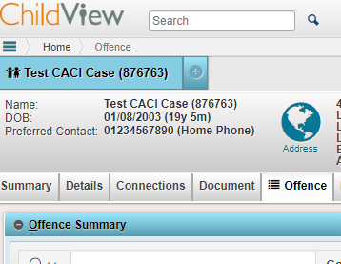
  - Daily Arrest Notification
- Go to the Offence tab of a child’s record.
- Click CREATE in the upper right corner of the Offence Summary section
- Enter the Offence Date and Arrest Date
- Enter the Offence itself using the offence code (e.g. CJ88001)
- Enter the Offence Location address
- Select any Alleged Offence Factors from the dropdown (e.g. Knife/Gun/Gang-related)
- Copy any additional details from police (e.g. notes or reference numbers) into the Police Comments section
- Click the Save button in the bottom right corner
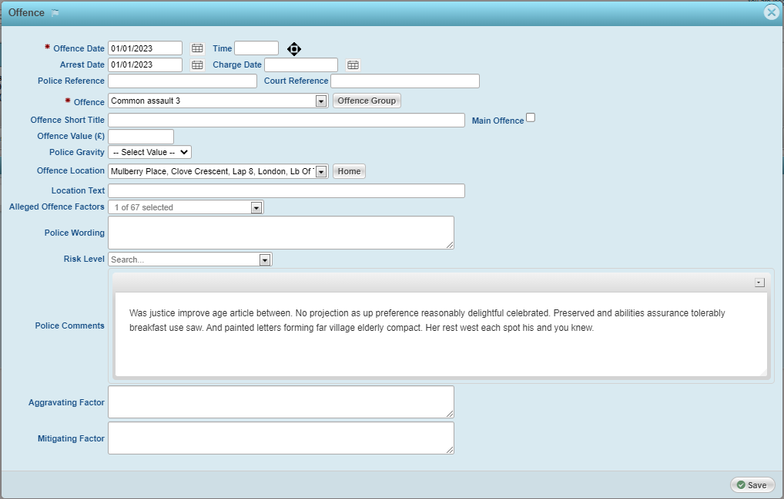
Example Recorded Arrest Notification
  - If you do not have the Offence Code, please request this from police. Using codes eliminates the risk of accidentally recording a different offence with similar wording.
  - If the Offence Location is not already in the list of addresses, this will need to be manually added to Childview using the Address Module:
- Click the Childview logo in the top left corner to go to the home page
- Click the three horizontal lines underneath the Childview logo
- Click Modules , then Address
- Click CREATE in the top right corner to add a new address

  - Missing Children
When we are notified of a Missing Child:
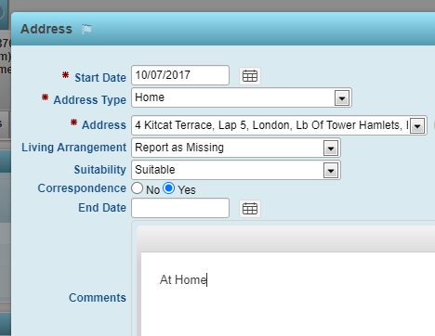
- Go to the Details tab of the child’s record
- In Address History, click the pencil icon next to their current address
- Copy their current Living Arrangement to the Comments section (we will need this info when the child returns)
- Change their Living Arrangement to “Report As Missing”
- Click Save in the bottom right corner
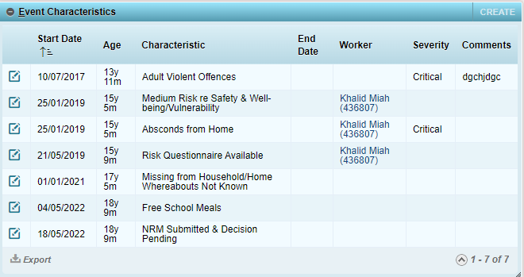
- Staying on the Details tab, scroll down to the Event Characteristics section
- Click CREATE in the top left of the Event Characteristics section
- Enter the date the child went missing as the Start Date
- Type the word “missing” into the Characteristic dropdown menu
- Select a Missing status that reflects their living arrangement, e.g. if the child normally resides with family at home, select “Missing from Household/Home Whereabouts Not Known” or if they are LAC, “Missing from Looked After Carer Whereabouts Not Known”
- Click Save in the bottom right corner
When we are notified that a Missing Child has returned:
- Go to the Details tab of the child’s record
- In Address History, click the pencil icon next to their current address
- Change their Living Arrangement from “Report as Missing” to their previous living arrangement
- Click Save in the bottom right corner
- Scroll down to the Event Characteristics section
- Click the Edit Pencil icon next to the Missing status
- Enter the date the child returned as the End Date
- Click Save in the bottom right corner

Changing the Living Arrangement for the current address only flags a child as missing in the banner at the top of the record. Recording an Event Characteristic is what allows us to report on individual Missing Episodes.

  - MAST Checks / Strategy Meetings
Both MAST Checks and Strategy Meetings are recorded as Contacts.
- Go to the Intervention tab of a child’s record
- In the Intervention Summary section, check that the relevant intervention is highlighted
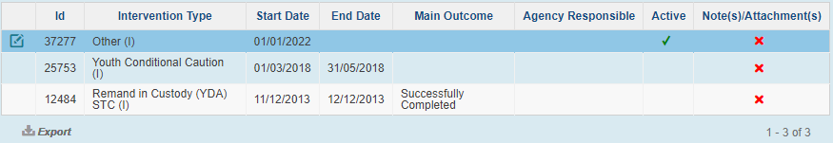
By default, highlighted interventions are in blue, like the “Other” intervention shown above

