Children's Services

Quality Assurance and Continuous Improvement Framework

Updated December 2020

Version Control

Date | Version | Changes
November 2019 | V.1 | Nancy Meehan  Stephen Hart
December 2020 | V.2 | Sue Whitmore  Faye McNiven

Contents Page

1. Introduction - the four lenses on quality 3
2. Using the four lenses to improve quality 5
3. Closing the loop – ensuring our QA activity has a positive 11
impact going forward
Appendix 1 – Revised Audit Tool for Social Care
Appendix 2 – Audit Hints and Tips
Appendix 3 – Torbay Audit Statements of Good
Appendix 4 – Dip Sample Template
Appendix 5 – Quality Assurance Schedule Exemplar
Appendix 6 – Service Performance Reviews Document
Appendix 7 – Practice weeks

Quality Assurance and Continuous Improvement Framework

Introduction

This Children’s Services Quality Assurance and Continuous Improvement Framework forms part of our Performance Management system. It focuses specifically on: -

- Social Work services for children provided by children’s social care
- early help services
- the quality assurance functions that underpin continuous improvement.

What is quality assurance?

Quality assurance (QA) is: -

“A systematic process to ensure the quality of outcomes”

It is the aim of this framework to deliver improved outcomes through a wide range of indicators of quality. Assuring quality of practice is essential to the provision of a good service to the children and young people of Torbay.

The four “lenses” on quality

There are four lenses through which quality should be viewed. A number of authorities have adopted the “four lenses” approach as a basis for their own quality assurance. The diagram below shows these lenses together with examples of aspects of quality assurance which relate to each lens:
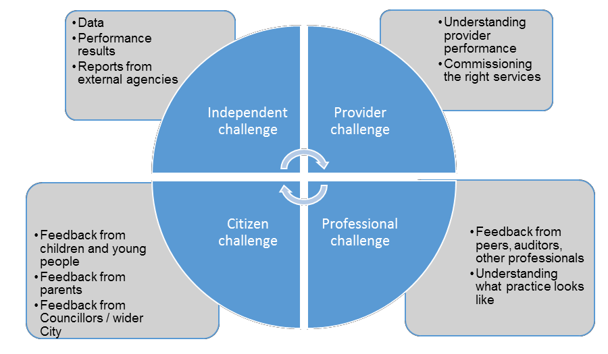

To complement these lenses, it is also helpful to be mindful of the key messages from the Munro Report: -
    - achieve better outcomes for children by being less concerned about measuring processes
    - improve the quality of direct work and relationships with children and their families
    - achieve effective early help for families
    - understand the child’s experience in their “journey”
    - review performance indicators; ensure they focus less on process, more on outcomes
    - restore faith in practitioner professional judgement
    - value reflective practice and supervision, and establish a learning culture

1.3 What does the framework achieve?

The quality assurance and continuous improvement framework articulates how Torbay’s Children’s Services manages and measures quality. Improving consistency and the quality of work improves outcomes for Torbay’s children. This supports the development of a culture that expects and values high standards that improve the quality of service to children, young people, their parents and carers. These aspirations and standards drive up expectations, improve learning and strengthen impact and outcomes.

The framework continues to evolve as learning from quality assurance activity embeds into the DNA of the service. Also informed by learning from the audits, single agency learning reviews, local safeguarding practice reviews and national reviews overseen by Torbay’s Safeguarding Partnership, it will be closely linked to the revised Workforce Development and Recruitment and Retention Strategies with a shared vision to:

“ensure that children and young people within Torbay are kept safe through high quality services provided by a qualified, well-resourced and skilled children’s work force.”

The implementation and sustainability of the continuous improvement framework is the responsibility of the Director of Children’s Services supported by the Head of Learning Academy Using the four lenses to assure and improve quality

  - The principles in delivering effective quality assurance

In order to deliver effective and impactful quality assurance, Children’s Services follow the following principles to:

    - establish a learning culture and be self-aware
    - sustain the drive and commitment to continuous improvement
    - promote value for money by improving the effectiveness and quality of work
    - provide support to enable staff to achieve the required changes
    - check to ensure that improvements have been achieved and maintained.

Using the four lenses approach

The diagram below shows the types of information viewed under each of the lenses.

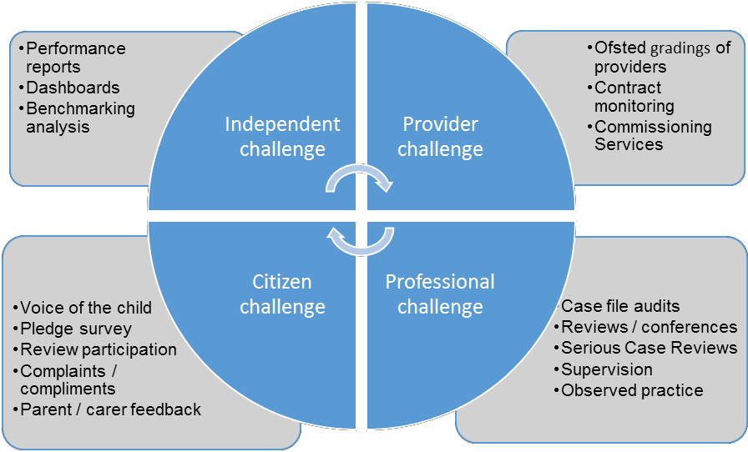
Self-Assessment
A summary of the Quality Assurance and improvement activity that is undertaken throughout the whole of children’s services is set out in the Children Services Quality Assurance Schedule.

Self-assessments

At the heart of our four lenses approach is the self-assessment. The service continues to assess and review itself and has an up to date and increasingly rigorous self-assessment.

Individual services develop their own self assessments through the performance review process (see below). This is key to the service knowing itself well and producing realistic and deliverable plans to be monitored by using the four lenses approach. All those who use our services have a right to expect that Children’s Services is fully aware of its strengths and the areas it is improving to ensure that all children and young people receive at least a good service.

The full Children’s Services self-assessment is updated annually and will enable the Council to participate fully in the regional challenge process (usually October each year) & Ofsted’s Annual Conversation. It is also critical to our intention to be always ‘inspection prepared’.

2.3.1. Service Performance Reviews

To make the self-assessment process dynamic and to ensure it drives improvement, Children’s Services undertakes a process of service performance reviews every six months. Heads of Service will produce their own self-assessment in April and October using the four lenses approach. These timescales can be adapted to fit with any external inspection schedule. The Head of Service will report on each of the four aspects of quality assurance and specifically identify what this intelligence is telling them about the performance of the service and how it is impacting upon the experiences of children and young people who receive services. A panel made up of members of the Children’s Services Leadership Team will provide critical friend challenge to keep the process ‘true and sharp’. The discussion leads to the creation of a service specific action plan for continuous improvement.

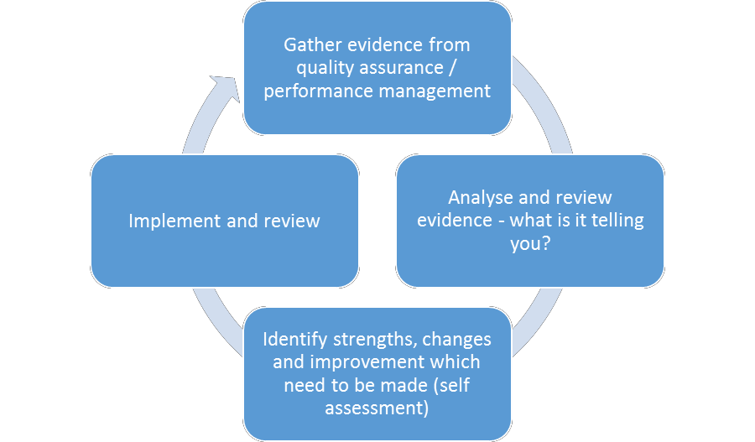
The self-assessment process is summarised in the diagram below:

A template for the service performance reviews, based on the four lenses has been developed and is attached at Appendix 4.

Independent Challenge

Children’s Services is subject to external scrutiny by Ofsted.

Children’s Services has a wide range of data that informs the tracking and reporting of performance using key performance indicators. Management information provides managers with detailed and timely information about progress against assessment and care planning processes and outputs. This enables managers and practitioners to review and identify good practice, and, when necessary, to take corrective action directly for individual children as well as target improvements in service design and practice guidance. The service continues to use national, statistical neighbour and regional benchmarking analyses to support our understanding as we aspire to achieve consistently good or better performance. However, in recognition of the fact that regional performance is not always consistently good, we will take steps to always benchmark against the best of our statistical neighbours and those local authorities rated by Ofsted to be good or outstanding.

Every month (on the 4th of the month or as shortly afterwards as possible) the performance compendium is created and shared with all managers in the service. This is reviewed in in the children’s social care leadership meetings and also by Children’s Services Leadership Team and is scrutinized in service level ‘performance surgeries’.

Performance data is shared with the Improvement Board at every meeting. The Corporate Parenting Board receives performance reports in line with the priorities identified in the corporate parenting strategy. Key indicators are included annually in the Council’s annual report. Political oversight of performance is achieved through regular Member briefings and Scrutiny Board is given performance information relating to areas of interest as required.

Provider Challenge

All commissioned services are commissioned and tendered using established processes and there are contracts in place to ensure services are delivered as specified. There is regular contract monitoring. Market development activity helps providers to develop and improve the quality of their services.

In relation to residential placements, Ofsted has overall responsibility for the inspection of children’s homes. All children’s homes are inspected twice a year. Inspection reports will be used to assure the continuing suitability of the placement. In addition, the quality assurance regime requires internal assurance that is provided by the involvement of a range of stakeholders including the commissioning team, procurement service, placements team, social workers and providers themselves in a process to evaluate the quality of the service designed to meet the child’s identified needs. Important and crucial feedback is also sought in a variety of ways from children and young people.

Torbay’s approach is always to place children in provision which is rated good or outstanding. At the point of placement there are a range of checks on the suitability of the provision for example by scrutinizing latest Ofsted reports, regulation 44 reports, references from other Local Authorities, the statement of purpose and satisfying the council’s requirements for appropriate insurance cover. It is the expectation that social workers must visit the provision in advance of placement as part of the process of assessing its suitability to meet the needs of the child.

If a provider receives an inadequate Ofsted rating, they are required to develop an action plan which shows how they will address Ofsted’s concerns within a given timescale. Torbay Children’s Services will wish to see the action plan. Social workers will also immediately visit the child to review whether it is appropriate for him/her to remain placed in the establishment and to ascertain whether needs are still being met. The Director must be informed of the outcome and a senior manager’s oversight placed on the child’s electronic file. In the event of the provider not being able to make the required improvements within a timescale suitable for the child or if there are safeguarding concerns, active consideration will be given to moving the child to a more suitable placement.

Citizen Challenge

For this framework the main citizen challenge is provided by the Children in Care Council. Consultation with children, young people and their families or carers will occur at every level. The Children’s Service aspires to have in place a wide range of significantly strengthened processes to engage children and young people in service design, commissioning services and wider developments. Vital information can be provided by surveys and feedback through the Children In Care Council and other participative groups. It is essential that such feedback shapes the services offered and the improvements made. We plan also to have a team of ‘young inspectors’ comprising children who receive or have received services who will assist the quality assurance functions by providing an informed child perspective.

The views of children and young people, their parents and carers must be heard to ensure that the service provides effective assessment of need, planning, intervention and review. The responsibility in capturing these and responding to their views lies with the allocated worker, their line manager and chairs of reviews. It is essential that audits and supervision continue to emphasize the need for the child / young person’s voice to be clearly heard and acted upon.

To support this activity there are a number of performance indicators that are routinely monitored as a means of ensuring that the voice of the child is heard. These proxy indicators included those that gather data on visits being undertaken on time, children being seen alone and participation of the child in their child protection conference or LAC review. They identify the direction of travel for this area of work in terms of compliance with service requirements but further work, for example through audit activity, is required to establish the quality of the service.

An important source of feedback directly by children, young people, their families and carers is provided by compliments and the resolution of complaints. Informal complaints and those made through the Torbay City Council formal complaints procedure are an important source of learning. The Children’s Complaints’ Officer regularly reports on the outcome of complaints as well as compliments which are shared across the Service.

Children’s Services will undertake regular surveys of LAC and Care leavers. We will commence an Annual Pledge survey from 2020. The Service as a whole will develop means of enabling children and young people involved in early help or social care to give us their views about the support they have been offered and the changes which have been made. The breadth of children and family feedback methods as well as what they are telling us forms part of the service performance review process of all services (see draft template at Appendix 6).

Monitoring the impact of work undertaken is an important part of this framework. Each care plan should make explicit the impact and outcome objectives for the child and each element of audit activity is now explicitly requiring impacts to be identified and evaluated for quality, relevance and timeliness for the child’s needs.

Elected Member Challenge

The purpose of the Safeguarding member’s scrutiny through a programme of practice weeks is to assure both elected members and the council that the services being delivered to the children, young people and families of Torbay are to a good standard and are fundamental in improving outcomes for Torbay families. The members undertaking visits will gather evidence and feedback their findings to enable the service to continually improve. This activity will be in addition to the business as usual functions of overview and Scrutiny and Corporate Parenting Boards.

An evidence based pack will be made available to members two days prior to the visit. The evidence pack will contain relevant information detailing the area to visit, information relating to service area and performance. Information gained from planned meetings with children and families will be supplemented by findings of a recent audit. The Senior leadership team and Members’’ visits will enable discussions to take place with partner agency representatives as well as front line managers and staff. This will enable triangulation the information to ensure the quality of service and responses are acceptable.

Professional Challenge

The professional challenge programme includes:

- moderation of individual file audits undertaken monthly across the service
- themed practice audits undertaken at relevant intervals assuring specific areas of practice.
- RAG rating of care and CP plans by the IRO / CP chair at each review
- observed practice sessions, and;
- supervision and appraisals of case holders and line managers.

Quality auditing of work with children and young people is a vital strand of service improvement activity. In order to address the need for continuous improvement and to ensure measurement of and focus on outcomes, there is a schedule for regular individual file audits. All social work services are targeted within this.

The monthly individual file audit process follows a standard approach. There is an agreed audit tool for social care (see Appendix 1). Managers who have been specifically trained as auditors complete the record scrutiny task and discuss their findings with the allocated worker to ensure direct feedback of learning and improvement. Audits are moderated. The recommendations from the audit will formulate part of the child’s plan which will be reviewed as part of the normal process in child protection, children in need and looked after children’s cases.

The Head of Learning Academy identify themes and practice issues which emerge. These are fed back regularly and are woven into formal audit feedback sessions to support practice improvement. All recommendations of audits are expected to be acted upon within the laid down timescales and managers are required to evaluate for impact. In addition, performance management processes will monitor and record compliance with audit findings.

The individual file audits are supplemented by themed audits, observations of practice and reviews which consider specific issues. The programme of themed audits, dip samples and observations of practice are set out in the Children’s Services Quality Assurance Schedule.

Where file audits or observations of practice identify areas of concern, a further deep dive audit of a similar sample will be undertaken to ensure that appropriate corrective action is taken. This process will follow the ‘Ofsted improvement offer’ methodology. This includes file audit, sampling, discussion with the allocated worker and feedback to the manager.

As part of their function to assure effective planning for children and young people, Independent Reviewing Officers (IROs) RAG rate care plans they see at reviews. Individual ratings are shared with workers and their managers and details are included in the monthly performance report as well as the IRO Annual Report that is presented to the Corporate Parenting Board. The RAG rating system extends to child protection conferences so that a wider quality assessment can be made. RAG rating proportions are reported within the monthly performance framework with generic learning being fed into practice improvement forums.

Every quarter, managers undertake forms of observed practice. This is reviewed with the worker so that areas of good practice and of improvement can be identified. This also informs more senior managers about the quality of live practice as it happens. Examples include the Senior Managers observing child protection conferences, LAC reviews, CIN reviews and Heads of Service observing a strategy discussion, or a Team Manager observing some direct work with a young person.

Every allocated worker has supervision, at least monthly, in line with the Council’s supervision policy. Outcomes of supervision, which are expected to include discussion on recent audit recommendations, are recorded and child related decisions and directions are recorded on the child’s file. Supervision is scheduled to be audited twice a year or be the subject of observed practice to ensure that it is effective.

Working with partner agencies through the Torbay Safeguarding Partnership Arrangements, the service uses audit, local safeguarding practice reviews and national reviews and experiences from other areas to assure and improve practice. Relevant representatives from Children’s Services teams participate in multi-agency audits and learning from these is fed back alongside internal audit activity.

The professional challenge lens requires specific governance to ensure that audit and observed practice activities are focused, consistent and well managed. For each audit completed, results are collated by the Lead auditor to ensure consistency of grading and the identification of general themes. This learning is fed back to auditors and practitioners and informs the focus of future audits and observed practice.

Closing the loop- ensuring that our QA has a positive impact going forward

All the QA activity described above only has a value if it leads to improvement in services received by children, young people and their families that then delivers better outcomes.

In order for the QA activity to deliver the improvement it is essential to “close the loop” to ensure the associated learning informs practice. This is achieved as follows:

- Each audit undertaken, as described above, includes direct feedback and discussion between the auditor and the allocated worker. This provides immediate opportunity to discuss good practice and improvement opportunities. Where the auditor does not grade a child’s record as at least good, Heads of Service and Team Managers ensure that appropriate corrective action is put in place to support improvement. Audits are placed on the child’s file following feedback from the auditor to the appropriate worker / manager.

- A percentage of audits are moderated each month by a Senior Manager to check for consistency. Moderators will provide feedback to the auditor and changes in grading and learning points will form the basis of the feedback. Moderated audits are also placed on the child’s file following the feedback and the recommendations automatically become part of the child’s plan and progress against them is reviewed in the normal way as part of the child in need, child protection or child protection processes.

Audits also lead to general learning and consideration will be given to producing a regular briefing note to share relevant material.

There are monthly opportunities to formally discuss practice improvements in the range of management meetings. These are key vehicles for sharing learning from audits and raising specific practice issues they highlight. These forums can also be used more generally to pick up on good work, through appreciative enquiry, or to use case study discussions to stimulate thinking. Team managers are required to cascade the messages and learning from these meetings within their teams.

The six-monthly service review process is designed to enable the creation of service- level summaries of quality assurance against each quality assurance lens. The framework includes a summary to be communicated to all team members to engage them in understanding the self-assessment and the improvement plans for the future.

Quality Assurance Service – December 2020

Appendix 1- Revised Audit Tool for Social Care

Auditor name |  |  |  |  | Audit date
Child’s ID number |  |  | Team
Audited previously? | YES | NO |  | If Yes, when?
Age band | 0 |  | 1 -5 | 6-10 |  |  | 11-15 |  | 16-21
Strand | Help and protection /  Children looked after and permanence  Children with disability  Adoption / Care Leavers  Leadership, management and governance  Local safeguarding children board
Which worker did you speak to as part of the Audit? (include date seen)

Field | Quality of child’s experience  (Exceeds good/meets good/ does not meet good) | Text  (please keep this evaluative and succinct)
1. Risk is identified, responded to and reduced in a timely way. Where relevant, include evaluation of identification and response to children who experience and/or are at risk of:  - neglect  - emotional abuse  - sexual abuse  - physical abuse  - domestic abuse  - gang affiliation  - sexual exploitation  - criminal exploitation | Exceeds good  Meets good  Does not meet good  Not applicable. | Evidence:  Impact:
2. Children, young people and families are appropriately involved  Is there evidence of impact of the involvement of children and their families in assessment, planning and intervention? Are the views of significant males effectively gathered?  Are children seen, and seen alone, and do they benefit from stable and effective relationships? Do children and parents/carers have an equal voice? Does it evidence individual work undertaken, including appropriate direct work?  Is this linked to the plan and the reduction of risk? What is the impact of this for children and their families? | Exceeds good  Meets good  Does not meet good  Not applicable. | Evidence:  Impact:
3. Decision making is effective and timely.  Is there evidence of effective and timely management oversight and direction for children, and clearly recorded rationale for decisions being made?  Is the recording about the child and family clear, comprehensive and reflective of work undertaken and focused on the experience and progress of children and young people? | Exceeds good  Meets good  Does not meet good  Not applicable. | Evidence:  Impact:
4. Assessments are timely, comprehensive, and analytical and of high quality - and lead to appropriately focused help. Do they incorporate historical factors, informed by up to date child’s chronology? Do they identify risk, needs and protective factors, including parental capacity? | Exceeds good  Meets good  Does not meet good  Not applicable. | Evidence:  Impact:
5. Coordination between agencies is effective. Is joint working, information sharing improving and sustaining the experience and progress of children and young people. | Exceeds good  Meets good  Does not meet good  Not applicable. | Evidence:  Impact:
6. Consideration of the child’s identity (how they see themselves) which includes exploration of the impact of diversity for example, age, disability, ethnicity, faith or belief, gender, identity, language, race and sexual orientation. | Exceeds good  Meets good  Does not meet good  Not applicable. | Evidence:  Impact:
7. Quality of plans.  Are they: up to date and updated, timely, comprehensive, specific with measurable outcomes and dynamic?  Are they implemented? Consider length of plan or any themes? Do they show quality of management oversight? Are they influenced by views of children and parents/carers and diversity issues? | Exceeds good  Meets good  Does not meet good  Not applicable. | Evidence:  Impact:
8. Permanency is achieved without delay and reflects assessed needs. Are plans for permanency, including living at or returning to live at home with parents, long term foster care, adoption, in the best interests of children and young people, and achieved without delay? Evaluate the quality of preparation for where the child is living. | Exceeds good  Meets good  Does not meet good  Not applicable. | Evidence:  Impact:
9. Children and young people participate in and benefit from effective regular reviews  Are reviews scrutinised and challenged robustly to ensure that they support children in making good progress.  What is the influence and impact of Independent Reviewing Officer/Child Protection? | Exceeds good  Meets good  Does not meet good  Not applicable. | Evidence:  Impact:
10. Quality of living arrangements  (at home or looked after) – Are children appropriately placed according to their assessed needs?  Evaluate the effectiveness of the following: matching, stability and maintenance of contact with family/friends support for placements (including adoption support) | Exceeds good  Meets good  Does not meet good  Not applicable. | Evidence:  Impact:
11. Are young people prepared for independence and are they living in high quality accommodation that meets their needs.  Is it safe, permanent and affordable (children at home or looked after)? | Exceeds good  Meets good  Does not meet good  Not applicable. | Evidence:  Impact:
12. How has the help provided improved outcomes?  Are children supported to achieve their full potential? Evaluate impact (including education, physical health, and their emotional well-being).  Do children have developed networks within their community and are they safe? | Exceeds good  Meets good  Does not meet good  Not applicable. | Evidence:  Impact:
13. Agreed actions to achieve good outcomes for child  (SMART actions) and service level / strategic learning and actions | Agreed Action (child) Person Completion date  Service / Strategic Action/s  Date Report shared with Team Manager  ………………………………………

Appendix 2:

Local Authority Audit Template Guidance (Not To be amended without the written consent of the Author)

Hints and tips for completion.

1. As we think about completing this exercise, we should remind ourselves of its philosophical basis. It is an exercise in doing audits with social workers and team managers as opposed to doing it to them; a charge often levelled against any audit process. We do not want this to be a deficit model. Instead we want it to be a model based upon focused and sometimes challenging conversations with those front line professionals so that we can come to a (hopefully) shared view about what can be done to secure at least a good experience for the child/young person who is receiving services. Our focus will not be on what has not been done (though we will identify and understand the relevance of these features), it will be on what now needs to happen.

2. Some argue that this model is too soft on poor compliance with statutory or policy and procedural requirements. It is absolutely not. It recognizes that these requirements are normally important to get right but it also recognizes that an auditor’s task is to identify the impact of those shortcomings on the child and young person’s experience. Sometimes there will not be any adverse impact or you will find that the perceived shortcoming occurred as a result of a conscious and thought through decision by the front line practitioners and managers. For example, a short delay in completing an assessment which tips the process beyond the laid down timescales might be justifiable if the workers can specifically identify why the over-run was necessary and show how any risk to the child was minimised, mitigated or managed.

3. So what are things we can do to make this audit process effective?

- Look back only 6 months unless there is a pressing need to look back further in order to understand the current position
- Focus on looking sparingly at documents. For a starting point these should include:
- the most recent referral,
- assessment,
- plan,
- review,
- court documents
- And the chronology.
These will give you what you need to follow through on. If you can’t find the information, stop looking and be confident that if the social worker or team manager can’t locate it, you can conclude that either it does not exist or it is not written up and you will have to make a judgement call about what that means to the judgement you are to make
- When you fill in the audit document be clear that the first thing you will fill in will be the judgement box. You will then turn to the narrative box where you are asked to write succinctly and evaluative. You will find both of these requirements easier to fulfil if you construct your thinking under the two headings evidence that supports the judgement and its impact on the child and young person.
- You should re-read what you write and take note that if shortcomings are numerous and/or significant you will need to work hard to be confident that a good judgement is justified.
- Equally if you can’t identify the impact of work you will find a ‘good’ judgement illusive. However, a cautionary note. If you don’t find impact evidence at first then go back over the material. Because social care professionals tend not to write impact material explicitly (although that is changing with the signs of safety model), it is sometimes ‘hidden below’ the actual words on the page.
4. Finally have confidence in your professional skills. What we are asking here is for you to exercise your judgement over and beyond assessing whether work is simply compliant. Enjoy the challenge and be confident that what you will find on an individual audit will help children have a better experience and the aggregated findings from all audits will help the service improve and give senior managers evidence about the capacity and capability of the service.

Appendix 3:

Torbay Statements of Good

- Children in need of help and protection:
Children and young people are listened to, practice is focused on their needs and experiences and influenced by their wishes and feelings or, where they cannot represent their view themselves, those advocated on their behalf. They are consistently seen and seen alone by social workers where statutory guidance requires that this should happen and it is professionally judged to be in the best interests of the child. Children, young people and families benefit from stable and meaningful relationships with social workers. They are engaged in all actions and decisions and understand the intentions of the help they receive. Where families refuse to engage there are continued attempts to help them to do so. However, where there are concerns about the safety and protection of children and parents do not engage, there is a full risk assessment and urgent involvement of a senior manager in all decisions about next steps. Children, young people and families are offered help when needs and/or concerns are first identified and, as a consequence of the early help offered, children’s circumstances improve and, in some cases, the need for targeted services is lessened or avoided. The interface between early help and statutory child protection work is clearly and effectively differentiated.
■ Information-sharing between agencies and professionals is timely, specific and effective and takes full account of the requirements set out in legislation and guidance about the need to obtain parental consent for enquiries to be made, except where in seeking that consent a child is likely to suffer significant harm or further harm.
■ Children and young people in need of help and protection are identified by professionals, including those in adult services, and appropriate referrals are made to children’s social care. Social work expertise and advice is available to support other professionals in determining the best steps to take next. There is a timely and effective response to referrals,19 including out of normal office hours.
■ Thresholds20 for intervention accord with the requirements of legislation, are appropriate, understood by partners, consistently applied, well embedded, reviewed and updated regularly. Drift and delay are avoided.
■ Children and young people receive help that is proportionate to risk; children and families are not routinely subjected to formal child protection investigations if these are not necessary.
■ Child protection enquiries are thorough and timely, informed by a decision made in a strategy meeting, except in emergencies where there must be evidence of immediate risk of harm to a child, and always led by a suitably qualified and experienced registered social worker. Findings in relation to significant harm are clear and result in urgent action to protect children and young people.
■ Decision-making is undertaken by suitably qualified and experienced social workers and managers, with decisions, all actions and engagement with the family and other professionals clearly recorded.
■ For children who need help and protection, assessments (including common or early help assessments) are timely, proportionate to risk, and informed by research and by the historical context and significant events for each child. They result in direct work with families, develop in response to that direct work, and they address all domains of the local framework for assessment. Senior managers have responsibility for authorising the recommended next steps.
■ Assessments (including children in need assessments) result in a direct offer of help to address any identified needs. Assessments and plans are dynamic and change in the light of emerging issues and risks. Authoritative action is taken where change is not secured and the risk to children intensifies or remains.
■ Children in need have a plan setting out the help that is offered. Children and young people who need protection are subject to a child protection plan that clearly identifies the work that will be offered to help the family and the necessary changes to be achieved within appropriate timescales for the child or young person. Social workers engage with the family who understand the help they will receive, what has to change and the options for the future.
■ Plans and decisions are reviewed and alternative authoritative action is taken where the circumstances for children do not change and the risk of harm or actual harm remains or intensifies.
■ Children and young people are protected thorough effective multi-agency arrangements. Case conferences, strategy meetings, core groups and multiagency risk assessment conferences (MARAC)22 are attended by key participants and are effective forums for timely information-sharing, planning and risk-based decision-making.
■ Children and young people who live in households where at least one parent or carer misuses substances or suffers from mental ill-health, or where there is domestic violence, are helped and protected. Incidents are monitored and multi-agency responses are effective and coordinated between agencies, including management through MARAC.
■ Children and young people who are missing from home, care or full-time school education and those at risk of sexual exploitation and trafficking receive well-coordinated responses that reduce the harm or risk of harm to them. Risks are well understood and minimised. Local authorities, schools and local police are aware of, and implement in full, the requirements of the statutory guidance for children and young people who are missing. Comprehensive records are held and shared between agencies to help and protect children and young people. Together they take steps to ensure that all children, including those who are excluded from school, are safe and that for those who are missing or often missing there is a clear plan of urgent action in place to protect them and to reduce the risk of harm or further harm.
■ Children and young people who are privately fostered are identified by the local authority, in conjunction with partners. Once they are identified, the local authority discharges in full its statutory responsibility to ensure that they are safe and that their health and well-being are properly promoted.
■ Allegations of abuse, mistreatment or poor practice by professionals and carers are taken seriously. Steps are taken to protect children and young people and the management of allegations is robust and effective.
■ Practice is informed by feedback from children and their families about the effectiveness of the help, care or support they receive from the time it is first needed until it ends.
■ Children, young people and families have timely access to, and use the services of, an advocate where appropriate.
■ Help and protection for children and young people is sensitive and responsive to age, disability, ethnicity, faith or belief, gender, gender identity, language, race and sexual orientation. Where protection and support is provided by a third party provider to which statutory functions have been delegated, children and young people receive the same high quality services that they could expect from the social work service provided directly by a local authority.

- Looked after Children
Decisions to look after children and young people are timely and made only when it is in their best interests. Those decisions are based on clear, effective, comprehensive and risk-based assessments involving other professionals working with the family where appropriate.
■ There is evidence of the effective use of the Public Law Outline, including letters before proceedings, family group conferences and parallel planning. Care is used only if this is in the child’s best interests. Children and young people are safely and successfully returned home; where this is not possible for them, permanent plans are made for them to live away from the family home. Families are made aware of, and encouraged to access, legal advice and advocacy.
■ Where the plan for a child or young person is to return home, there is evidence of purposeful work to help the family to change so it is safe for the child to return. Further episodes of being looked after are avoided unless they are provided as a part of a plan of support.
■ Applications and assessments for care or other orders are accepted by the courts, minimise the appointment of experts and avoid unnecessary delay. The wishes and feelings of children and young people, and those of their parents, are clearly set out and contemporary. Viability assessments of members of the family are carried out promptly to a good standard and sequential assessments are avoided.
■ Children and young people are seen by their social worker alone and understand what is happening to them. Professionals and carers, who know them well, develop positive relationships with them and are committed to protecting them and promoting their welfare. Children and young people are helped to understand their rights and the responsibilities that accompany those rights and legal entitlements. They understand how to complain and have access to an advocate and independent visitor. Complaints are treated seriously and result in a clear response, urgent action and improved services where that is required. Senior managers regularly review and act upon complaints from looked after children.
■ Children and young people are protected or helped to keep themselves safe from bullying, homophobic behaviour and other forms of discrimination.
■ Any risks associated with children and young people offending, misusing drugs or alcohol, going missing or being sexually exploited are known by the local authority and by adults who care for them. There are plans and help in place that are reducing the risk of harm or actual harm and these are kept under regular review by senior managers.
■ Children and young people are in good health or are being helped to improve their health and their health needs are identified. Child and adolescent mental health provision, therapeutic help and services for learning or physically disabled children and young people are available when needed and for as long as they are required.
■ Children and young people attend school or other educational provision and they learn. Accurate and timely assessments of their needs, as well as specialist support where it is needed, help them to make good progress in their learning and development wherever they live. They receive the same support from their carers as they would from a good parent. The attainment
gap between them and their peers is narrowing. The local authority maintains accurate and up-to-date information about how looked after children are progressing at school and takes urgent and individual action when they are not achieving well. All looked after children and young people attend a good school.
■ Children and young people who do not attend school have access to 25 hours per week of good-quality registered alternative provision. They are encouraged and supported to attend the provision and there is regular review of their progress. Urgent action to protect children is taken where they are missing from school or their attendance noticeably reduces.
■ The local authority holds clear records in respect of the numbers of children receiving alternative education and for those missing from education.
■ Social workers, residential staff and carers support children and young people to enjoy what they do and to access a range of social, educational and recreational opportunities. Those adults have delegated authority to make decisions about children’s access to recreation and leisure activities.
■ Children and young people live in safe, stable and appropriate homes or families with their brothers and sisters when this is in their best interests. They move only in accordance with care plans, when they are at risk of harm or are being harmed. They do not live in homes that fail to meet their needs and they do not move frequently.
■ Care plans comprehensively address the needs and experiences of children and young people. They are regularly and independently reviewed, involving as appropriate the child or young person’s parents, kinship carers (connected persons), foster carers, residential staff and other adults who know them. This helps ensure that the placement and plans for their future continue to be appropriate as well as ambitious.
■ Children and young people have appropriate, carefully assessed and supported contact with family and friends and other people who are important to them
■ Children and young people who live away from their ‘home’ authority have immediate access to education and health services that meet their needs as soon as they begin to live outside of their ‘home’ area. Placing authorities adhere to the requirements of the placement regulations including notifying the ‘receiving’ authority that a child is moving to the area and assessing the adequacy of resources to meet the child’s need before the placement is made
■ The placement of children and young people into homes and families that meet their needs is effective because there is a comprehensive range and choice available.
■ Family-finding strategies are informed by the assessed needs of children and young people. There is decisive action to find families and the avoidance of drift and delay is a priority. Respite care is only used when this is in the best interests of children and young people.
■ The recruitment, assessment, training, support, supervision, review and retention of foster carers including kinship carers (connected persons) and, as appropriate, special guardians, ensures that families approved are safe and sufficient in number to care for children and young people with a wide range of needs. This enables children to be placed with their brothers and sisters and have contact with their birth family and friends when this is in their best interests.
■ Children and young people whose care and support is provided by a third party provider to which statutory functions have been delegated will receive the same high quality services that they could expect from the social work service provided directly by a local authority.
■ Early planning and case management results in appropriate permanent placements, including Special Guardianship or Child Arrangements Orders, that meet the needs of children and young people without delay or unnecessary moves.
■ Well-trained and supported social workers engage effectively with the Children and Family Court Advisory Support Service (Cafcass), courts and other partners, including health professionals, to reduce any unnecessary delay in proceedings or in achieving permanence and to support arrangements once they are made.
■ Children and young people are effectively prepared for, and carefully matched with, a permanent placement. Their wishes and feelings are understood and influence the decisions about where they live.
■ Children and young people are helped to develop secure primary attachments with the adults caring for them. Social workers help them to understand their lives and their identities through life history work that is effective and provided when they need it. Therapeutic materials are made available to the child and their family when and wherever the child is placed.
■ Plans to make permanent arrangements for children and young people are effectively and regularly reviewed by independent reviewing officers (IROs). IROs bring rigour and challenge to the care planning and monitor the performance of the local authority as a corporate parent, escalating issues as appropriate. They enable timely plans to be agreed to meet the needs of children and to ensure that their best interests remain paramount. IROs engage with children’s guardians and there is evidence that this is focused on what children need and how the plans for them can be properly progressed.
■ Children’s records reflect the work that is undertaken with children and clearly relate to the plans for their futures. The style and clarity of records enhances the understanding that children and young people have about their histories and experiences.
■ Children and young people are represented by a Children in Care Council or similar body which is regularly consulted on how to improve the support they receive.
■ Children and young people receive care that is sensitive and responsive to age, disability, ethnicity, faith or belief, gender, gender identity, language, race and sexual orientation.
- Care Leavers
The experiences and progress of care leavers is likely to be judged to be good if:
■ Care leavers are safe and feel safe, particularly where they are living, and are helped to understand how their life choices will affect their safety and well-being. Any risks associated with offending, drug or alcohol misuse, going missing or with sexual exploitation are known by adults who have a responsibility for them and effective plans are in place to reduce the risk of or actual harm to them. Care leavers are supported to take responsibility for their behaviour.
■ Pathway planning is effective and plans (including transition planning for looked after children with learning difficulties and/or disabilities) address all young people’s needs and are updated as circumstances change.
■ The health needs of care leavers are clearly assessed, prioritised and met. Child and adolescent mental health services, adult mental health provision, therapeutic help and services for learning or physically disabled young people and adults are available when they are needed.
■ Care leavers have access to and understand their full health history and are provided with all key documents they need to begin their lives as young adults, for example national insurance numbers, birth certificates and passports.
■ Care leavers develop the skills and confidence they need to maximise their chances of successful maturity to adulthood, including parenthood. This includes learning to budget, to live independently and to manage safe relationships and behavior. Care leavers form and maintain relationships with carers and staff from the local authority and develop supportive relationships within the community, including where appropriate contact with family and friends. They are confident that the local authority or a provider of social work services to which statutory functions have been delegated will act as a reasonable parent in supporting their transition into adulthood and providing practical, emotional and financial support until they are at least 21 and, where necessary, until they are 25. This will include the availability of a trusted and known adult (for example, the allocated personal adviser or their social worker) to support them.
■ Care leavers succeed in their transition to greater independence and adulthood at a time that is right for them. Young people aged 16 and 17 are encouraged to remain looked after until their 18th birthday where this is in their best interest. They can remain in placements beyond their 18th birthday or, where more appropriate, live in permanent and affordable accommodation that meets their needs and those of their children, where relevant.
■ Care leavers have access to appropriate education and employment opportunities, including work experience and apprenticeships. They are encouraged and supported to continue their education and training, including those aged 21 to 24 years. Care leavers are progressing well and achieving their full potential through life choices, either in their attainment in further and higher education or in their chosen career/occupation.
■ Care leavers are positive about themselves. Their achievements are celebrated and the local authority shows they are positive and proud of their care leavers.
■ Care leavers are helped to find housing solutions that best meet their needs. Risks of tenancy breakdown are identified and alternative plans are in place.
■ Accommodation for care leavers is appropriate for each young person to safely develop their independence skills. Houses of multiple occupancy are only used when it is a young person’s preferred option and it can demonstrably be shown to be in their best interests.
■ Care leavers are provided with information (including through the care leaver’s pledge) about their legal entitlements such as access to their records, assistance to find employment (including work experience), training, financial support and how to complain where necessary supported by an advocate.
- Leadership, Management and Governance
Leadership, management and governance are likely to be judged good if:
■ Local authority senior managers, leaders and elected members discharge their individual and collective statutory responsibilities. There are clear lines of accountability and governance with a clear distinction between political, strategic and operational roles. Leaders, including elected members and managers, have a comprehensive and current knowledge of what is happening at the ‘front line’ and how well children and young people are helped, cared for and protected.
■ The local authority has detailed and relevant knowledge of its local communities, including looked after children and care leavers. Commissioned and in-house services respond to and meet the needs of local children, young people and families in need of help, care and protection. The local authority works effectively with their safeguarding partners and other strategic bodies, such as the Health and Well-being Board and Clinical Commissioning Groups, to promote and secure a sufficient range of good quality provision to meet local need. This should include services, placements and adoptive families for children and young people for whom the authority has a statutory responsibility and where necessary for vulnerable adults who are also parents.
■ The joint strategic needs assessment and the sufficiency statements are aligned and set out clear local priorities and the range of available services that respond to and meet the needs of local children, young people and families in need of help, care and protection.
■ The local authority is an active, strong and committed corporate parent that knows the children and young people it looks after well. It is an effective and successful champion of their progress (particularly in education and learning) and an ambitious corporate parent, ensuring that each child has every opportunity to succeed. It actively challenges and engages partners where appropriate to support children and young people, such as engaging the local authority strategic housing function.
■ The local authority, through performance management and monitoring, has an accurate and systematically updated understanding of its effectiveness. It demonstrates a track record of dealing rigorously and effectively with areas for development. Leaders, including elected members and managers, have a comprehensive and current knowledge of what is happening at the ‘front line’ and a track record of responding appropriately and quickly to service deficiencies or new demands.
■ Management oversight of practice, including practice scrutiny by senior managers, is established, systematic and demonstrably used to improve the quality of decisions and the provision of help to children and young people.
■ The local authority knows itself well, is a learning organisation and can demonstrate evidence of practice that is informed, modified and sustainably improved by feedback, research and intelligence about the quality of services and the experiences of children, young people and families who use them. This may, for example, include feedback from the children in care council, change that arises from complaints that children and families make about their experiences or from successful or disrupted placements or adoption breakdown.
■ Effective relationships with Cafcass, the health community, the family courts and the local Family Justice Board ensure that avoidable delay in care proceedings is reduced and children, young people and their families benefit from efficient and effective progress through legal proceedings.
■ The local authority social care workforce is sufficient, stable, suitably qualified and competent to deliver high-quality services to children and their families. Managers and practitioners are experienced, effectively trained and supervised and the quality of their practice improves the lives of vulnerable children, young people and families. There is effective organisational support for the professional development of social workers with reference to the employer standards,33 and leaders provide the right environment for good social work to take place.
■ Where a local authority delegates any of its statutory functions to a third party provider, commissioning and contract compliance ensures those children and young people receiving this service progress at least as well as those served by a good local authority.

Appendix 4: Dip Sample Template

CYPS Quality Assurance – Dip sample Report

Auditor

Dip sample Period

Dip sample Reference

Dip sample Scope and hypothesis.

Based on data it would appear………Xxx children were removed from a CP plan within the first 3 months between dates xxxx and xxxx. Dip sample to determine if there are any patterns and trends to specific area or was the decision initial risk averse.

Summary of Findings

Childs ID | Activity | Activity | Activity | Activity | Activity | Has the child’s outcomes improved

Action | Responsible Officer | Date of Completion

Appendix 5: Quality Assurance Schedule Exemplar

Appendix 6: Service Plans

Appendix 7:

Practice Weeks

The inaugural Practice Week is due to be held on week commencing 23rd March 2020 and will subsequently be held on a quarterly basis.

Practice Weeks will involve the following: -

- Members of the Corporate Senior Leadership Team;
- Members of the Cabinet;
- The Independent Chair and embers of the Children’s Improvement Board

All participants/their PAs will be contacted with proposals for events matching their availability across the week and the service activities that they will undertake, will include: -

- desk top audits with Team Managers and discussion with Social Workers;
- attendance on visits to service users;
- attendance on visits to Children Looked After
- observation of Strategy meetings;
- observation of Initial/Review Conferences;
- observations of Core groups
- observations of Child in Need Meetings;
- observation of reflective group supervision;
- observations of Panels; and
- observation of internal transfer meeting

These will be offered at alternative dates and times if necessary.

A briefing will be held by either the Deputy Director of Children’s Social Care, the Head of Safeguarding and Quality Assurance and the Head of Business Support with each Member and Officer involved one week prior to the Practice Week. A briefing pack will also be issued that contains: -

- the area of service selected and details of the task to be undertaken/observed;
- background information on the child’, including assessments, plans chronology etc;
- relevant agendas and associated reports for any meetings to be attended, including terms of references for any panels.

Stephen Hart, Independent Social Care Consultant
Nancy Meehan, Deputy Director of Children’s Services
November 2019 (updated December 2020)

