Directorate of People Services  Corbyn Road, Russells Hall, Dudley,  West Midlands, DY1 2JZ  Tel: (01384) 813200 Fax: (01384) 813201 |  |  | 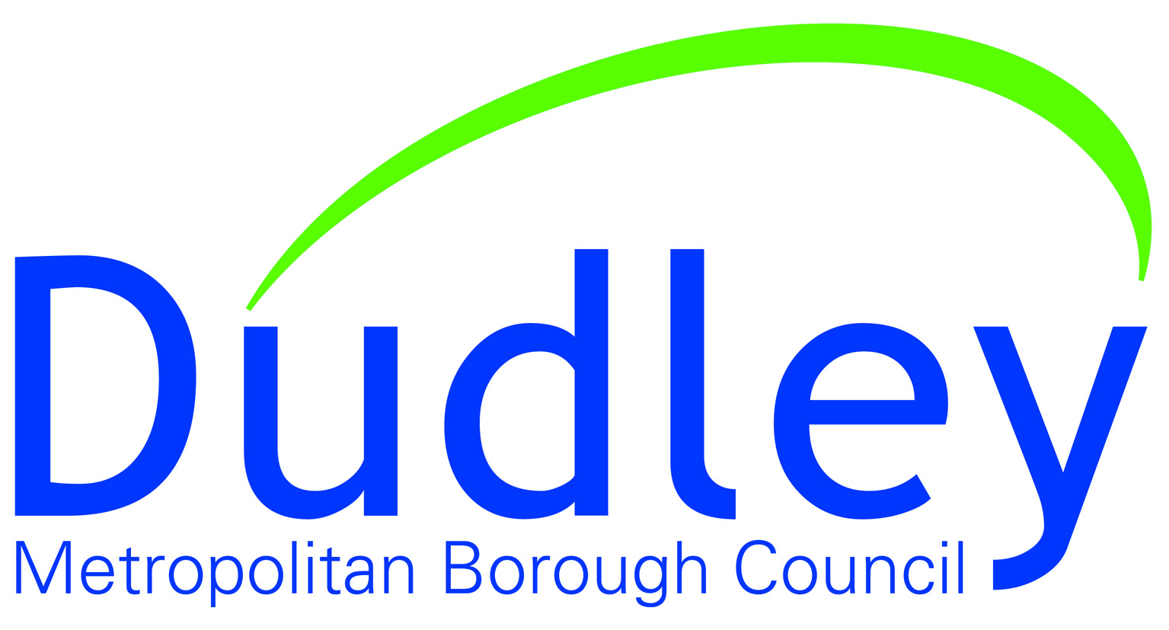
Our ref: | Service: | Direct Line: |  | Date:
 | Children’s Services | 01384 813200 |  | Enter Date

Dear Parent/Carer

My name is (ADD SOCIAL WORKERS NAME), I am a Social Worker for Dudley Metropolitan Borough Council. A Social Worker’s job is to look at what is working well in your family and, what we may need to be worried about and how we can support to keep your child/children safe and help them to reach their full potential.

I work at Children’s Services, Corbyn Road, Dudley DY1 2JZ and my telephone number is (ADD NUMBER).

My manager is called (ADD TM’s NAME) and they can be contacted on (ADD TELEPHONE NUMBER).

As I work with families in their own homes, I am not always in the office. If I am not available and you need to speak to a Social Worker, a duty worker is always available 9am to 5pm Monday to Friday on 01384 813 200, or in an emergency outside of these times, on 0300 555 8574.

Please do not hesitate to contact me should you have any questions regarding the current involvement and assessment process.

Thank you

