Directorate of People Services  Corbyn Road, Russells Hall, Dudley,  West Midlands, DY1 2JZ  Tel: (01384) 813200 Fax: (01384) 813201 |  |  | 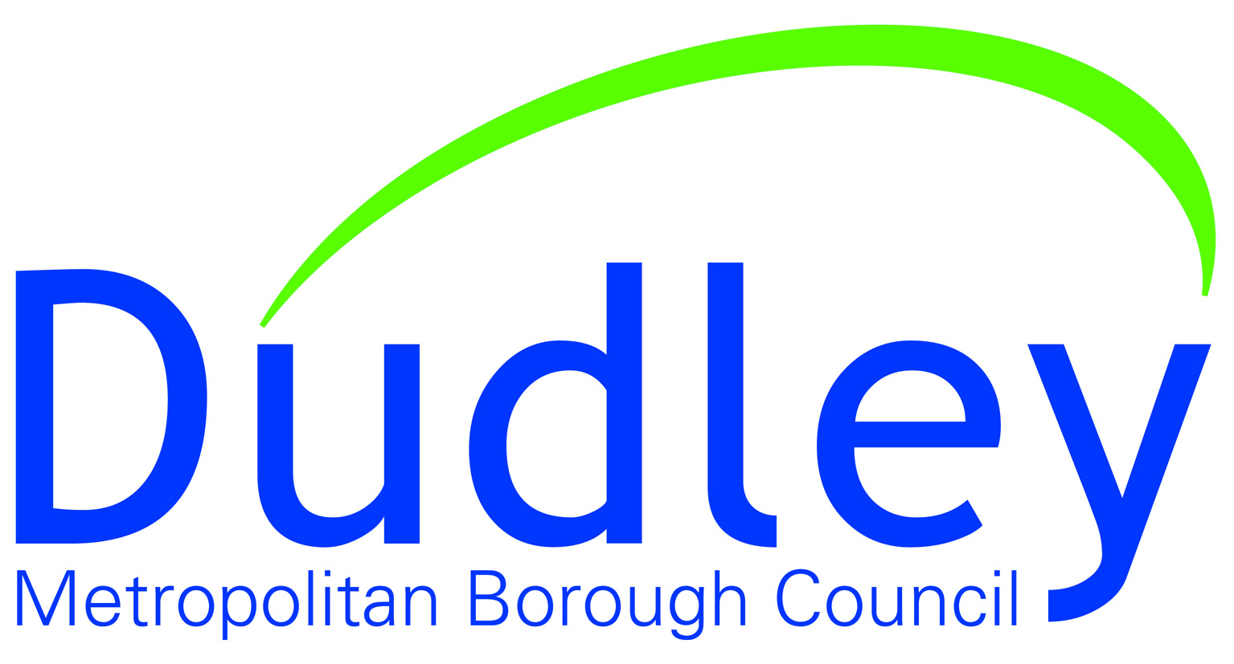
Our ref: | Service: | Direct Line: |  | Date:
 | Children’s Services | 01384 813200 |  | Enter Date

My name is (ADD SOCIAL WORKERS NAME), I am a Social Worker for Dudley Metropolitan Borough Council. A Social Worker’s job is to look at what is working well in your family, what we may need to be worried about and how we can support you stay safe, be happy and be the best that you can be.

I work at Children’s Services, Corbyn Road, Dudley DY1 2JZ and my telephone number is (ADD NUMBER).

My manager is called (ADD TM’s NAME) and they can be contacted on (ADD TELEPHONE NUMBER).

I am your Social Worker and this means that I will visit you, talk about important things with you and will listen to what you think and I will make sure that I write your wishes and feelings down in our records. You will be able to ask me questions and we will be able to work together to make sure you stay safe and happy.

As I work with families in their own homes, I am not always in the office. If I am not available and you need to speak to a Social Worker, a duty worker is always available 9am to 5pm Monday to Friday on (ADD OFFICE NUMBER), or in an emergency outside of these times, on 0300 555 8574.

Thank you

