Rose’s Happy Jar

What do you like best about yourself

What helps you feel calm

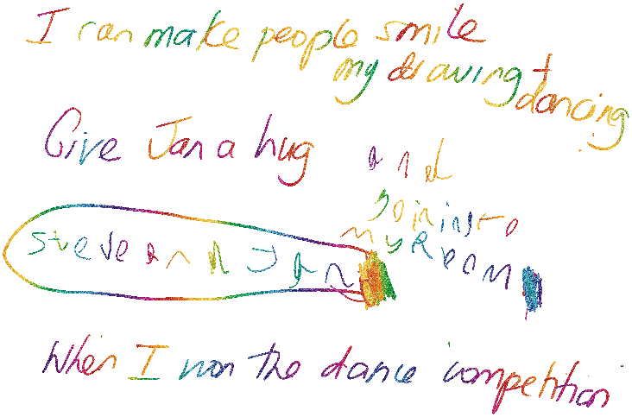What makes you happy/smile

What is your best memory

Who is an important person in your life/friend