Private Fostering

Contents
Private Fostering Introduction 2
Starting Private Fostering Pathway 2
Private Fostering Pathway Navigation 4
Private Fostering – Seven Working Day Report 5
Private Fostering – Reg 8 Visit 5
Attaching Private Fostering Documents 6
PFAAR (Private Fostering Arrangement Assessment Record) 7
Private Fostering End 8
Agreements to be signed 9

Private Fostering Introduction
The following guide will inform you as to how the Private Fostering Pathway can be triggered, how to complete the required tasks and how to end the Private Fostering when the time comes.

However, once you have triggered the Private Fostering Pathway there is a set order to which tasks need to be completed which is as follows:
- Trigger/Start the Private Fostering Pathway
- Complete the Seven Working Day Report (this is a form with the PF Pathway)
- Complete the PFAAR (this is a form with the PF Pathway)
- The Complete Reg 8 Visits (this is a form with the PF Pathway) within the correct timescales (6 weekly during the first year, 12 weekly there-after)
- Review the Private Fostering Arrangement when necessary
- End the Private Fostering Pathway when the time comes
- Get the relevant agreements signed when required

Starting Private Fostering Pathway

Private Fostering can be started in three ways;
- As the outcome of a Referral form
- As the outcome of a Single Assessment
- Started manually from the main Pathway

To start Private Fostering manually;
- Go into the Main Pathway and click on Full Map
- Click on the box entitled “Private Fostering”
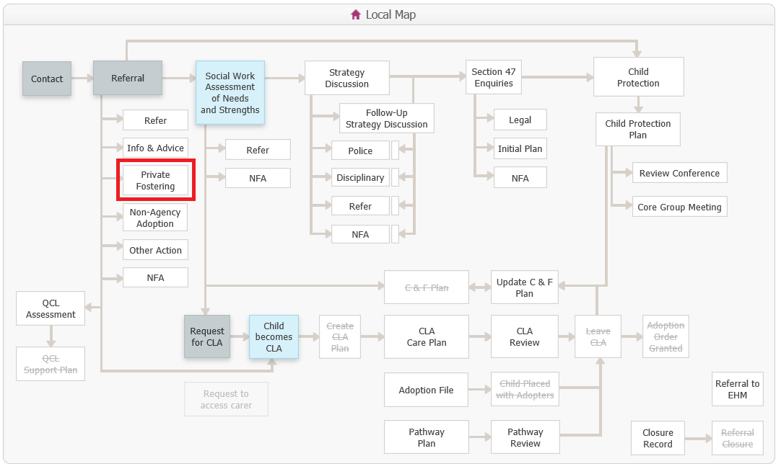

- Click on the box entitled “Private Fostering Agreement”
- Enter today’s date or a retrospective date
- Click “Start this Step”
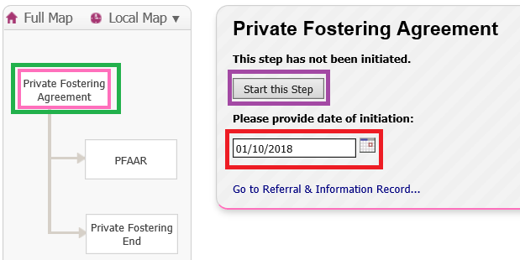

- Enter a “Private Fostering Notification Date”
- Enter a “Proposed Start Date”
- Then Click “Add Carer” to choose the relevant person from Liquidlogic (the person who is going to be the Private Fosterer).
- Click “Add Carer” again if you need to add a second Private Foster carer
- Click “Create Record”
NOTE: The adults that you select must have a case created in Liquidlogic – but they do not have to be set up as registered carers.
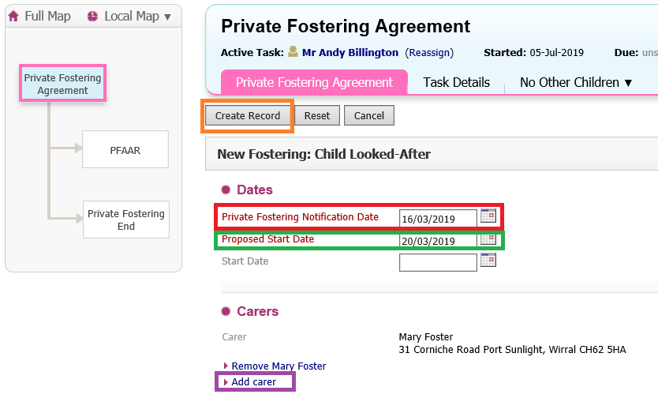

The Record will now have a “BPF” flag to indicate that it is “Becoming Private Fostering”

Private Fostering Pathway Navigation

There are two main tabs to click on within the Private Fostering pathway that will allow the Social Worker to complete different aspects of Private Fostering work.

When you are in the Private Fostering Pathway, you need to ensure that you are clicked on the “Private Fostering Agreement” box:

To kick off stand alone forms, or to add Private Fostering case notes - ensure you are clicked on the “Private Fostering Agreement” tab and highlighted below:
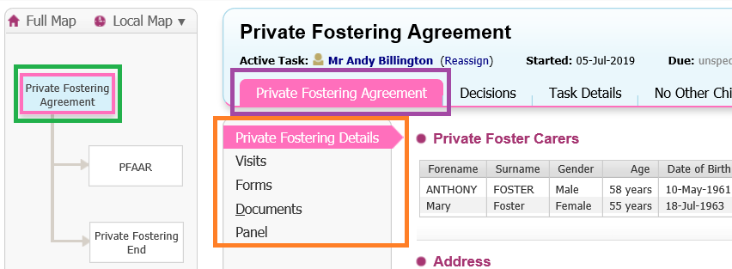

If you want to trigger one of the other two Pathway Steps (PFAAR or Private Fostering End) then make sure you have clicked on the “Private Fostering Agreement” box:
Then click on the “Decisions” tab
Click “Start” next to the required option
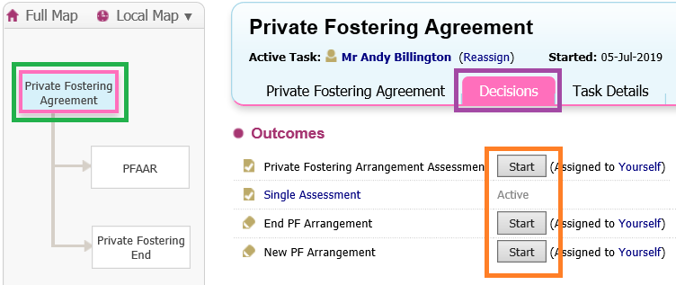

Private Fostering – Seven Working Day Report
This is a stand-alone form and after you have started the Private Fostering, this should be the form that you trigger first.
To trigger the Private Fostering – Seven Working Day Report:
- Go into the Private Fostering Pathway
- Click on the “Private Fostering Agreement” box
- Click on the “Private Fostering Agreement” tab
- Click on “Forms”
- Choose “Private Fostering – Seven Working Day Report”
- Click “Start”
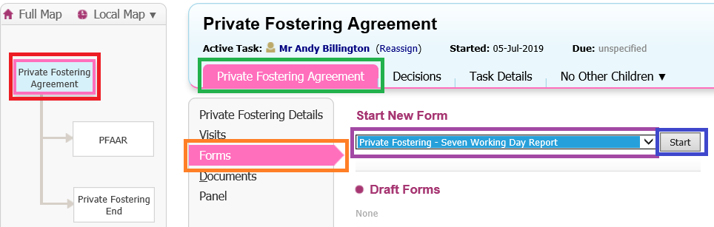

Private Fostering – Reg 8 Visit
This is a stand-alone form that should be started when you need to record a Reg 8 Visit.
To trigger the Private Fostering – Reg 8 Visit:
- Go into the Private Fostering Pathway
- Click on the “Private Fostering Agreement” box
- Click on the “Private Fostering Agreement” tab
- Click on “Forms”
- Choose “Private Fostering – Reg 8 Visit”
- Click “Start”
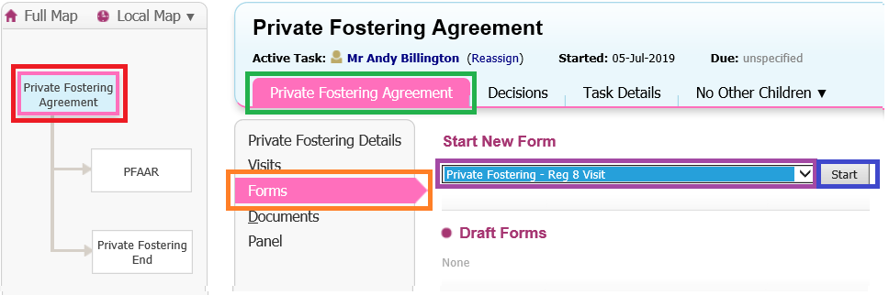
Once the form has been completed click “Finalise” and the form will be sent to your Manager to be checked and authorised.

Attaching Private Fostering Documents
- Go into the Private Fostering Pathway
- Click on the “Private Fostering Agreement” box
- Click on the “Private Fostering Agreement” tab
- Click on “Documents”
- Click “Create/Attach Documents”
- Follow the process (the document you wish to attach must be saved into a drive on your computer before this process is started).
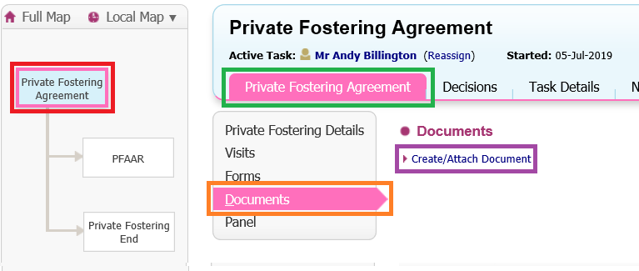

PFAAR (Private Fostering Arrangement Assessment Record)
- Go into the Private Fostering Pathway
- Click on the “Private Fostering Agreement” box
- Click on the “Decisions” tab
- Click “Start” next to the “Private Fostering Arrangement Assessment” option
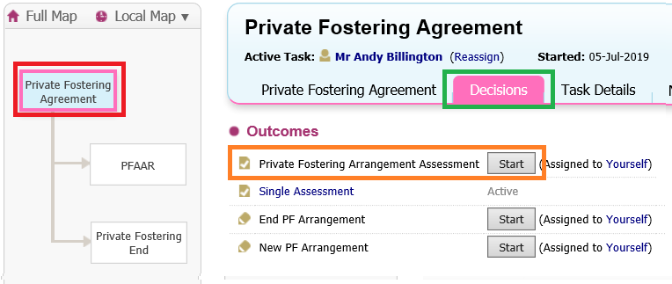
- Enter a start date
- Click “Confirm”
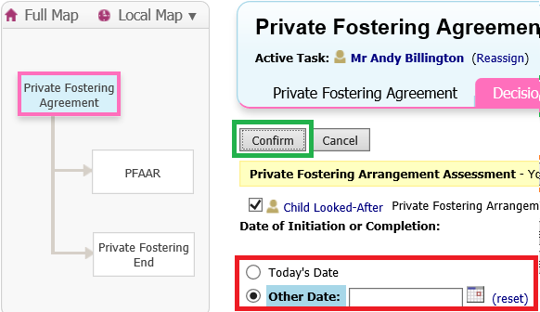
The PFAAR Box within the Private Fostering pathway will have turned blue, indicating that the task is active – this means that you will now have the task sitting in your task tray as well.

To start the form either click on the new task description in your task tray or:
- Click on the “PFAAR” box
- Click on the link that reads “Private Fostering Arrangement Assessment”
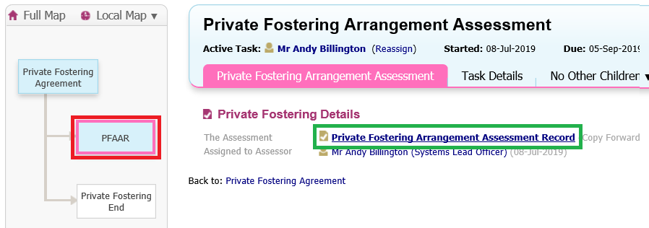
Once the form has been completed click “Finalise” and the form will be sent to your Manager to be checked and authorised.

Private Fostering End
- Go into the Private Fostering Pathway
- Click on the “Private Fostering Agreement” box
- Click on the “Decisions” tab
- Click “Start” next to the “End PF Arrangement” option
NOTE: The “End PF Arrangement” option will not be available if the PFAAR is still active.
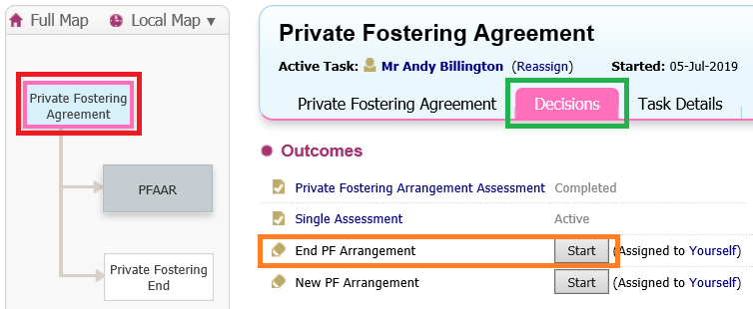
Once the form has been completed click “Finalise” and the form will be sent to your Manager to be checked and authorised.

Agreements to be signed
There are three types of Agreement forms:
- Notification to Private Foster
- Private Foster Carers Delegated Authority
- Private Fostering Placement Agreement
Having the agreement available within Liquidlogic means that when you need to print off an agreement to be signed, the agreement will already contain the relevant names and addresses.
To print off an agreement:
- Go into the Private Fostering Pathway
- Click on the “Private Fostering Agreement” box
- Click on the “Private Fostering Agreement” tab
- Click on “Documents”
- Click “Create/Attach Document
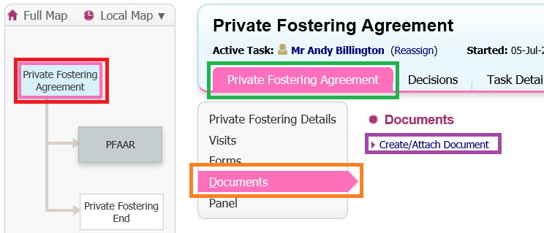
- From Category choose “Private Fostering”
- From Type choose the agreement that you need
- Click “Finish”
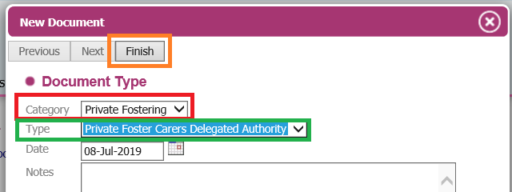

- Click “Download Document” to open the Agreement in Word (you can then print it off or save it to a folder)
- Click “Complete Document” once you have saved or printed off the agreement to remove the task from your task tray
