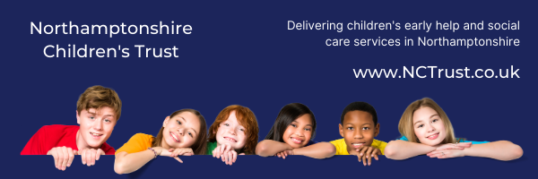
Learning from Audits
6 Step Briefing
Title of audit - date completed
Thematic Peer Audit – Young Parents (u18)
Sept/Oct 2020

Context / reason for audit
Serious Case Review findings – Child Ak

Young people who are also parents must still be considered in their own right by services

What’s working well?
- In almost all cases it is evident that the needs of the young person were considered in their own right, distinct from consideration of them as a parent; this is a significant improvement of practice following Child Ak’s SCR findings and has been reported back to NSCP
- Two records of the 14 audited were good; this has been fed back to the workers and their managers to build on this practice in the wider team / service
- Most records evidenced multi-agency involvement in assessment of the parenting capacity of the young person; this means that we engaged partners to offer appropriate support for the young parent
- Voice of the Child was captured well in young parents’ records
- Effective management oversight was evidenced through authorisation of plans and day-to-day oversight
- Almost all audits were completed side-by-side with SWs

Worries
- Chronologies were not kept up-to-date; the impact of this is that significant events are less apparent when constructing plans for the young person / parent
- Genograms not kept up-to-date; the impact of this could mean full details of wider support networks or risky relationships do not inform on-going work / future assessments
- Formal supervision is not as evident as required; whilst workers can talk about their managers being supportive, if this is not recorded into the child’s record, evidence of this guidance is not accessible for external review
- Direct work and Voice of the Child was reflected in Case Observations, but this was less well evidenced in young parents’ CareStore records
- SOS was not sufficiently utilised in case work reviewed; this means that the practice framework is not used to its fullest capacity to support young people to be the best parents they can be

What needs to happen? Agreed actions
Ensure all children and young people’s records have an up-to-date chronology and genogram in line with the Brilliant Basics Action Plan; this will support more effective assessment and care planning to achieve better outcomes for young people

Bring case supervision in line with NCT policy to ensure every child’s record has an up-to-date SOS compliant supervision. Amendments have been approved for new supervision procedures and guidance and the refreshed framework will support evidence of management oversight and impact arising from regular reflective supervision

Encourage practitioners conduct direct work with all children and young people and this is seen on the child’s record. Item for discussion / sharing at Team Meetings

Ensure Practice Champions have the opportunity to attend bite-sized training offers and have capacity within their workload to support colleagues

Good practice

Two cases evidenced that SOS was used well; these records have been shared with our SOS Lead Practitioner so elements can be used as good practice examples. Feedback has also been given to the SWs

