***Wirral Lifelong Learning, your journey to*** *employment, volunteering or further learning starts here…*



**Employability**

**All learners complete an assessment for placement into correct level – call 07789 922542 or email: lifelonglearning@wirral.gov.uk**

[](http://developmentcrossroads.com/wp-content/uploads/2011/09/whatsnext_logo.jpg)

**Progression Options**

Change Up*

Social Care Short Course*

Meditation to Improve Lifeskills, Relaxation & Interviews*

Preparing for Interviews*

Food Safety

Universal Credit Support

Intro to Social Care*

Confidence Skills

Working from Home (the right way)*

1st Steps to: Retail, Office Work, Customer Service*

Sports Coaching*

Employment

Volunteering

Catering and Hospitality

L2 Supporting Teaching & Learning in Schools

BSL up to L4

SIA Licence

CSCS Card

English

Introduction to Retail Skills*

BSL for Work and Volunteering

Teaching Assistant L1

Working in Business Admin*

IT

Working in a Customer Friendly Way*

Careers in Business Admin*

Progression to Wirral Met

Maths

Introduction to Retail*

CSCS Card: L1 H&S in Construction*

Working with Children (short course)*

*Indicates Partner Provision



 For timetable information

“I’ve really enjoyed the TA course and loved the mix of practical and theory. It’s been a great experience and I’ve learnt so much.”

**Case Study:**

**Catering at TRFC**

**including Food Safety Level 2**

‘We recently attended a course offered to us by the Club to help gain our Food Safety certificates. In addition to classroom work, there was a practical element where we had to identify hazards and learn about cleanliness issues in the kiosk (this was staged to aid our learning, it’s usually spotless!). Also, as part of the practical, we got to cook our own lunch of Cowshed Wirral Burgers.’

‘The facilities offered for our learning were excellent and was delivered in a professional but light-hearted manner by the Tranmere staff. We were delighted to do the course, to further our learning and gain confidence. After the course we were encouraged to become match day kiosk staff to utilise our experience in the field.’

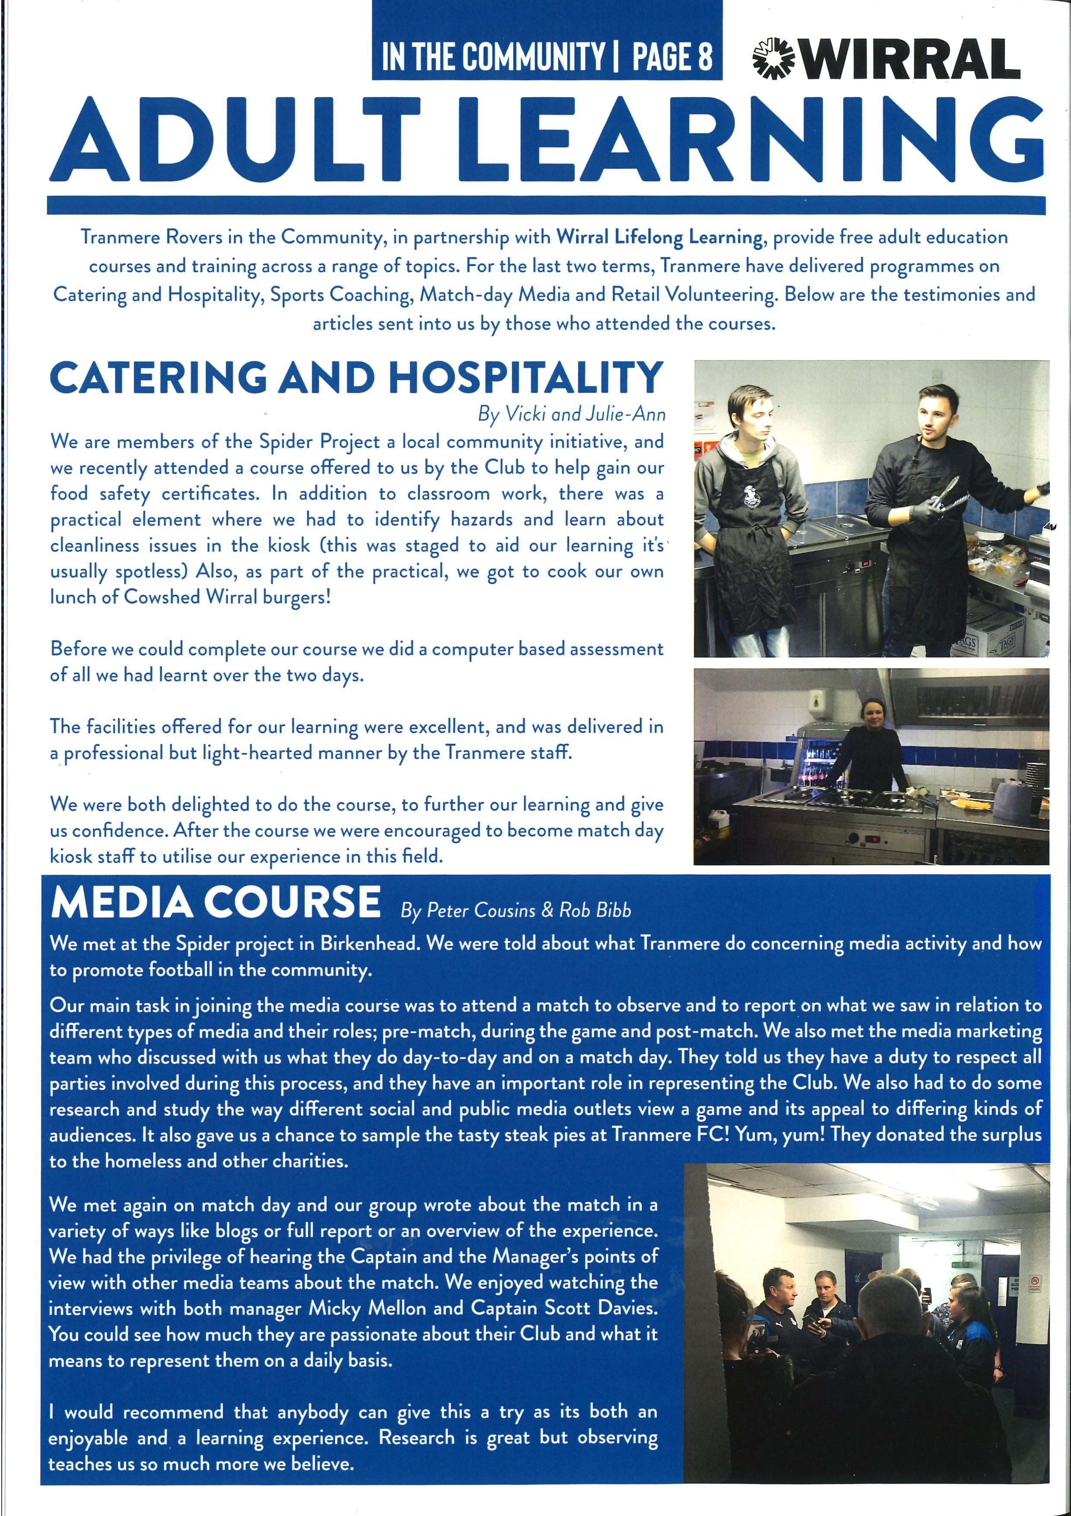

Restaurant Manager

£16,002 to £31,373

Chef

£12,739 to £19,824

Fast Food Operative

£8,218 to £15,505

**Potential Career Salaries:**