***Wirral Lifelong Learning, your journey to*** *employment, volunteering or further learning starts here…*



**English Levels: Pre Entry – Level 1 All learners complete an assessment for placement into correct level – call us 07789 922542 or email: lifelonglearning@wirral.gov.uk**

[](http://developmentcrossroads.com/wp-content/uploads/2011/09/whatsnext_logo.jpg)

**Progression Options**

RARPA:

Improve Your English

English Catch Up

Improve Your Grammar & Punctuation

Ascentis Stepping Stones

Stepping Stones Portfolio

Getting Started with Literacy

Literacy Skills Catch Up

Literacy Buddy

Progression to Wirral Met

English

Functional Skills L2

GCSE

Progression to Wirral Met

Functional Skills L1

Basic Skills Provision* (discrete provision)

QCF Units

*Indicates Partner Provision

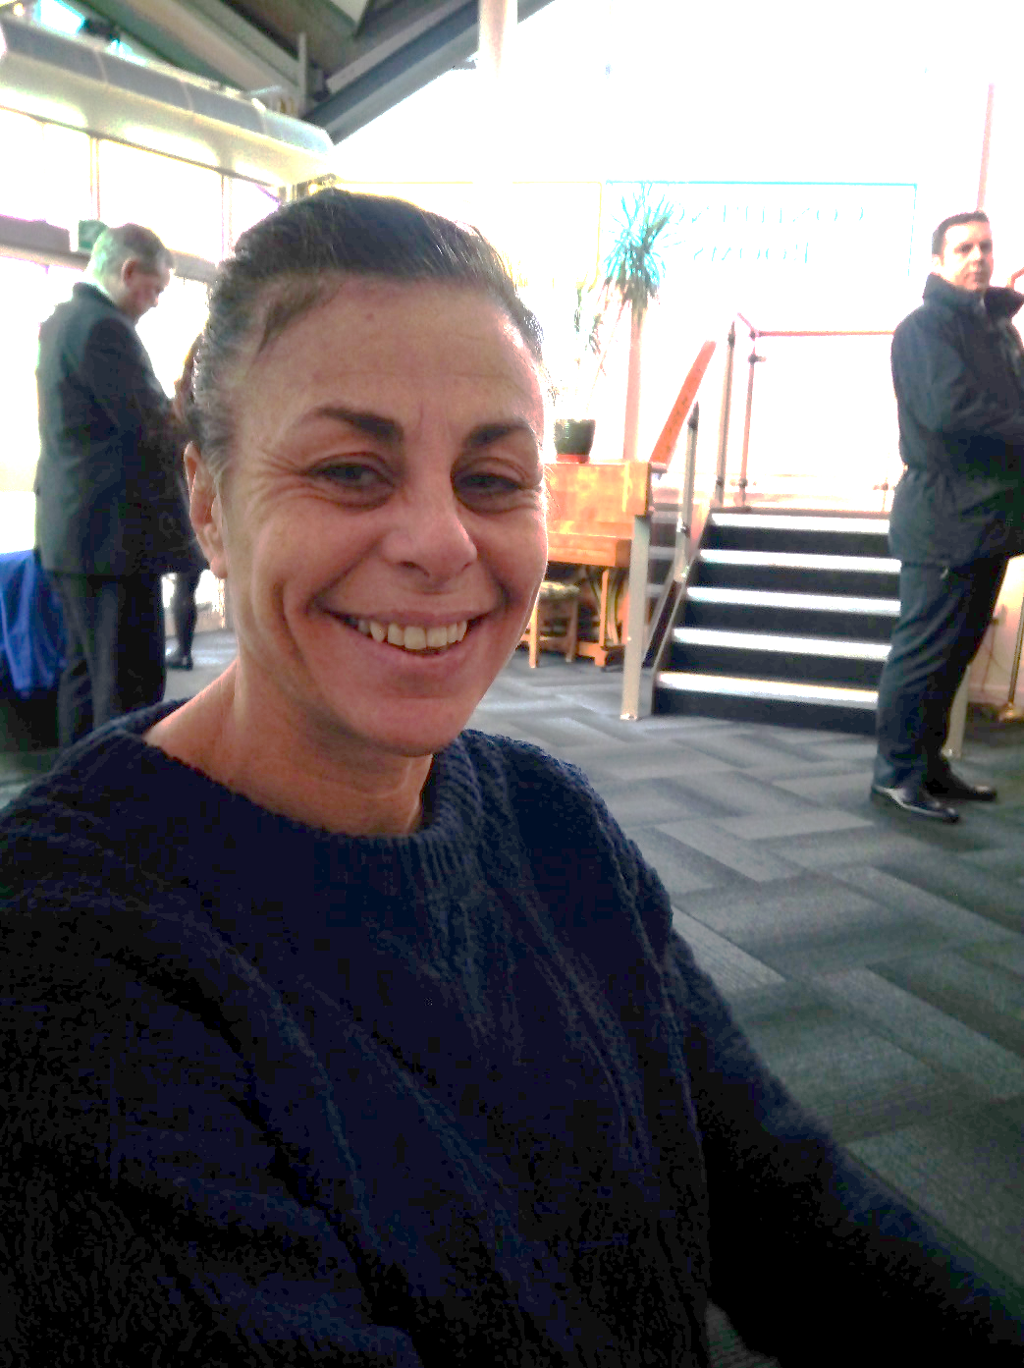

 For timetable information

“These courses allowed me to progress in learning, my mental health improved as I wasn’t stuck at home, it gave me motivation and confidence to go back to the workplace.”

**Case Study**

 Debbie started with us in 2016 to improve her English and maths. “I knew I was behind, I wanted to get a job and knew I would have to improve my English & Maths to get one. The first time I came in I was nervous as I didn’t know anyone and I struggle with anxiety. I came back because I realised it would help me as a person as well as getting qualifications.”

“At the time I thought the other people in the class were better than me but now I’m a lot higher than them because I carried on going, I didn’t give up. I started off at E2 and now I’m working towards L2 English. When I’ve done all that I’ll be looking for a job, even part time would get me going and get me back on track. It’s been great for me.”

English E2, E3, L1

Computer Operator

£14,000- £50,000

Office Assistant

£13,000 - £23,000

Shop Assistant

£10,000 - £18,000

