***Wirral Lifelong Learning, your journey to*** *employment, volunteering or further learning starts here…*



**ESOL – English for Speakers of other Languages Levels Pre-Entry – Level 1 All learners complete an assessment for placement into correct level – call us: 07789 922542 or email: lifelonglearning@wirral.gov.uk**

[](http://developmentcrossroads.com/wp-content/uploads/2011/09/whatsnext_logo.jpg)

Sewing Cooking Gardening Driving

Food Safety Qualification Volunteer Qualification

First Aid

Intensive 1:1

Blended Learning

Teaching Assistant

Community Interpreting

Intensive Small Group

**Employment Gateway**

Assessment IA/DA

Taster workshops

Plus

Pre Vocational ESOL contextualised to employment pathways includes key vocabulary and work readiness for employment /types of job

Working as a Gardener

Working with Children

**Progression Options**

RARPA:

Intro to Citizenship, Speaking and Listening, Reading Skills, Writing Skills, Family Phonics, Intro to Story Sacks, Working with Children’s Numeracy, ESOL Catch Up, ESOL Fast-track, ESOL Digital Skills

Progression to Wirral Met Community Volunteering

MEAS volunteer

ESOL Buddy

Employment

AEB provision Level 2 qualifications

Employability Progression Units

Progression to Wirral Met

Getting Started

Reading & Conversation

Health and Social Care

ESOL Quals

Pre Entry-L1, Intro to Social Care

 For timetable information

to

“Speaking English is very important if you live here.”

**Case Study:**

ESOL Entry 3

Tabitha arrived in the UK from Brazil in July 2018. She started ESOL classes in the December to help improve her English partly in preparation for her visa test. She told us, “My classmates are very friendly the teacher is very good and I have learned more and more English - it helps me so much.”

We asked Tabitha what she hopes to do next. She told us, “I would like to get a paid job, I was a registered psychologist in Brazil. I want to do the next level and I want to take some classes to develop my skills for a job.” Tabitha is making great progress:

“I have started to work as a volunteer with Barnardos and this course helps me to do that. I have to speak English all the time there. Listening is easier than speaking and listening to the TV is easier than talking to people in the street. If you come to this course, this is a place where you will meet people from all over the world, and we all improve our English together, I like this class.”

“If you come to this course, this is a place where you will meet people from all over the world, and we all improve our English together, I like this class. “

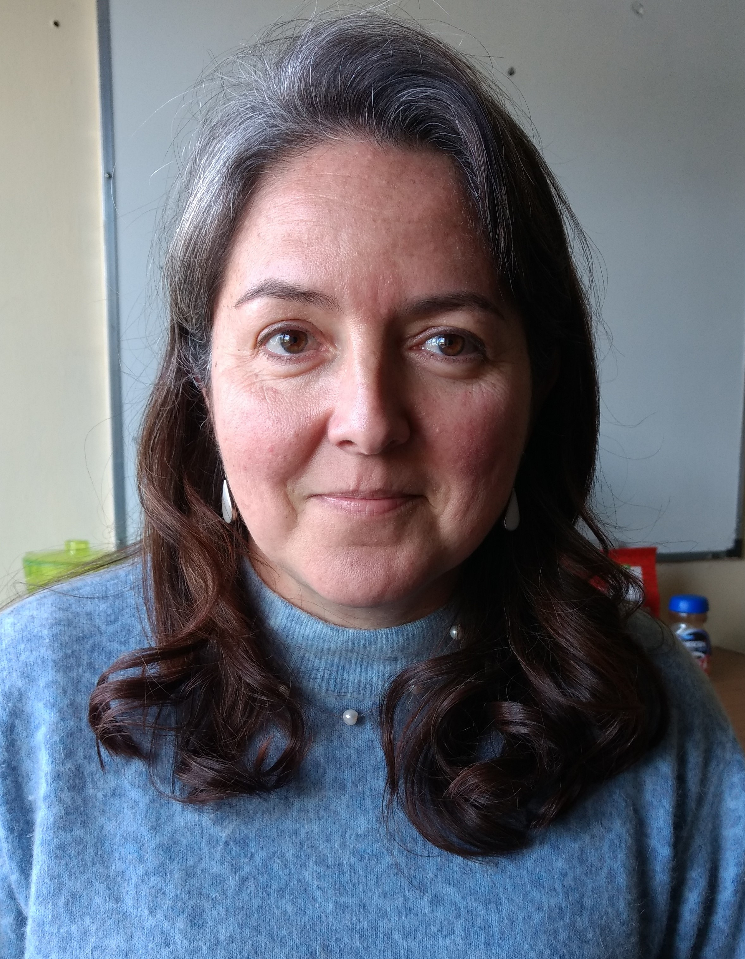

Chef

£12,739 to £19,824

Gardening Nursery Assistant

£13,000-£19,000

Bus Driver

£15,000- £18,700

**Potential Career Salaries:**