Wirral Lifelong Learning, your journey to employment, volunteering or further learning starts here…

Family Learning – some classes are just for parents, other classes focus on the parents in the first hour, second hour includes the children – call us: 07789 922542 or email: lifelonglearning@wirral.gov.uk



English Keeping Up with Your Child’s Literacy Story Sacks Level 1 Family Phonics Book Club, Read With Me, Intro to Family Coaching Skills

Progression Options
Supporting Learning- Parents Only
Employment
Volunteering
English & Maths
L2 Supporting Teaching & Learning in Schools
Further Education
Taster Workshops
Story Telling Talking About Money Grandparents’ Day Christmas Crafts
Times tables/Multiplication Pattern & Symmetry 2D & 3D Shapes Position & Direction Time Area & Perimeter Measures Angles Money Decimals &Percentages Place Value Fractions Negative Numbers
Space & Rockets Plants Living & Growing Food Chains Eco-Families World Earth Day
Healthy Snacks/Lunchboxes Food & Mood Health Improvement Understanding Mental Health
Special Event Days Chinese New Year Ramadan & Eid Diwali Polish
Cook and Taste Tastes of the World

Volunteering Course

IT Keeping Your Child Safe Online Family ICT Easy Steps in Computers
Learning Champions
Maths Keeping Up with Your Child’s Numeracy Lego & Domino Maths Budgeting Skills & Family Finance

Progression to Wirral Met
Teaching Assistant L1

ESOL Story Sacks Family Phonics, Working with Children, Numeracy, Support Child Learning at School

Supporting English and Maths L1

Peer Mentoring L2
Health &Wellbeing Health Improvement Food Safety & Hygiene L2

 For timetable information
“I enjoyed the atmosphere and learning how literacy skills can be practiced at home.”
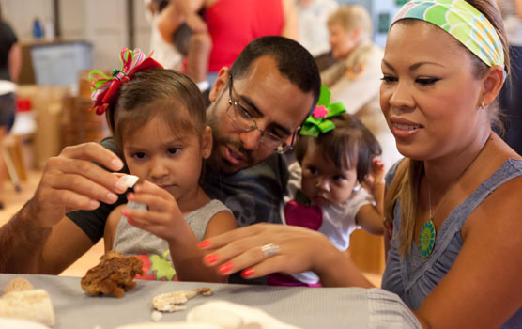

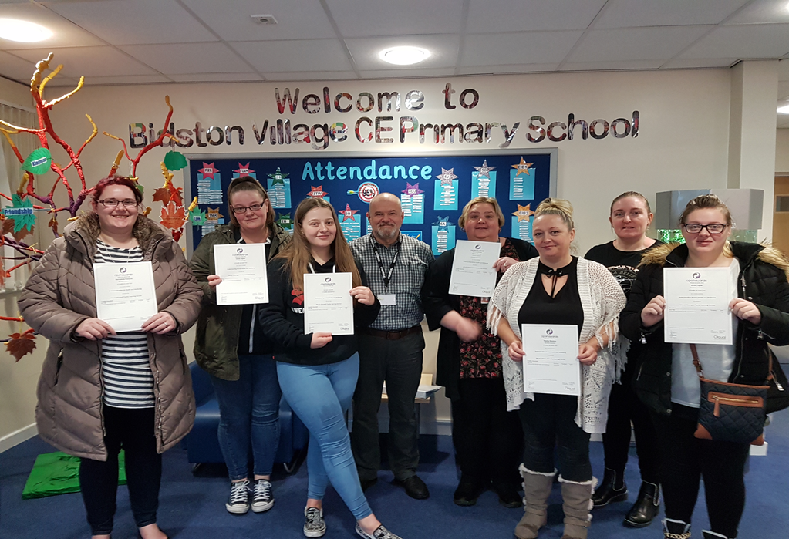
Case Study
The Bidston Village parents’ group started with a short 2hr Family Learning workshop in Healthy Eating. They decided that they wanted to go on and learn more together as a group. They completed a Food Hygiene Certificate – which was useful on their CV’s, for working as a volunteers and paid staff in the school on occasions, and then completed Level 2 Peer Mentoring, Level 2 Mental Health Awareness and Wellbeing and Level 1 Becoming a Teaching Assistant.
“We’re aware of all the information about health and lifestyle choices but we’d like to study it and understand what’s going on – because it will make a real impact on each one of us individually, and our children and families.”

Peer Mentoring
Level 2
Higher Level TA

£17,000 - £24,000
Education Mentor

£12,000- £18,000
Teaching Assistant

£13,500

Potential Career Salaries:

