***Wirral Lifelong Learning, your journey to*** *employment, volunteering or further learning starts here…*



**Information Technology Levels: Complete Beginners – Level 1**

**All learners complete an assessment for placement on to the correct course – call us: 07789 922542 or e mail: lifelonglearning@wirral.gov.uk**

[](http://developmentcrossroads.com/wp-content/uploads/2011/09/whatsnext_logo.jpg)

**Progression Options**

E Safety for Foster Carers

English

Maths

Employment Pathways

FS ICT L2

Keeping Your Child Safe Online

Prepare for Online Interviews

IT for Work; Skills Check

Monitoring Your Child Via Phone Apps

Easy Steps 5 weeks

Getting the most out of Microsoft Office

Progression to Wirral Met

Intro to Internet 5 weeks

Functional Skills ICT Level 1 10 weeks

Intro to Microsoft Office 5 weeks

Using Microsoft Office 5 weeks

For timetable information

“To me personally these computer courses have really helped and enabled me to achieve my goal of changing career.”

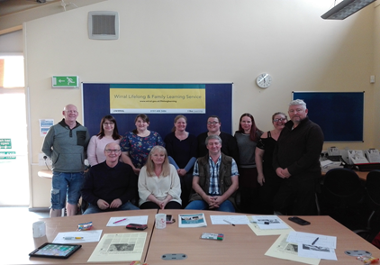**Case Study**

 “This training course is a must for all Foster Carers. The syllabus covers all aspects of children’s safety with regards to internet security. We were taught so much about the internet, and just how much of a mind-field it can be when it comes to safety and safeguarding the children in our care.

“The course opened our eyes to what is happening in the world and what risks our children may be taking in all innocence. It has made us more vigilant when they are using their electronics ... Stay Safe!”

E Safety for Foster Carers

Systems Analyst

£20,000 to £62,000

Tech Support Officer

£16,000 to £35,000

Computer Operator

£14,000- £50,000

**Potential Career Salaries**: