Wirral Lifelong Learning, your journey to employment, volunteering or further learning starts here…
Mental Health
All learners complete an assessment for placement into correct course – call us: 07789 922542 or e mail: lifelonglearning@wirral.gov.uk 666 3330

*Indicates Partner Provision
Progression Options
Meditation to Improve Life Skills, Aid Relaxation & Help with Interviews*
Way 2 Building Resilience in Challenging Times*

Choose curriculum pathway: English/Maths/IT
This is me*
Mental Health Awareness*
Food and Mood*
Resilience*
Emotional Resilience*
Family and Nutrition*
5 Ways to Holistic Mental Wellbeing & Resilience taster*

Wellbeing Resilience & MH Awareness*

Managing Stress & Anxiety*

Safeguarding

Employment
Further Learning
Counselling L2
Progression to Wirral Met
Confidence Masterclass*
Intro to Understanding Your Child’s Mental Wellbeing*
Peer Mentoring
Intro to Psychology for Wellbeing*

Intro to 5 ways to Holistic Mental Wellbeing & Resilience*

Improvement to Mental Health & Wellbeing*

Volunteering
Volunteering
Volunteering & Community Projects for People Living with Social Anxiety Disorders*

Wellness Recovery: Steps to Work*

Wellness Education*

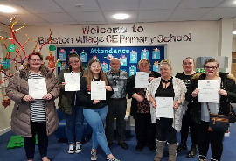

“For us it’s about learning and studying so we can make informed decisions, rather than just listen to the latest fad and fashion.”

Case Study
“When I started the course, I suddenly knew I wasn’t the only mother who has anxiety, panic attacks and depression. The teachers really understand me, and the stigma attached to mental health.
After my courses it was suggested I could volunteer which I did 3 days a week in the Claughton shop. I really look forward to going, it’s given me confidence.

“Next I hope to volunteer in my daughter's school and work towards becoming a Teaching Assistant. It’ll be great, another way of moving myself forward.

“My mental health was stopping me getting out and affecting my children, doing the courses has helped me get a better life for me, my husband and my children.”

Food and Mood
Counsellor

£16,002 to £31,373

Learning Mentor

£14,000 to £30,000

Care Assistant

£14,000 - £17,000

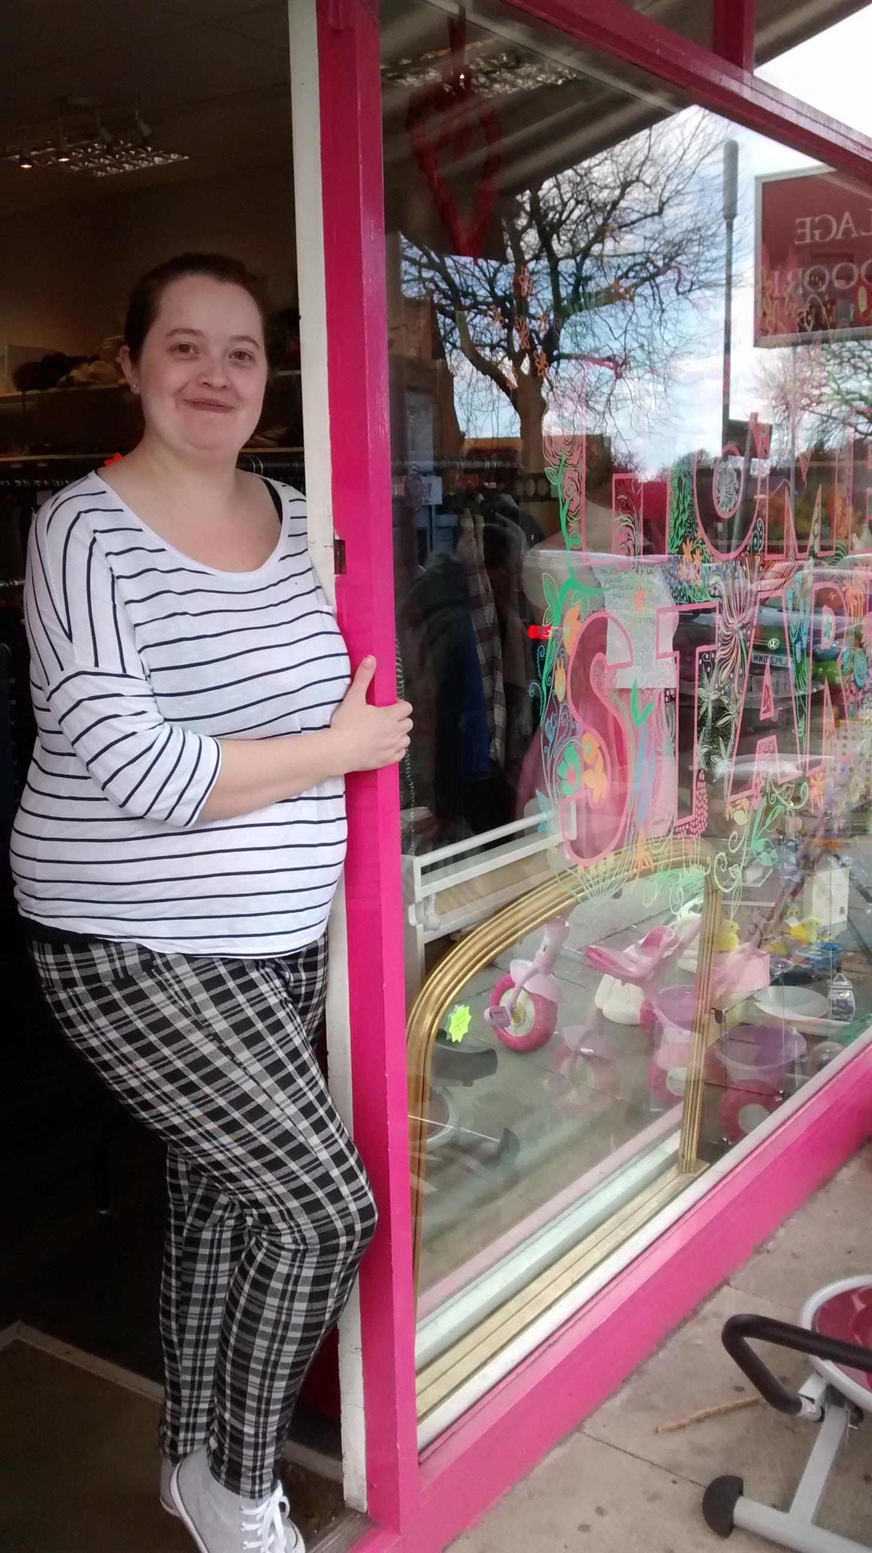

Potential Career Salaries:

