***Wirral Lifelong Learning, your journey to*** *employment, volunteering or further learning starts here…*



**Sewing Levels: Beginner – Level 2**

**All learners complete an assessment for placement into correct level – call us: 07789 922542 or e mail: lifelonglearning@wirral.gov.uk**

[](http://developmentcrossroads.com/wp-content/uploads/2011/09/whatsnext_logo.jpg)

Basic Design and Mood Boards

**Progression Options**

Industrial Sewing

Self Employment

Liverpool Community College

Industrial Machinist

Upcycling and Recycling

Intro to Sewing Techniques

Progression to Wirral Met

Sewing Techniques Level 1

Sewing Techniques Level 2

Sew Face Masks

Simple Sewing

Setting up a Sewing Machine

 For timetable information

Using an Overlocker

photo

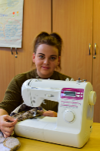

“Once I’d made my daughter’s christening dress, I knew I had the skills to make things people would want to buy.”

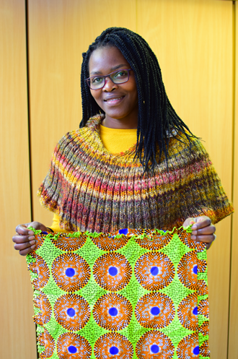**Case Study**

Sewing Skills

Level 1

 “All I did was go on the internet and look for Adult Sewing Classes on Wirral. These classes were ideal for me. The short (5 week) intro course was what I needed to get started, and once I’d met the tutor and found out how helpful and supportive she was, it was just natural to progress to do the full Level 1 qualification.”

“I now sell things via eBay and my own website, so I’m progressing each week. My aim is to develop a well-established business that enables me to earn a living from the skills I’ve learned”

“The course helped me gain a recognised qualification and has increased my confidence in my abilities.”

Direct Materials Buyer

£20,000-£30,000

Hand Alterations

£14,000 to £22,000

Clothing Machinist

£14,000- £21,000

**Potential Career Salaries**: