DASH GUIDANCE - RECRUITMENT

Summary

You are now required to complete an online DASH Business Case for any:
- New agency recruitment requests
- Agency extension requests
- New permanent recruitment requests

The request will still be reviewed at the Children’s Services HR panel which is held every week on a Wednesday.

Process

- The DASH system is accessible on the Intranet via the following link:
https://wirral-dash.achieveservice.com/

This will take you to the home screen where you can “Login” to access your “Dashboard”, “My requests” and “Services”

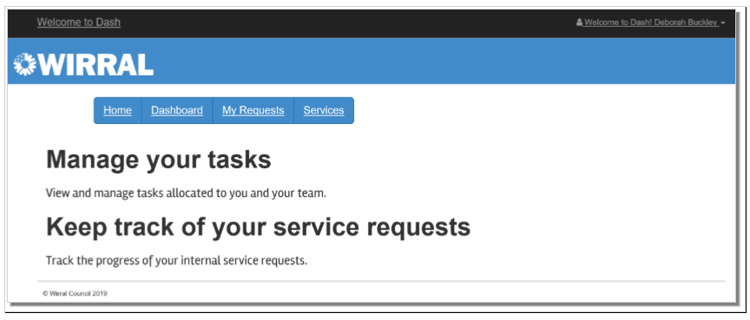

- Click on the “Services” tab and then from the “Other” Tab select “Recruitment Request Form”

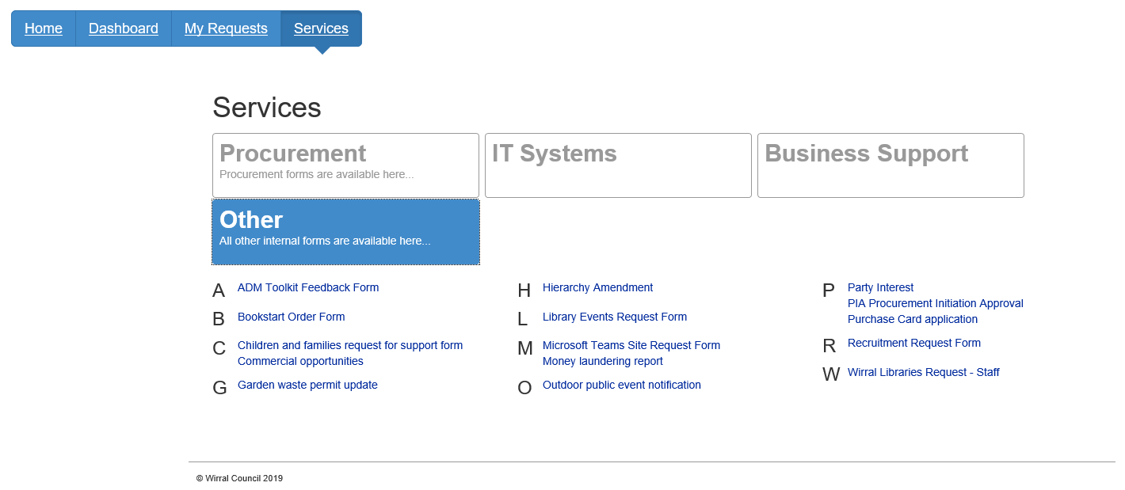

- From the drop-down selection, choose one of the following options:
- Agency – for any agency recruitment requests
- Employee – for any permanent recruitment requests

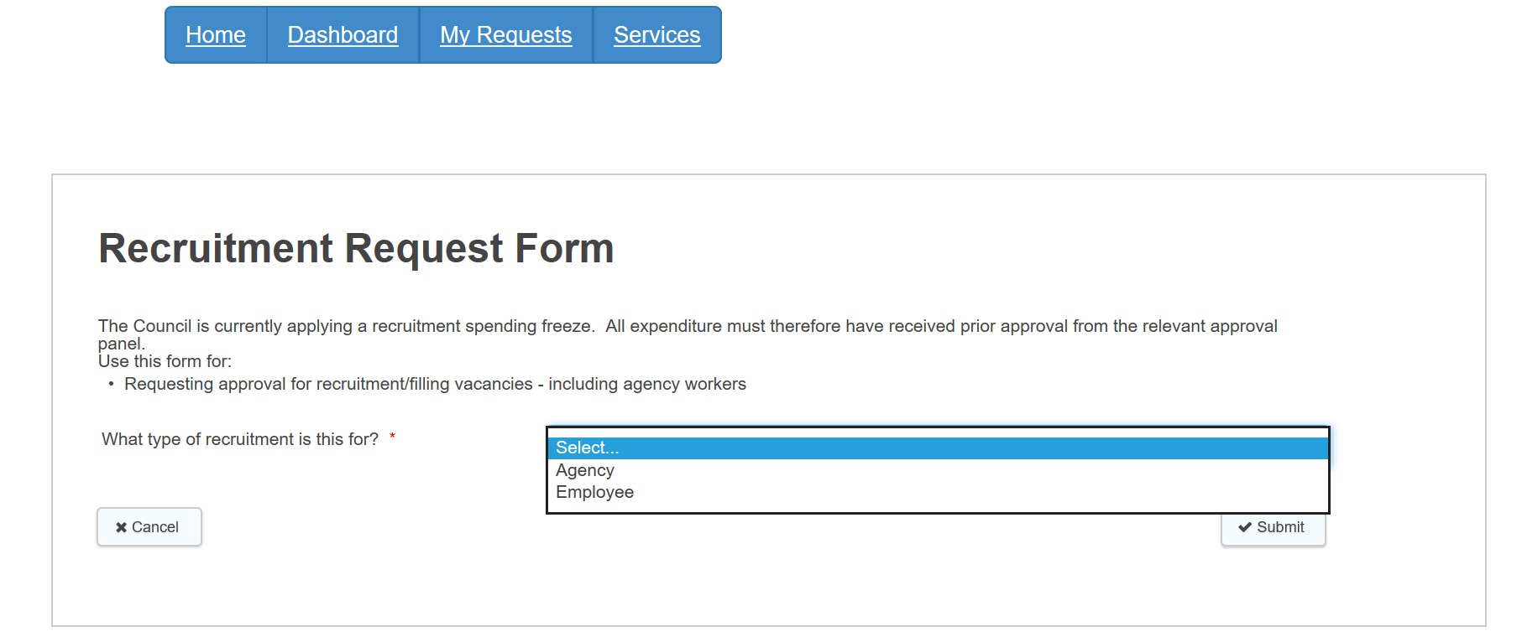

- This will produce the appropriate “Recruitment Request Form” which you can then click on to begin your business case.

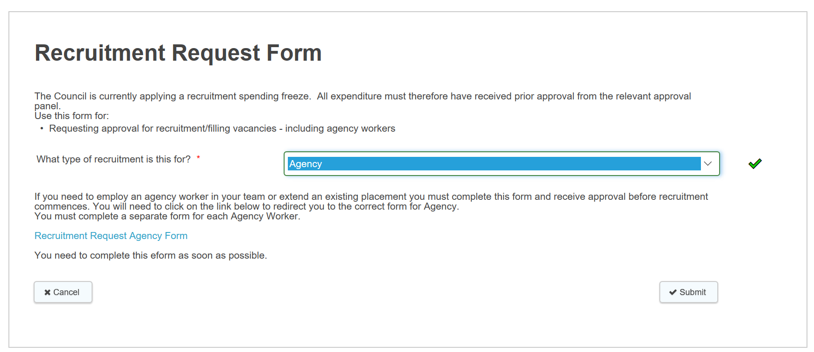

5. The online form can then be completed, and you can move through the 4 stages of the form by selecting “next” once all mandatory fields are populated. The 4 stages that require information are:

6. There are three key pieces of information required:

- COST CODE The cost code is required in order to proceed with your business case. Without this you will not be able to complete your request.
- POST NO Please ensure you have the post number before proceeding with your business case. Without this HR cannot be sure which post you are trying to fulfil.
- NAME If your business case is to extend a current agency workers placement, please ensure they are mentioned by name. Without this HR cannot be sure who you are requesting this for.

7. Once complete, you can then “submit” the form.

8. Once the form is submitted:
- if you are NOT the budget holder, the system will firstly route the business case to the budget holder for approval;
- if you ARE the budget holder; the system will route the business case to the HR, Finance and for approval at the weekly Children’s HR panel.

9. The approval panel will update the DASH system to either:
- Approve,
- Decline, OR
- Request more information.
You will receive an automated e-mail from the DASH system to notify you of the decision.

*PLEASE MAKE A NOTE OF THE BUSINESS CASE NUMBER (ref: FS-Case-xxxxxxxx) AS YOU WILL NEED IT LATER.

- If your business case has been approved:
- For agency worker requests, HR will then place the order on Matrix.
PLEASE NOTE – approvals for temporary workers will only be approved for an initial period of 12 weeks.
- For permanent worker requests, you will receive an e-mail from HR with further guidance on the next steps.

Agency Placement Extensions

If you still require the agency worker beyond the 12 weeks that was originally approved, you must submit an extension request in DASH providing reasons why the extension is needed.

Extensions can be made using the original request form (*using the same BUSINESS CASE NUMBER you made a note of), avoiding the need for you to re-key all the original information.

You can access the extension form from their ‘My Requests’ tab in DASH by searching on the original business case number.

Please ensure that the candidates name is included on any extension.

Approving Business Case requests

If you are a budget holder and are required to approve requests for recruitment of permanent or agency workers, you will receive an email requesting an approval (for budget purposes) and you can access the business case by “clicking” on the email.

Notifications and reminders

Managers receive notifications from DASH and Matrix that placements are coming to an end. It is important to submit your business case to extend the placement as soon as possible, to ensure the extension is granted in time. Failure to do so could result in issues such as the staff member not being paid, due to the placement closing.

Support and Guidance.

If you encounter any difficulties with this process, please contact:
Derry Shannon, Agency Staff Commissioning Business Partner derryshannon@wirral.gov.uk
Melissa Berry, Performance and Improvement Officer on 8049 or melissaberry@wirral.gov.uk

