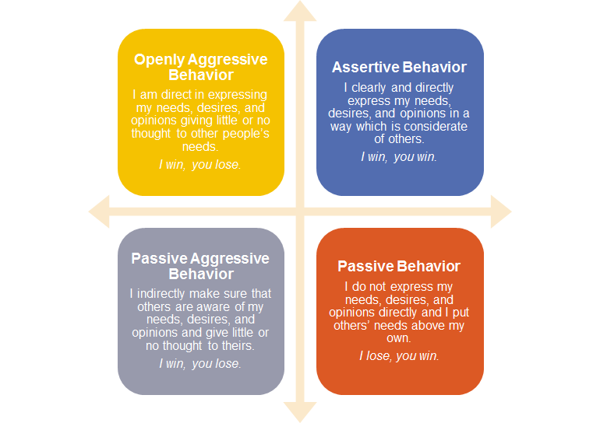

Where do you see yourself in this scenario?

What is fuelling this?
e.g – previous experience with this person, lack of confidence, physical and emotional responses, uncertain of response of SU

Where do you see the service user?

What is fuelling this?
e.g. Worries/fears/temperament/mental and physical health issues/history/SU’s expectations

How can the two interact?

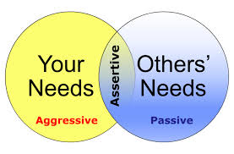

Assertiveness. How can we achieve this in this specific intervention?
We discussed the need to try and find ways of bridging the gaps and find opportunities to be in the overlapping part of the circles.

Anticipate
How you may feel - Fear/anxiety.
How the SU may feel or present.

Prepare
Purpose of the intervention.
What do I want to get out of this? Need to maintain some emotional distance.
The other person has a point of view. Need to identify ways of acknowledging his views, empathising but moving on and keeping focus. Finding a balance. Feeling comfortable that you have said what you need to say.
Statements – scripts. Use of language. I language – ownership. ‘You may disagree but this is what I need’. Posture and tone of voice – eye contact.

Rehearse
Play the words through in your head. Think through a couple of transactions – try and anticipate the response. Be mindful of statements which can inflame and these can start with ‘yes but, no but’. Say I understand acknowledge and repeat your point of view or the view you want to make.

Being Assertive. https://www.youtube.com/watch?v=ubSL1tFmgDc
How to deal with difficult people. https://www.youtube.com/watch?v=kARkOdRHaj8

