**MOSAIC User Guide for**

**Missing & Return Home Interview**

**……………………………………………………………………………………………………………………**

**Children’s Services**

Author: Annie Palmer

Version: 0.1

Date: 19/05/2020

**Contents**

Introduction 2

Missing, Return Home Interview and Intelligence Team 3

Adding a Note 3-5

Record of Missing Workstep 5-12

Return Home Interview – Workstep 13-18

**Introduction**

Complex Safeguarding Service

Two new teams have been developed and will be providing intervention and services to our Children/Young people of BCP.

The **Child Exploitation Team** will cease to exist and will be undertaking work under the two new teams below.

The two new teams are the;  
**Missing, Return Home Interviews and Intelligence Team**

and   
**The Complex Safeguarding Team**.

There is a slight change to the way this work is completed within Mosaic. Highlighted in   
this guide is the how the Missing & Return Home Interviews are now to be recorded on   
the system.

A guide for the new way of working for **The Complex Safeguarding Team** will be shown in a different guide.

**Missing, Return Home Interview and   
Intelligence Team**

When a Child is reported missing, a report is generated by the Police who will then record the notification on their electronic system and notify Children’s Social Care of this missing episode. This notification will be sent straight to the **First Response Team** (a.k.a. **MASH**) where they will enter this onto Mosaic.

This will apply to all referrals where Children and Young people are not known, or, not open to Children’s Social Care as well as for Children or Young People who are already known and allocated to a worker in one of the Childcare teams.

**So, for Children/Young People that have been previously closed, or not known to BCP on Mosaic, the following will happen;**

* **First Response Team** will create a person record on Mosaic, using all the details that have been provided by the Police, if the Child is not known on Mosaic.
* If the Child is known from a previously closed referral, the **First Response Team** will ensure all details are correct on that person. You should record and update any address changes or telephone numbers etc.
* The **First Response Team** will open a **Contact (MASH) and Referral Workstep** and will progress this in accordance with their process.   
    
  See also *MOSAIC User Guide for Creating MASH Workflow v2.0*

**Adding a Note**

The **First Response Team** (a.k.a. **MASH**) will add a Missing Person Warning **Note.**This must be added to the Person Summary screen alongside completing a **Record of Missing Workstep**.

* To add a **Note**, click on Person Details and select **Notes**

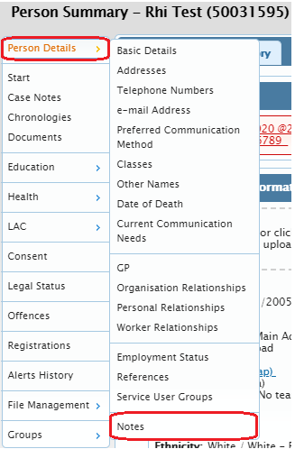

* The **Person Notes History** screen will appear. Here you will see any   
  previous **Notes** that have been recorded

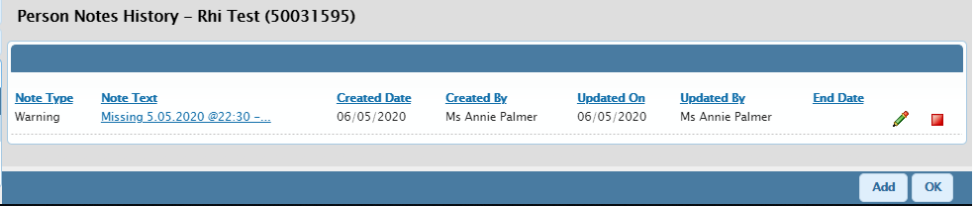

Click Add

* Click 
* You will then be presented with a screen where you can choose the type of **Note**
* Select **Warning** and add a Note in the Note field

For the Warning to display on the Person Summary screen, you will need to choose ‘Warning’

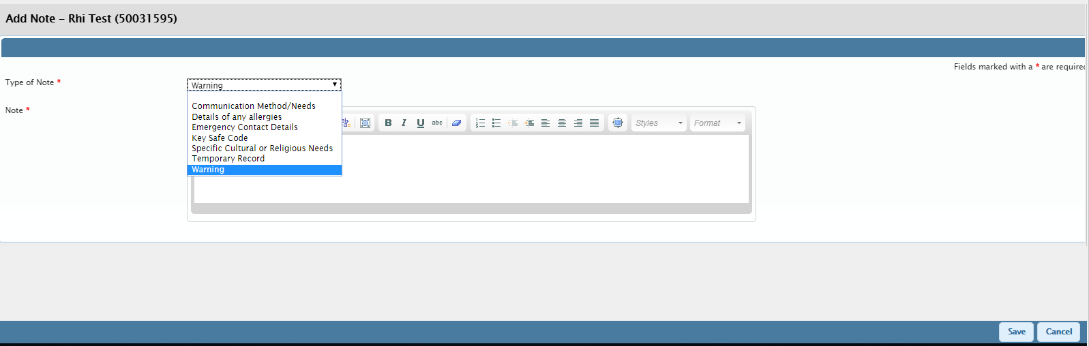

Click Save once you have completed the Warning **Note** with all the detail required.

* By clicking  this will take you back to the Person Notes History page where you will see the **Note** has been added
* You will be able to edit the note by clicking the  ICON
* In the cases where the Child has returned, you can then update the **Note** with this detail and then End Date the **Note**
* To end the Warning **Note,** click the  ICON



* Once completed, click the  button, and then click the  button
* You will now see the Warning displayed on the Person Summary screen

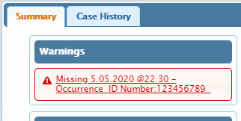

cid:image006.jpg@01D50C05.8119F730You will need to open a **Record of Missing Child Workstep** *(if not   
already opened)*.

*This* ***Workstep*** *will only be available to the* ***First Response Team*** *to* ***Start*** *and will not be available for other teams to initiate in this way.*

**Record of Missing Workstep**

Click **Start,** select the **Record of Missing Child Workstep**

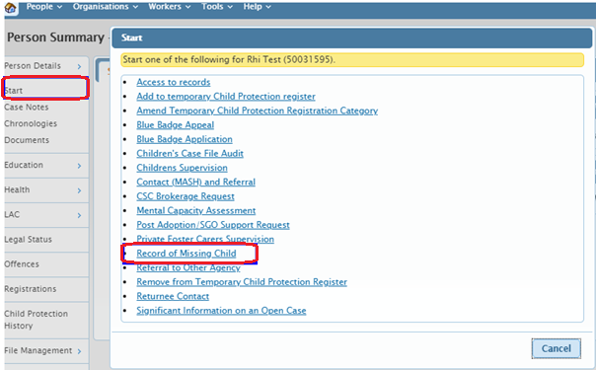

Select **Record of Missing Child**

Click **Start**

Within this step you have 4 Sections to complete.

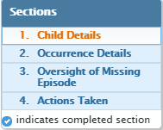

**Section 1 -** The **First Response Team** will check that all the correct details have pulled through form the Person Summary screen.

**Section 2** – Part 1 to be completed by the **First Response Team**.

They will need to enter;

* Missing from
* Date & time last seen
* Date and time reported
* Police Occurrence ID.

cid:image006.jpg@01D50C05.8119F730***It is important all these details are typed in correctly.***

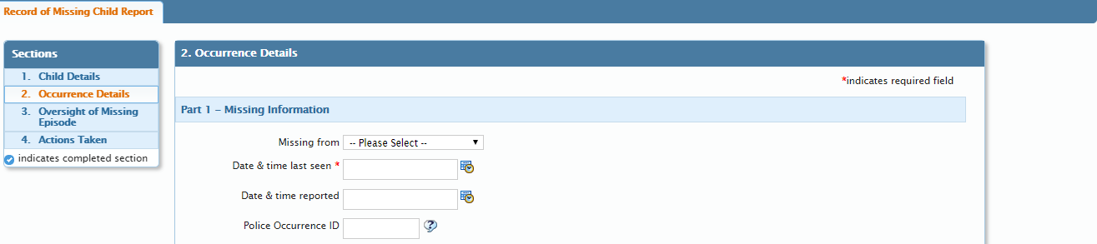

Once all these fields have been completed click the  ICON.

cid:image006.jpg@01D50C05.8119F730

**Section 2** – Part 2 to be completed by the **First Response Team** should   
this information be available at the time that this Record of Missing is being completed and before assigning it to the **Missing, Return Home Interviews and Intelligence Team**

* You will need to attach the Record of Missingnotification via the  ICON
* Click the  ICON, click Attach a document, then choose the file you wish to attach. **Open** and select a Main Category, then **Add**



**Name of document – Date of actual attachment**e.g. *PPN 123456789 from Police record of missing – 06.05.2020*

* This will then change the number in the brackets next to the paperclip.   
  The number shows how many attachments have been uploaded to this Workstep



* You can view this attachment within the **Workstep** summary screen, or under the attachment’s files on the Person Summary screen

*Attachment within the* ***Step****.*

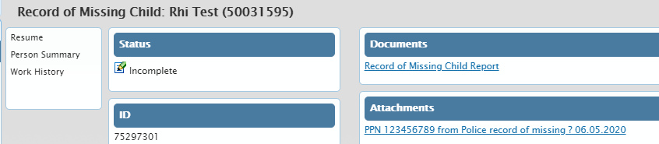

Once this has been completed, you will need to click the  ICON which will **Save** and **Close** the **Workstep**.

This **Workstep** will now need to go to the **Missing, Return Home Interviews and Intelligence Team**. However, as this **Workstep** has been started, this will need to be   
Assigned to a named worker. (*Currently this should only be assigned to Natasha Sowlet*).

In order to do this;

* Go to your Current Work, find the correct **Record of Missing Child Workstep**
* Hover over the  ICON
* The ICON will change to the  ICON
* Click on the yellow/golden cog and Assign Work

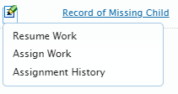

Click Assign Work

* To Pass to Worker, click on 
* Search for the worker this **Workstep** needs to be Assigned to
* Once you have found the worker, click on their name and you will be returned to the Assign Work screen. Their name is now showing in the Pass to Worker field
* You can add a note for the worker if you wish. (*Ensure this is professional and clear*)
* Click  once completed
* This **Workstep** is now Assigned to the worker chosen for them to complete  
  and **FINISH** the **Workstep**

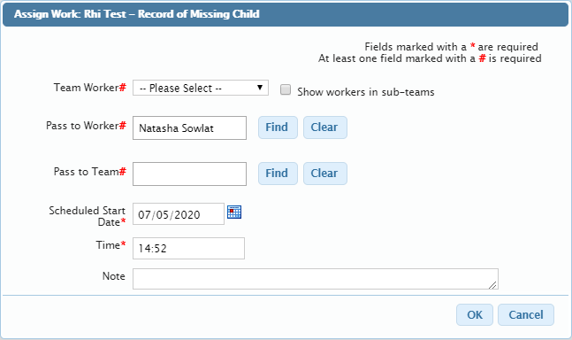

* The Assigned Worker can then **Resume** the **Record of Missing Child Workstep** from their Current Work. As this work has already been started, it will be in the Incomplete Work folder of their Current Work

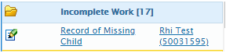

* Hover over the  ICON
* The ICON will change to the  ICON
* Select Resume Work (or if you click on the title of the **Record of Missing Child,**this will take you to the **Workstep** Summary screen and you can Resume   
  from there

 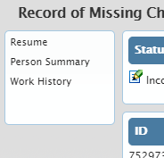

Click on Resume

Click on the **Workstep** Title

cid:image006.jpg@01D50C05.8119F730

Continue and complete Sections 2-4 of this **Workstep**.

There are mandatory parts in Section 2 and Section 3 that will need to be filled in.

**Section 4 – Actions Taken**: This is where you choose the **Next Actions** of what should happen next, depending on the outcome of the **Record of Missing**.

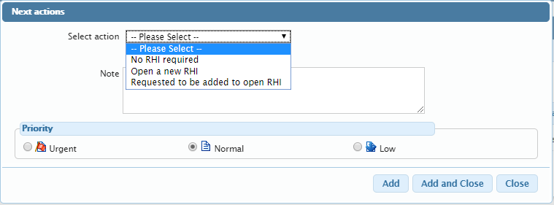

**You have 3 Next Actions;**

|  |  |  |  |
| --- | --- | --- | --- |
| Next Action alias | **No RHI required** | Assigned to | Terminating step |
| Next Action title | N/A | Can be early | No |
| When to send | N/A | Available for Group working | No |

|  |  |  |  |
| --- | --- | --- | --- |
| Next Action alias | **Open a new RHI** | Assigned to | Any Worker |
| Next Action title | Return Home Interview | Can be early | Yes |
| When to send | You can send this step immediately to the team or worker that you wish to (this would most likely be the workers in the **Missing, Return Home Interviews and Intelligence Team** who will be undertaking the **Return Home Interview)** or, if agreed or case is already allocated, this will return to the Allocated Worker to completed.  If you choose to send Immediately, the status will say Proposed until you click the  ICON.  You can now complete the **Workstep** straight away if you are waiting for information and want to prevent delay in the **Return Home Interview** being started.    There will be times a worker has not been identified so ‘Pass to Team’ allows for the **Return Home Interview** to go to the **Missing, Return Home Interviews and Intelligence Team** until it can  be assigned. | Available for Group working | No |

|  |  |  |  |
| --- | --- | --- | --- |
| Next Action alias | **Requested to be added to an open RHI** | Assigned to | Terminating Step |
| Next Action title | Return Home Interview | Can be early | No |
| When to send | This means that the Child already has a **Return Home Interview Workstep** open and active. If the child goes missing again, you can add this occurrence to the open **Return Home Interview**. | Available for Group working | No |



If you have chosen the Next Action of **Requested to be added to  
an open Return Home Interview,** you will need to send a **Request**   
via the clipboard to alert the worker who is completing the **Return   
Home Interview** that there is a further **Record of Missing** to be included.



* Click the  ICON
* Click the radio button with the  ICON   
  **Please include this missing episode in RHI**

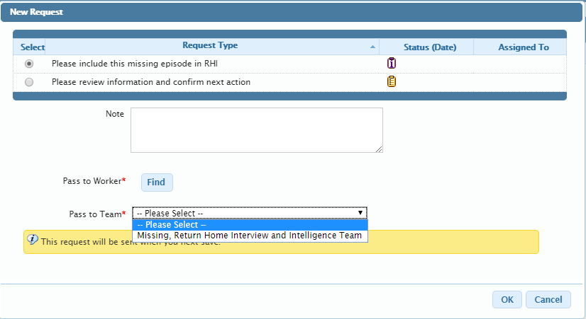

* If the **Return Home Interview** **Workstep** is already open to a worker, to   
  Pass to Worker, click on 
* Search for the worker this **Workstep** needs to be Assigned to
* Once you have found the worker, click on their name and you will be returned to   
  the Assign Work screen. Their name is now showing in the Pass to Worker field
* Add a note in the note field and include the Police Occurrence ID number with date and time of missing. This is so the worker can add these details to the **Return Home Interview** **Workstep**. (*Ensure this is professional and clear*)
* Click  once completed
* Click  to send this **Request** to the worker. They will have the request   
  in the Incoming Request folder in their Current Work

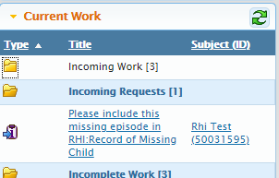

* Once all aspects have been completed click the  ICON to   
  **FINISH** this **Workstep**

**Return Home Interview - Workstep**

* Locate this **Workstep** from either your Incoming Work under Current Work, or from the Person Summary screen
* Click on **Start** to open the **Workstep** and there, you will be able to record the information gained from the **Return Home Interview**

You will see down the left-hand side there are 8 Sections. As a worker completing the **Return Home Interview** you will need to complete Sections 1-6 in as much detail

as possible.

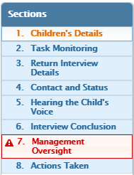

**Section 1 -** In this Section, details about the Child will have been pulled through   
from the Child’s Person Summary screen. If any details are incorrect you will   
need to navigate back to the Person Summary screen.

You can do this by either.

* Saving and closing the **Workstep**, go to the Person Summary screen, update the details, when you reopen the **Workstep**, the new details will pull through

**Or**

* Click the  ICON. This ICON with take you straight to the Person Summary screen while leaving the **Workstep** open
* Update the details
* Go back to the **Workstep**, (you will need to click on your Chrome Icon in your task bar to locate your open **Workstep**)
* Click the  ICON and any changes will then be updated within this **Workstep**

cid:image006.jpg@01D50C05.8119F730

**Click the**  **ICON after completing each Section to ensure that no work   
is lost**.

**Section 2 -** In this Section you can record the following.

* Occurrence ID numbers and the Date Last Seen
* Any **Earlier Attempts for this Interview**
* If the **Return Home Interview** request proceeded to a successful interview

*By clicking add, it will open another box for you to add the details in.*

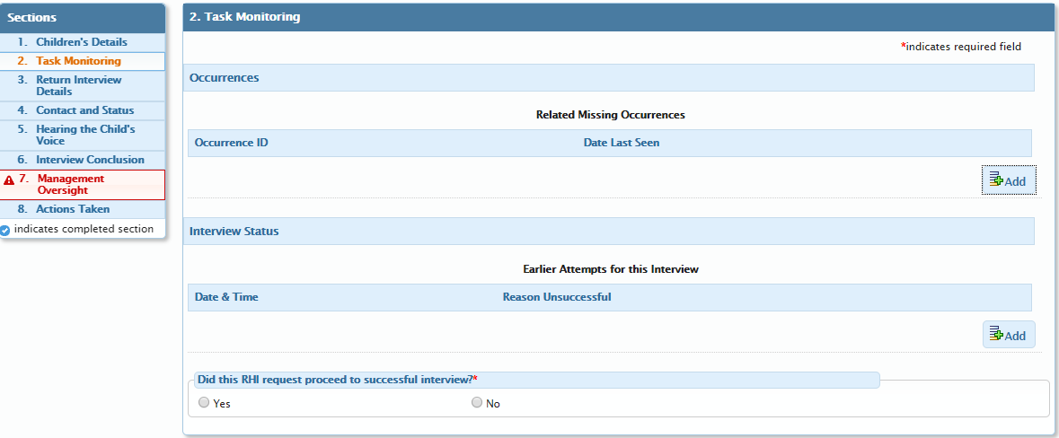

* If you have more than one to add, you would select  button and this will   
  allow you to add another Occurrence ID etc.
* Once you have added all the Occurrence ID’s and the Date’s Last Seen, click  button

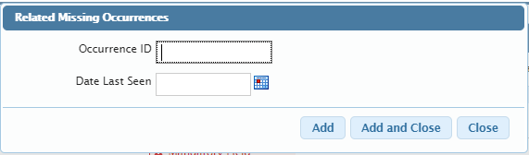

If no is selected for **Did this RHI request proceed to successful interviews\*** you   
will need to add the Reason and Date of the decision. This will then hide Sections 3-6,   
but you would need to send the **Required** Request to the Manager for oversight.

**Section 3 -** In this Section you are to.

* Add the time and date of the **Return Home Interview**
* Find and add all persons present at the interview here. (click the  button to search for yourself or other workers as shown earlier in this guide)
* This time when you click , you will have 4 tabs to choose from

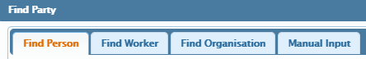

**Section 4 –** In this Section it allows you to find and add.

* The Lead Professional involved
* Any Other Known Professionals Involved with the Child/Young Person
* Any Known Associates
* You can also add any Known Locations

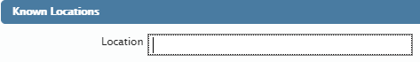

**Section 5 -** In this Section you can record.

* The Record of discussion
* Any other relevant information
* Hopes / Dreams / Future Picture – What does the Child think or would like to change?
* Any Push & Pull Factors via the tick boxes. You can tick multiple boxes for each factor. *(You will be asked to comment on the ones you have ticked in the Push / Pull Comments Section)*
* Who the Child was with when they went missing?
* Any themes that were a feature of the Missing Episode, ensuring this is recorded in the earlier box Record of discussion within this Section

**Section 6 -** In this Section, you can record the Interview Conclusion and any   
safeguarding issues that were raised, along with a section for you to record who this information has been passed to. You need to complete this Section by ticking the Worker’s E-signature which captures the time and date this **Return Home Interview** was completed.

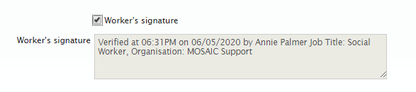

Once you have Saved and completed all the Sections, you will need to send this back to Management for oversight. Currently they go back to Natasha Sowlat.

To send this to Natasha you need to.

* Click on the ICON to send the **Required Request** Please review information and confirm next action
* Pass to Worker, click on 
* Search for Natasha Sowlet
* Add a note in the note field (*Ensure this is professional and clear*)
* Click  once completed
* Click  to send this **Request**. The request will be in the Incoming Request folder in their Current Work
* You will then need to come out of the **Workstep**, click on the  ICON on the right-hand side, to allow the Manager to **Resume** and **FINISH** this **Workstep**.

# The Managers role:

Resume the **Workstep**, review and check Sections 1-6.

In Section 7 you will be required to provide an oversight within the **Signs of Safety** model.

Once this Section is completed, you will need to tick the E-signature, Signature of Manager.

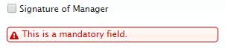

Click the  ICON, find the request and complete.

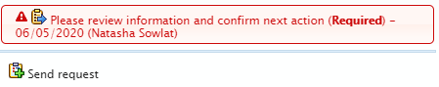

By clicking on the request where it shows your name you will be able to acknowledge that your oversight has been completed.

cid:image006.jpg@01D50C05.8119F730

**Completed** will acknowledge the request and authorise completion of the task.

**Returned** will send the request back to the sender. This would be used if there were more details required to complete the task. If you do send it back, please leave clear notes describing what else is needed for completion.

Once completed, the worker Resends the request for completion.

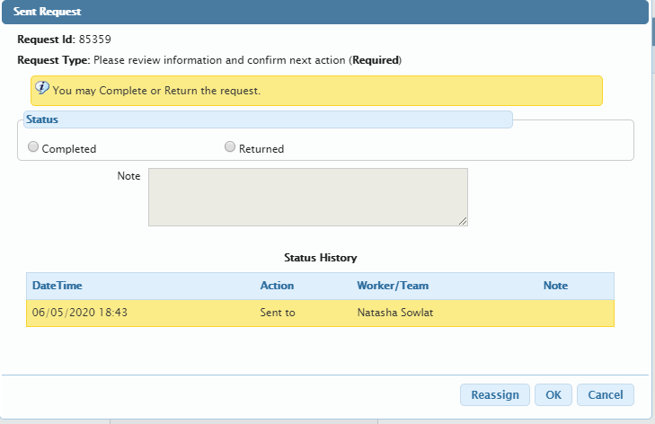

Once Oversight has been completed, if the case has an Allocated Worker, it is only then  
you will need to send the second **Request** which is a notification.

Click the radio button with the  ICON, Please review and acknowledge actions from **RHI**. This notification will alert the Allocated Worker that there has been an Oversight completed, where they can review and acknowledge any actions from the **Return Home Interview** to be included in the Child’s Plan, either CP, CIN or CiC (LAC).

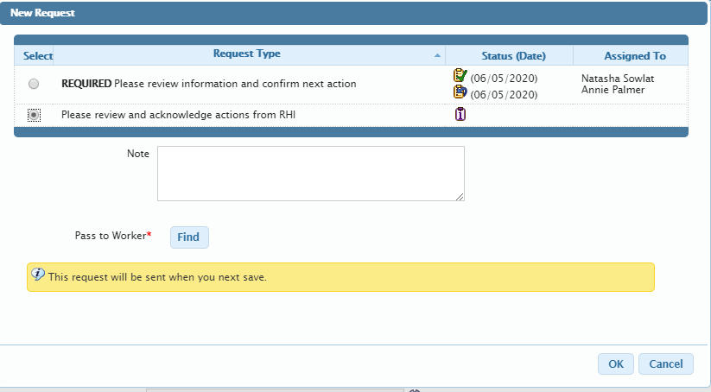

**Section 8 -** In this Section there is only one Next Action which must be selected.   
This action is **Report Completed** and will then terminate the workflow.

Once all Sections have been completed, and Saved, you will need to click the  ICON   
to **FINISH** this **Workstep** which will conclude the **Missing and Return Home Interview** **Worksteps**.

