Operational Guidance for Family Hub Teams (Parenting and Family Support) Safeguarding children in the context of the Coronavirus outbreak
January 2021 revised

Purpose of the Guidance
- To clarify arrangements for visiting and supporting vulnerable children during the national response to coronavirus.
- All team members will work within this guidance and any specific issues/risks will also be assessed and recorded through on-going ah-hoc and formal supervision and on case file summary.
- This guidance is aligned to the revised guidance issued on statutory visited issued By Irfan Alam on 21 September 2020.
- This guidance is underpinned by the RAC-19 CSC Home Visits which should be read by all team members.
General Principles
Legislation has not changed and therefore statutory visits to children need to be maintained. The children we work with are the most vulnerable in our communities.
It is important to balance our responsibility to maintain the health of our team members with our responsibilities to safeguard, protect and promote the wellbeing of the most vulnerable children in Bradford.
Parenting Workers and Family Support Workers are part of the network of essential key workers and are our most valuable resource. We continue to be extremely grateful to all of you for your efforts, flexibility and creativity during this difficult period.
You have shared some amazing examples of how you continue to meet families needs; working flexible hours, delivering groups one to one and moving some of these online, helping some move to places of safety, picking up possible issues of children being home alone, working with social workers when we need to step up, addressing basic needs and creative ways of keeping connected to children and young people. Thank you!
We continue to need to prioritise the needs of families open to Family Hubs, particularly those where basic needs have been a concern, those with very young or disabled children and larger families and those where the impact of DA continues to be a concern.
Our teams are directly preventing the need for social work involvement through providing proactive and positive early help. You have also been working closely with schools on supporting children and young peoples return to school since September.
Parenting teams have done a great job moving parenting groups online. There are no immediate plans to resume face to face group work.
Informed and ‘written’ consent can continue to be taken via Whatsapp and email as per guidance during Covid. It has also been agreed that we will take parenting referrals from NHS with verbal consent during this Covid period.
Under this revised guidance, we will move from door step only visits to resuming home visits.

Home visiting checklist and guidance?
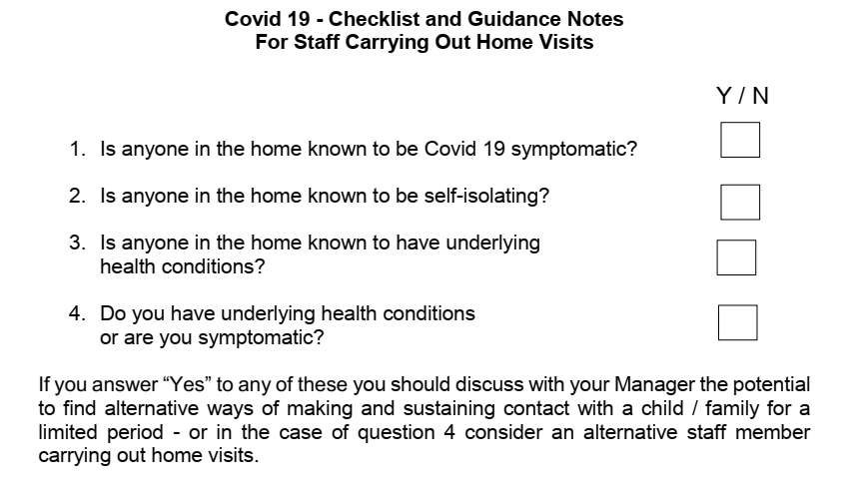
If a team member is regularly attending an office and/or has an underlying health issues/higher risk group then an individual risk assessment must be completed using the template below over and above the general risk assessment ‘RAC19 – CSC Home Visits’.
- Social distancing rules still remain and it is essential that staff wear face masks during a visit and ask the parent(s) and carer(s) to do the same.
- Before home visiting and if appropriate staff are expected to call ahead and ask if anyone has Covid-9 symptoms or self-isolating. Staff should check case records for any alerts.
- Before visiting the family staff should request that only the family members are present that are required for the visit and discourage others from attending.
- If visiting a family and you are concerned that a member of the household may be symptomatic then end the visit as soon as is practicably possible and report and discuss this with your Manager.
- Before and after visiting the family home, staff are advised to wash their hands.
- Staff are advised not to shake hands with any member of the household and seek to sit or stand maintaining a 2 metre distance from others.
- Staff are advised not to touch any unnecessary surfaces, toys, doors or accept drinks or refreshments from the family.
- Staff should spend only the time necessary with families, to carry out checks, assessment or direct work according to the circumstances of the case.
- Please remember, “visits” are more than a “welfare check”, direct work and home visits need to have a clear purpose linked to the family plan.

Direct work with children and young people
It is vital to explore in detail the child or young person’s views and wellbeing. Family support workers must work hard to engage children and young people and develop trusted relationships. If workers do not have open conversations with children and young people about the issues that are impacting them, it is not possible to know that the worries have reduced.
Where children and young people are struggling to express themselves beyond “everything’s fine”, workers should use direct work tools that are appropriate to their interests, age, need and level of understanding.
To ensure variety and to access specialist materials use signs of safety worksheets or see www.socialworkerstoolbox.com.
Other resources have also been banked in a shared folder:
K:\Children's Department Shared Area\Coronavirus
Worksheets should be uploaded to EHM (a photo is acceptable if children want to keep their work).
Prior to Covid, a newly allocated family with intensive support would receive at least one or more weekly visit.
From this point forward:
- Each Family Support Co-ordinator will continue to identify ‘most worried about’ families who will continue to receive an enhanced level of visits. These families will receive at least one weekly home visit. Each hub will continue to identify these families and review on a weekly basis. If a family is on this list then this should be clearly stated on the case summary.
- ALL cases allocated to family support workers – at least one weekly phone contact and one home visit every two weeks. Workers should maintain social distance at all times and now enter the home taking into account the wider guidance in this document.
- In addition, these visits should be supplemented (but not replaced) by telephone and video calls where available and appropriate to the needs of the children.
- If any family member reports symptoms, then virtual visits only should be undertaken during the 14-days in which the family should be isolating. Again, this should be kept up-to-date on the case summary.
- A telephone call with no visual sight of a child and/or parent is NOT a virtual visit and should not be recorded as such.
Where children cannot be seen at all and concern for their wellbeing is heightened, Social Work colleagues should be contacted immediately by the relevant Co-ordinator to enable further discussion of the available options.
If the child or carers are known or believed to have Covid-19 or are displaying Covid-19 symptoms, then a request will need to be made to the multi-agency Covid-19 team if the child needs to be seen in a way that would breach social distancing rules.

Caseload monitoring, assessments and reviews
In Family Hubs, the family support pathway was reinstated in May.
Caseloads should be monitored to the usual guidance of between 10-12 families per full-time worker.
For newly allocated cases, workers should make first contact with a family within five working days and completed assessments within 20 working days of allocation.
We appreciate some flexibility may be needed, so if timescales for initial contact, assessment or reviews are not achieved, then the relevant Co-ordinator should place a management footprint on file which confirms revised dates for completion. This should be though by exception only.
PPE appropriate to the above actions which do maintain social distance is available from Owlet in the usual way and also now can be arranged via
FamilyHubKeighleyShipley@bradford.gov.uk
FamilyHubWest@bradford.gov.uk
Cases awaiting for allocation should be managed in the same way before Covid, adding any children to the ‘most worried about’ list if indicated as needed. Weekly workload reports on key work will continue to be shared with Service Managers.
If any workers cannot undertake door step visits on their caseload their families will need to visited by other team members. They in turn though can be undertaking duty contacts and/or phone calls on cases of their peers who are completing door step visits on their behalf.
Working from home
- At this stage, team members will continue to work from home.

- Heads of Service, Service Managers and Team Managers have set up communication systems to enable them to be in frequent contact with their teams via phone, virtual or email to ensure that staff safety is maintained and that work is managed and prioritised.

- Formal team meetings with an agenda and minuted will take place with each team at least fortnightly.

- Team meetings and supervisions for all team members are to continue via phone or virtually.

